**Index**

**1. Login Page.** 9

**2. Home Page.** 11

**3. Users with the role “Administrator”.** 12

***3.1 Customers Page.*** 12

*3.1.1 How to Navigate to “Customers” Page.* 12

*3.1.2 How to Search a Customer.* 13

*3.1.3 How to Add a New Customer.* 18

*3.1.4 How to Edit Information of a Customer.* 19

*3.1.5 How to Delete a Customer.* 21

***3.2 Customers PN Page.*** 22

*3.2.1 How to Navigate to “Customers PN” Page.* 22

*3.2.2 How to Search a Customer PN.* 23

*3.2.3 How to Add a New Customer PN.* 26

*3.2.4 How to Edit Information of a Customer PN.* 28

*3.2.5 How to Delete a Customer PN.* 29

***3.3 PPAP’s Page.*** 30

*3.3.1 How to Navigate to “PPAP’s” Page.* 30

*3.3.2 How to Search a PPAP.* 31

*3.3.3 Meaning of the Colors of the Registers.* 36

*3.3.4 How to Add a New PPAP.* 38

*3.3.5 How to Edit Information of a PPAP.* 42

*3.3.6 How to Copy the Information of a PPAP.* 44

*3.3.7 How to Delete a PPAP.* 45

*3.3.8 How to Automatically Create a Renewal for a PPAP.* 46

*3.3.9 Duplicating Register Alert.* 47

*3.3.10 How to Check the “PPAP ET” & “IMDS ET” of a BluSeal PPAP.* 48

*3.3.11 How to Check the “PSW ET” & “IMDS ET” of a Cable PPAP.* 48

*3.3.12 How to Export the Information of the Table to an Excel Document.* 49

***3.4 BluSeal Page.*** 52

*3.4.1 How to Navigate to “BluSeal” Page.* 52

*3.4.2 How to Search a PPAP.* 53

*3.4.3 Meaning of the Colors of the Registers.* 58

*3.4.4 How to Add a New PPAP.* 60

*3.4.5 How to Edit Information of a PPAP.* 64

*3.4.6 How to Copy the Information of a PPAP.* 66

*3.4.7 How to Delete a PPAP.* 67

*3.4.8 How to Automatically Create a Renewal for a PPAP.* 68

*3.4.9 Duplicating Register Alert.* 69

*3.4.10 How to Check the “PPAP ET” & “IMDS ET” of a PPAP.* 70

*3.4.11 How to Export the Information of the Table to an Excel Document.* 70

***3.5 Cables Page.*** 73

*3.5.1 How to Navigate to “Cables” Page.* 73

*3.5.2 How to Search a PPAP.* 74

*3.5.3 Meaning of the Colors of the Registers.* 79

*3.5.4 How to Add a New PPAP.* 81

*3.5.5 How to Edit Information of a PPAP.* 85

*3.5.6 How to Copy the Information of a PPAP.* 87

*3.5.7 How to Delete a PPAP.* 88

*3.5.8 How to Automatically Create a Renewal for a PPAP.* 89

*3.5.9 Duplicating Register Alert.* 90

*3.5.10 How to Check the “PSW ET” & “IMDS ET” of a PPAP.* 91

*3.5.11 How to Export the Information of the Table to an Excel Document.* 91

***3.6 Tapes Page.*** 94

*3.6.1 How to Navigate to “Tapes” Page.* 94

*3.6.2 How to Search a PPAP.* 95

*3.6.3 Meaning of the Colors of the Registers.* 100

*3.6.4 How to Add a New PPAP.* 102

*3.6.5 How to Edit Information of a PPAP.* 106

*3.6.6 How to Copy the Information of a PPAP.* 107

*3.6.7 How to Delete a PPAP.* 109

*3.6.8 How to Automatically Create a Renewal for a PPAP.* 110

*3.6.9 Duplicating Register Alert.* 111

*3.6.10 How to Export the Information of the Table to an Excel Document.* 112

***3.7 Tubes Page.*** 114

*3.7.1 How to Navigate to “Tubes” Page.* 114

*3.7.2 How to Search a PPAP.* 115

*3.7.3 Meaning of the Colors of the Registers.* 120

*3.7.4 How to Add a New PPAP.* 122

*3.7.5 How to Edit Information of a PPAP.* 126

*3.7.6 How to Copy the Information of a PPAP.* 127

*3.7.7 How to Delete a PPAP.* 129

*3.7.8 How to Automatically Create a Renewal for a PPAP.* 130

*3.7.9 Duplicating Register Alert.* 131

*3.7.10 How to Export the Information of the Table to an Excel Document.* 132

***3.8 Products Page.*** 134

*3.8.1 How to Navigate to “Products” Page.* 134

*3.8.2 How to Search a Product.* 135

*3.8.3 How to Add a New Product.* 141

*3.8.4 How to Edit Information of a Product.* 144

*3.8.5 How to Delete a Product.* 145

***3.9 Users Page.*** 147

*3.9.1 How to Navigate to “Users” Page.* 147

*3.9.2 How to Search a User.* 148

*3.9.3 How to Add a New User.* 149

*3.9.4 How to Edit Information of a User.* 150

*3.9.5 How to Delete a User.* 152

*3.9.6 How to Check the Password of a User.* 152

***3.10 Vendors Page.*** 153

*3.10.1 How to Navigate to “Vendors” Page.* 153

*3.10.2 How to Search a Vendor.* 154

*3.10.3 How to Add a New Vendor.* 156

*3.10.4 How to Edit Information of a Vendor.* 157

*3.10.5 How to Delete a Vendor.* 158

***3.11 Errors.*** 159

*3.11.1 Customers Page Errors.* 159

3.11.1.1 Register Form Errors. 159

3.11.1.1.1 Customer ID must start with ‘CUS’. 159

3.11.1.1.2 Customer ID must contain only numbers after ‘CUS’. 159

3.11.1.1.3 The customer *customer’s name* - *country* already exists. 160

3.11.1.1.4 The customer *customer’s name* already exists. 160

3.11.1.1.5 Customer PPAP Number must have the form 'PP00000'. 161

3.11.1.1.6 The Customer PPAP Number *Customer PPAP Number* already exists. 162

3.11.1.1.7 You must select at least 1 product for the customer. 163

3.11.1.2 Edit Form Errors. 164

3.11.1.2.1 Customer ID must start with ‘CUS’. 164

3.11.1.2.2 Customer ID must contain only numbers after ‘CUS’. 164

3.11.1.2.3 The customer *customer’s name* - *country* already exists. 165

3.11.1.2.4 The customer *customer’s name* already exists. 165

3.11.1.2.5 Customer PPAP Number must have the form 'PP00000'. 166

3.11.1.2.6 The Customer PPAP Number *Customer PPAP Number* already exists. 167

3.11.1.3 Delete Form Errors. 167

3.11.1.3.1 This customer can't be deleted, because it already has registers. 167

*3.11.2 Customers PN Page Errors.* 168

3.11.2.1 Register Form Errors. 168

3.11.2.1.1 The customer *customer’s name* - *country* doesn’t exist. 168

3.11.2.1.2 The customer *customer’s name* doesn’t exist. 169

3.11.2.1.3 The Eurotech PN *Eurotech PN* doesn't exist. 170

3.11.2.1.4 A Customer PN already exists for the Eurotech PN *Eurotech PN* and the customer *customer’s name* - *country*. 171

3.11.2.1.5 A Customer PN already exists for the Eurotech PN *Eurotech PN* and the customer *customer’s name*. 172

3.11.2.1.6 You are duplicating the Customer PN *Customer PN* for the customer *customer’s name* - *country*. 173

3.11.2.1.7 You are duplicating the Customer PN *Customer PN* for the customer *customer’s name*. 174

3.11.2.2 Edit Form Errors. 175

3.11.2.2.1 The customer *customer’s name* - *country* doesn’t exist. 175

3.11.2.2.2 The customer *customer’s name* doesn’t exist. 176

3.11.2.2.3 The Eurotech PN *Eurotech PN* doesn't exist. 177

3.11.2.2.4 A Customer PN already exists for the Eurotech PN *Eurotech PN* and the customer *customer’s name* - *country*. 178

3.11.2.2.5 A Customer PN already exists for the Eurotech PN *Eurotech PN* and the customer *customer’s name*. 179

3.11.2.2.6 You are duplicating the Customer PN *Customer PN* for the customer *customer’s name* - *country*. 180

3.11.2.2.7 You are duplicating the Customer PN *Customer PN* for the customer *customer’s name*. 181

3.11.2.3 Delete Form Errors. 182

3.11.2.3.1 This customer PN can’t be deleted, because it already has registers. 182

*3.11.3 PPAP’s, BluSeal, Cables, Tapes and Tubes Pages Errors.* 183

3.11.3.1 Register Form Errors. 183

3.11.3.1.1 The fields ‘Supplier PN’, ‘Customer’, ‘Country’, ‘Customer PN’, ‘Eurotech PN’ and ‘Description’ don’t match. 183

3.11.3.1.2 PPAP Number must have the form 'PP00000-0000'. 185

3.11.3.1.3 The fields ‘PPAP Number’, ‘Customer’ and ‘Country’ don’t match. 186

3.11.3.2 Edit Form Errors. 187

3.11.3.2.1 The fields ‘Supplier PN’, ‘Customer’, ‘Country’, ‘Customer PN’, ‘Eurotech PN’ and ‘Description’ don’t match. 187

3.11.3.2.2 PPAP Number must have the form 'PP00000-0000'. 189

3.11.3.2.3 The fields ‘PPAP Number’, ‘Customer’ and ‘Country’ don’t match. 190

*3.11.4 Products Page Errors.* 191

3.11.4.1 Register Form Errors. 191

3.11.4.1.1 The Eurotech PN *Eurotech PN* already exists. 191

3.11.4.1.2 The description *description* already exists. 191

3.11.4.1.3 The Supplier PN *Supplier PN* already exists. 192

3.11.4.1.4 The Eurotech PN *Eurotech PN* and the description *description* already exist. 193

3.11.4.1.5 The Eurotech PN *Eurotech PN* and the Supplier PN *Supplier PN* already exist. 193

3.11.4.1.6 The Supplier PN *Supplier PN* and the description *description* already exist. 194

3.11.4.1.7 The Eurotech PN *Eurotech PN*, the Supplier PN *Supplier PN* and the description *description* already exist. 195

3.11.4.1.8 The vendor *vendor’s name* doesn’t exist. 196

3.11.4.2 Edit Form Errors. 197

3.11.4.2.1 The description *description* already exists. 197

3.11.4.2.2 The Supplier PN *Supplier PN* already exists. 197

3.11.4.2.3 The Supplier PN *Supplier PN* and the description *description* already exist. 198

3.11.4.2.4 The vendor *vendor’s name* doesn’t exist. 198

3.11.4.3 Delete Form Errors. 199

3.11.4.3.1 This product can’t be deleted, because it already has registers. 199

*3.11.5 Users Page Errors.* 200

3.11.5.1 Register Form Errors. 200

3.11.5.1.1 Username *username* already exists. 200

3.11.5.2 Edit Form Errors. 200

3.11.5.2.1 Username *username* already exists. 200

*3.11.6 Vendors Page Errors.* 201

3.11.6.1 Register Form Errors. 201

3.11.6.1.1 The vendor ID *vendor ID* already exists. 201

3.11.6.1.2 The vendor *vendor’s name* already exists. 201

3.11.6.1.3 The vendor with the short name *vendor’s short name* already exists. 202

3.11.6.1.4 The vendor ID *vendor ID* and the vendor *vendor’s name* already exist. 202

3.11.6.1.5 The vendor ID *vendor ID* and the short name *vendor’s short name* already exist. 203

3.11.6.1.6 The vendor *vendor’s name* and the short name *vendor’s short name* already exist. 203

3.11.6.1.7 The vendor ID *vendor ID*, the vendor *vendor’s name* and the short name *vendor’s short name* already exist. 204

3.11.6.2 Edit Form Errors. 204

3.11.6.2.1 The vendor *vendor’s name* already exists. 204

3.11.6.2.2 The vendor with the short name *vendor’s short name* already exists. 205

3.11.6.2.3 The vendor *vendor’s name* and the short name *vendor’s short name* already exist. 205

3.11.6.3 Delete Form Errors. 206

3.11.6.3.1 This vendor can’t be deleted, because it already has registers. 206

**3.12 Log out.** 206

*3.12.1 How to log out from the web site.* 206

**4. Users with the role “User”** 207

***4.1 PPAP’s Page*** 207

*4.1.1 How to Navigate to “PPAP’s” Page.* 207

*4.1.2 How to Search a PPAP.* 208

*4.1.3 Meaning of the Colors of the Registers.* 213

*4.1.4 How to Export the Information of the Table to an Excel Document.* 215

***4.2 BluSeal Page*** 217

*4.2.1 How to Navigate to “BluSeal” Page.* 217

*4.2.2 How to Search a PPAP.* 218

*4.2.3 Meaning of the Colors of the Registers.* 223

*4.2.4 How to Export the Information of the Table to an Excel Document.* 225

***4.3 Cables Page*** 227

*4.3.1 How to Navigate to “Cables” Page.* 227

*4.3.2 How to Search a PPAP.* 228

*4.3.3 Meaning of the Colors of the Registers.* 233

*4.3.4 How to Export the Information of the Table to an Excel Document.* 235

***4.4 Tapes Page*** 237

*4.4.1 How to Navigate to “Tapes” Page.* 237

*4.4.2 How to Search a PPAP.* 238

*4.4.3 Meaning of the Colors of the Registers.* 243

*4.4.4 How to Export the Information of the Table to an Excel Document.* 245

***4.5 Tubes Page*** 247

*4.5.1 How to Navigate to “Tubes” Page.* 247

*4.5.2 How to Search a PPAP.* 248

*4.5.3 Meaning of the Colors of the Registers.* 253

*4.5.4 How to Export the Information of the Table to an Excel Document.* 255

**4.6 Log out.** 257

*4.6.1 How to log out from the web site.* 257

**1. Login Page.**

Once you are on the website and you have not logged in yet, the page will show the “Login Page”, where you must enter a valid username and password.

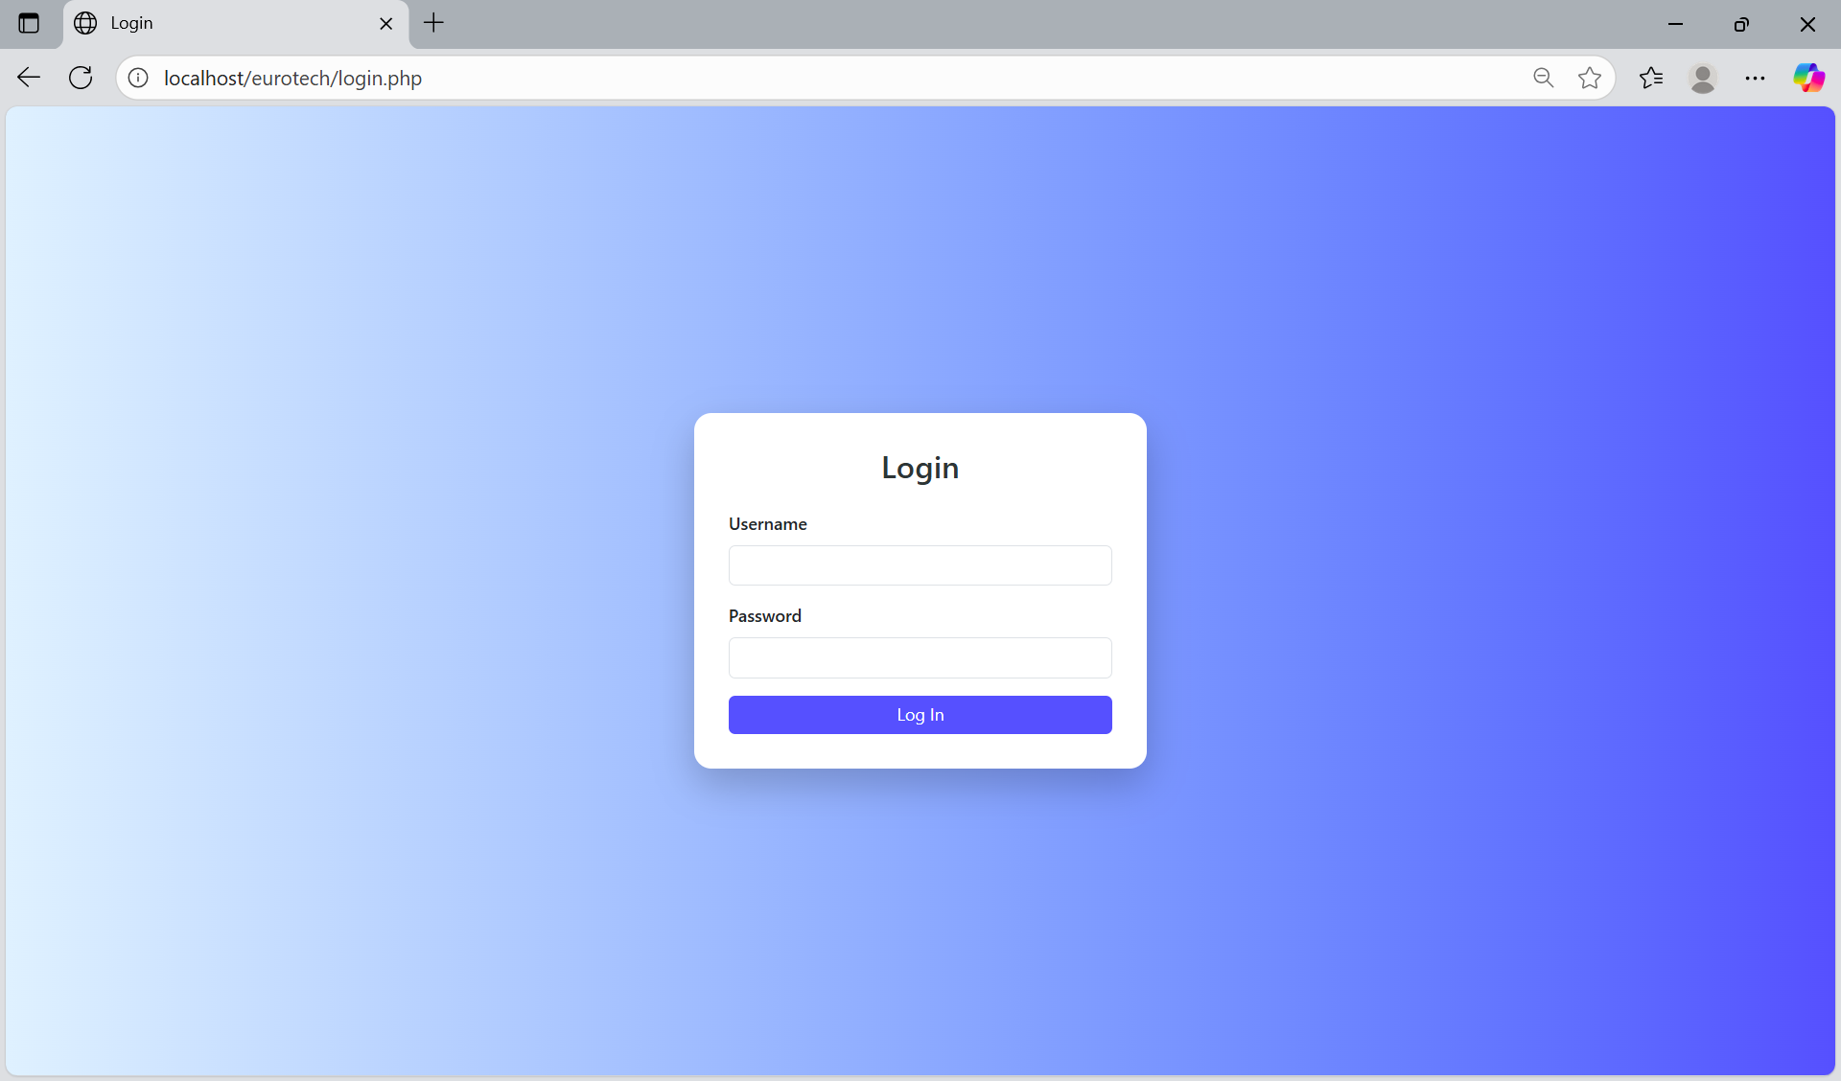

In the “Username” field, you must enter a valid username.

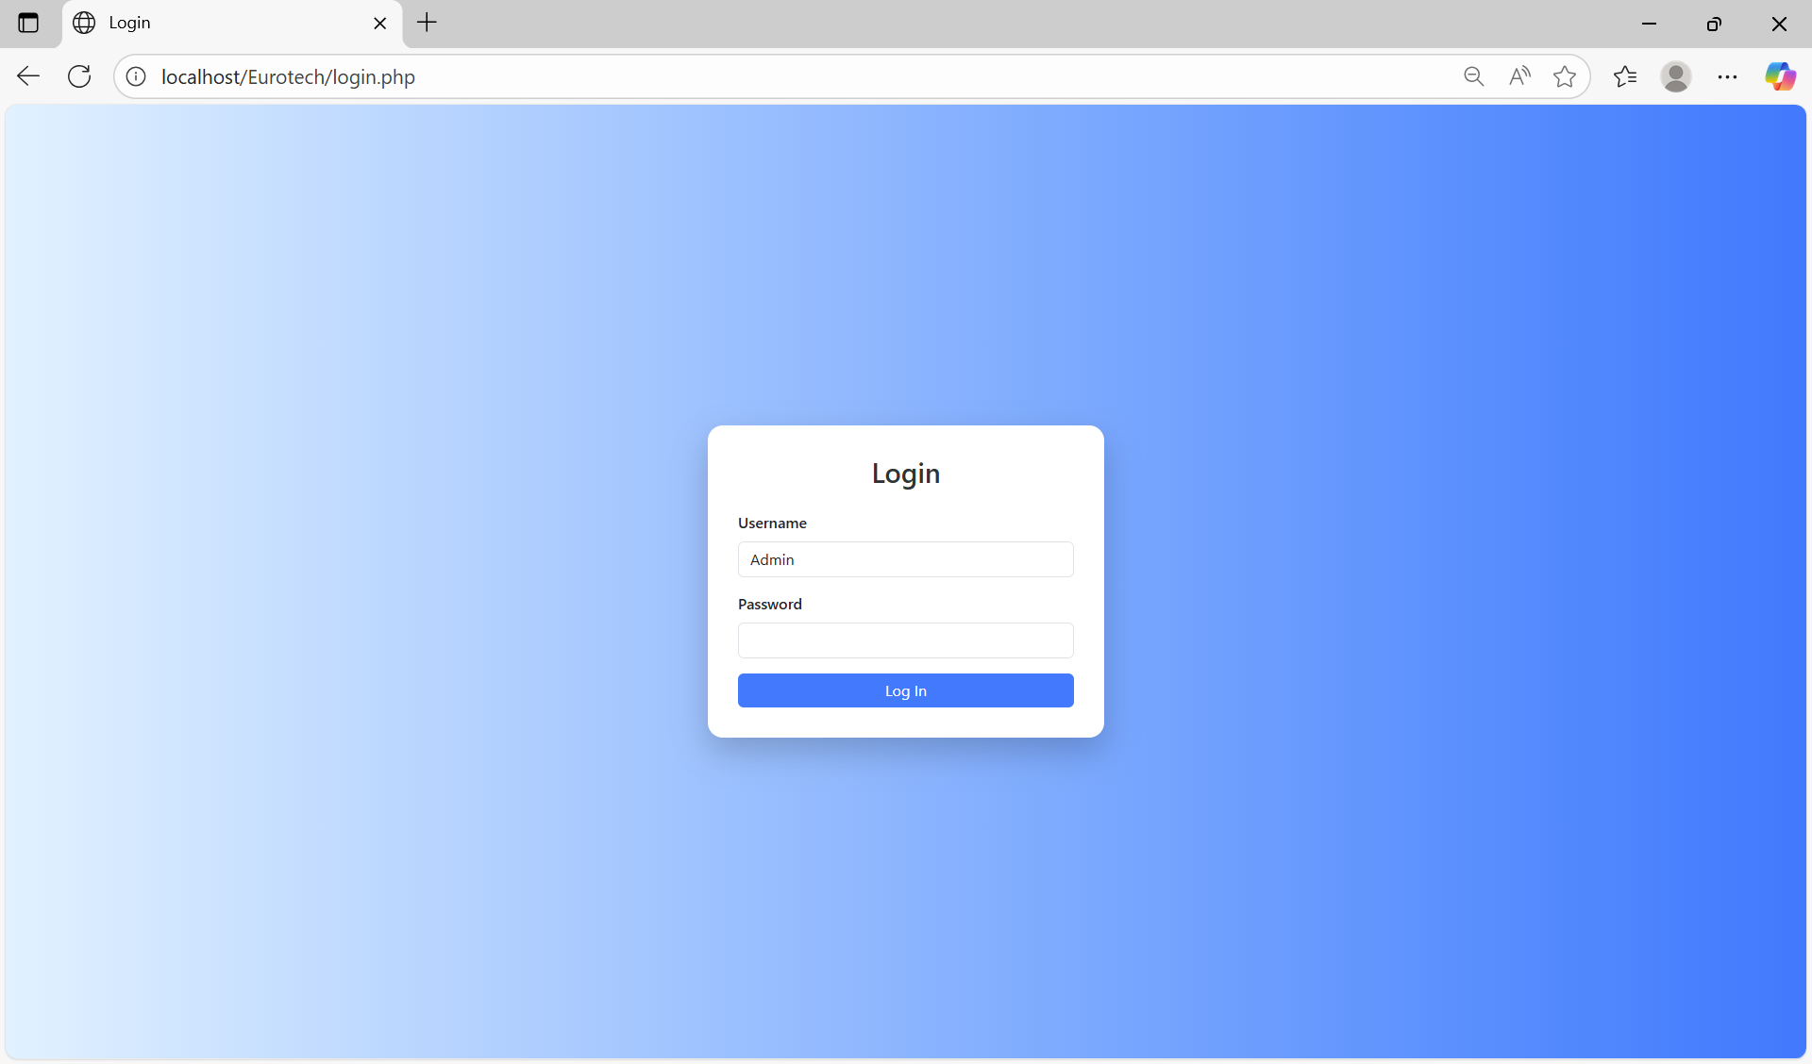

In the “Password” field, you must enter the password of the username.

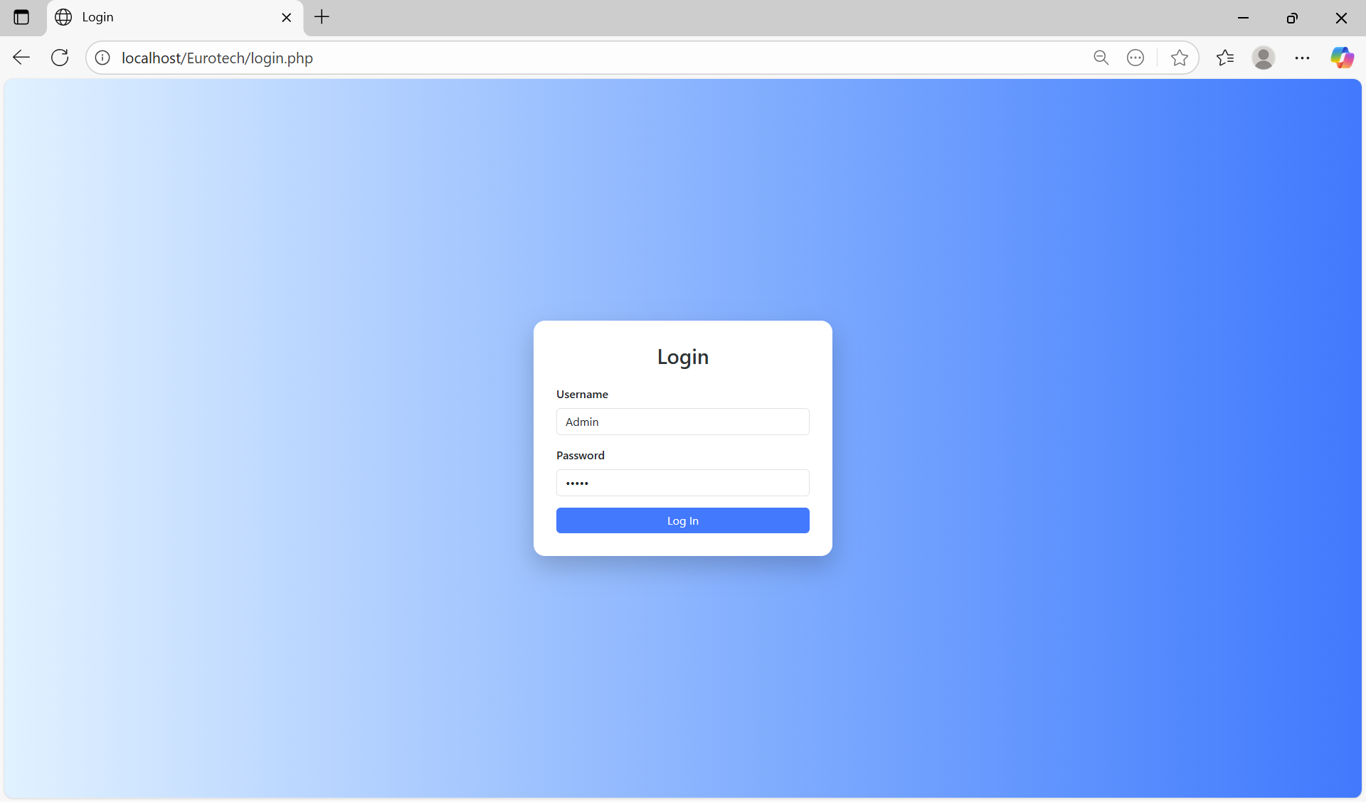

Once you write the username and password, you must click the “Log In” button.



If you didn’t write the username or password correctly, it will show you an error message that says that the username or password are incorrect.

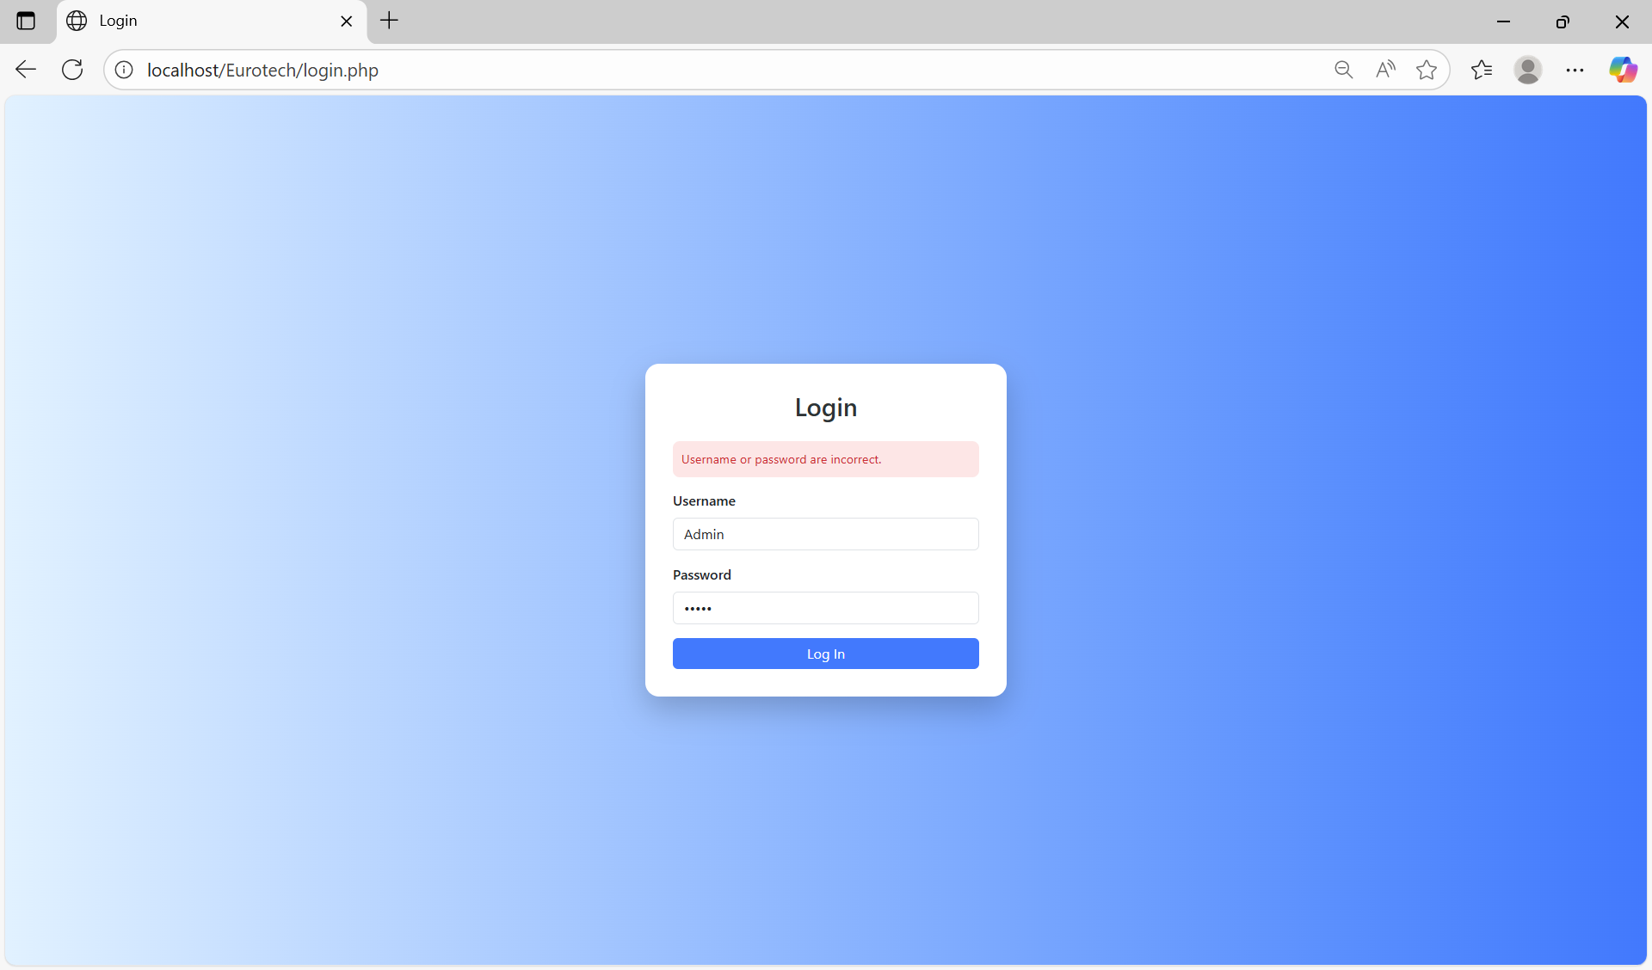

If you wrote the username or password correctly, you will be sent to the “Home Page” with the user you logged in.

# **2. Home Page.**

The “Home Page” shows you a welcome message and the purpose of the web site. Depending on your user’s role, it will show different options in the navigation bar that is at the top of the page.

If you log in with a user that have the role “Administrator”, you will have permissions to navigate into the pages “Customers”, “Customers PN”, “PPAP’s”, “BluSeal”, “Cables”, “Tapes”, “Tubes”, ”Products”, “Users” and “Vendors” with the options that are at the top of the page.

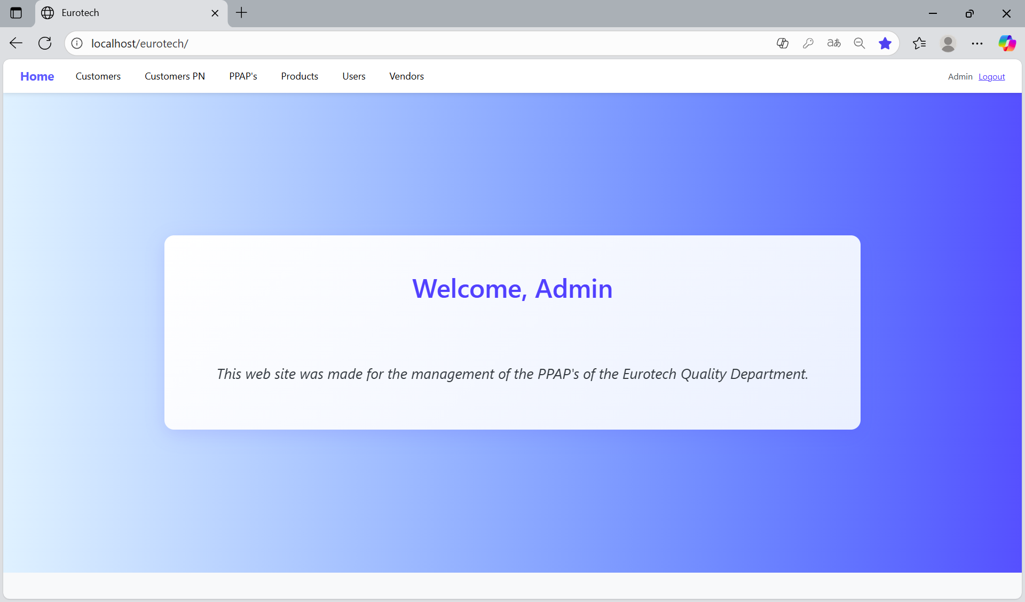

If you log in with a user that have the role “User”, you will only have permissions to navigate into the pages “PPAP’s”, “BluSeal”, “Cables”, “Tapes” and “Tubes” with the options that are at the top of the page.

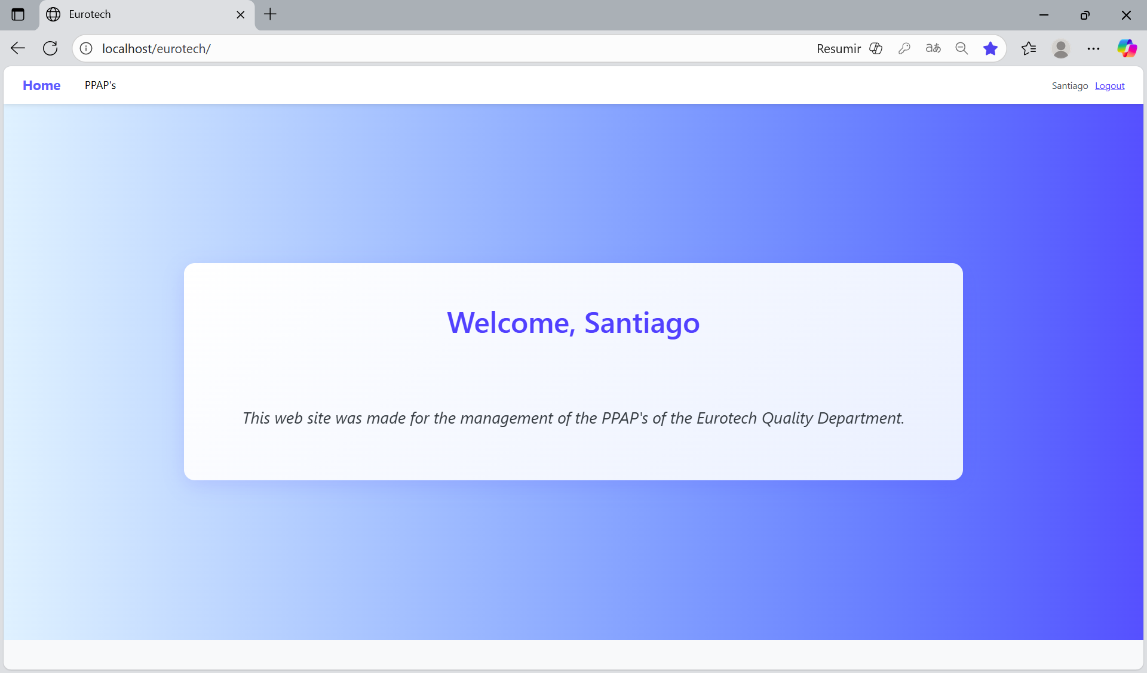

# **3. Users with the role “Administrator”.**

## ***3.1 Customers Page.***

### *3.1.1 How to Navigate to “Customers” Page.*

On the navigation bar, you can navigate to the “Customers” page.

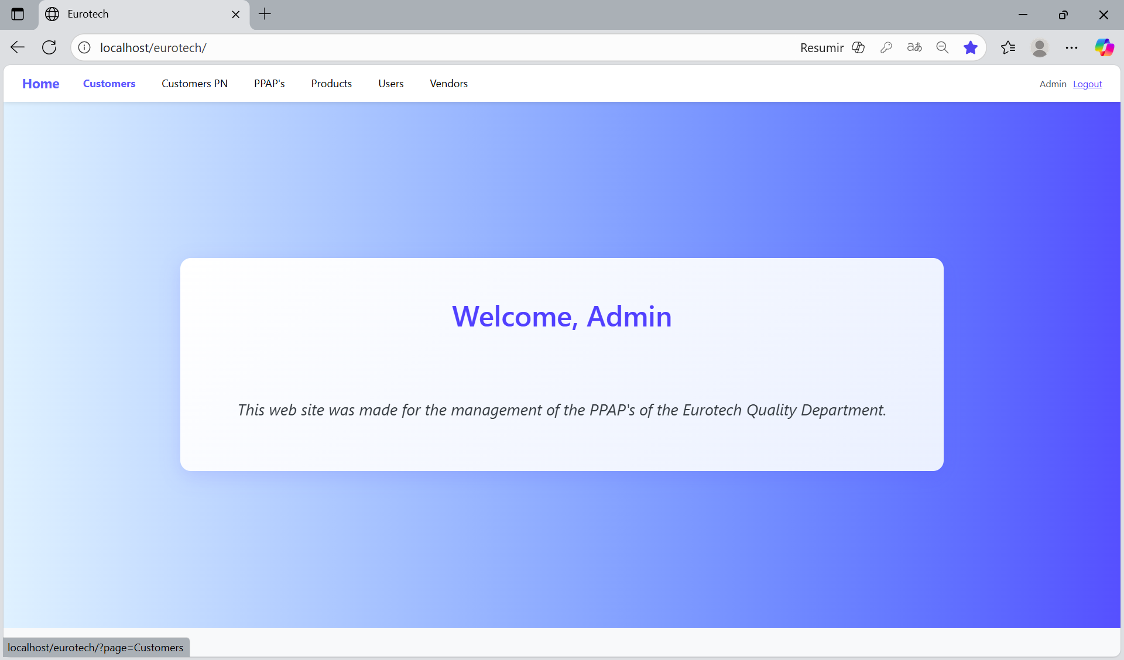

In this page you can manage the registers of all the customers.

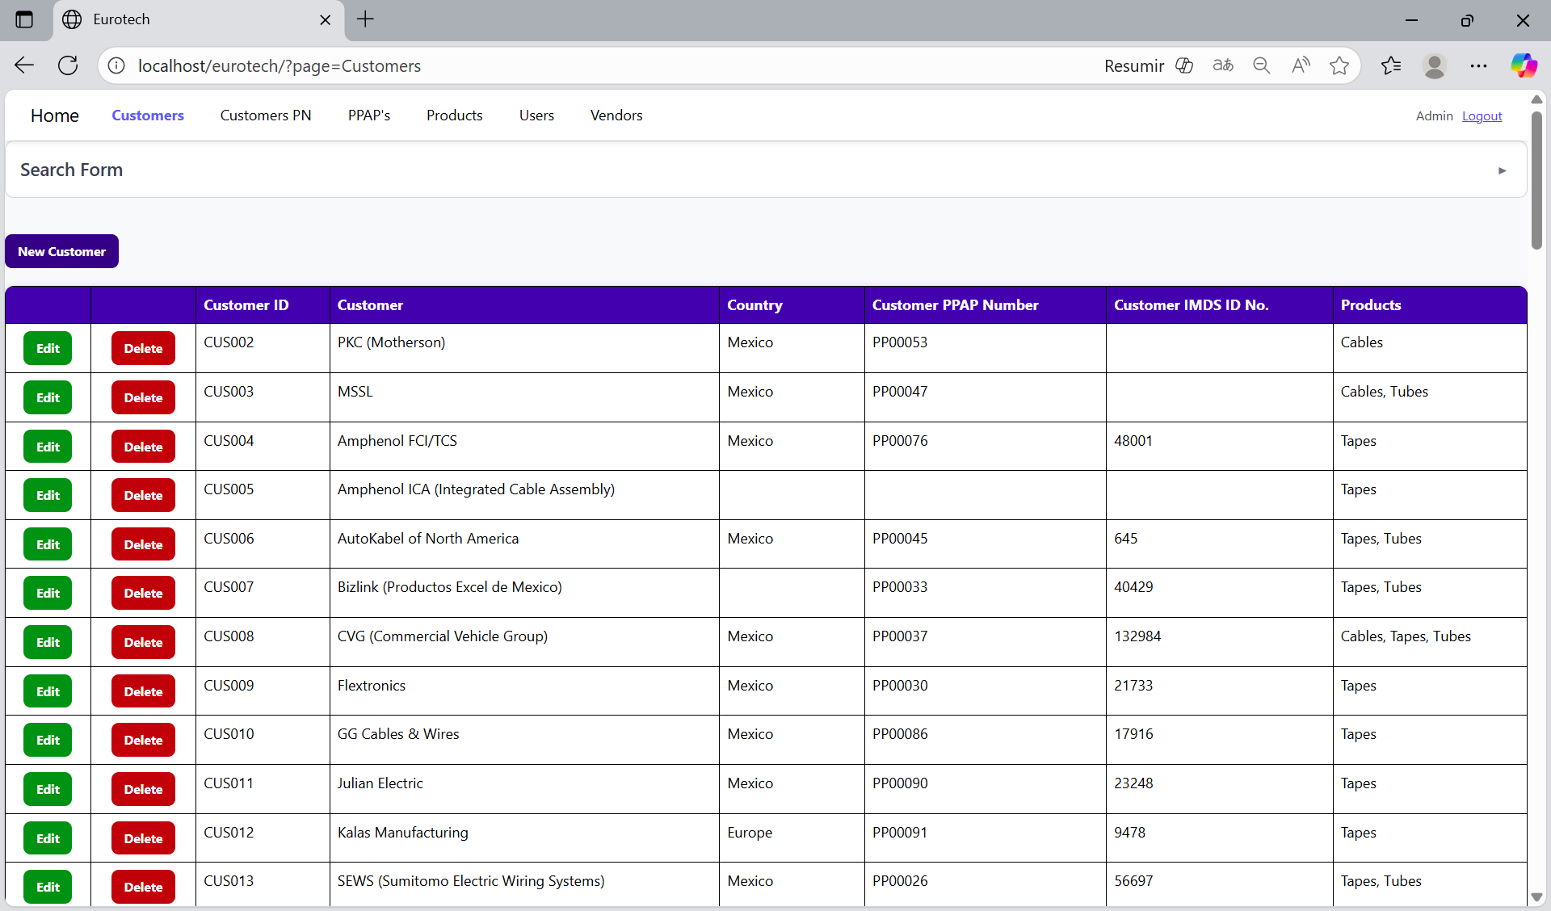

### *3.1.2 How to Search a Customer.*

At the top of the page, it will be a dropdown “Search Form” that has all the fields of the table for querying registers.

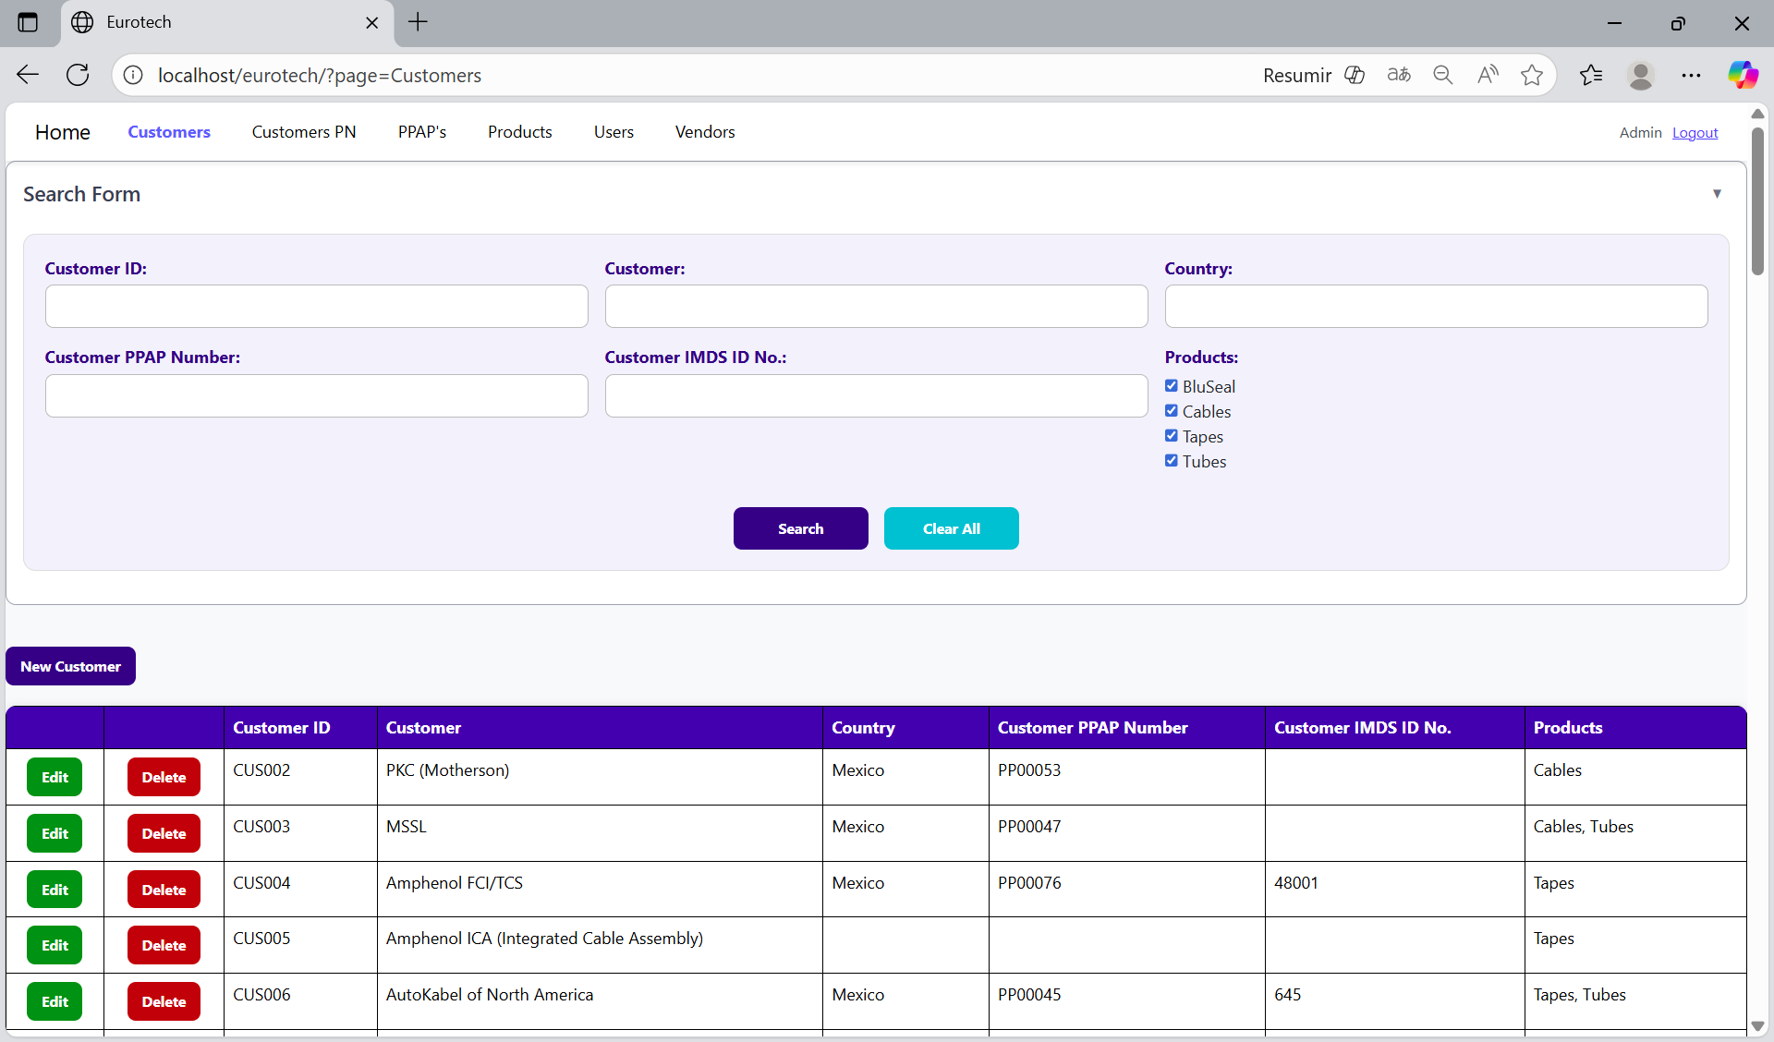

The search form allows you to perform searches by “Customer ID”, “Customer”, “Country”, “Customer PPAP Number”, “Customer IMDS ID No.” and “Products”.

You can search by “Customer ID”, using the “Customer ID” field and clicking the “Search” button.

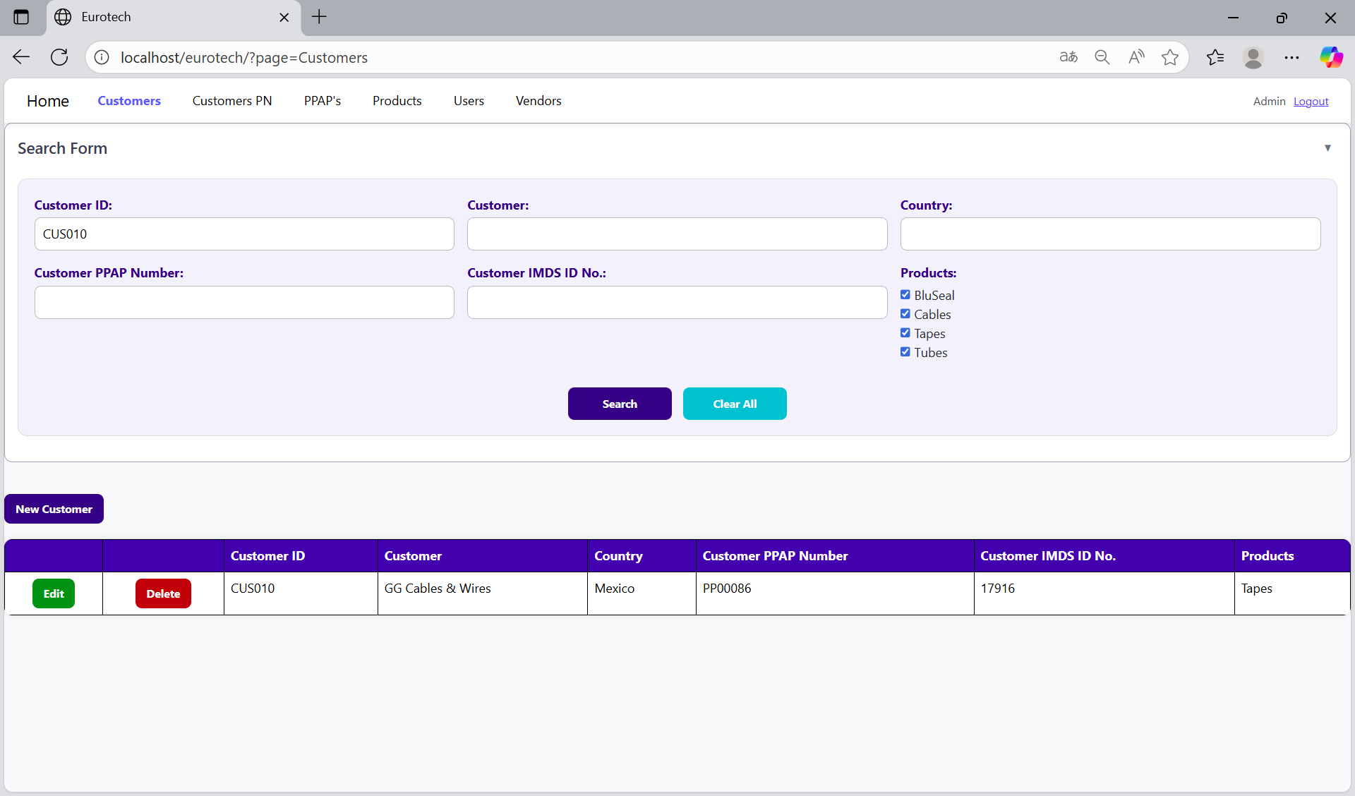

You can search by “Customer”, using the “Customer” field and clicking the “Search” button.

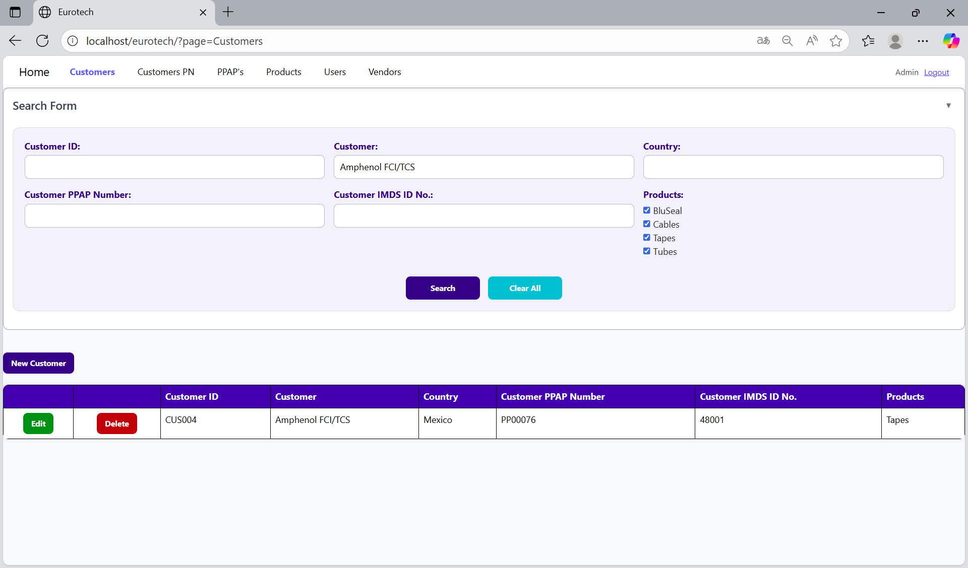

You can search by “Country”, using the “Country” field and clicking the “Search” button.

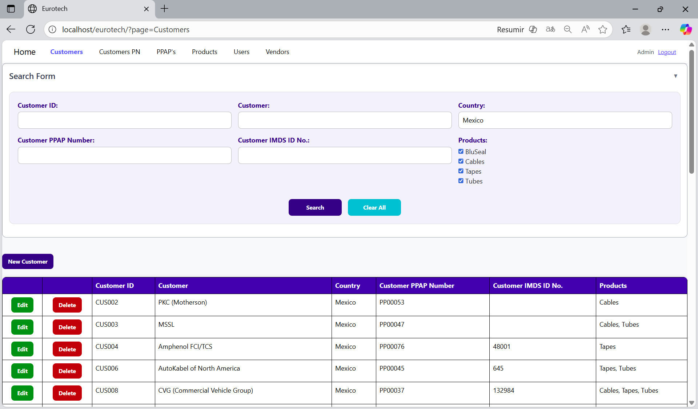

You can search by “Customer PPAP Number”, using the “Customer PPAP Number” field and clicking the “Search” button.

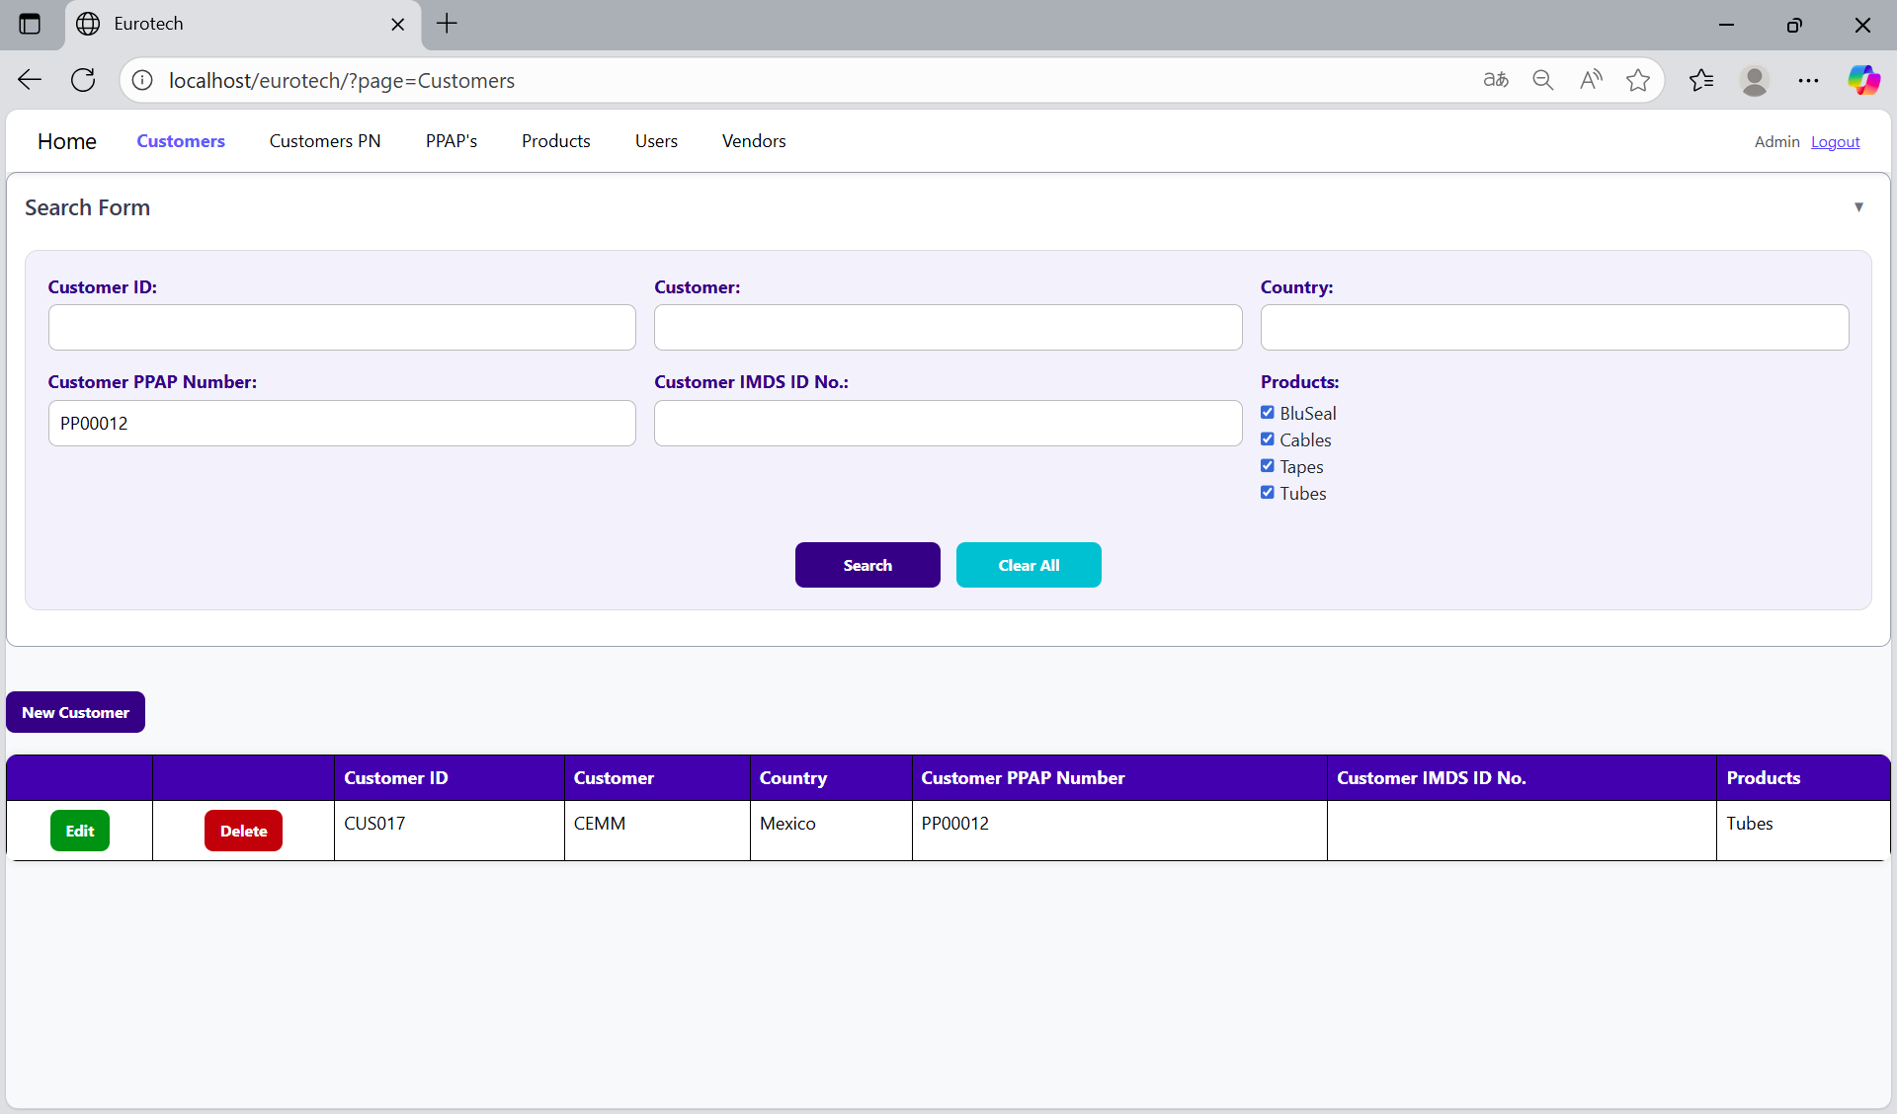

You can search by “Customer IMDS ID No.”, using the “Customer IMDS ID No.” field and clicking the “Search” button.

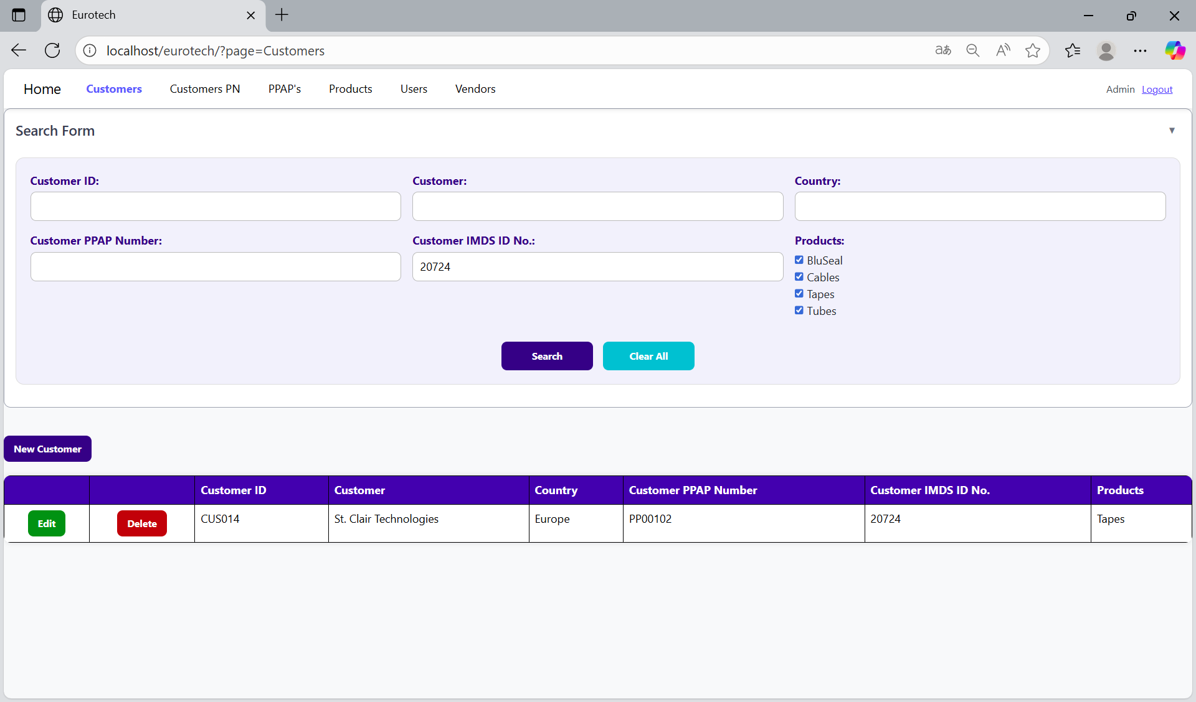

You can search by “Products” (this means the products of the PPAPs that will be realize for the customers), using the “Products” field and clicking the “Search” button.

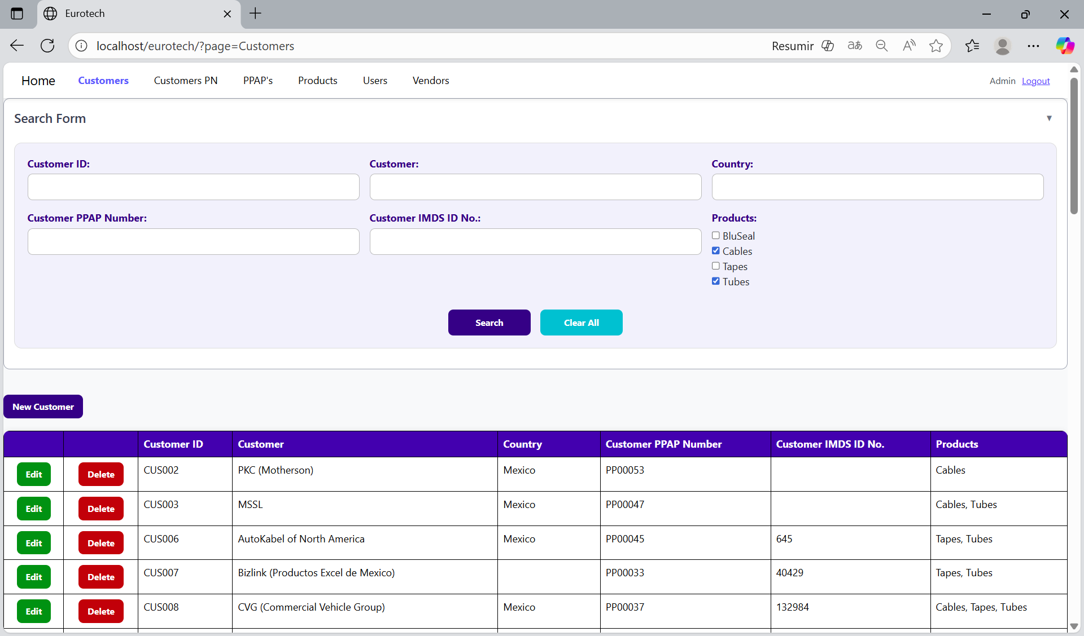

And with the “Clear All” button, you can clean the querying and see all the registers of the customers.

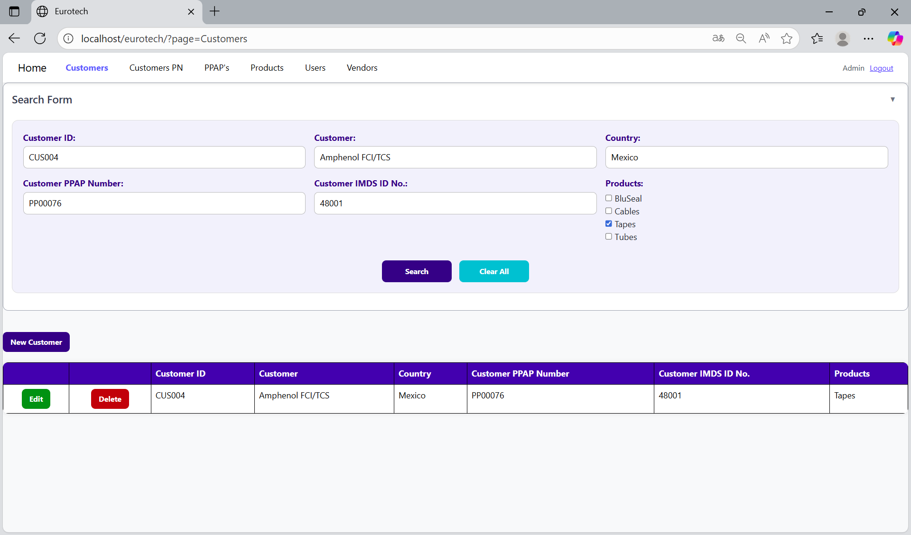

Once you click the “Clear All” button, the fields of the “Search Form” will be empty, and in the table will be shown all the customers.

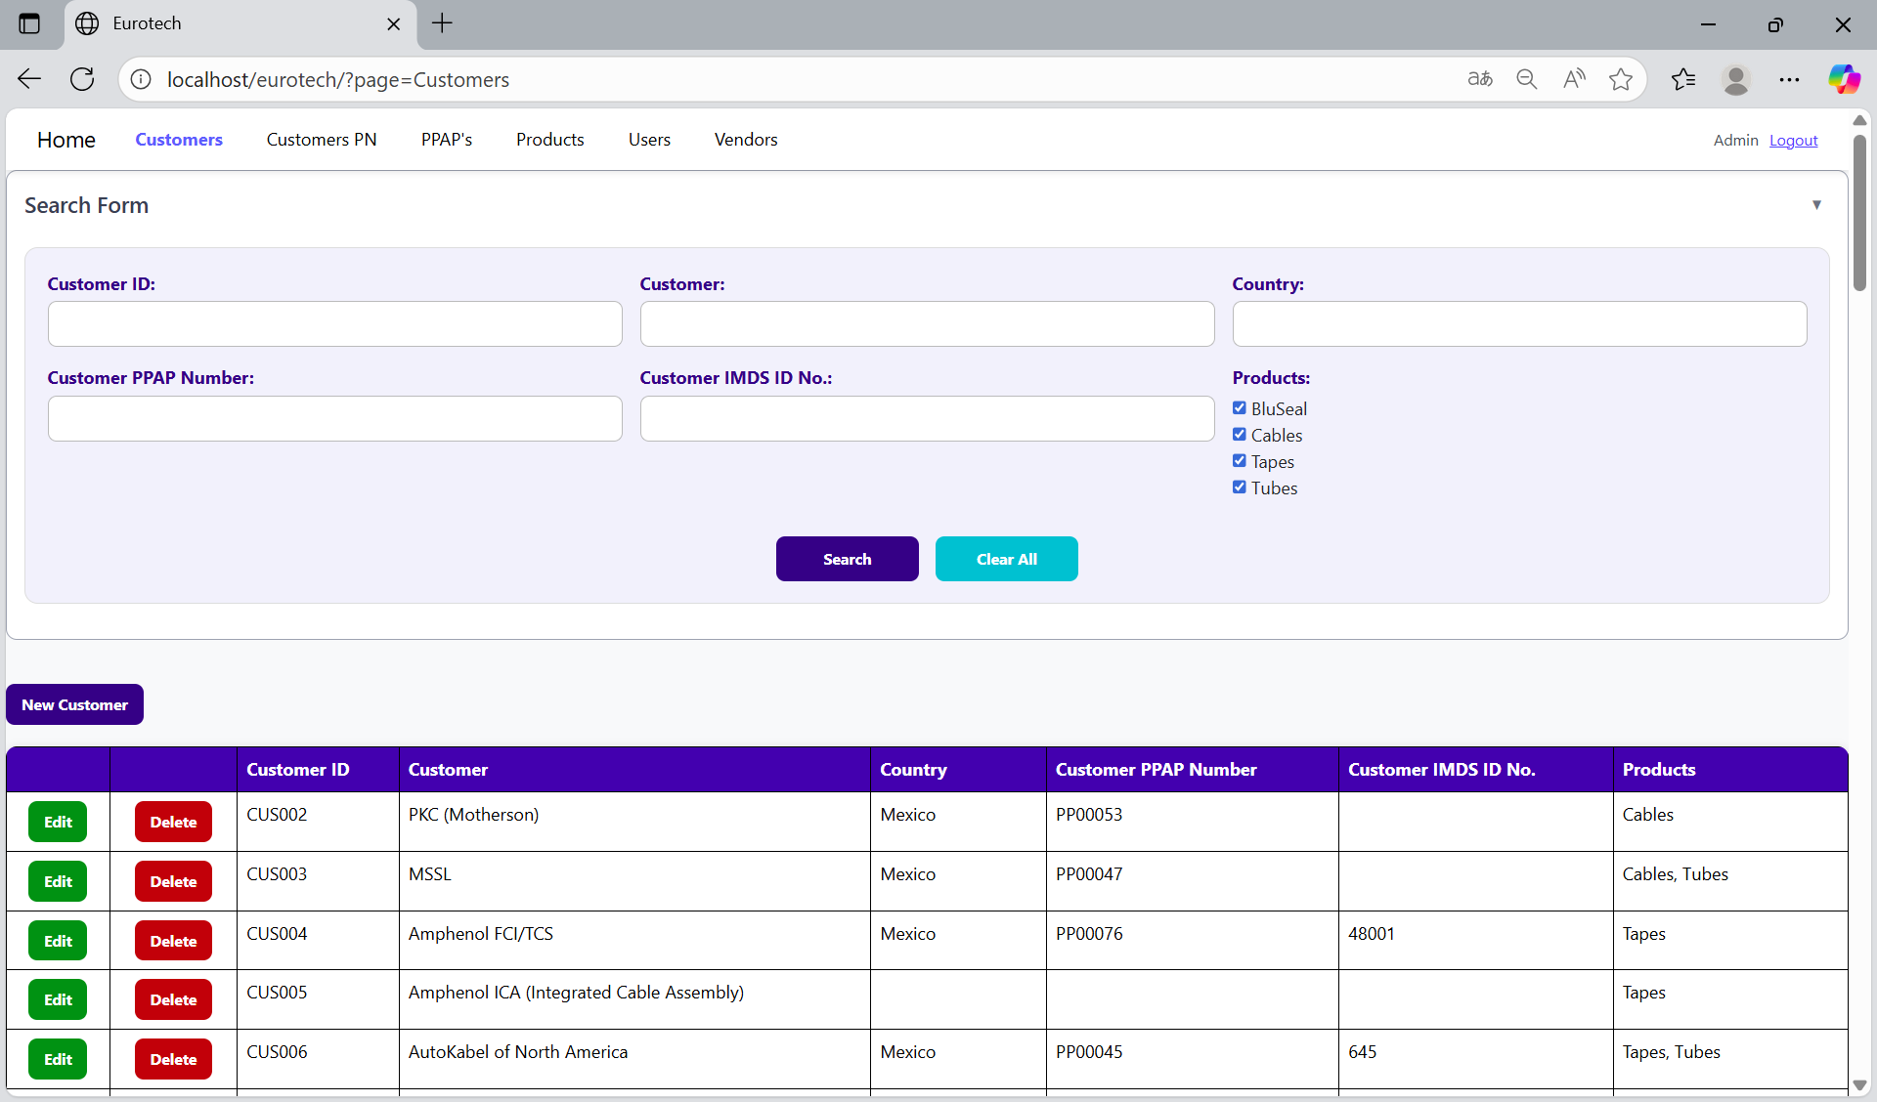

### *3.1.3 How to Add a New Customer.*

If you want to add a new customer, you must click the “New Customer” button that is below the “Search Form”.

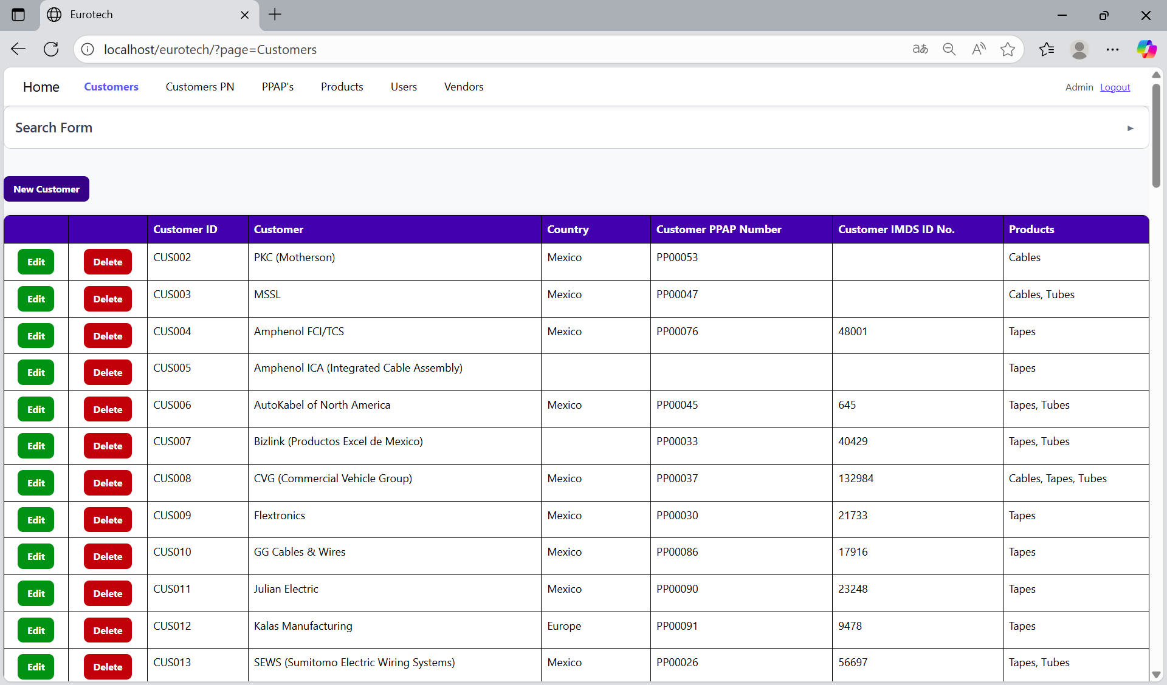

Once you click the “New Customer” button, it will display a register form to create a new customer.

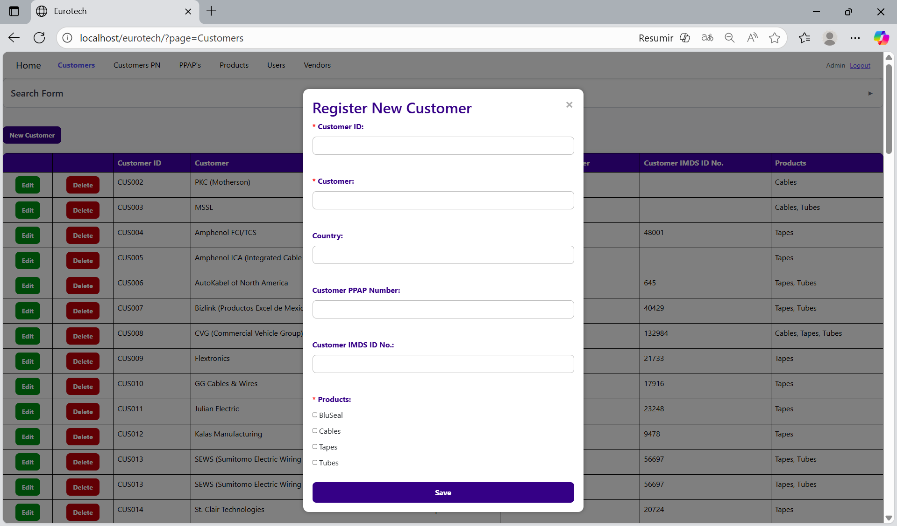

Non-mandatory fields

Mandatory fields

If you want to save the register of a new customer, you must click the “Save” button.

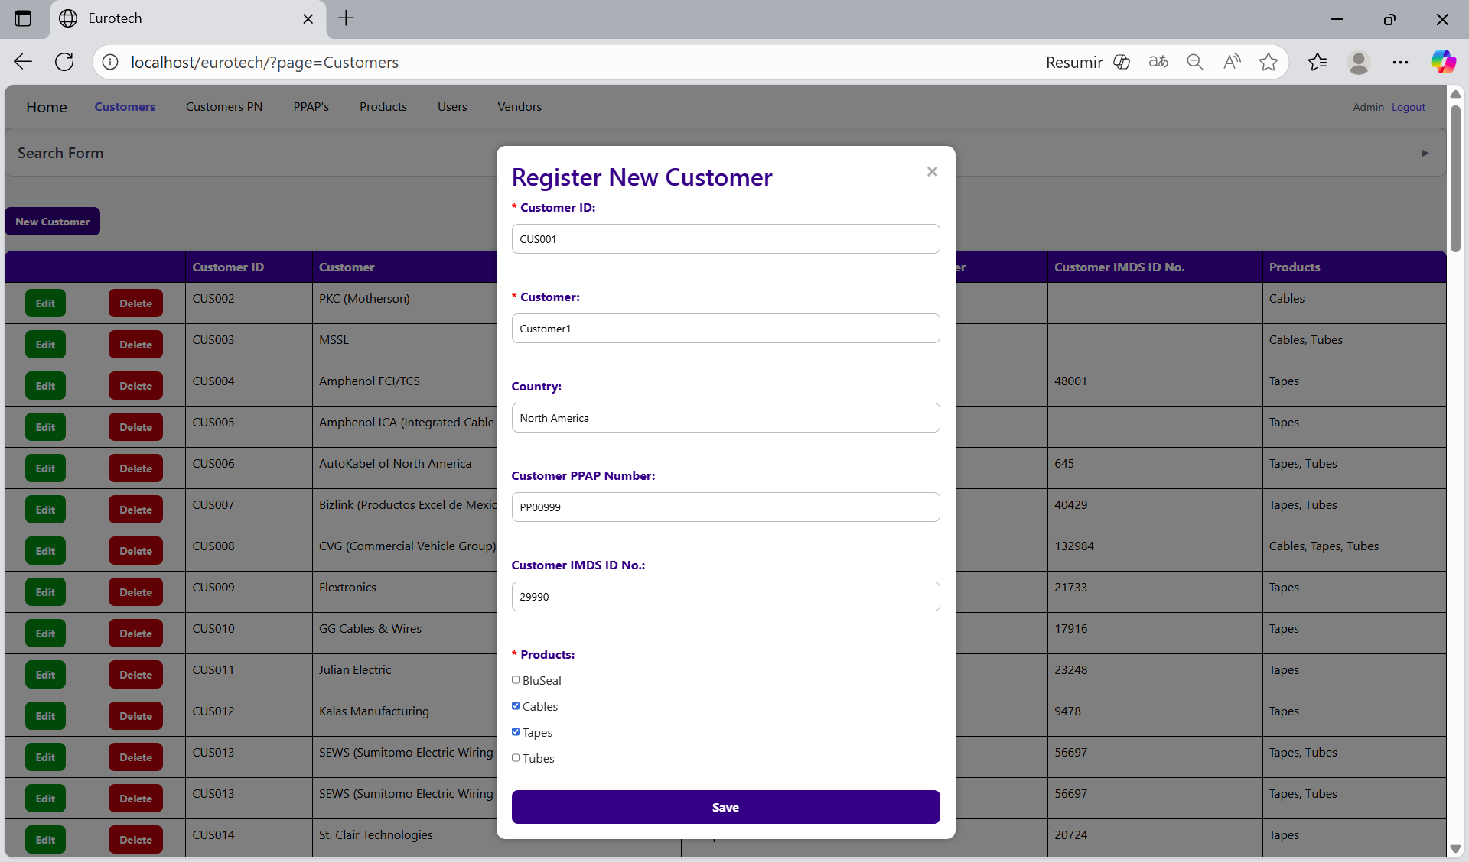

If no errors are found, the register will be added successfully.

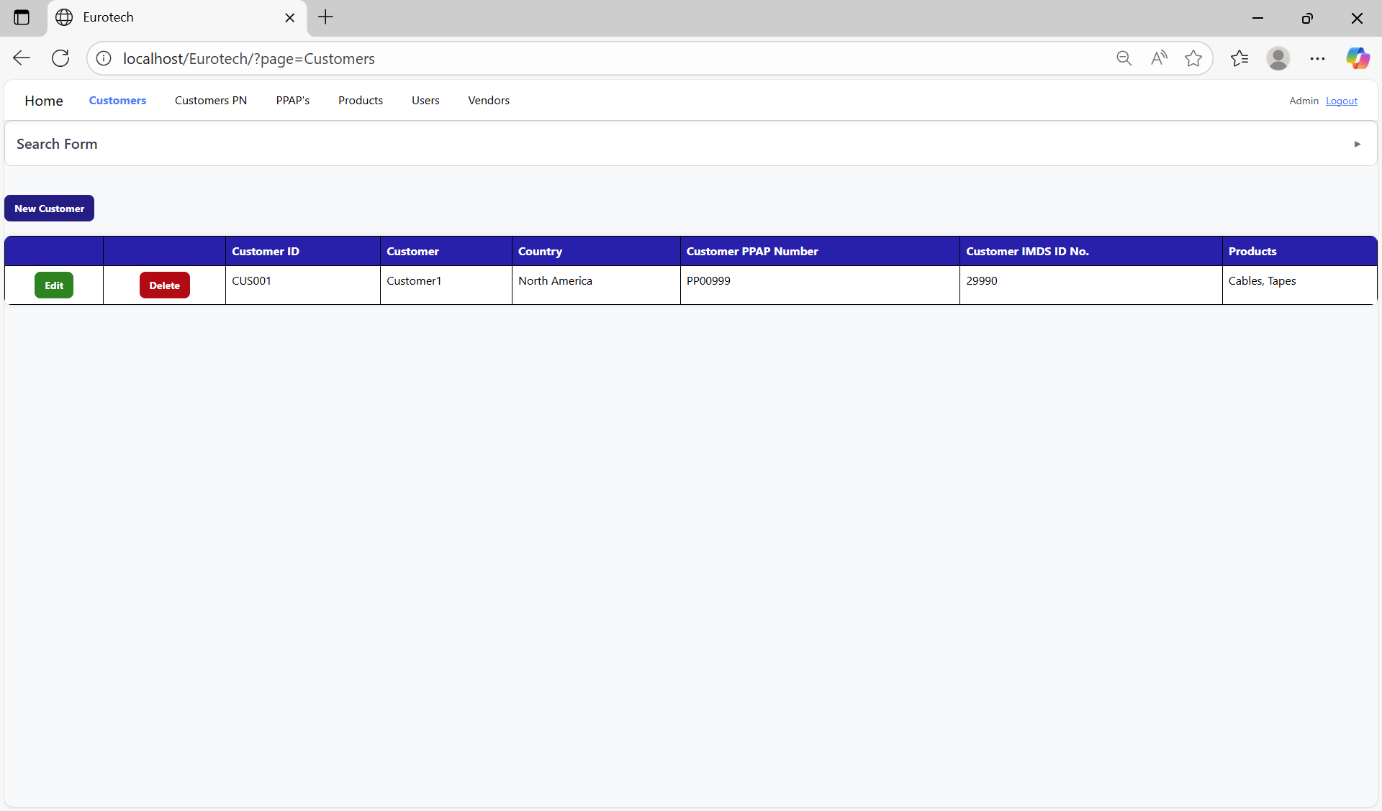

If an error is found, you can check in the Index the instruction *3.11.1.1 Register Form Errors.*

### *3.1.4 How to Edit Information of a Customer.*

In each register from the table, it will be an “Edit” button. You must click the “Edit” button of the register you want to update.

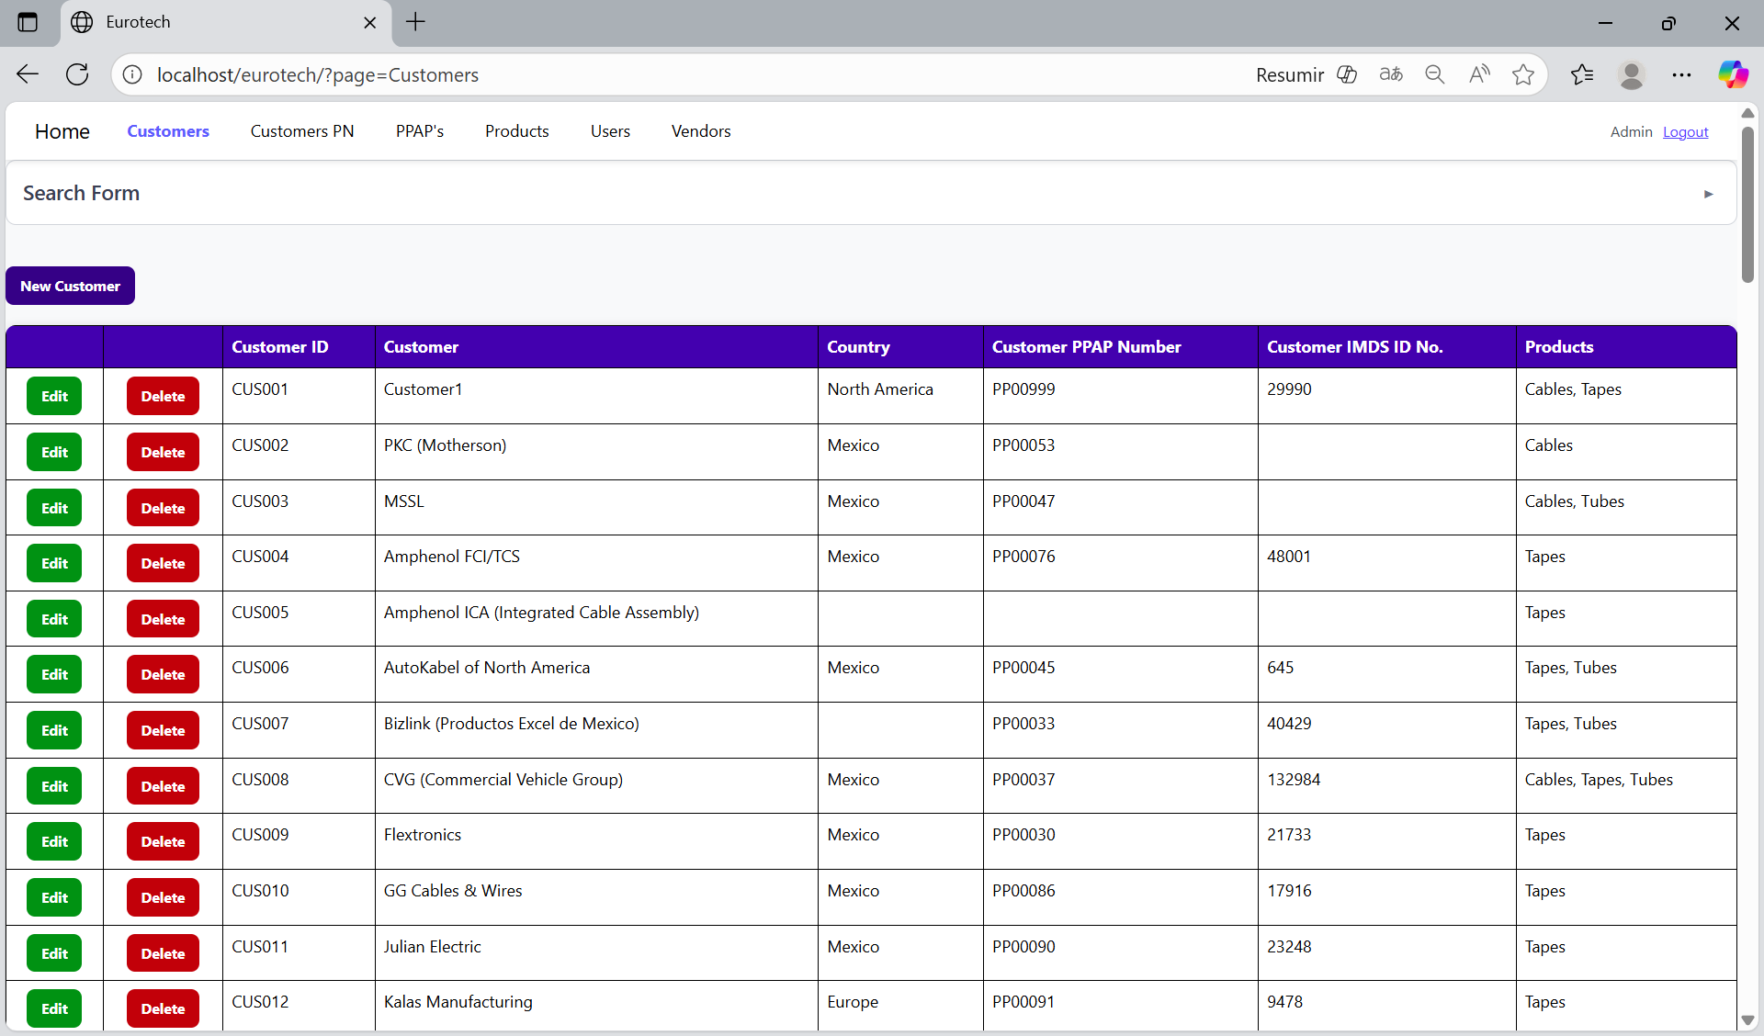

Once you click the “Edit” button, it will display an update form to edit the information of the selected customer.

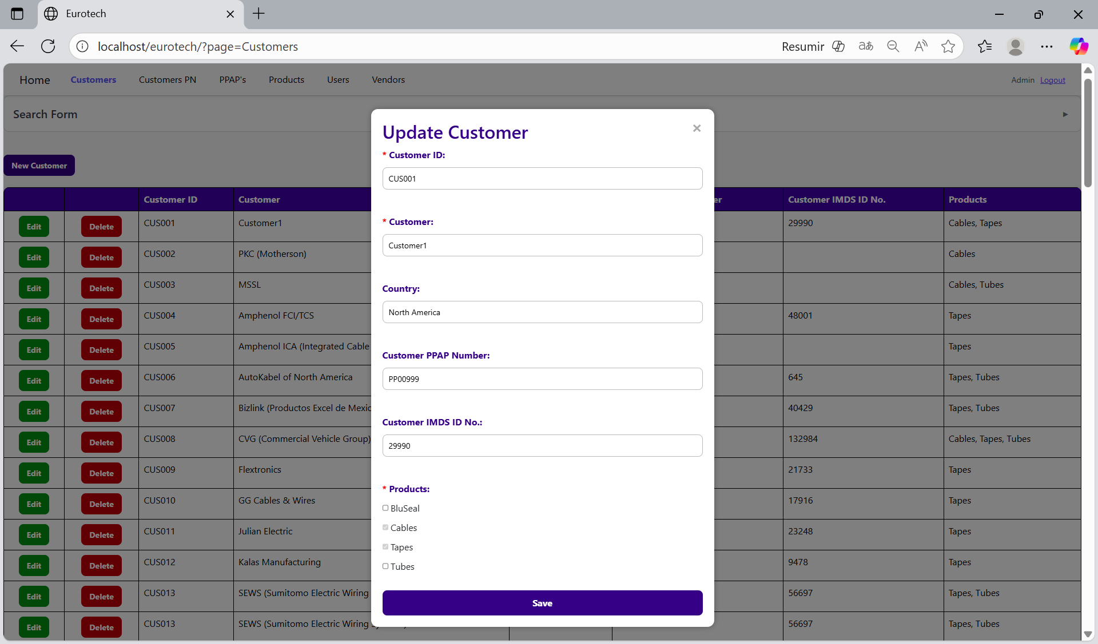

To save the changes, you must click the “Save” button.

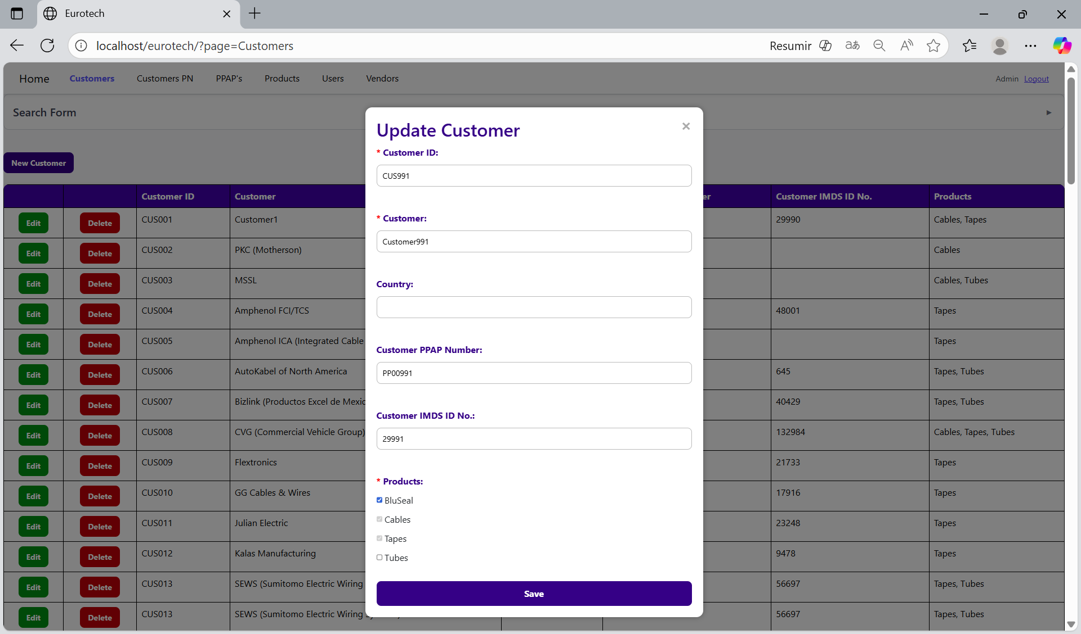

If no errors are found, the register will be updated successfully.

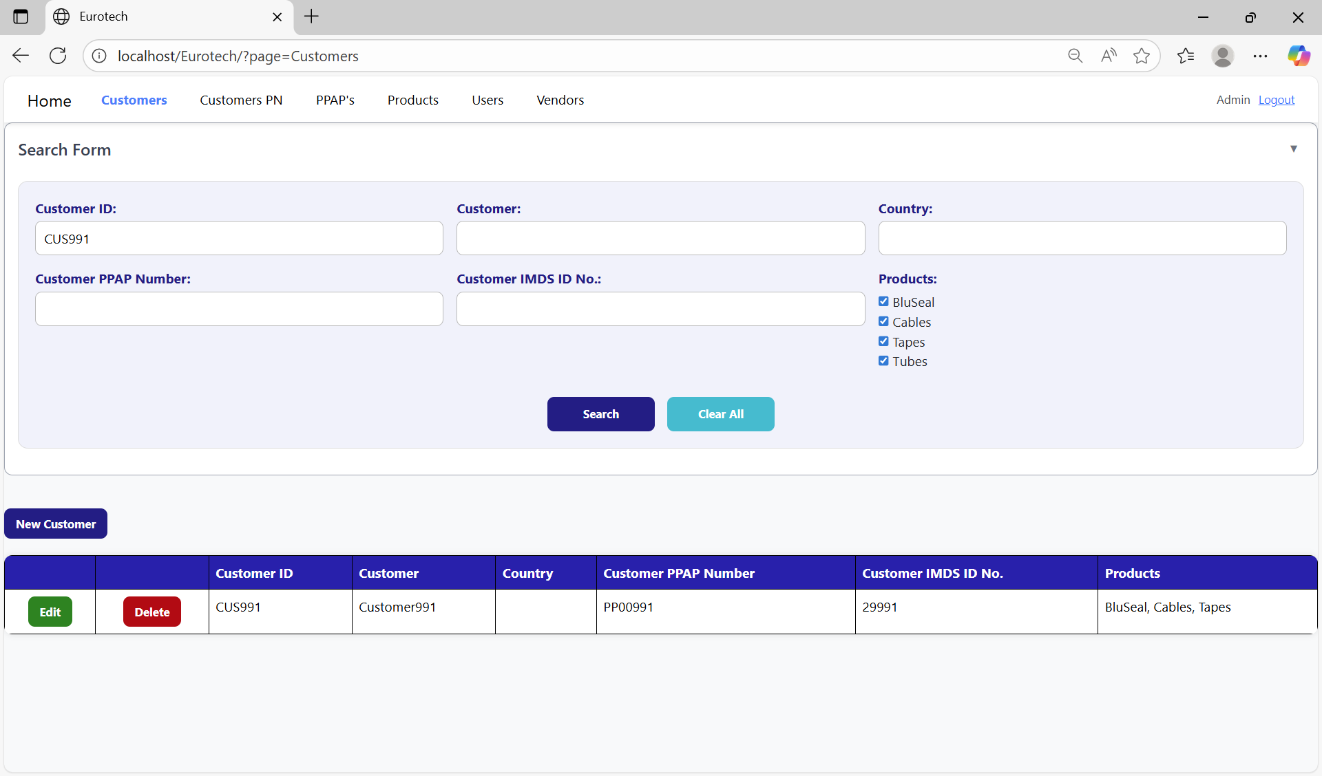

If an error is found, you can check in the Index the instruction *3.11.1.2 Edit Form Errors.*

### *3.1.5 How to Delete a Customer.*

In each register from the table, it will be a “Delete” button. You must click the “Delete” button of the register you want to delete.

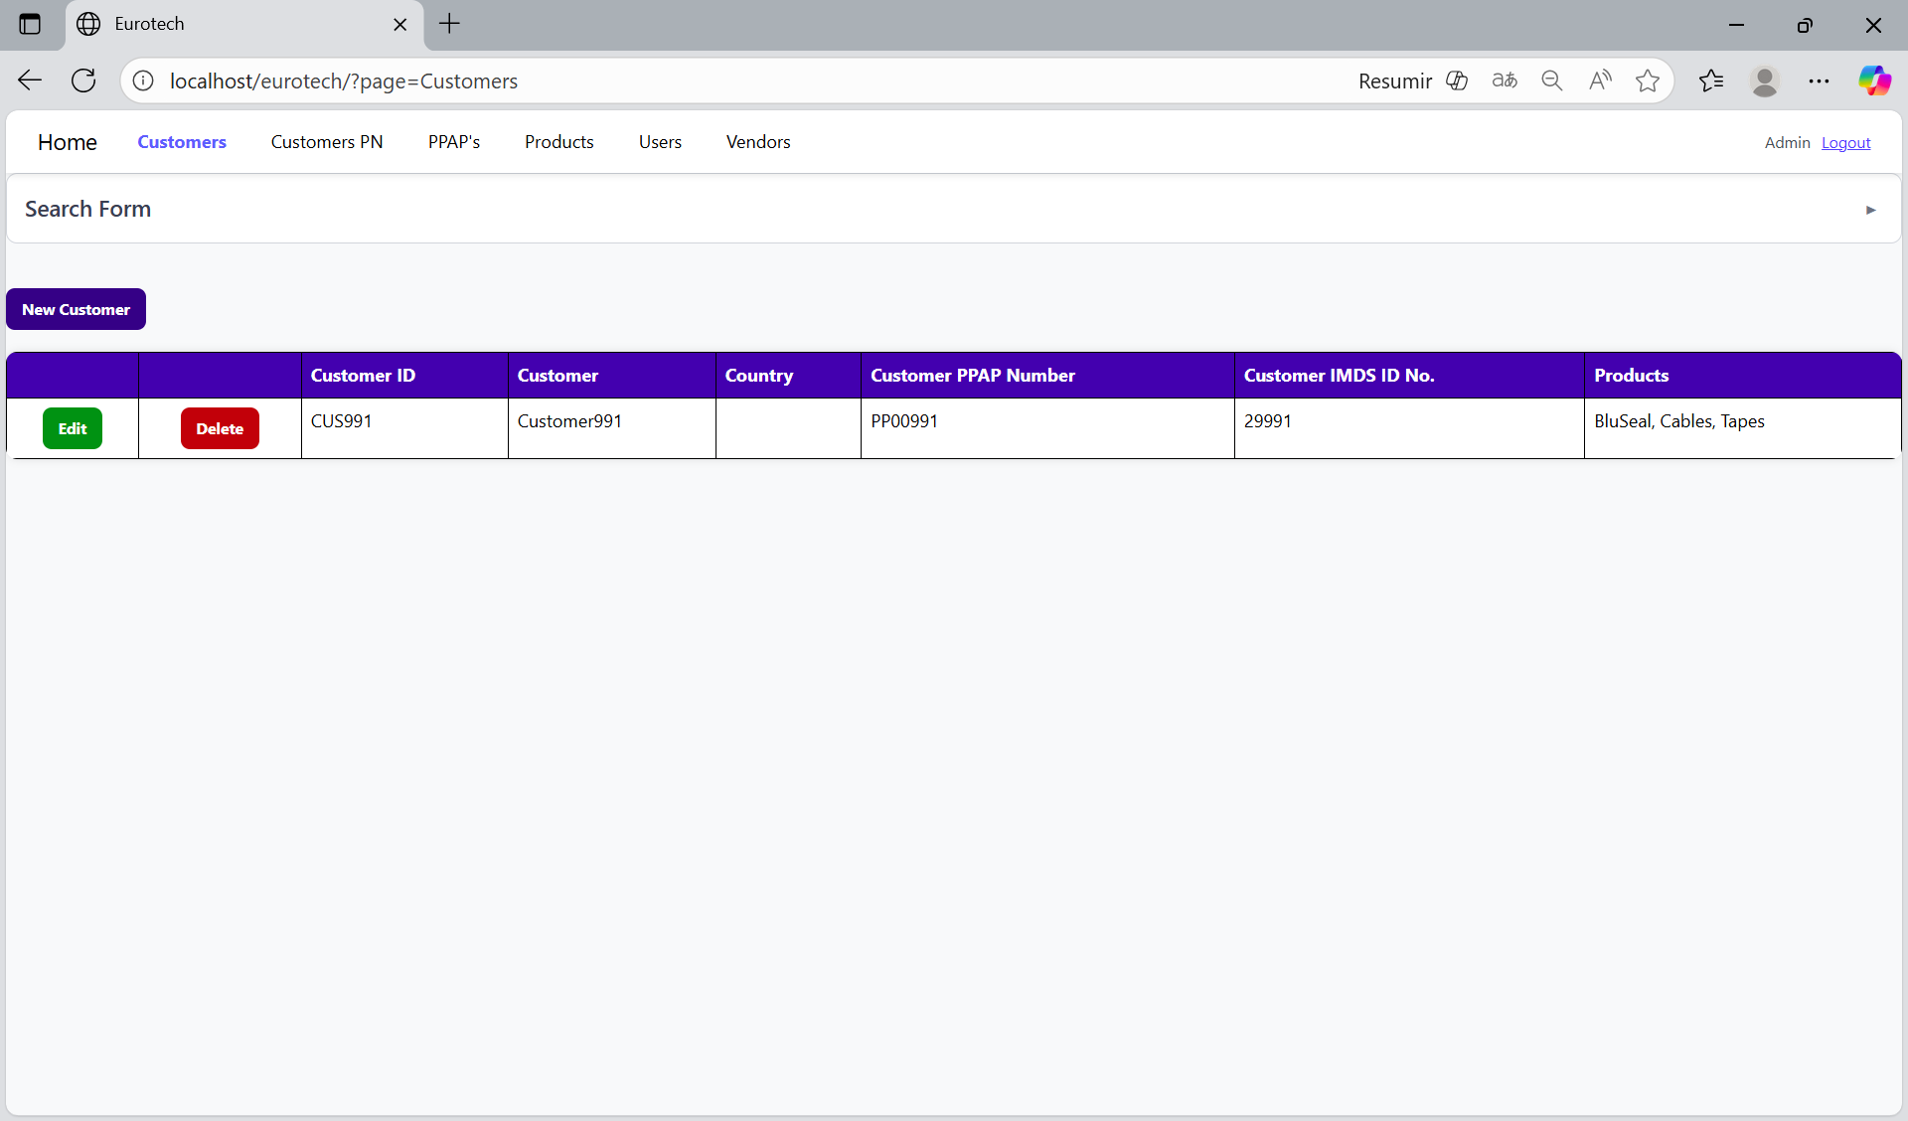

Once you click the “Delete” button, it will display the information of the selected customer with a message to confirm the delete action. To confirm the delete of the customer, you must click the “Confirm” button. It only deletes customers that don’t have registers in “Customers PN” and “PPAP’s” pages.

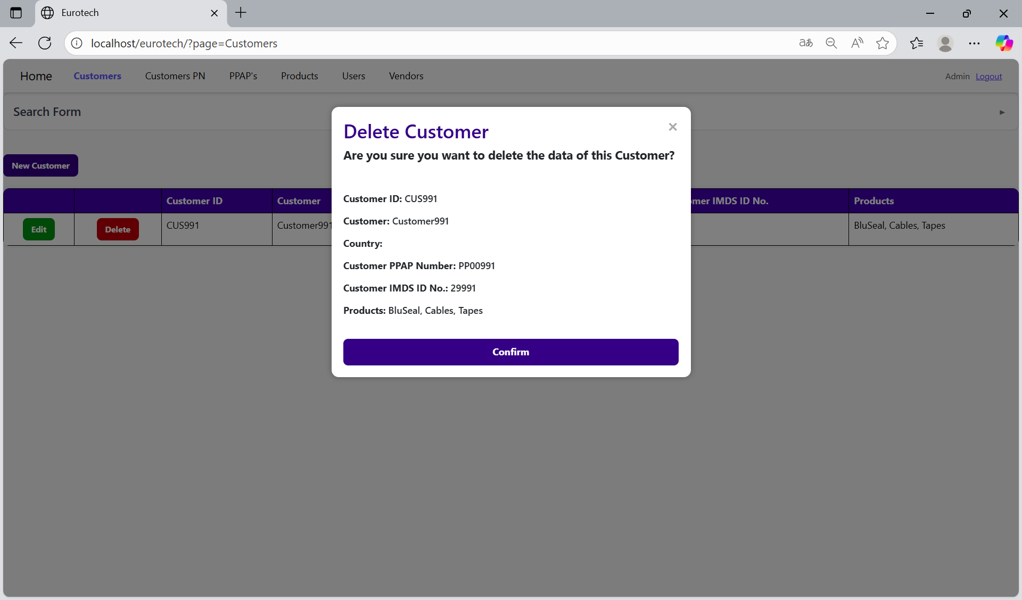

If an error is found, you can check in the Index the instruction *3.11.1.3 Delete Form Errors.*

## ***3.2 Customers PN Page.***

### *3.2.1 How to Navigate to “Customers PN” Page.*

On the navigation bar, you can navigate to the “Customers PN” page.

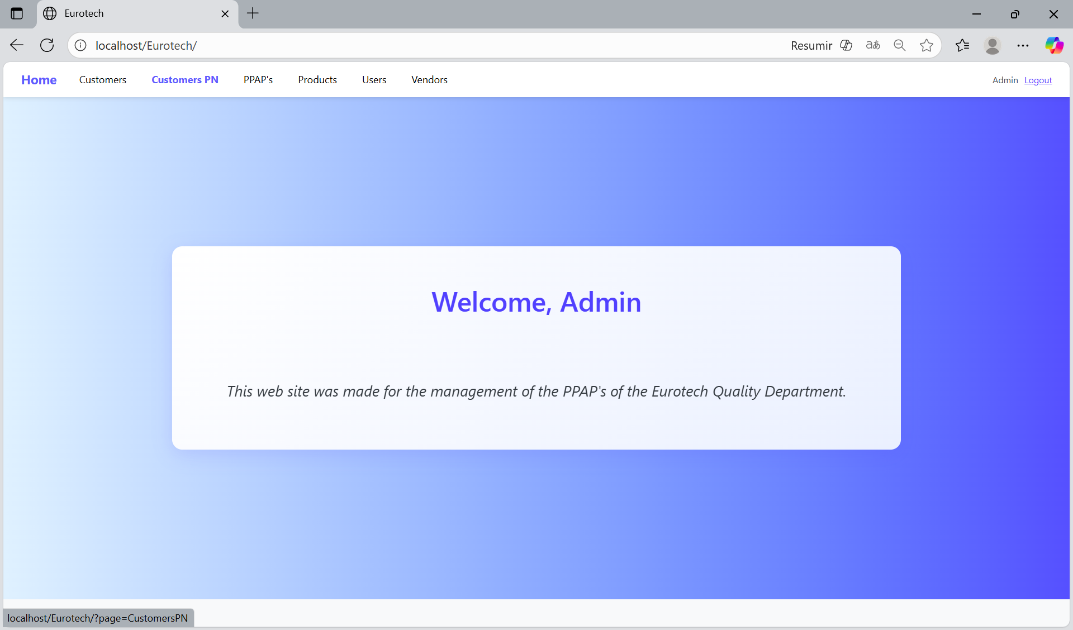

In this page you can manage the registers of all the Customer PN.

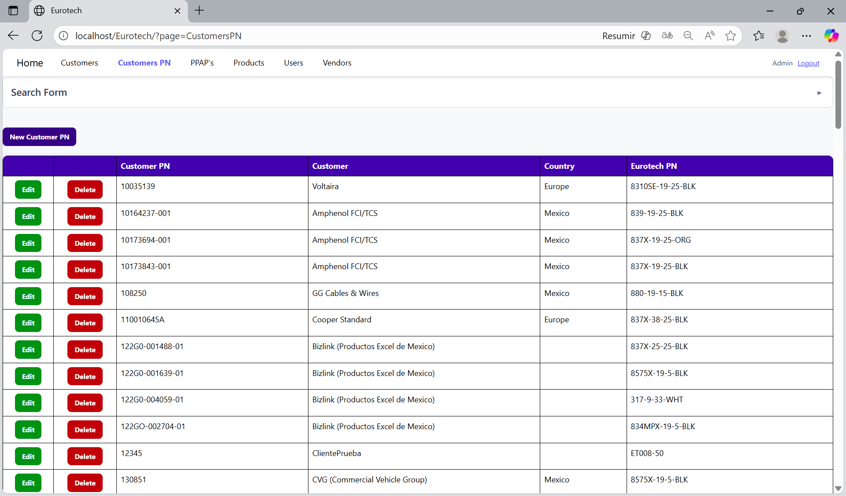

### *3.2.2 How to Search a Customer PN.*

At the top of the page, it will be a dropdown “Search Form” that has all the fields of the table for querying registers.

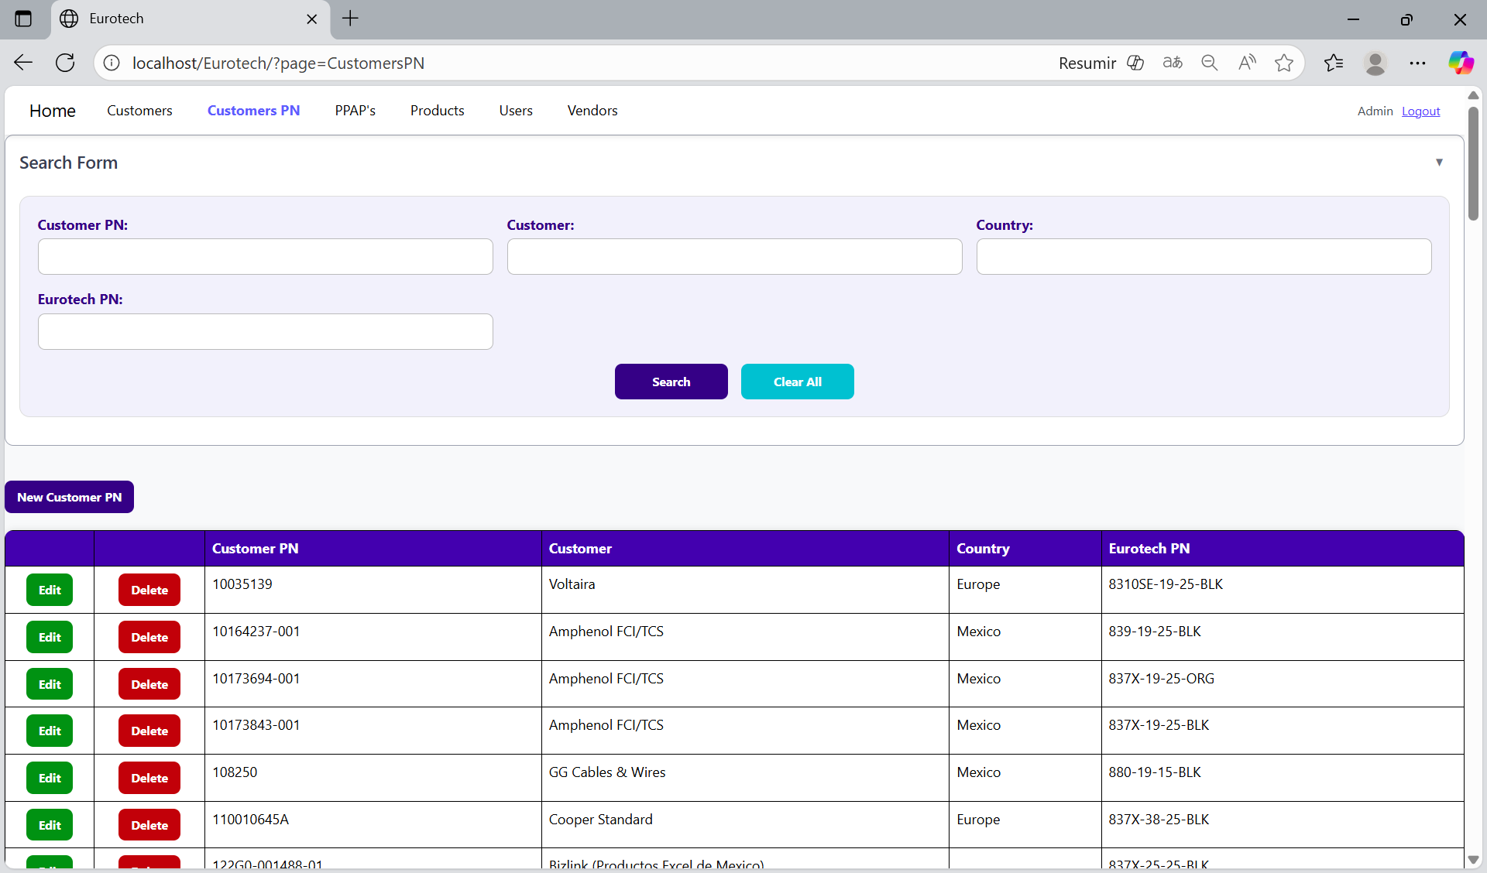

The search form allows you to perform searches by “Customer PN”, “Customer”, “Country” and “Eurotech PN”.

You can search by “Customer PN”, using the “Customer PN” field and clicking the “Search” button.

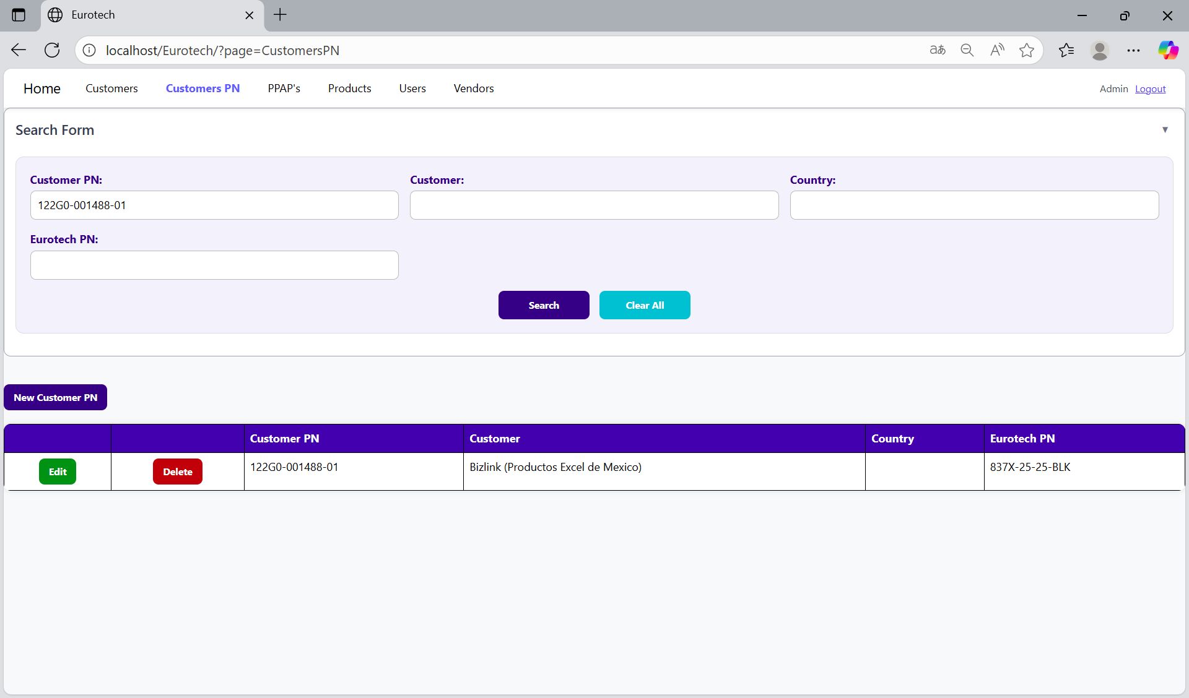

You can search by “Customer”, using the “Customer” field and clicking the “Search” button.

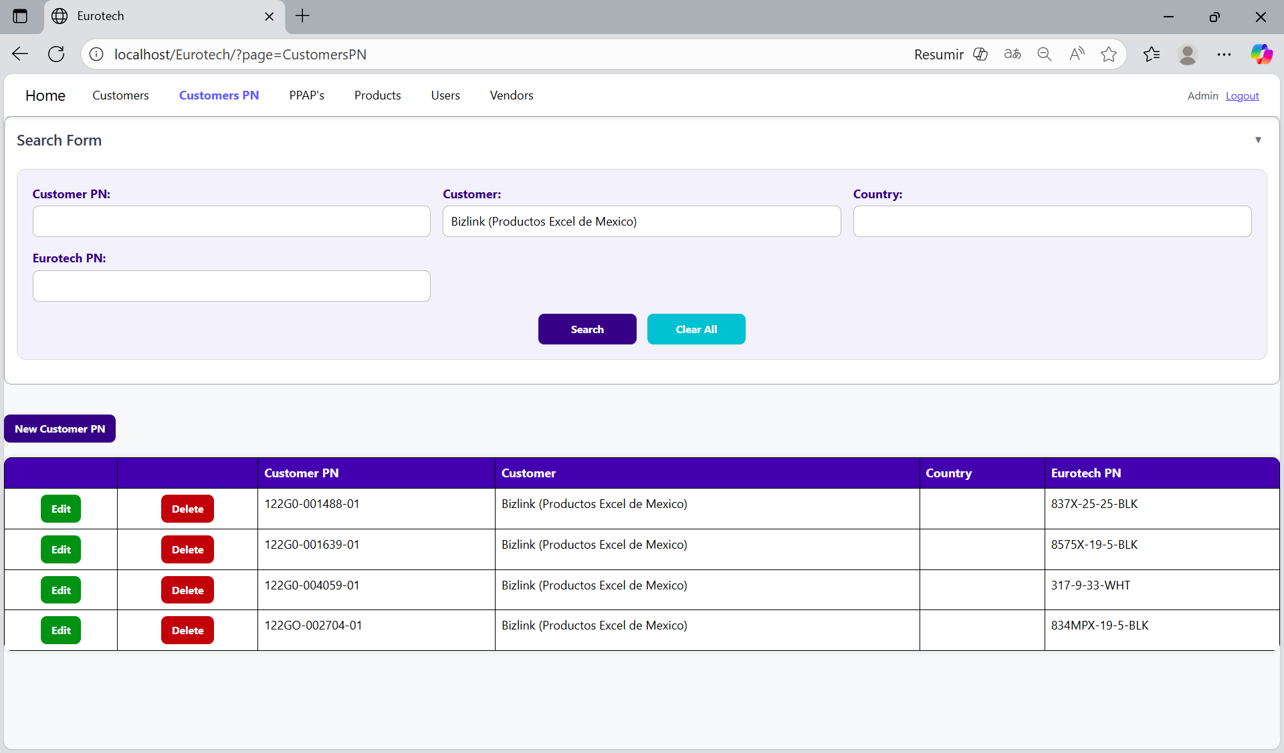

You can search by “Country”, using the “Country” field and clicking the “Search” button.

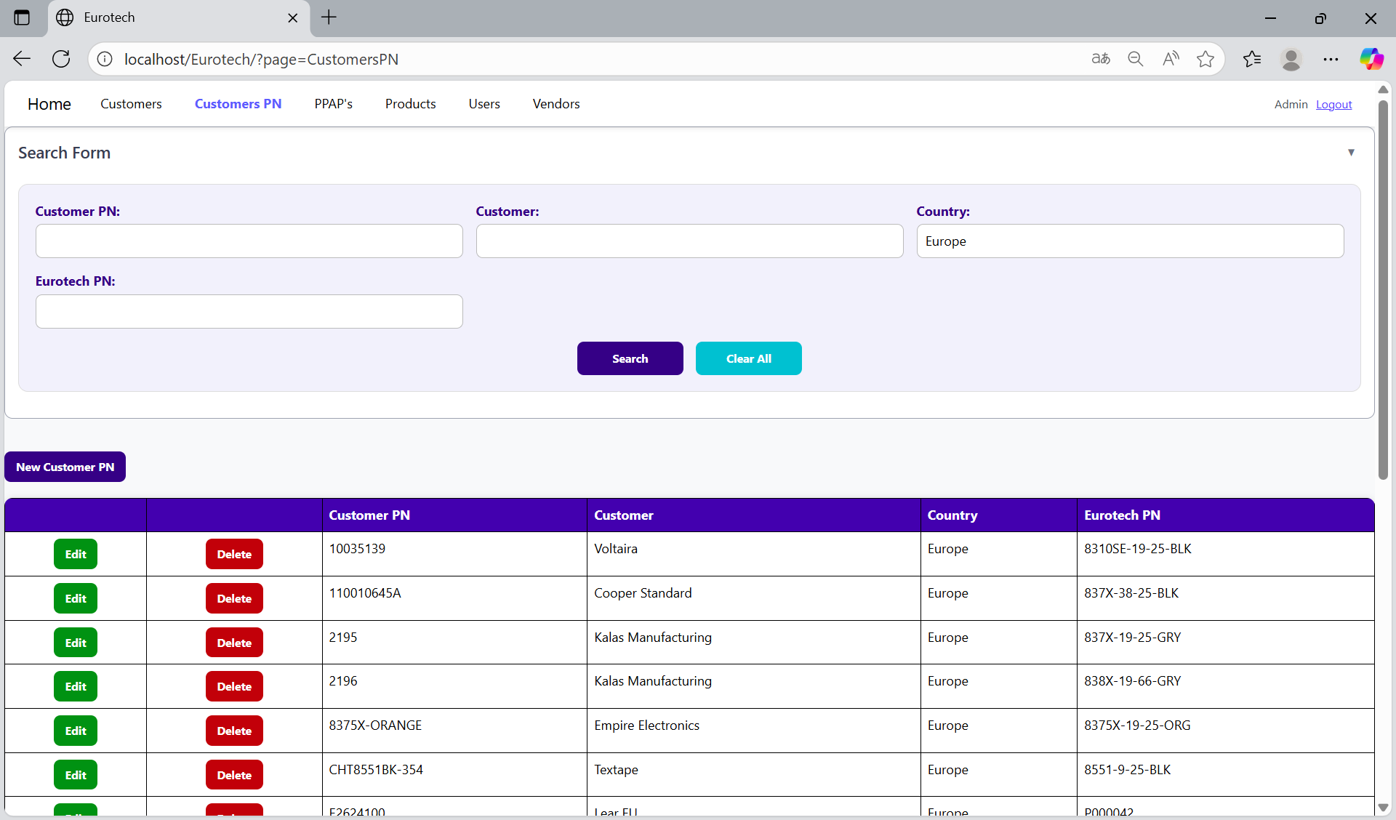

You can search by “Eurotech PN”, using the “Eurotech PN” field and clicking the “Search” button.

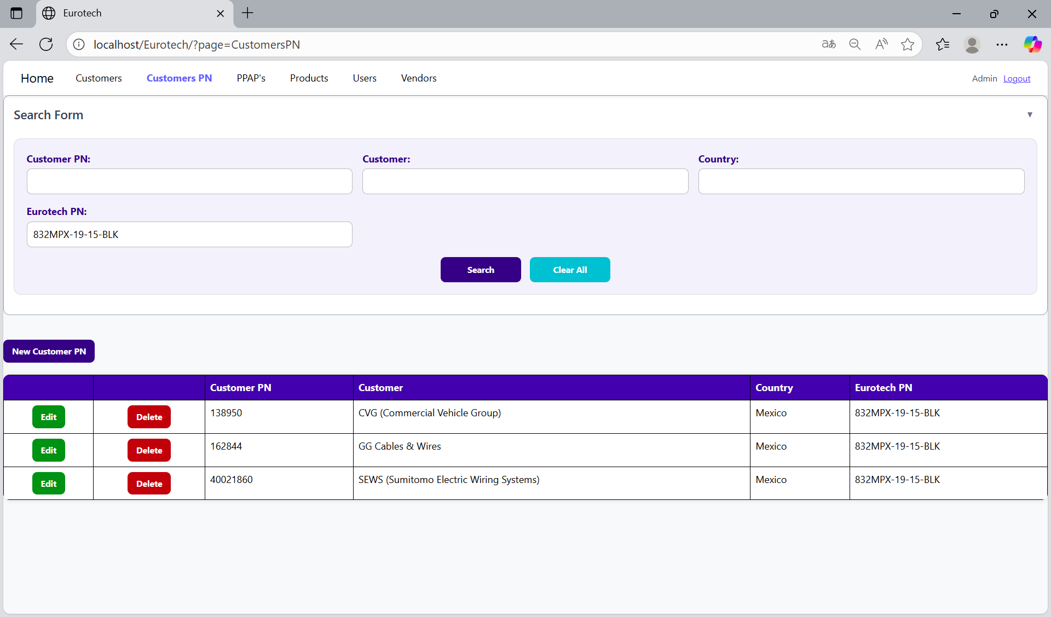

And with the “Clear All” button, you can clean the querying and see all the registers of the Customer PN.

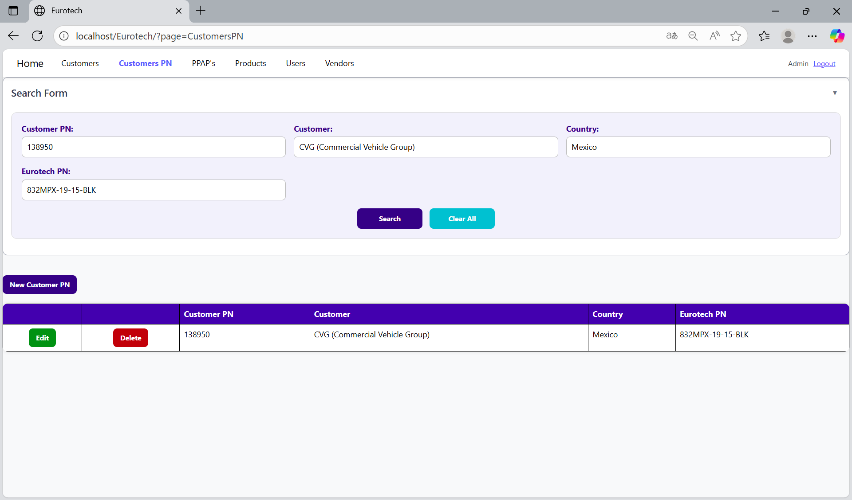

Once you click the “Clear All” button, the fields of the “Search Form” will be empty, and in the table will be shown all the Customers PN.

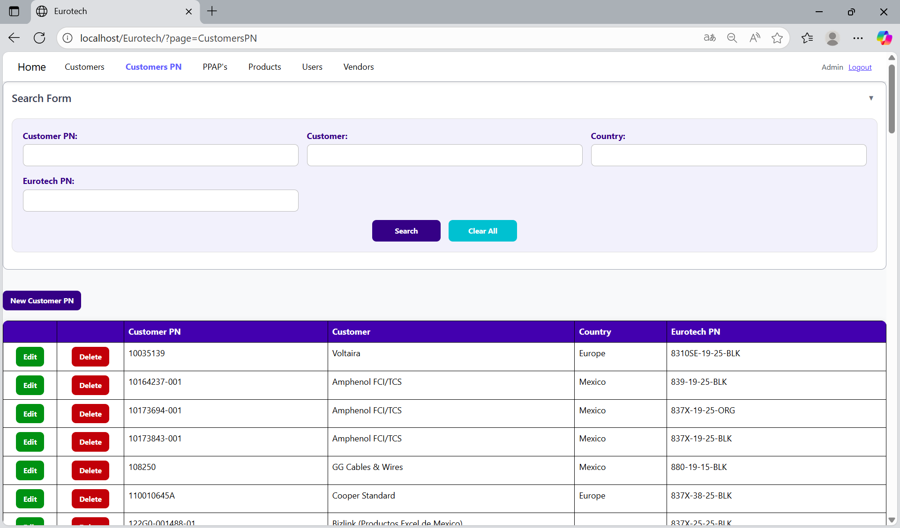

### *3.2.3 How to Add a New Customer PN.*

If you want to add a new Customer PN, you must click the “New Customer PN” button that is below the “Search Form”.

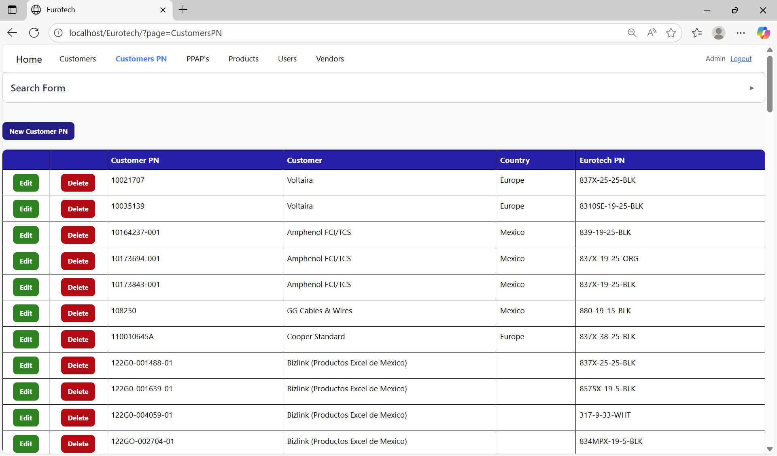

Once you click the “New Customer PN” button, it will display a register form to create a new Customer PN.

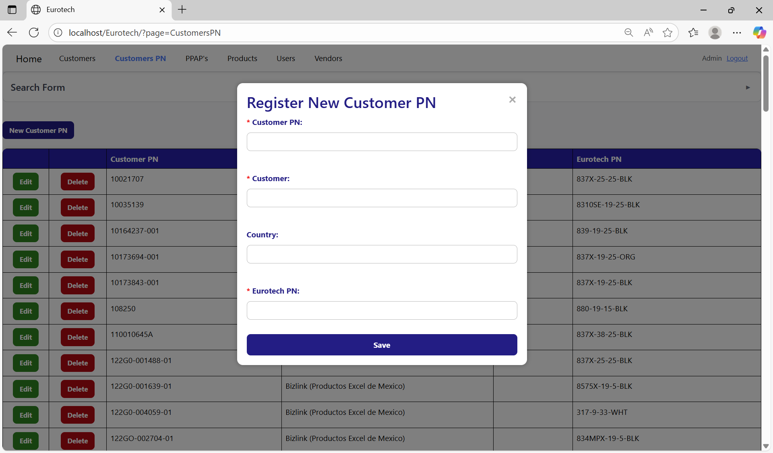

Non-mandatory field

Mandatory fields

If you want to save the register of a new Customer PN, you must click the “Save” button.

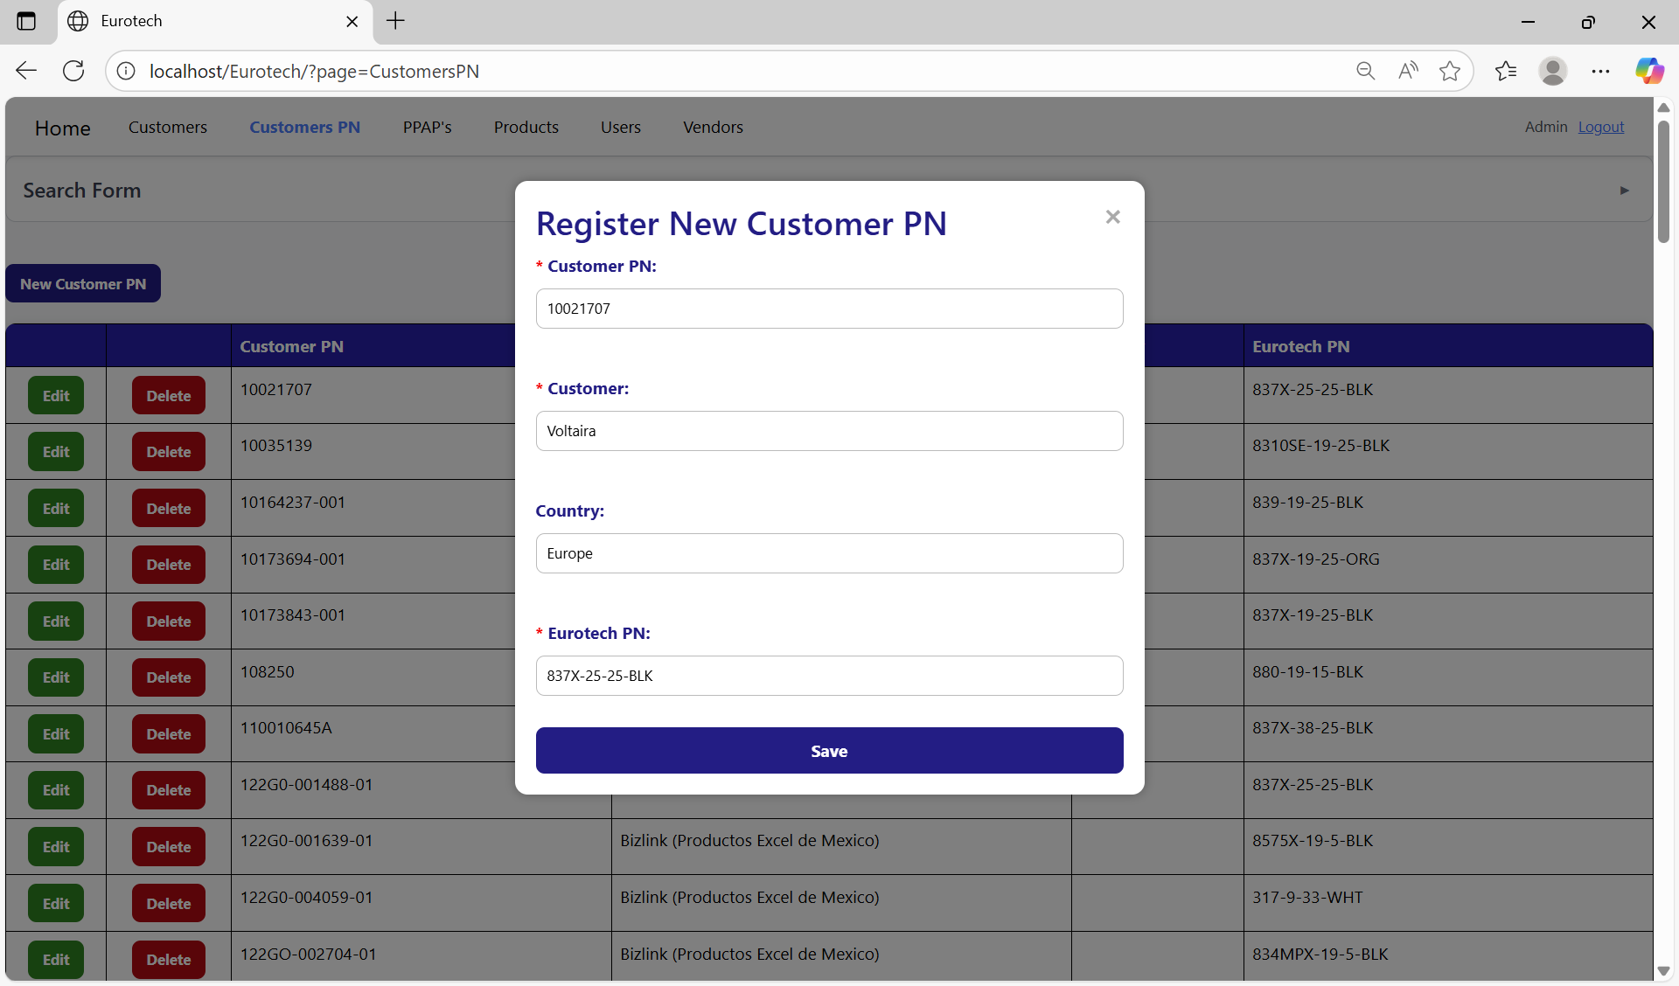

If no errors are found, the register will be added successfully.

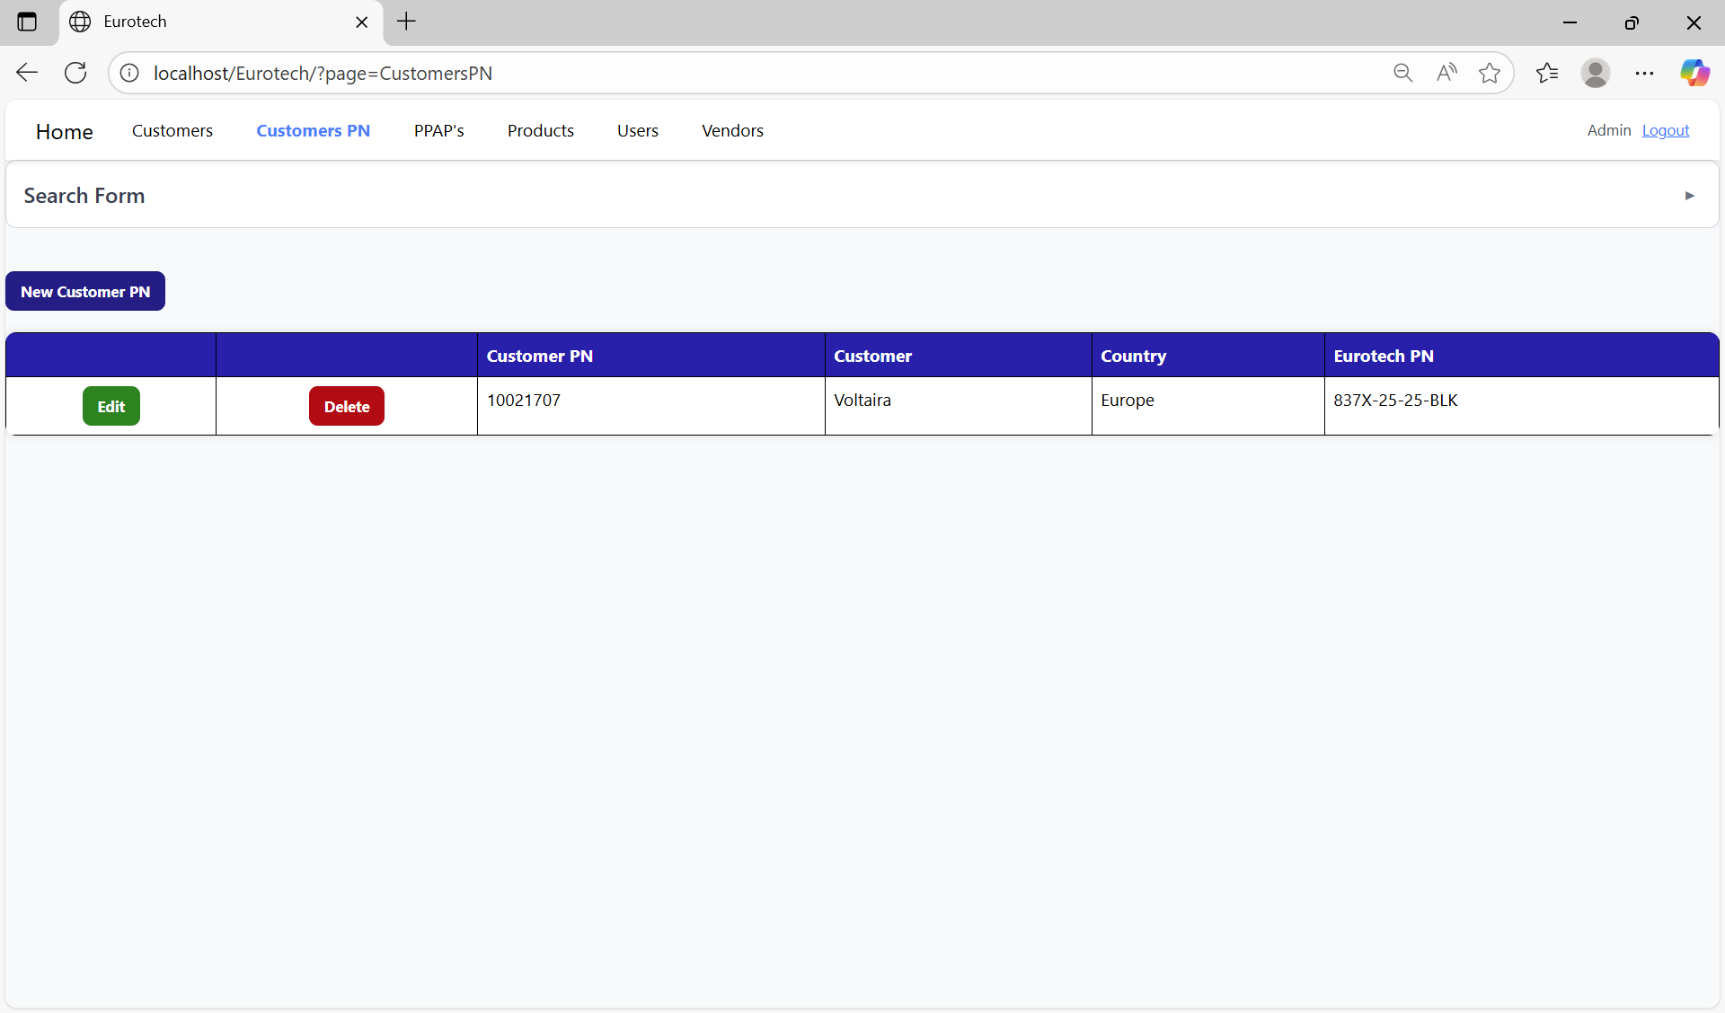

If an error is found, you can check in the Index the instruction *3.11.2.1 Register Form Errors.*

### *3.2.4 How to Edit Information of a Customer PN.*

In each register from the table, it will be an “Edit” button. You must click the “Edit” button of the register you want to update.



Once you click the “Edit” button, it will display an update form to edit the information of the selected Customer PN.

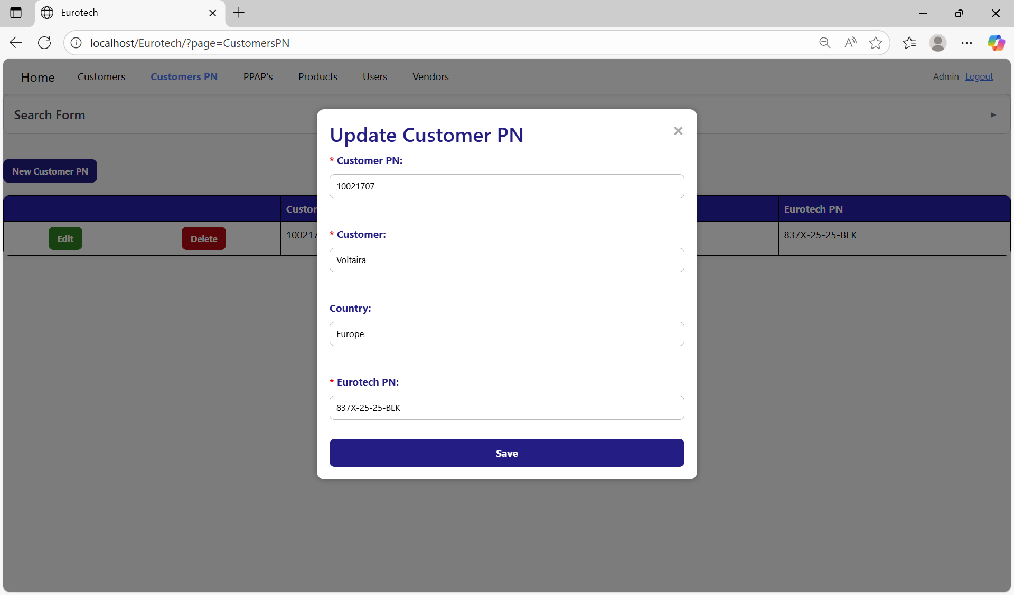

To save the changes, you must click the “Save” button.

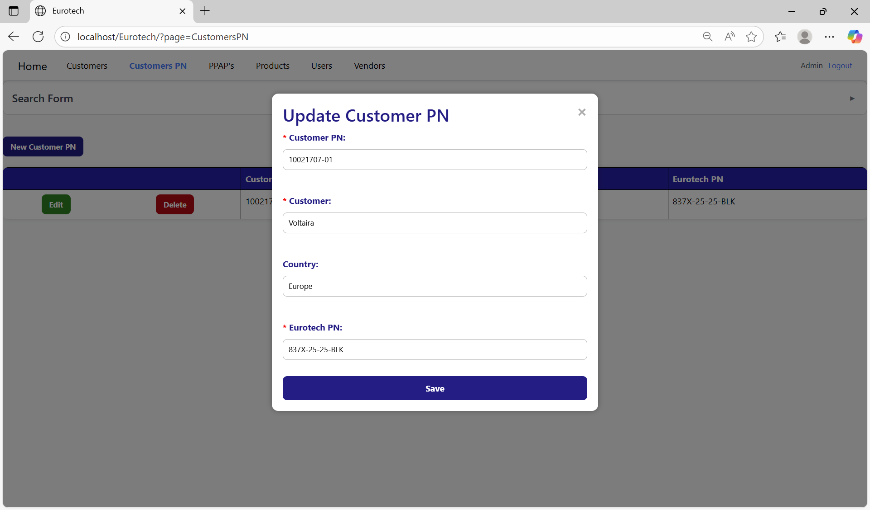

If no errors are found, the register will be updated successfully.

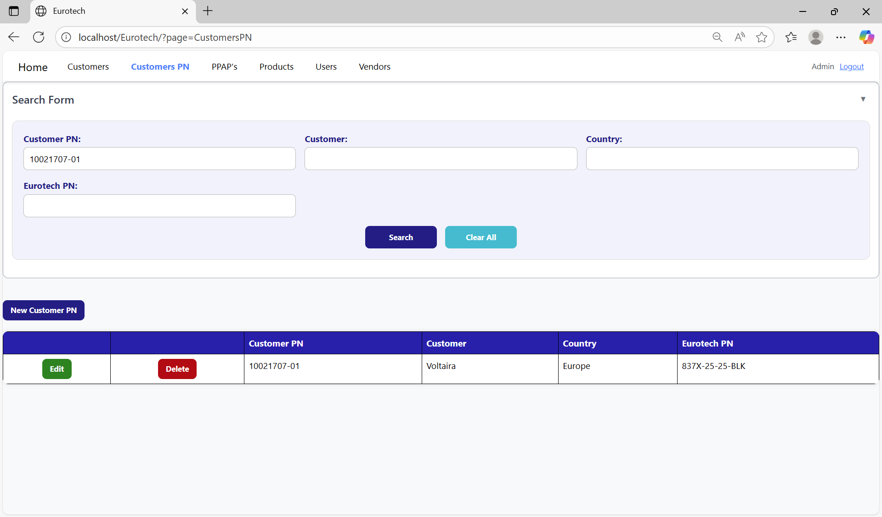

If an error is found, you can check in the Index the instruction *3.11.2.2 Edit Form Errors.*

### *3.2.5 How to Delete a Customer PN.*

In each register from the table, it will be a “Delete” button. You must click the “Delete” button of the register you want to delete.

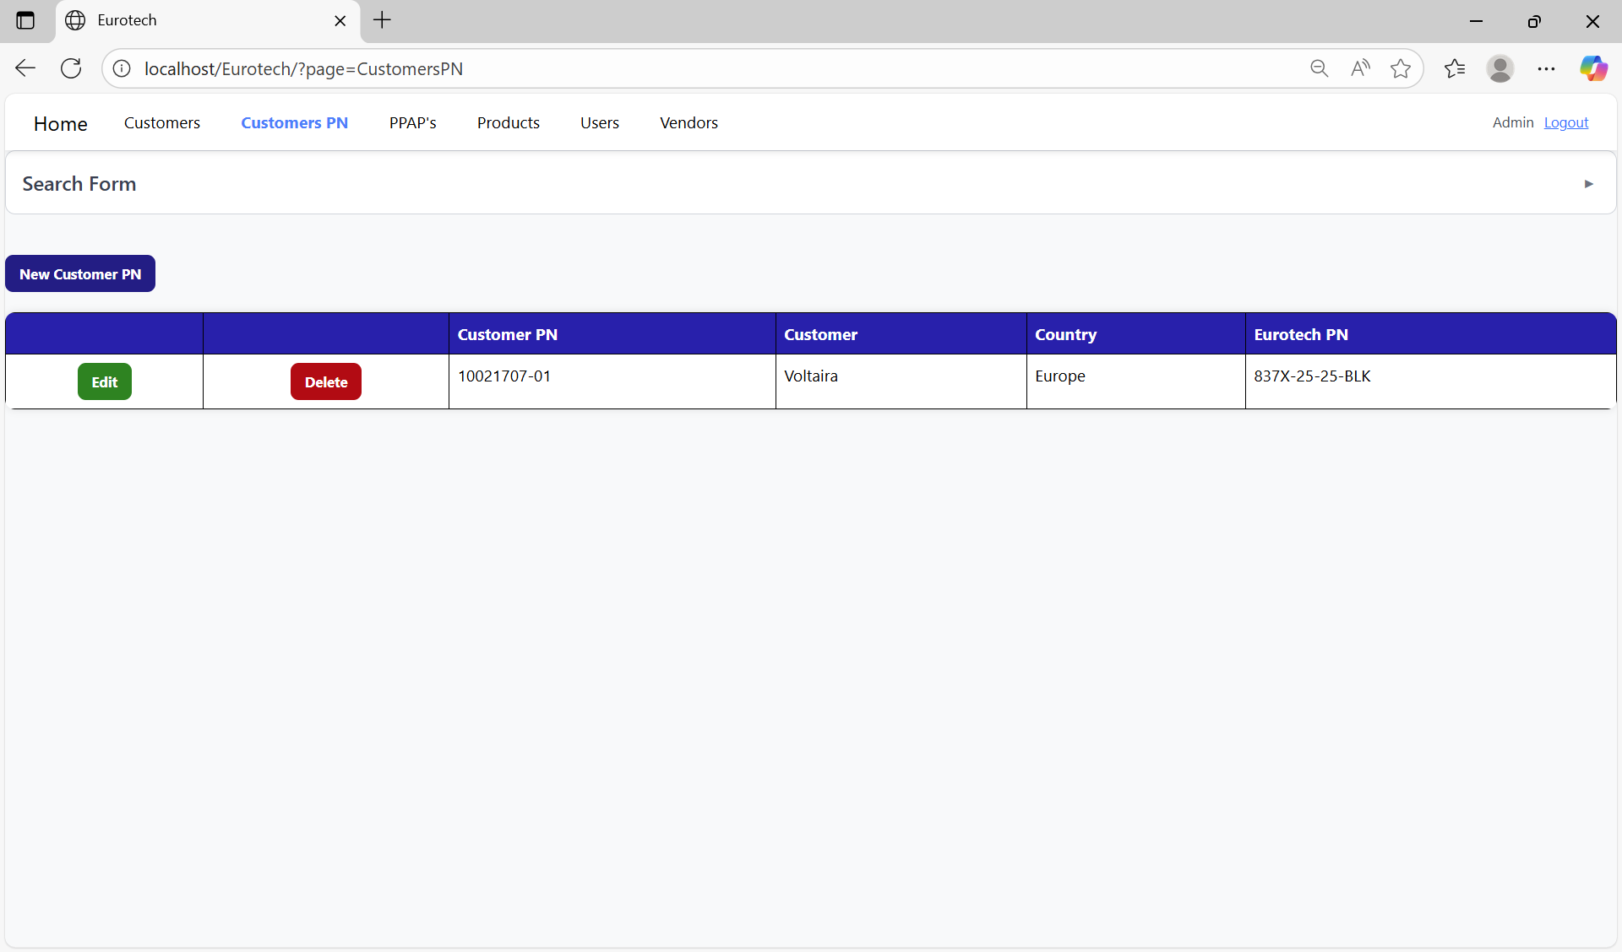

Once you click the “Delete” button, it will display the information of the selected Customer PN with a message to confirm the delete action. To confirm the delete of the Customer PN, you must click the “Confirm” button. It only deletes Customers PN that don’t have registers in “PPAP’s” page.

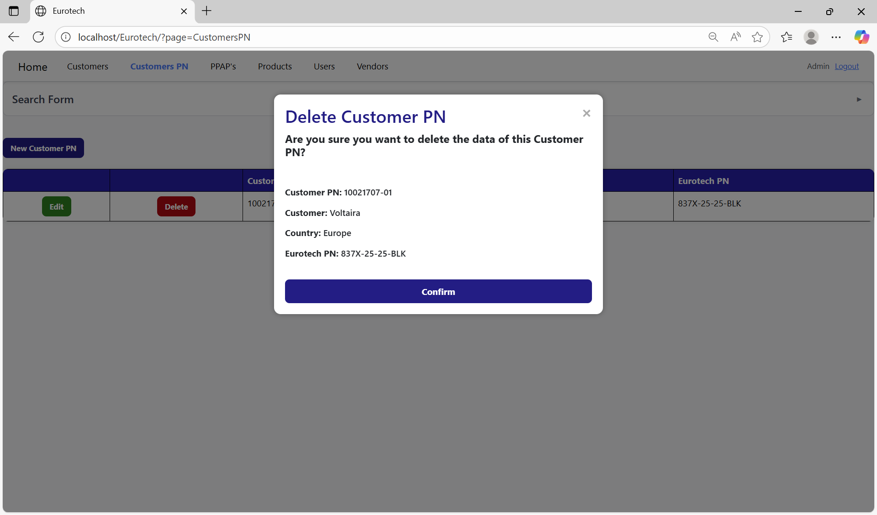

If an error is found, you can check in the Index the instruction *3.11.2.3 Delete Form Errors.*

## ***3.3 PPAP’s Page.***

### *3.3.1 How to Navigate to “PPAP’s” Page.*

On the navigation bar, you can navigate to the “PPAP’s” page.

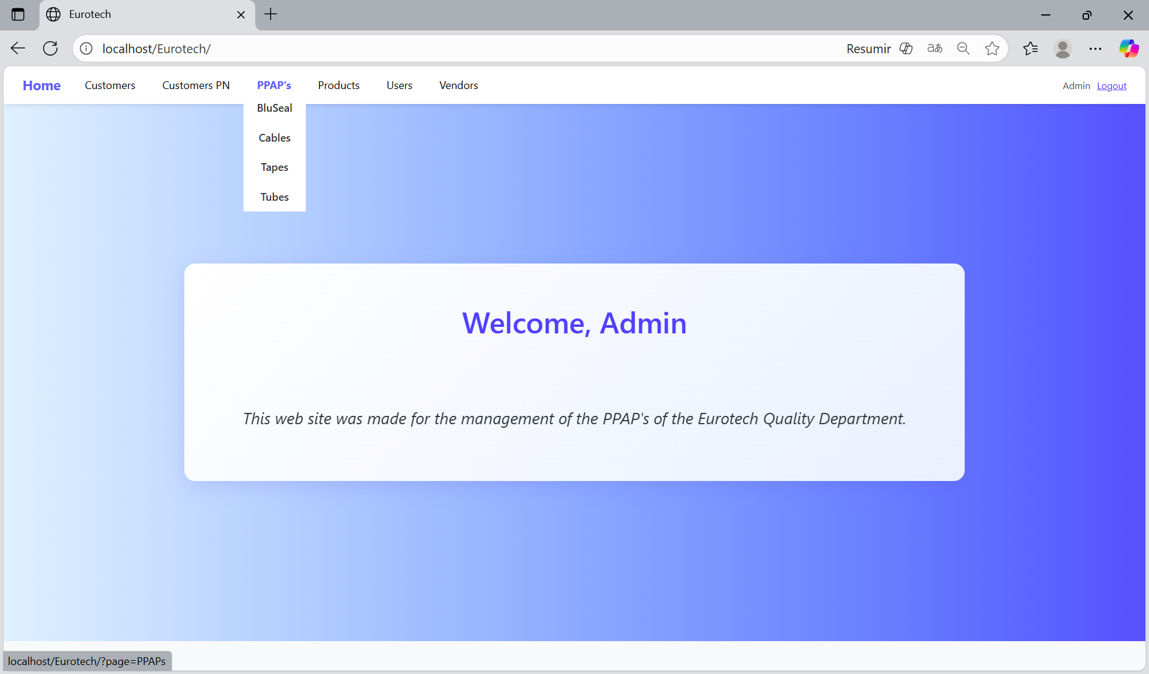

In this page you can manage the registers of all the PPAPs of all the products.

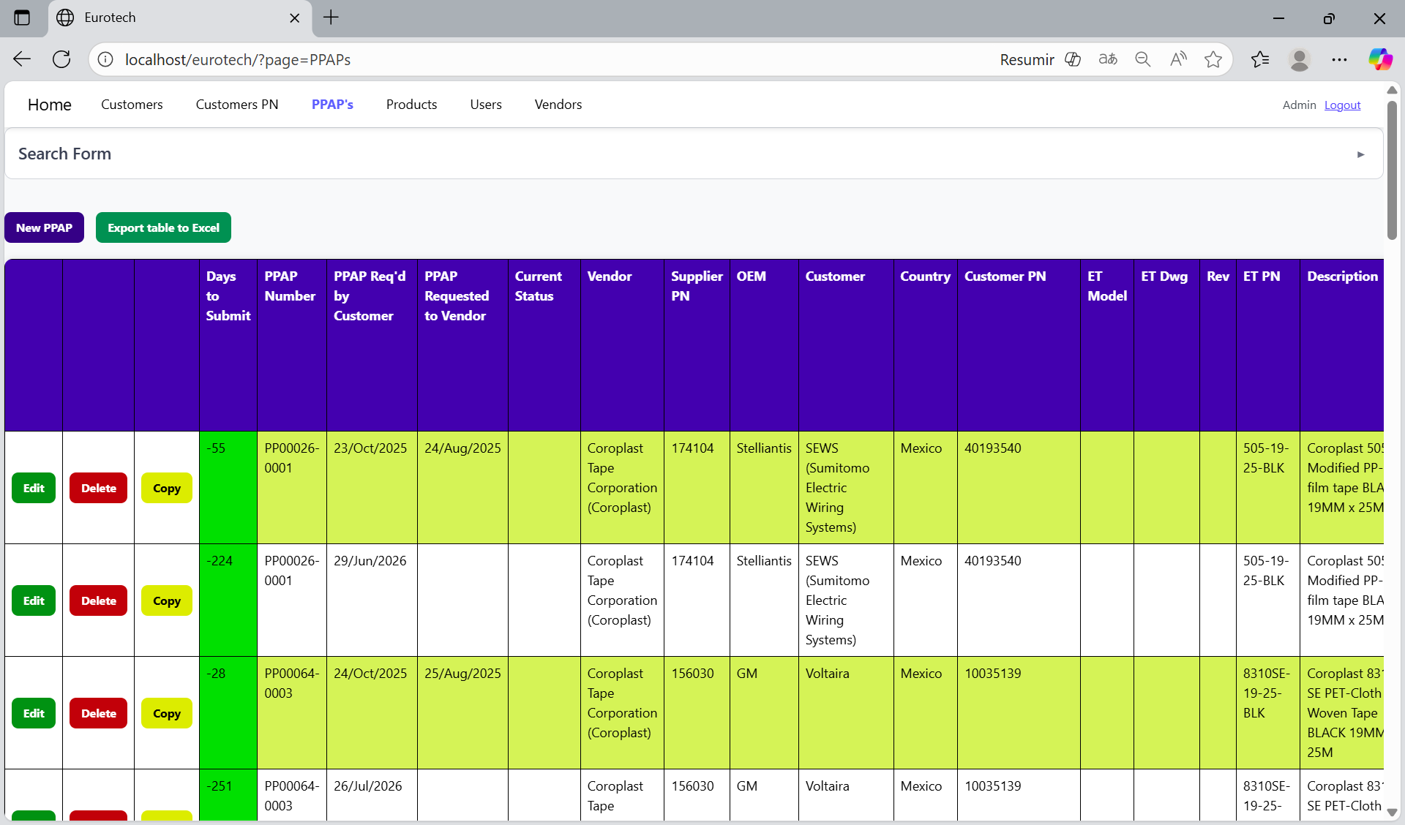

### *3.3.2 How to Search a PPAP.*

At the top of the page, it will be a dropdown “Search Form” that has all the fields of the table for querying registers.

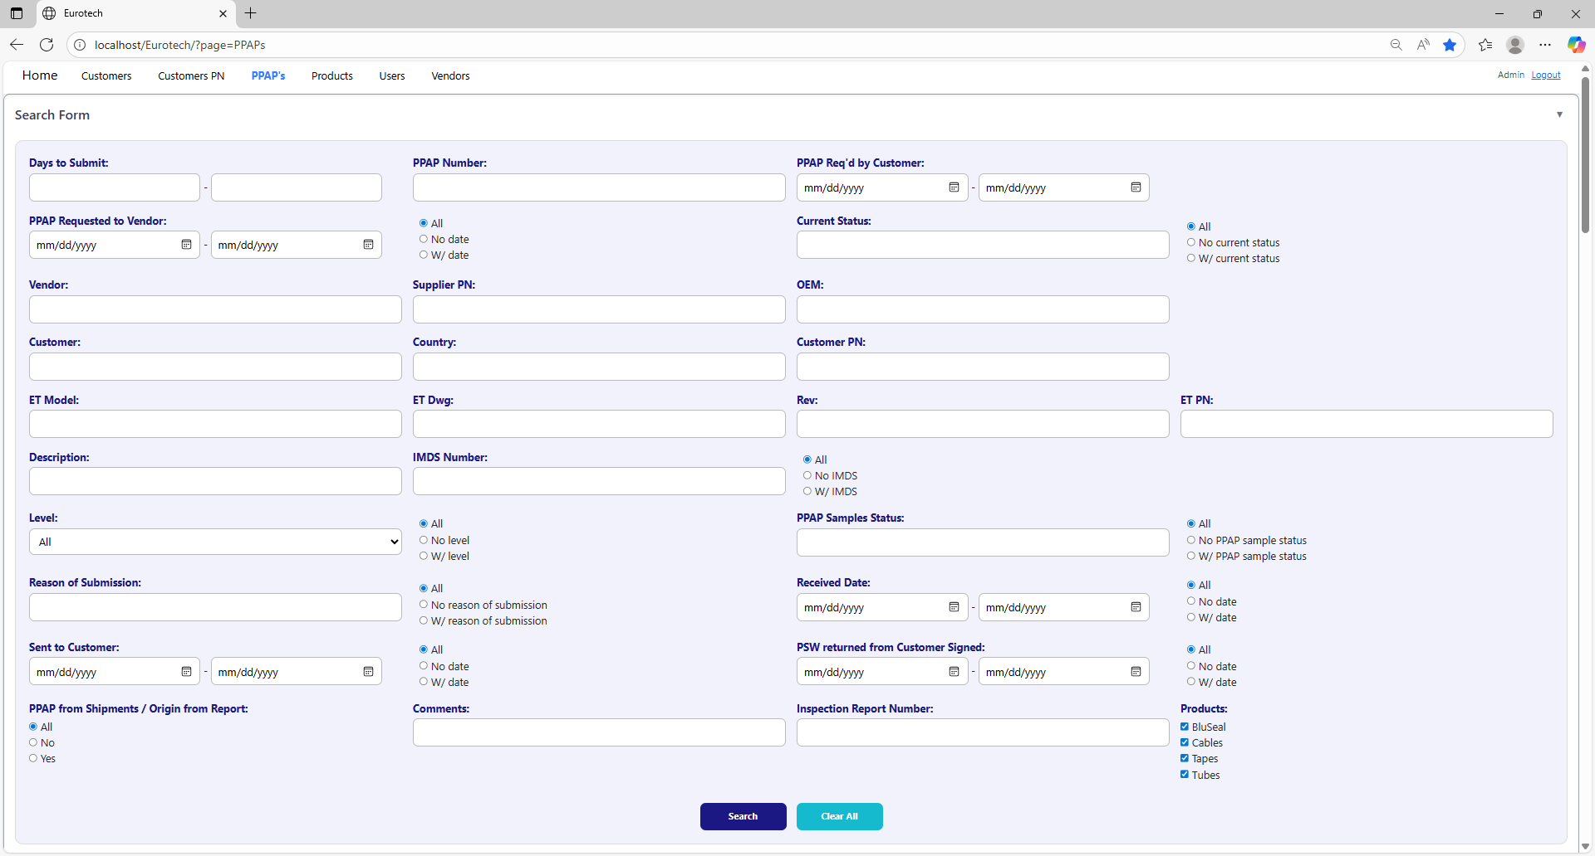

The search form allows you to perform searches by:

* Level
* PPAP Samples Status
* Reason of Submission
* Received Date
* Sent to Customer
* PSW returned from Customer Signed
* PPAP from Shipments / Origin from Report
* Comments
* Inspection Report Number
* Products
* Days to Submit
* PPAP Number
* PPAP Req’d by Customer
* PPAP Requested to Vendor
* Current Status
* Vendor
* Supplier PN
* OEM
* Customer
* Country
* Customer PN
* ET Model
* ET Dwg
* Rev
* Eurotech PN
* Description
* IMDS Number

You can search by “Days to Submit”, writing the range of days.

You can search by “PPAP Number”.

You can search by “PPAP Req’d by Customer”, writing the range of dates.

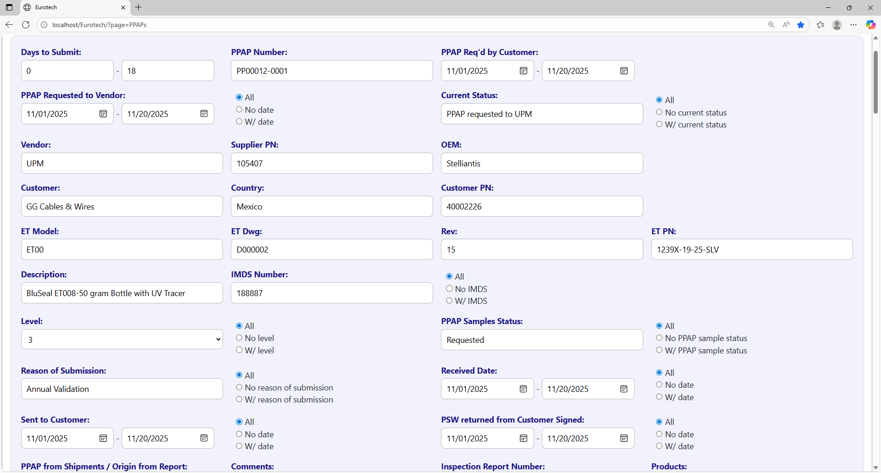

You can search registers that either have or don’t have the “Current Status” field filled in, or all the registers.

You can search by “Current Status”.

You can search registers that either have or don’t have a date on “PPAP Requested to Vendor”, or all the registers.

You can search by “PPAP Requested to Vendor”, writing the range of dates.

You can search by “OEM”.

You can search by “Vendor”.

You can search by “Supplier PN”.



You can search by “Customer PN”.

You can search by “Customer”.

You can search by “Country”.

You can search by “ET PN”.

You can search by “Rev”.

You can search by “ET Dwg”.

You can search by “ET Model”.



You can search registers that either have or don’t have the “IMDS Number” field filled in, or all the registers.

You can search by “IMDS Number”.

You can search by “Description”.

You can search by “PPAP Samples Status”.

You can search by “Level”.

You can search registers that either have or don’t have the “PPAP Samples Status” field filled in, or all the registers.

You can search registers that either have or don’t have the “Level” field filled in, or all the registers.



You can search registers that either have or don’t have a date on “Received Date”, or all the registers.

You can search by “Received Date”, writing the range of dates.

You can search registers that either have or don’t have the “Reason of Submission” field filled in, or all the registers.

You can search by “Reason of Submission”.

You can search registers that either have or don’t have a date on “PSW returned from Customer Signed”, or all the registers.

You can search registers that either have or don’t have a date on “Sent to Customer”, or all the registers.

You can search by “PSW returned from Customer Signed”, writing the range of dates.

You can search by “Sent to Customer”, writing the range of dates.

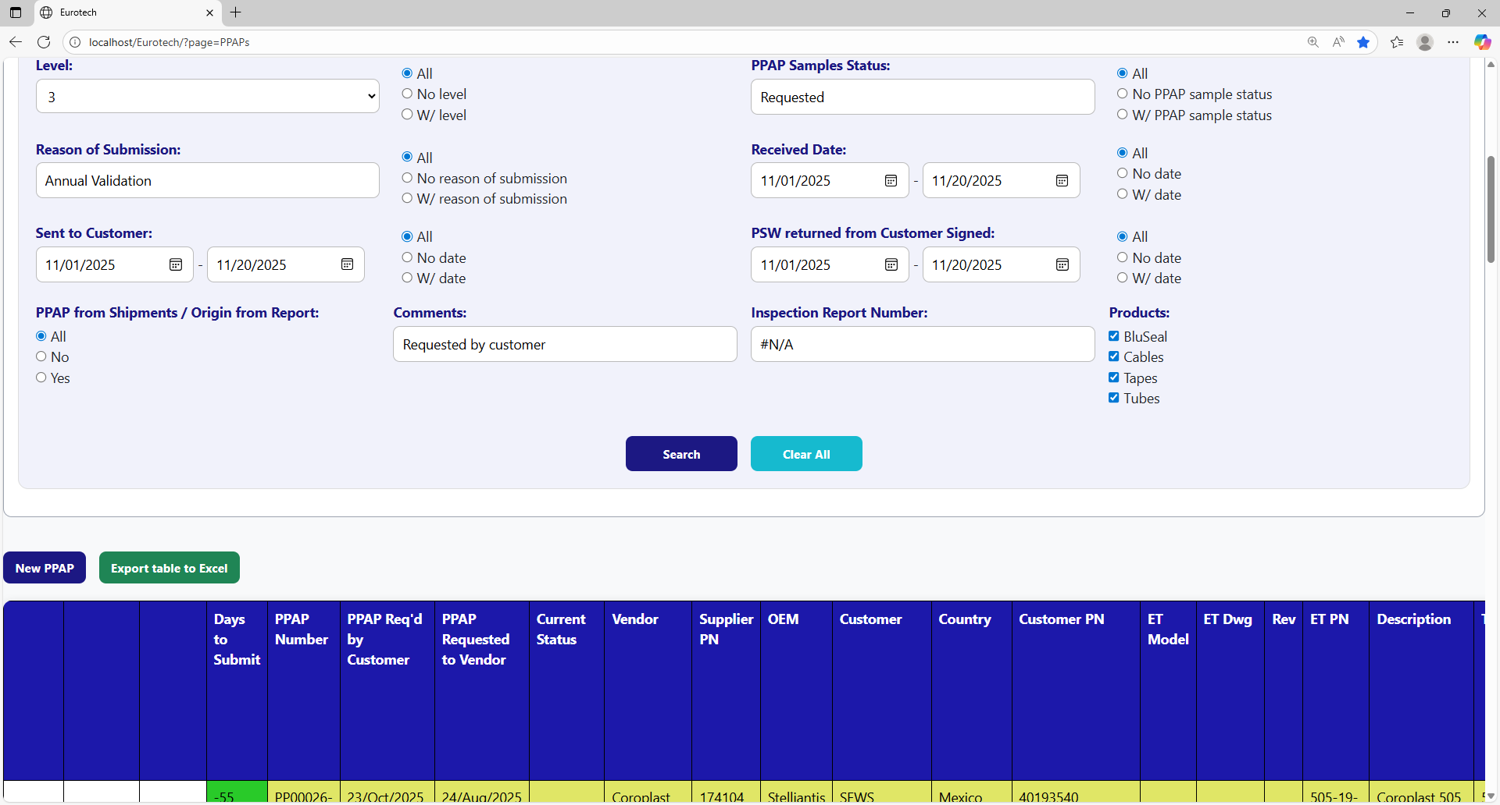

You can search by “Products”.

You can search by “Inspection Report Number”.

You can search by “Comments”.

You can search by “PPAP from Shipments / Origin from Report”.

You must click the “Search” button after you fill any of the fields of the “Search Form” to make the search.

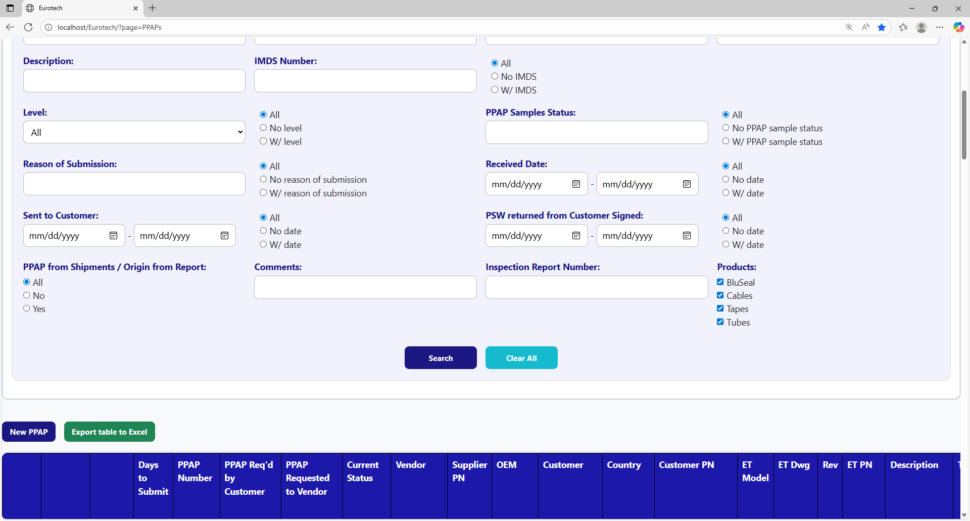

This is an example of how the table would look like after a search (the meaning of the colors of the registers will be explained later).

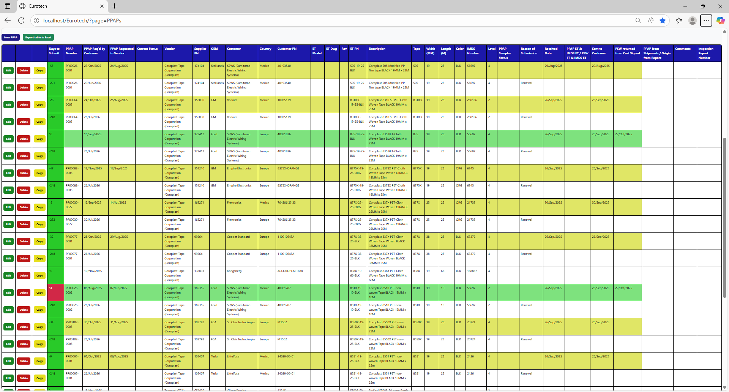

And with the “Clear All” button, you can clean the querying and see all the registers of the PPAPs.



Once you click the “Clear All” button, the fields of the “Search Form” will be empty, and in the table will be shown all the PPAPs.

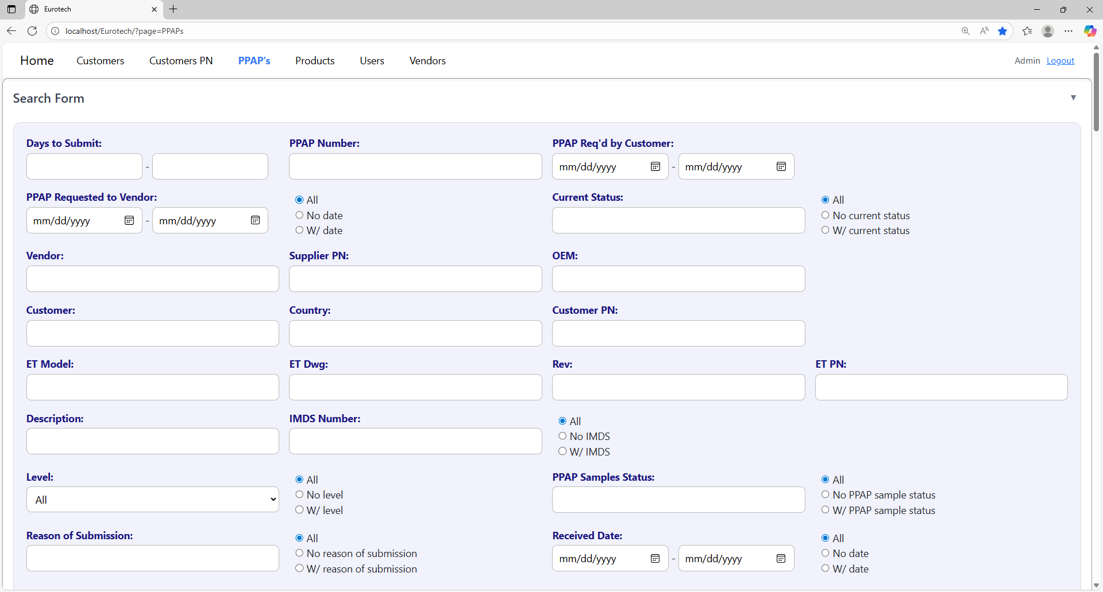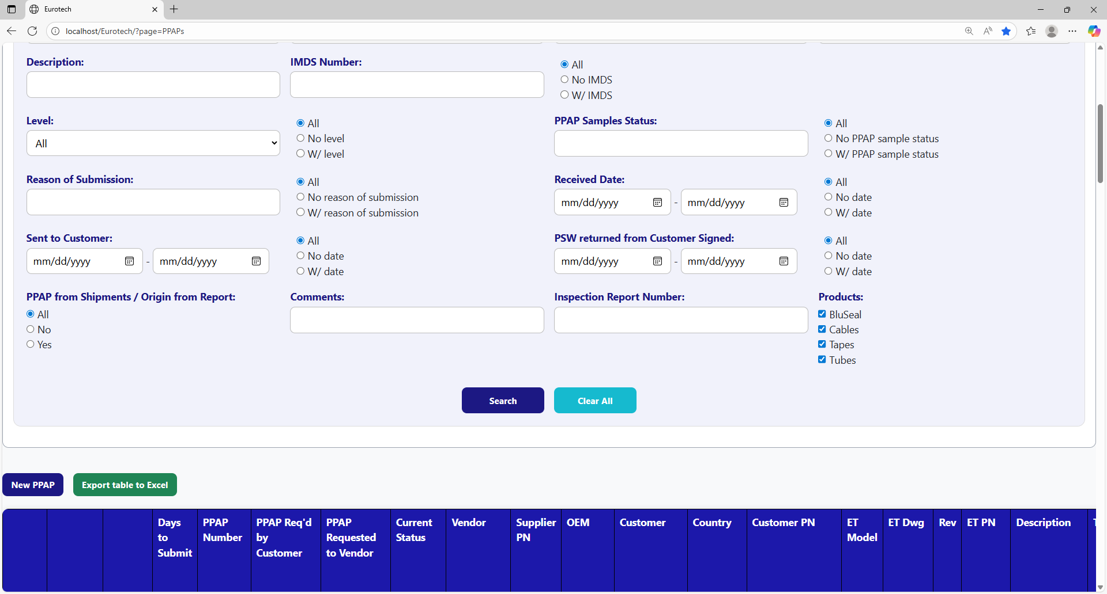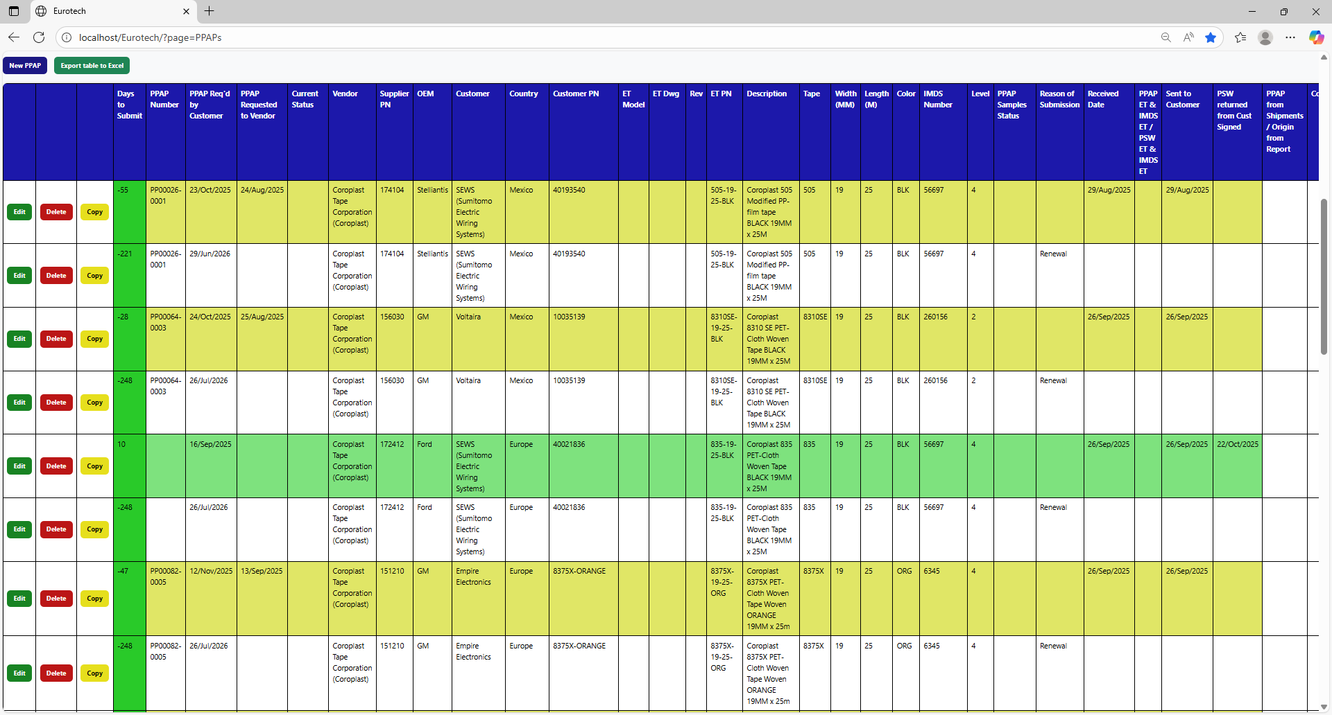

### *3.3.3 Meaning of the Colors of the Registers.*

1.- In the “Days to Submit” column there will be:

* Registers with green field indicate that the difference between the “PPAP Req’d by Customer” date and the “Sent to Customer” date is less than 19 days (if there is no “Sent to Customer” date yet, it is compared with the current date).

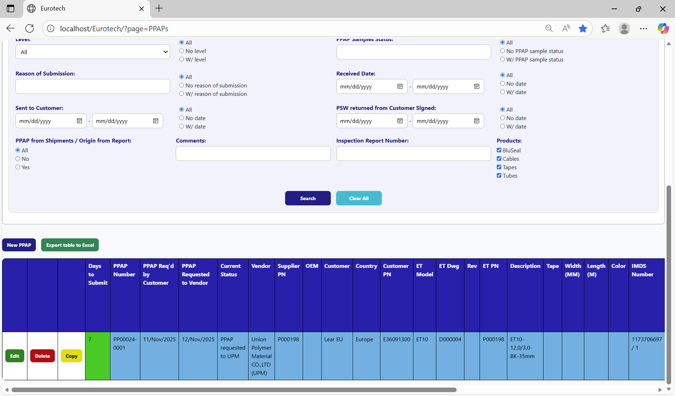

* Registers with yellow field indicate that the difference between the “PPAP Req’d by Customer” date and the “Sent to Customer” date is between 19 and 29 days (if there is no “Sent to Customer” date yet, it is compared with the current date).

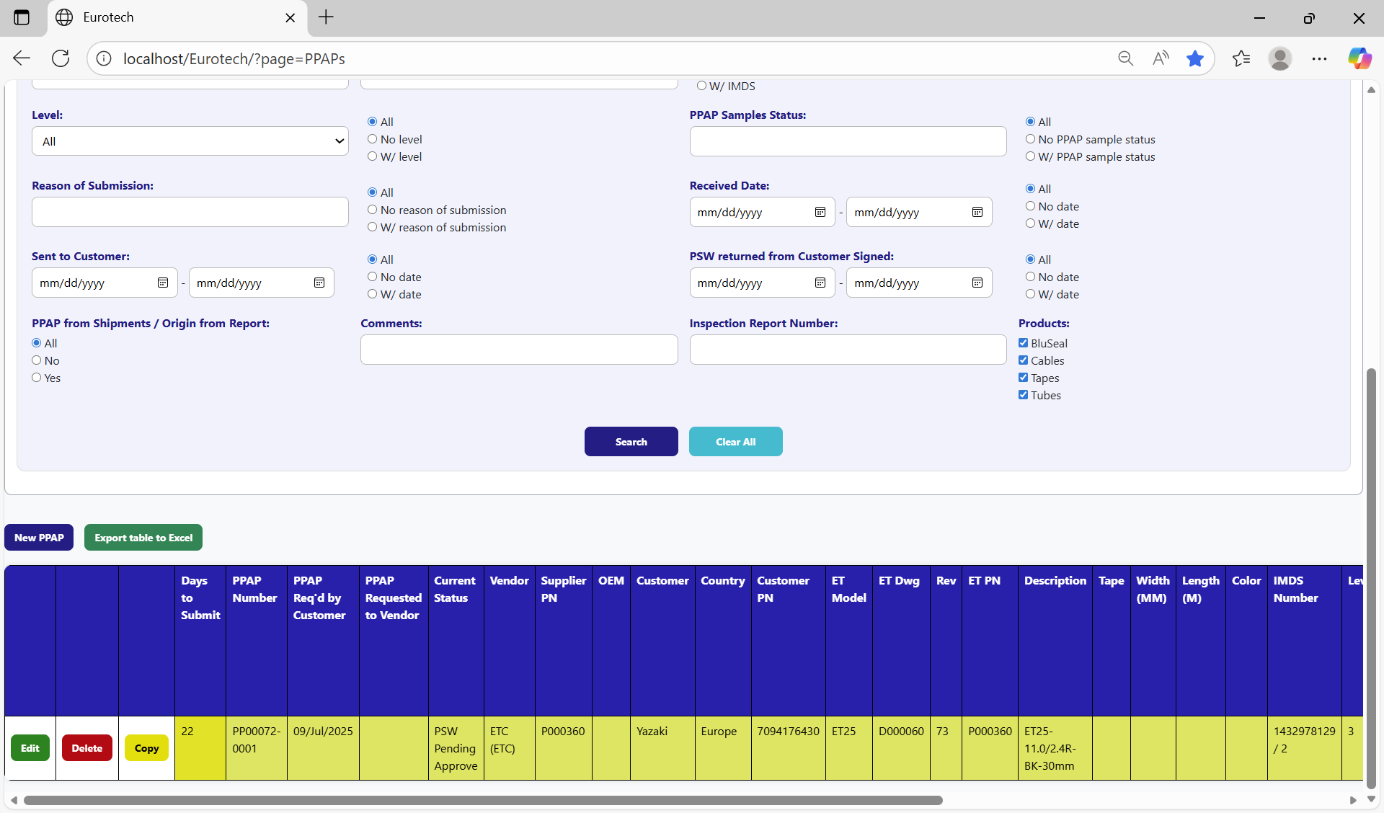

* Registers with red field indicate that the difference between the “PPAP Req’d by Customer” date and the “Sent to Customer” date is greater than 29 days (if there is no “Sent to Customer” date yet, it is compared with the current date).

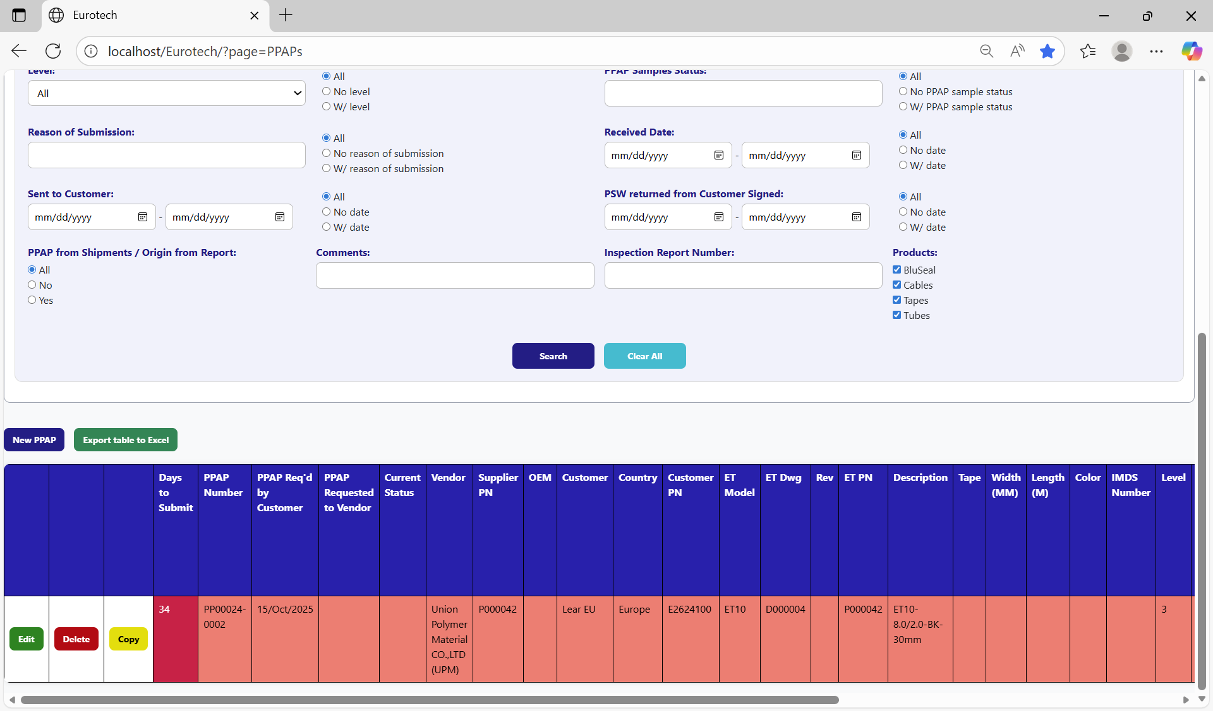

2.- In the rest of the columns of the registers will be:

* Registers with white background indicate that the PPAP has been requested by the customer, the request has not been sent to the vendor, and 30 days have not passed without the documentation being sent to the customer.

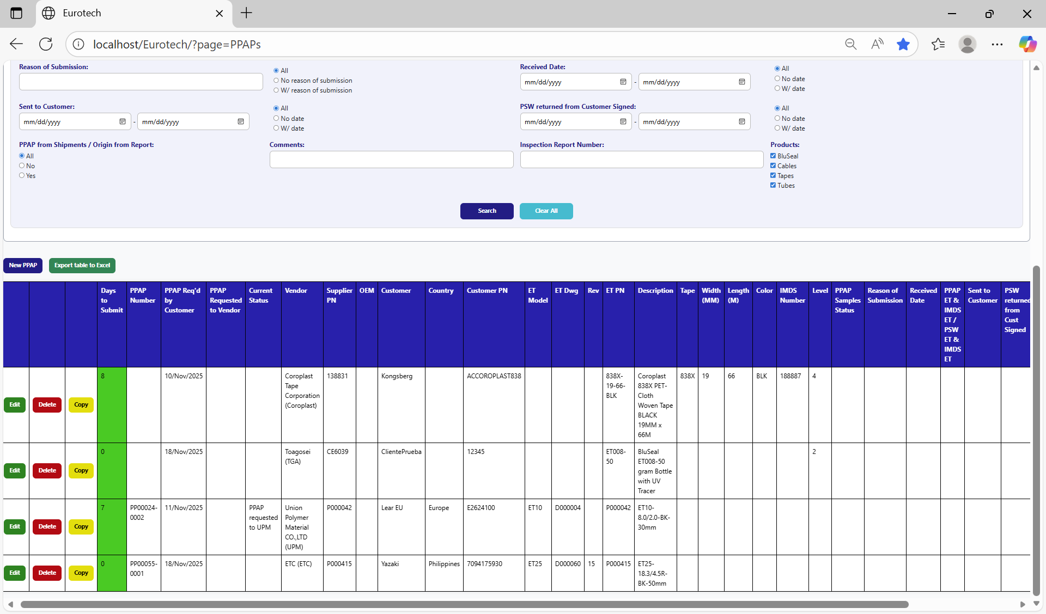

* Registers with blue background indicate that the PPAP has been requested by the customer, the request has been sent to the vendor, and 30 days have not passed without the documentation being sent to the customer.

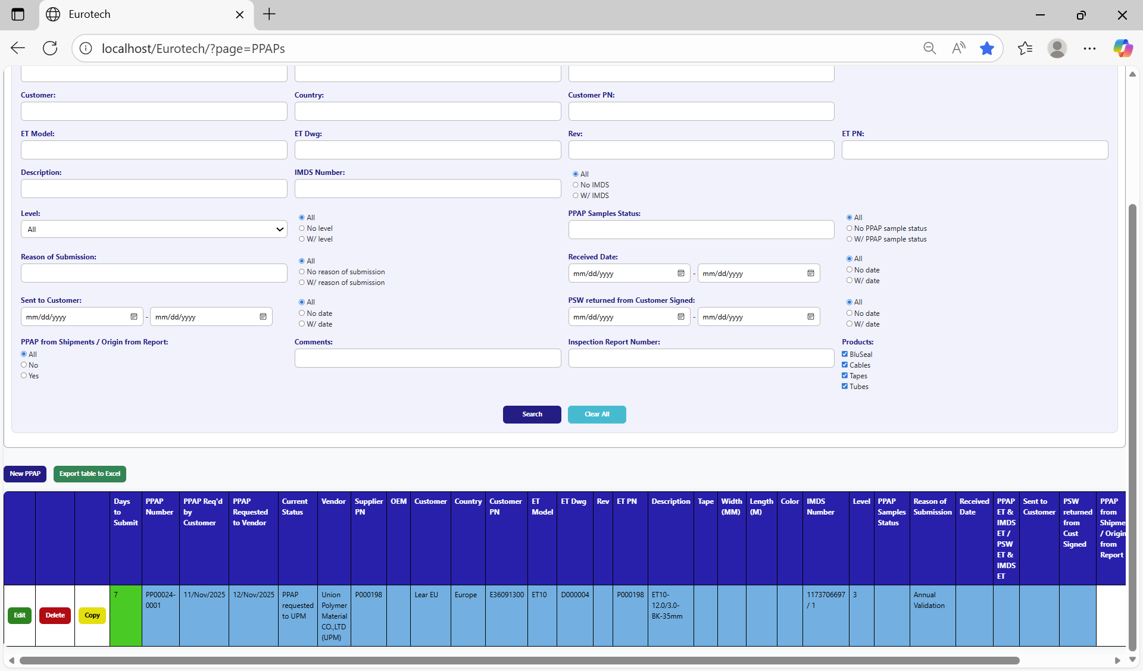

* Registers with red background indicate that the PPAP has been requested by the customer, and the 30-day limit has passed without the documentation being sent to the customer.

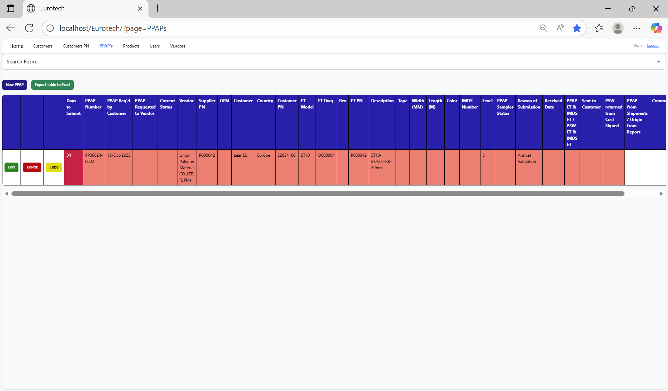

* Registers with yellow background indicate that the PPAP has been sent to the customer, and the PSW has not been returned signed by the customer.

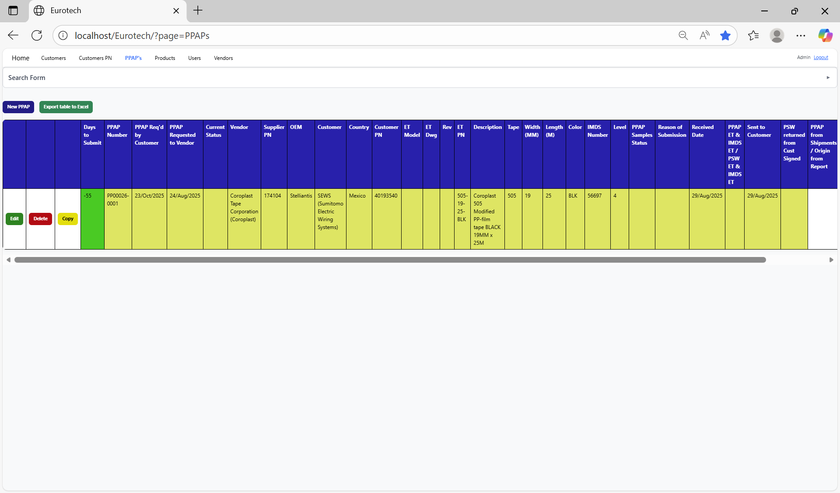

* Registers with green background indicate that the PSW has been returned signed by the customer.

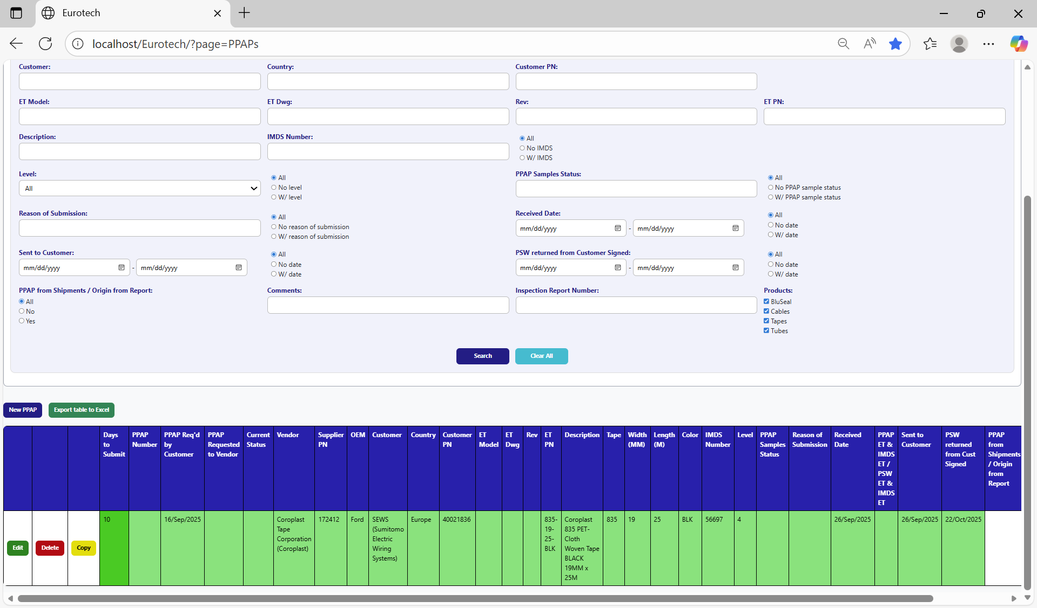

### *3.3.4 How to Add a New PPAP.*

If you want to add a new PPAP, you must click the “New PPAP” button that is below the “Search Form”.

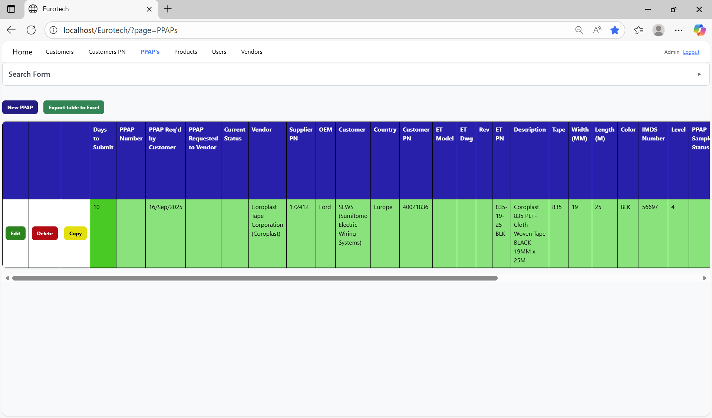

Once you click the “New PPAP” button, it will display a register form to create a new PPAP.

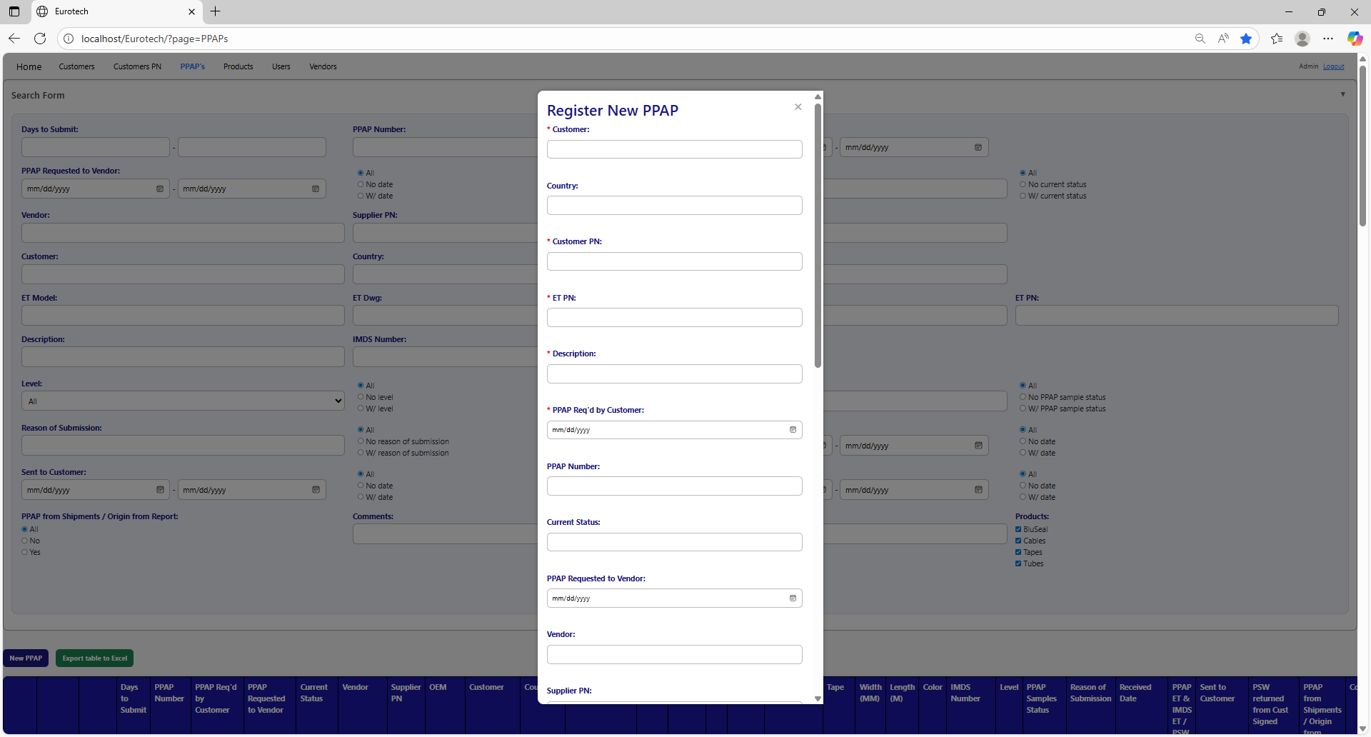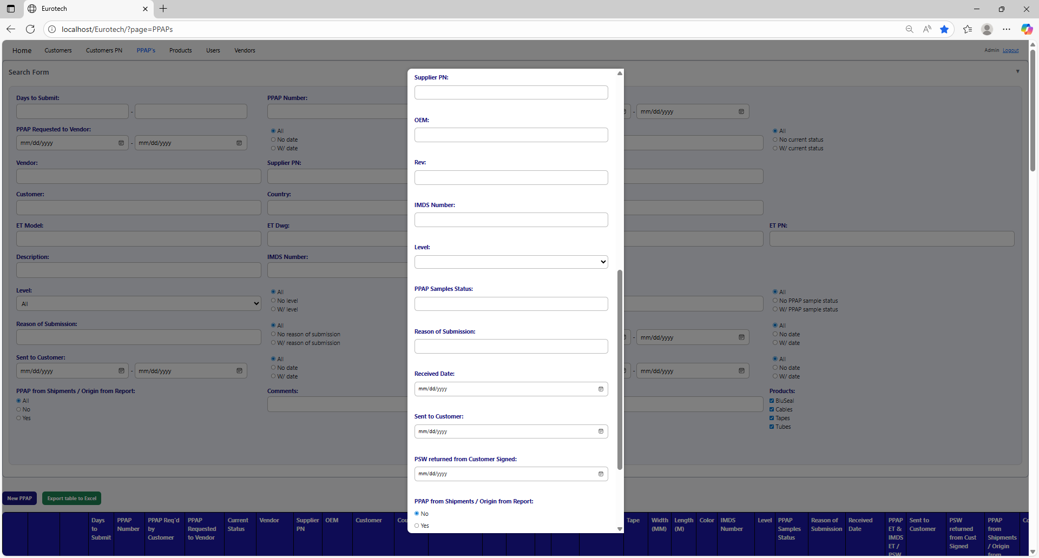

Non-mandatory field

Mandatory fields

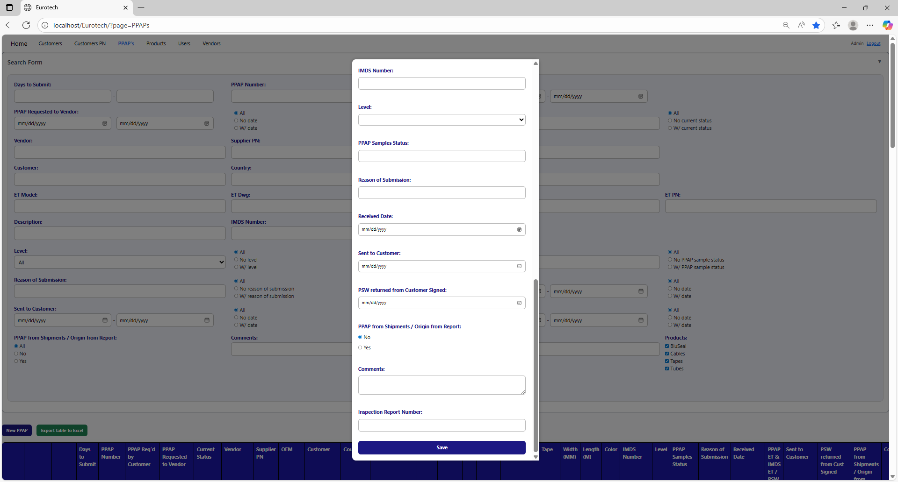

Non-mandatory field

If you want to save the register of a new PPAP, you must click the “Save” button.

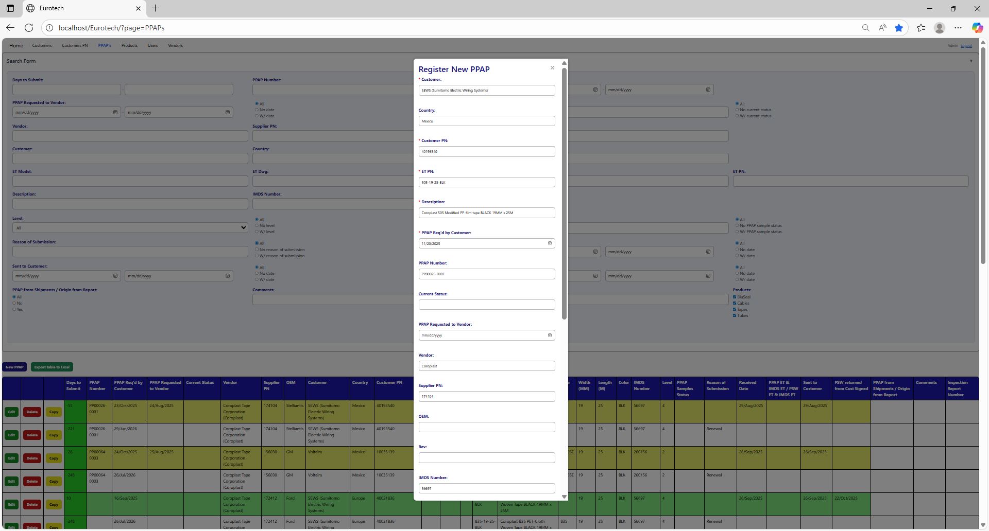

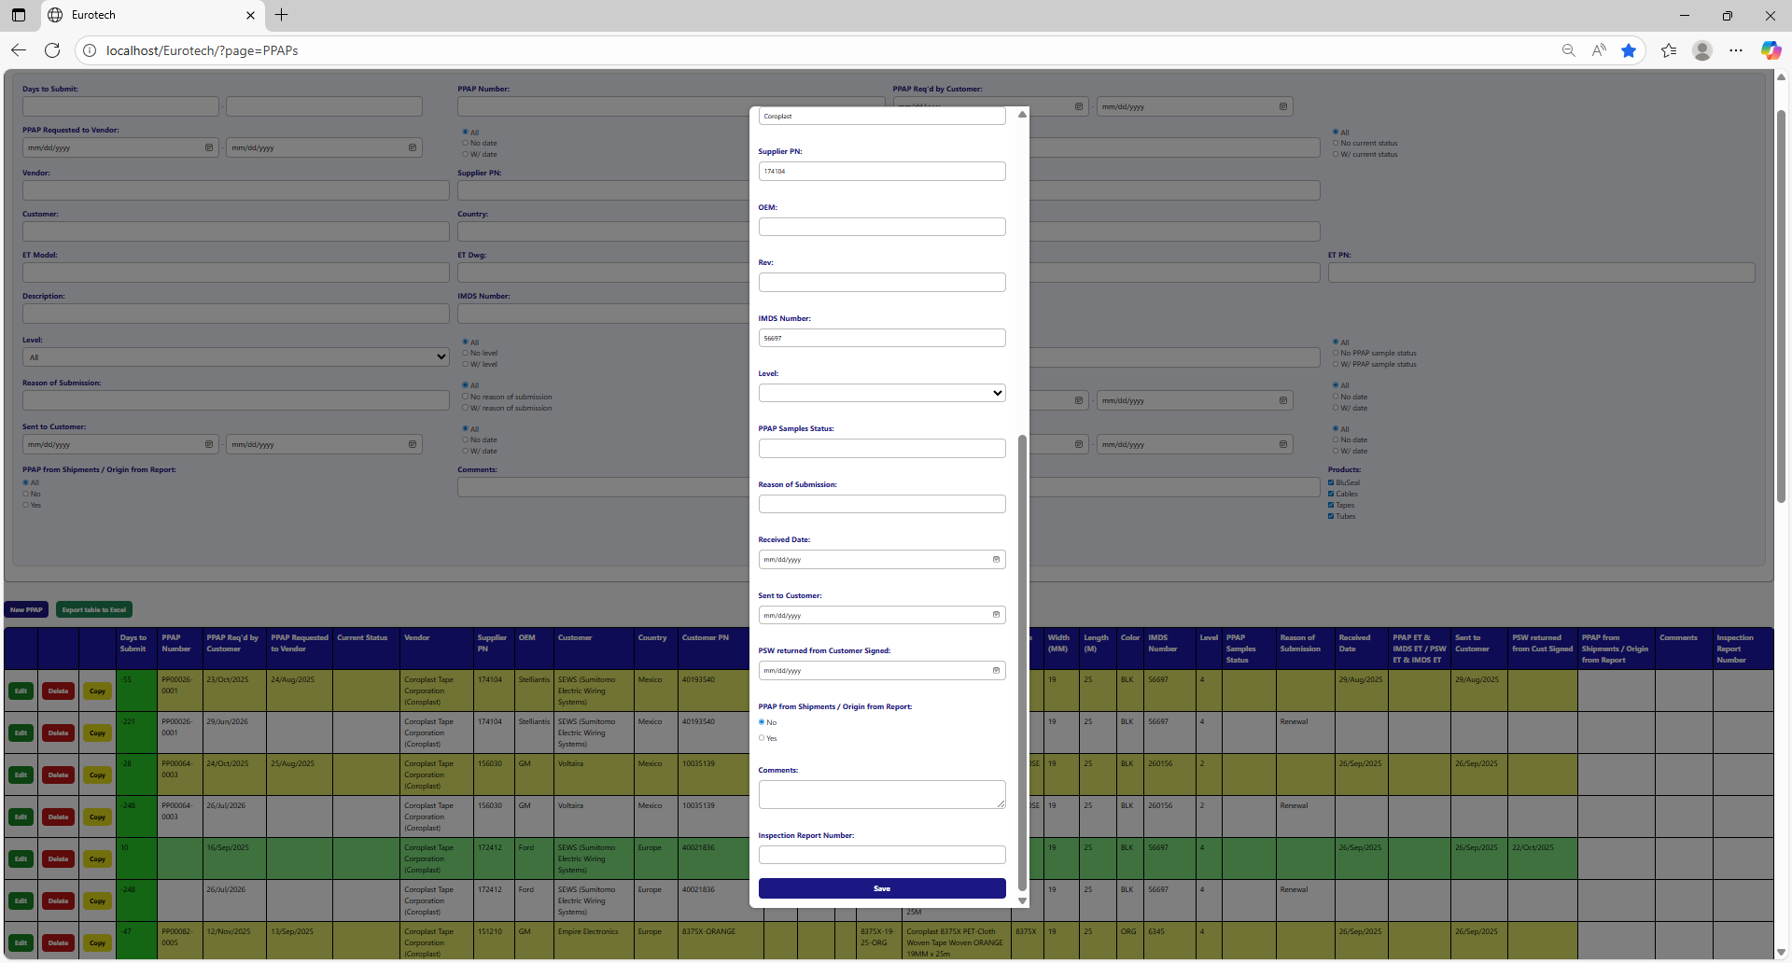

If no errors are found, the register will be added successfully.

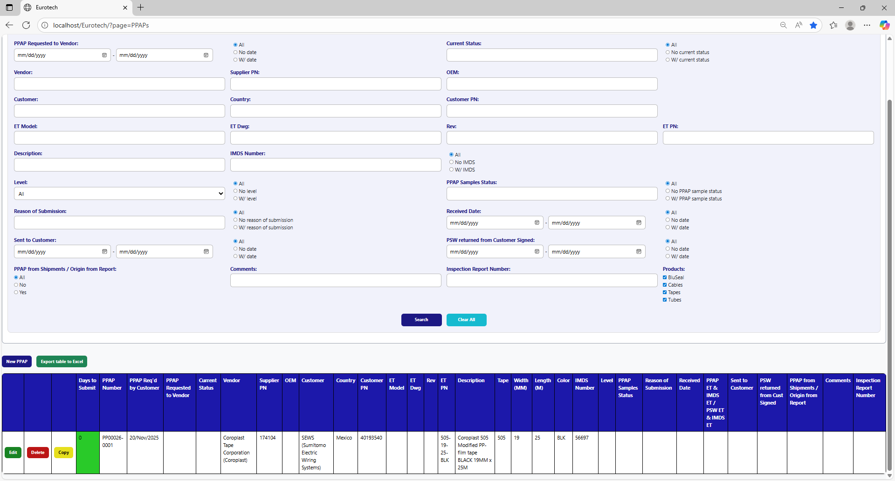

If an error is found, you can check in the Index the instruction *3.11.3.1 Register Form Errors.*

### *3.3.5 How to Edit Information of a PPAP.*

In each register from the table, it will be an “Edit” button. If this button is clicked, it will display an update form to edit the information of the selected PPAP.



Once you click the “Edit” button, it will display an update form to edit the information of the selected PPAP.

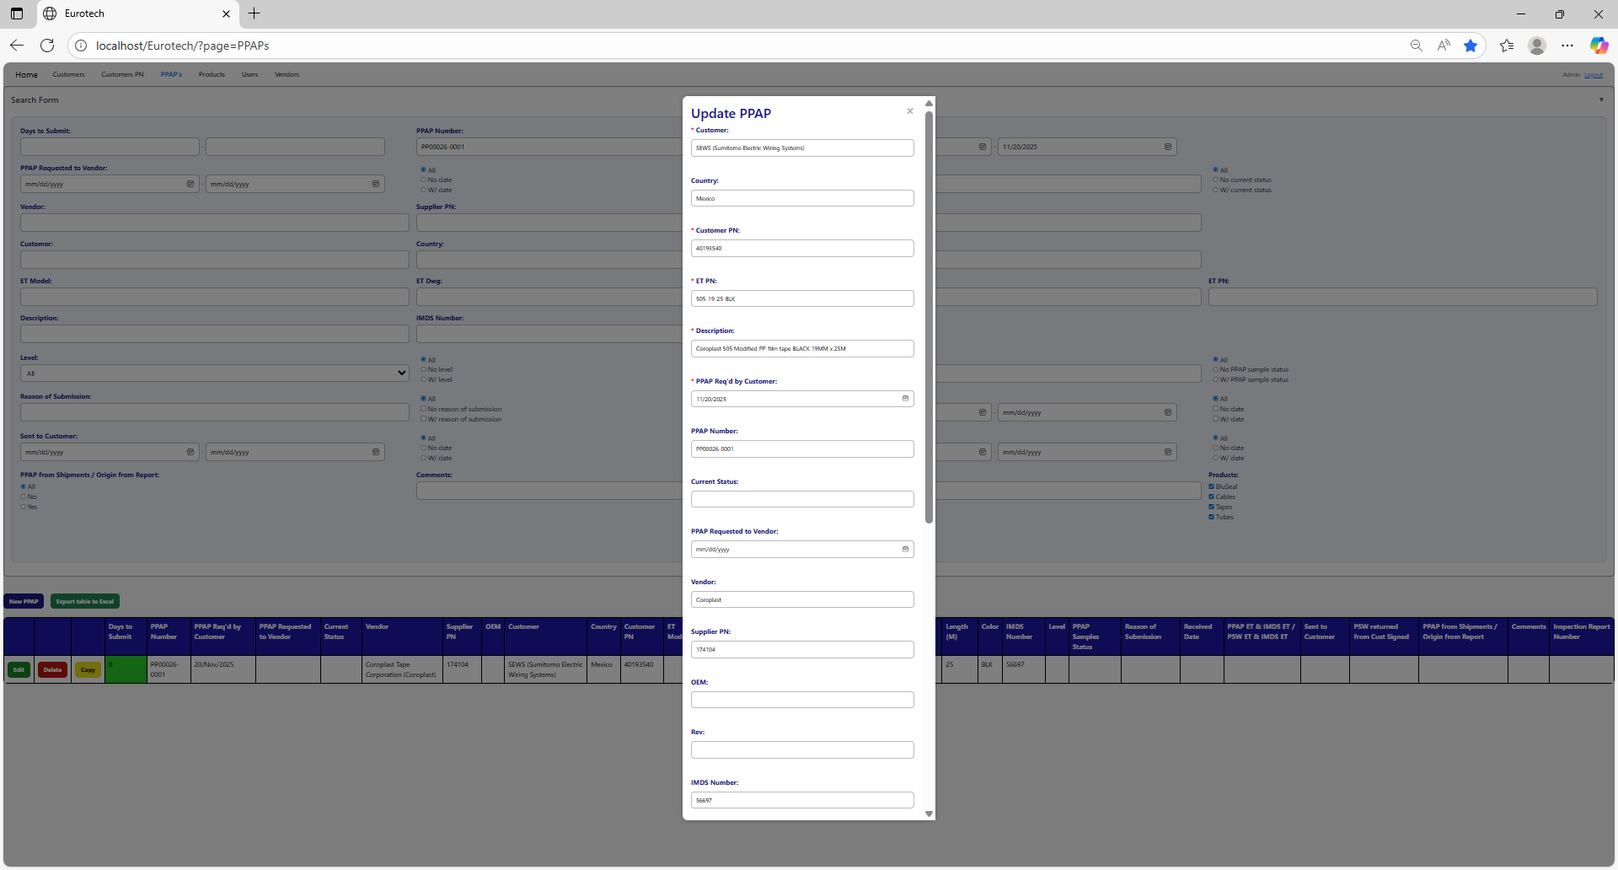



Example of a modification:

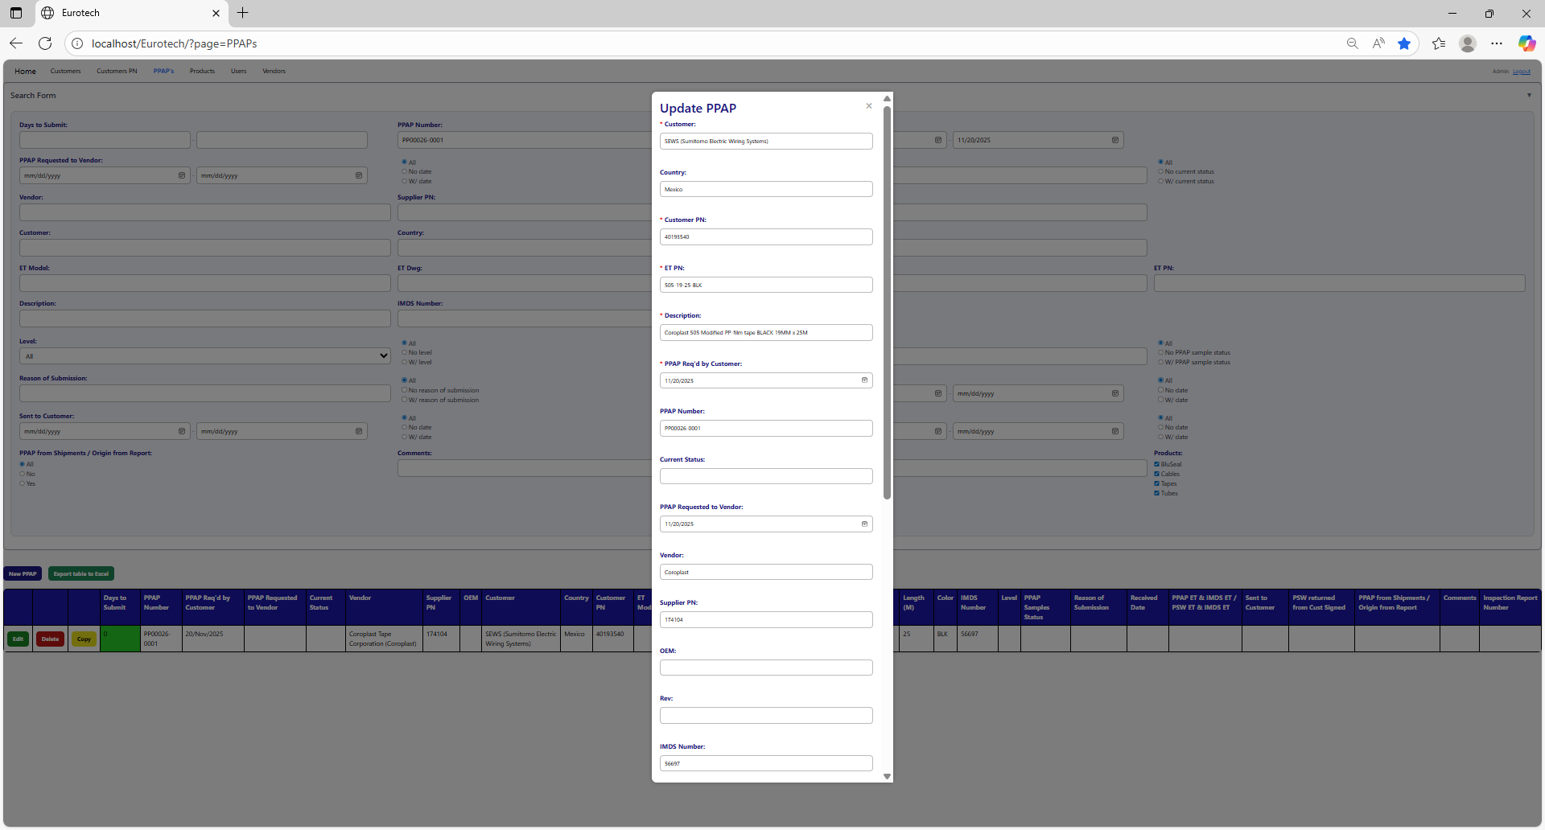

To save the changes, you must click the “Save” button.

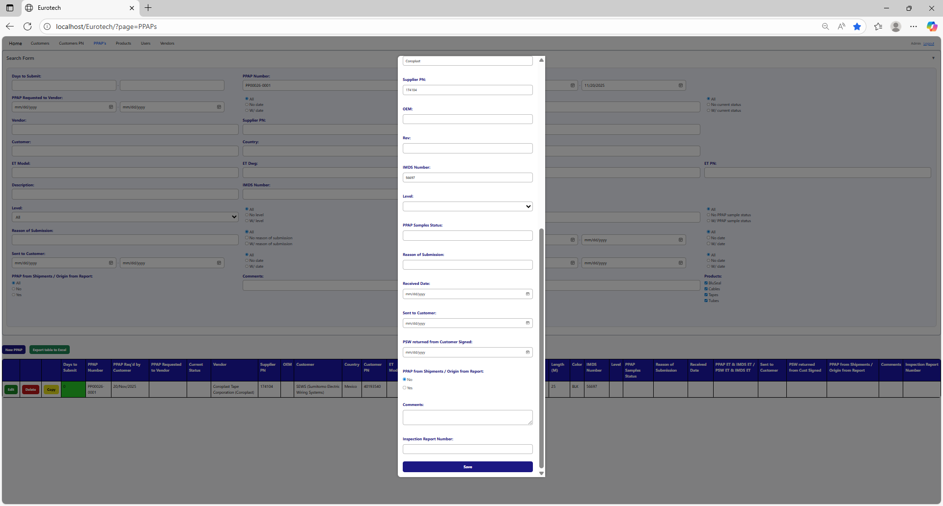

If no errors are found, the register will be updated successfully.

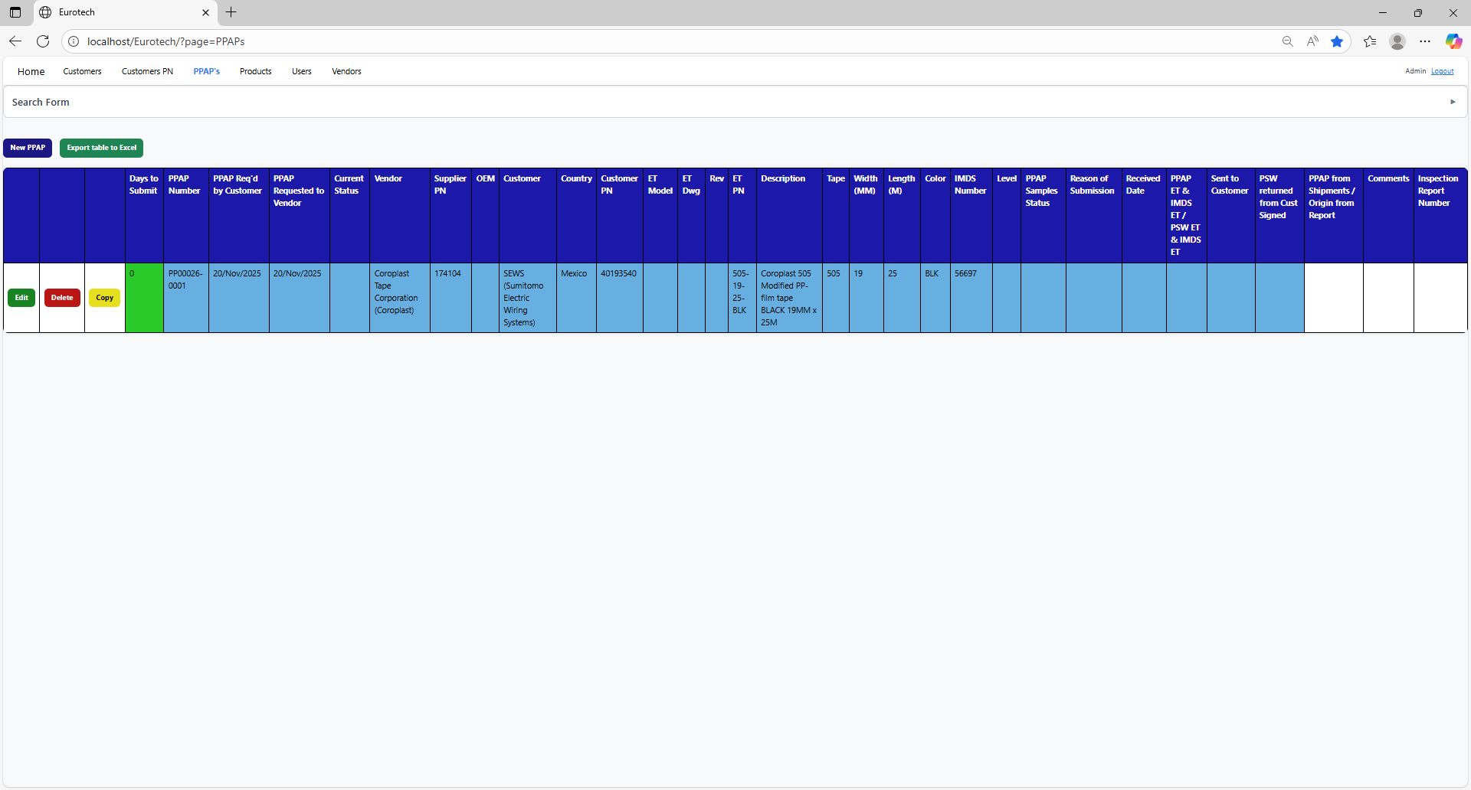

If an error is found, you can check in the Index the instruction *3.11.3.2 Edit Form Errors.*

### *3.3.6 How to Copy the Information of a PPAP.*

In each register from the table, it will be a “Copy” button. You must click the “Copy” button of the register you want to copy its information.



Once you click the “Copy” button, it will display the register form, but with the information of the PPAP selected.



You can do the modifications you need to the information and use the “Save” button to save the new register.

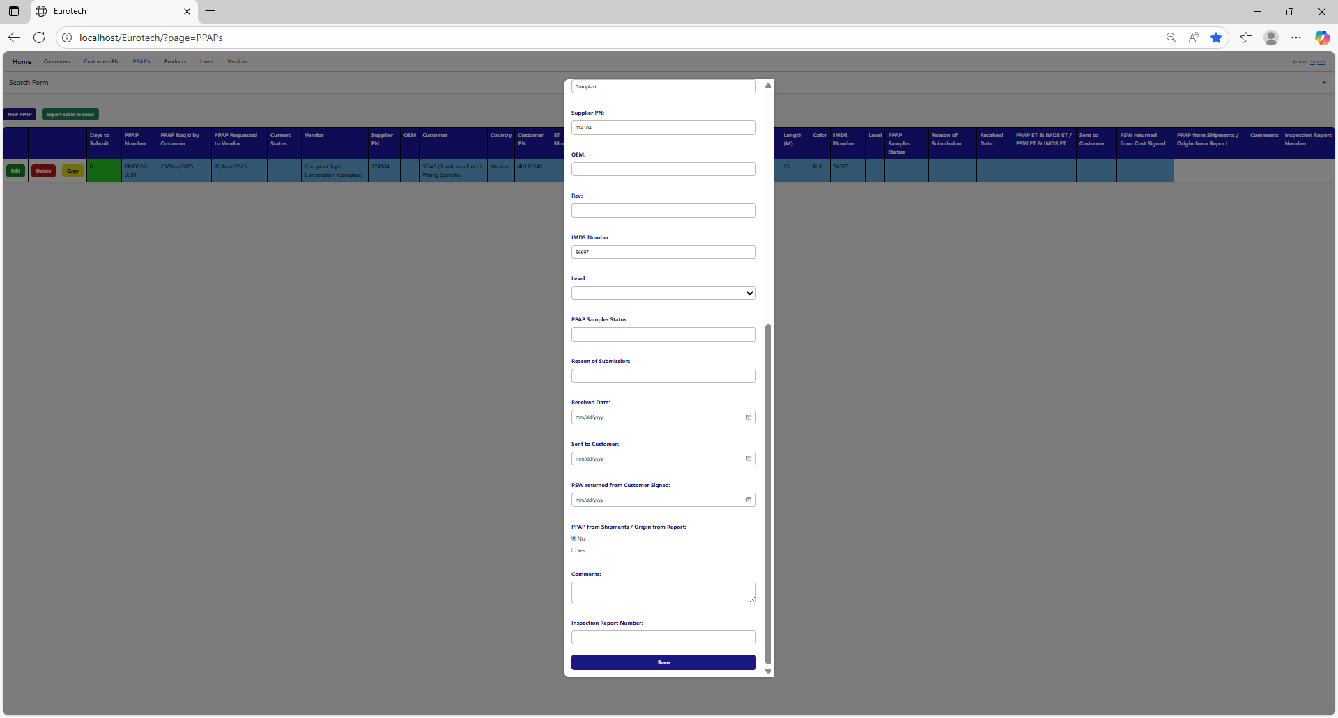

### *3.3.7 How to Delete a PPAP.*

In each register from the table, it will be a “Delete” button. You must click the “Delete” button of the register you want to delete.



Once you click the “Delete” button, it will display the information of the selected PPAP with a message to confirm the delete action. To confirm the delete of the PPAP, you must click the “Confirm” button.

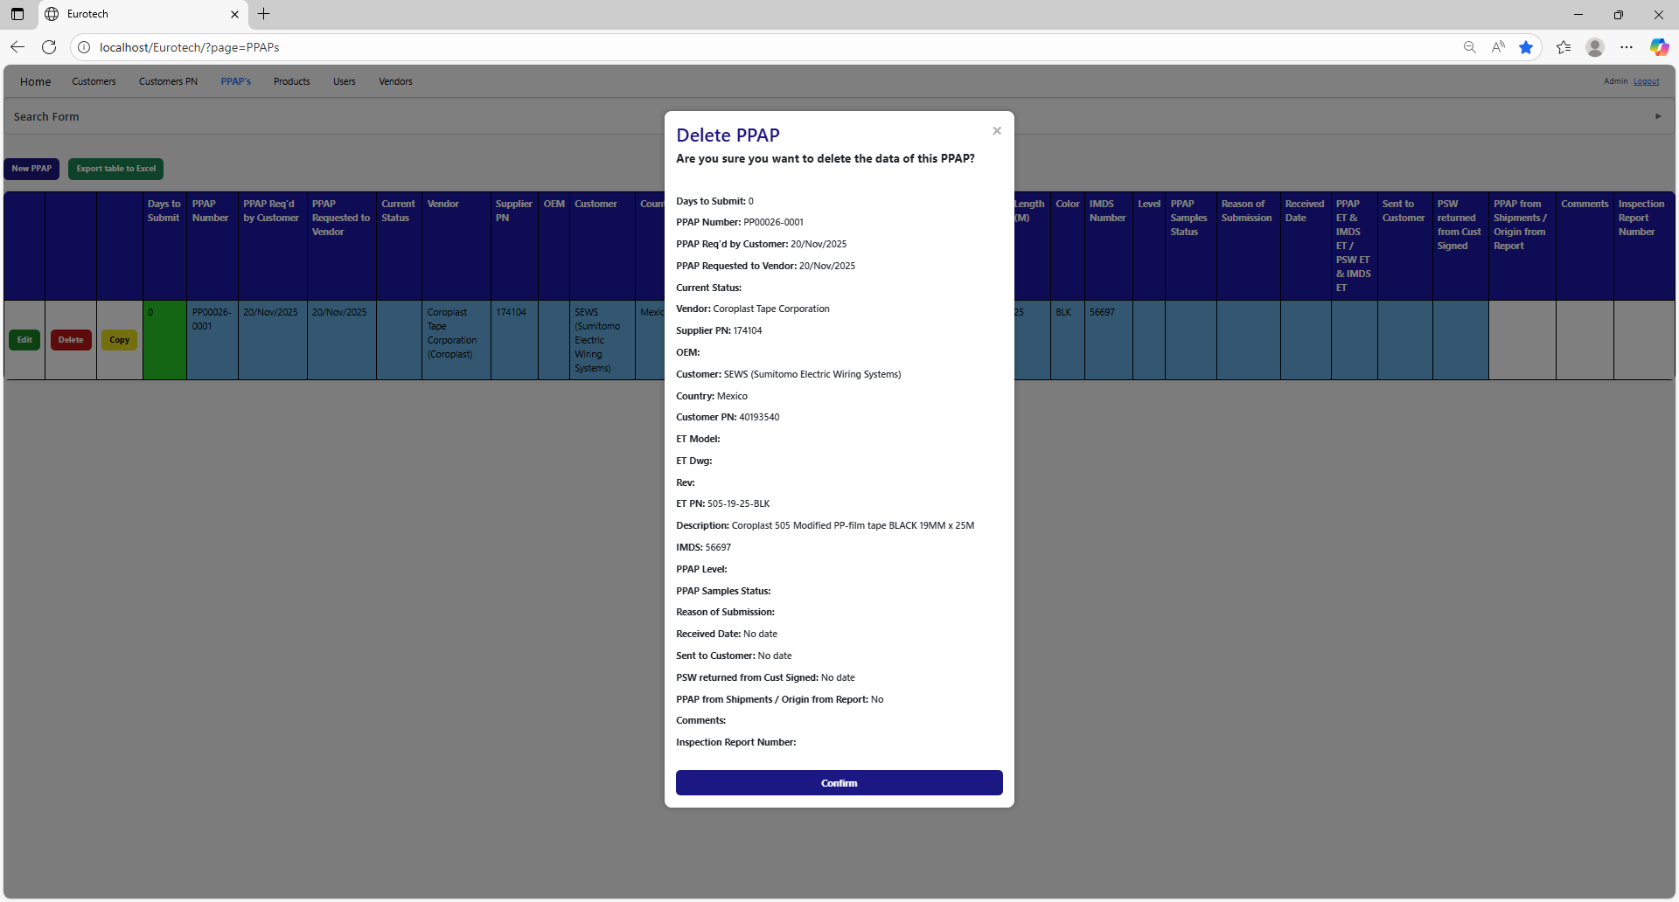

### *3.3.8 How to Automatically Create a Renewal for a PPAP.*

When a PPAP is registered or updated, and the "Sent to Customer" field is filled in, it also creates the register for the following year's renewal, putting the date of "Sent to Customer" in the "PPAP Req'd by Customer" field, adding 10 more months.

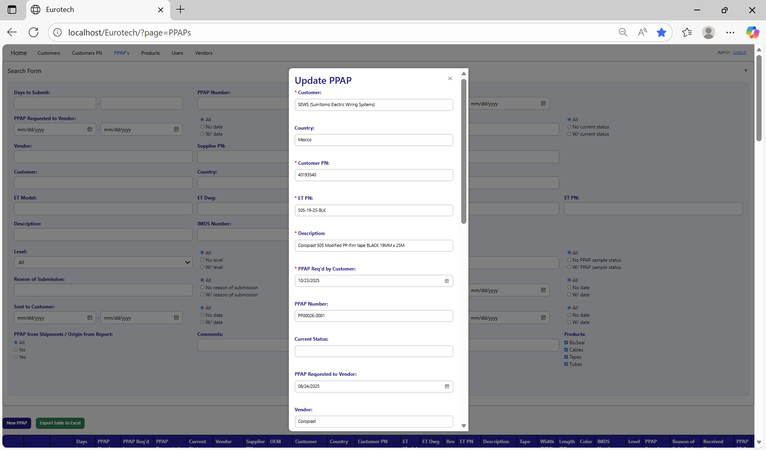

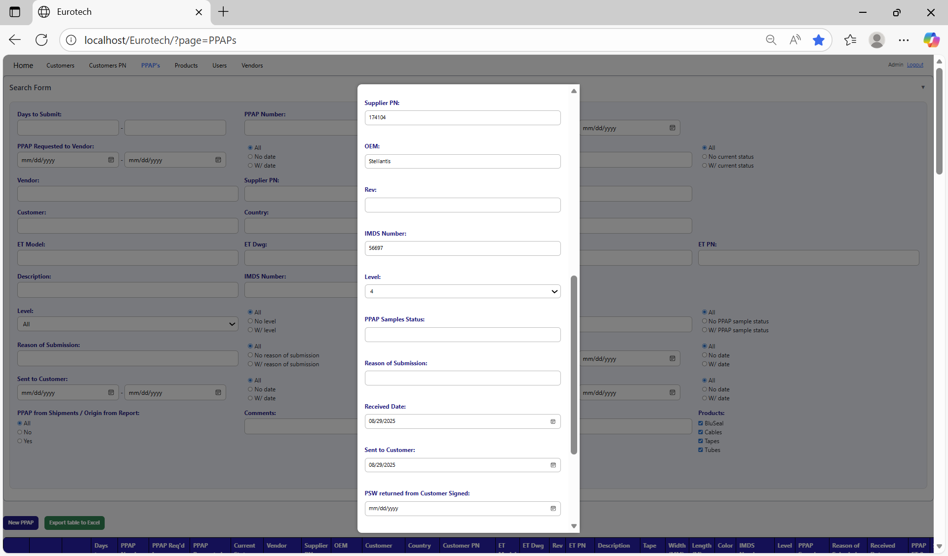

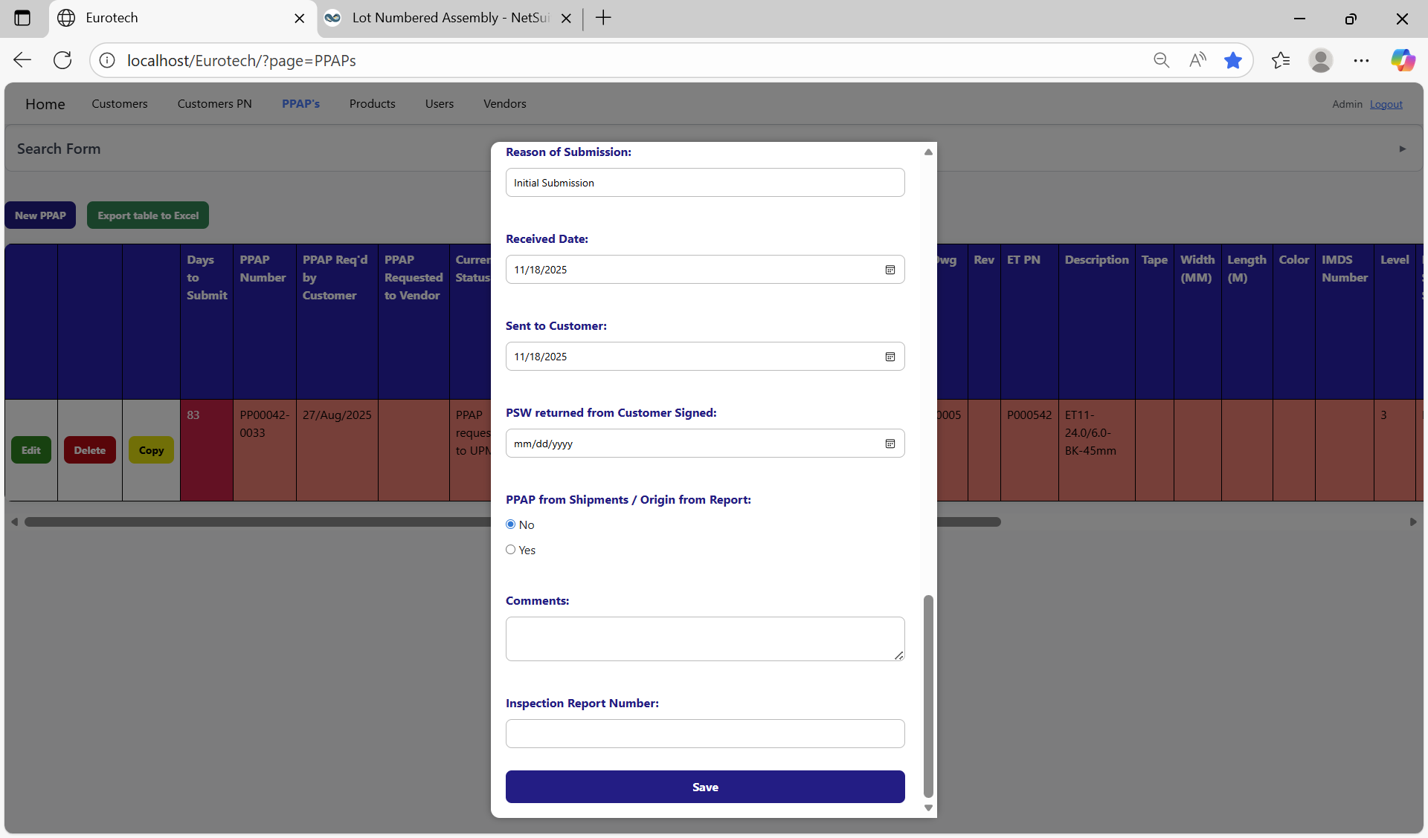

Once you click the “Save” button, the register for the following year's renewal will be created.

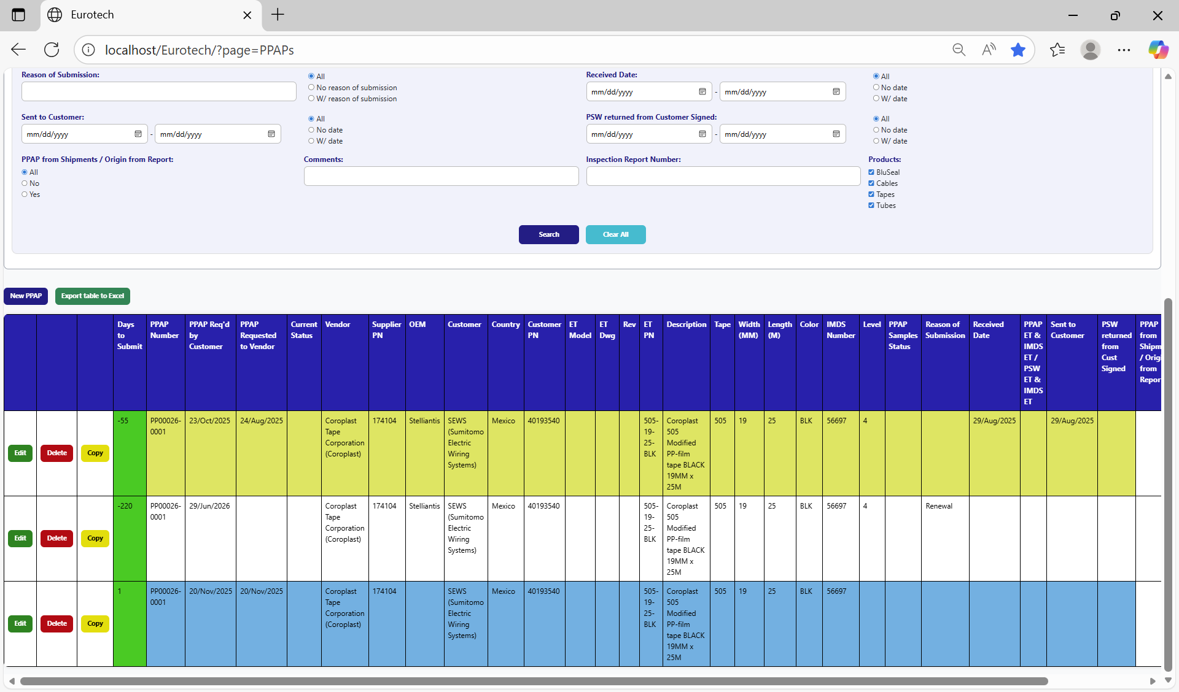

### *3.3.9 Duplicating Register Alert.*

If you were trying to register a new PPAP and it shows you a message with the title “Duplicating Register”, is not an error. The page is trying to prevent duplicate registers by verifying if there is another register in which the fields “Customer”, “Country”, “Customer PN” and “ET PN” match with the data of the new PPAP and its dates are between 10 months before the “PPAP Req'd by Customer” date of the new PPAP and that same date, or if there is a future renewal register that already exists, it will show its renewal date, and it will ask you if you are sure to register the PPAP.

This is an example of the “Duplicating Register” alert:

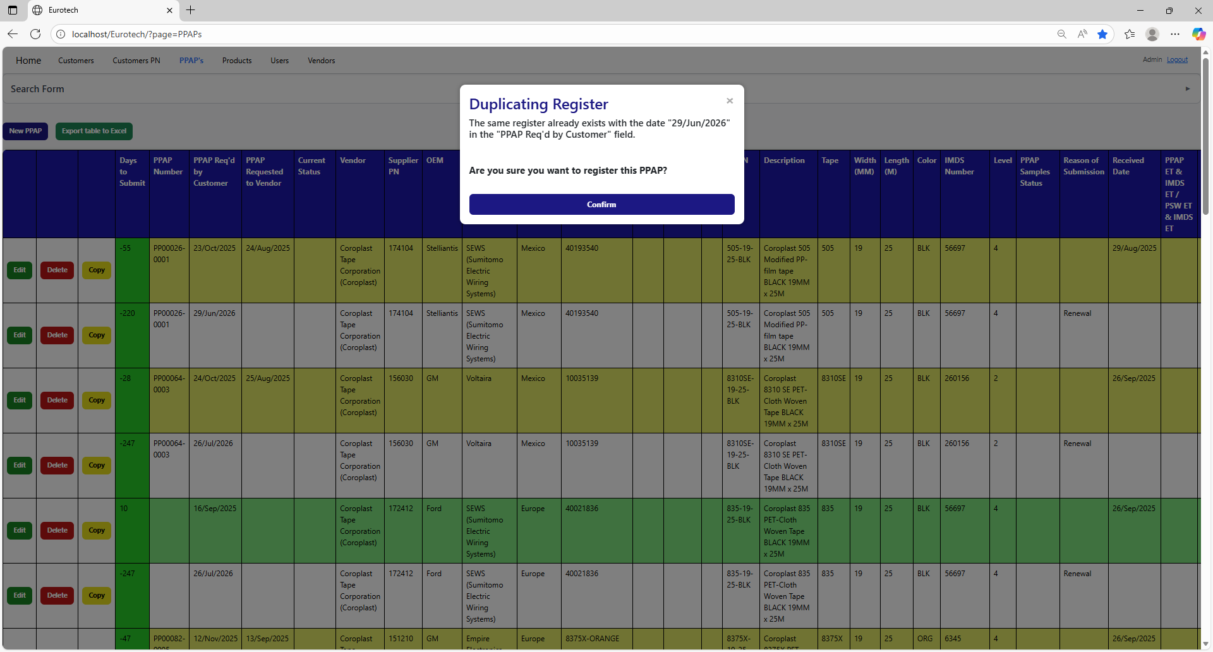

Once you are sure to register the PPAP, you must click the “Confirm” button.



### *3.3.10 How to Check the “PPAP ET” & “IMDS ET” of a BluSeal PPAP.*

To check the “PPAP ET” and “IMDS ET” of a BluSeal PPAP, you must click the “Note” button that is in the “PPAP ET & IMDS ET / PSW ET & IMDS ET” field (the button only appears on registers that have a date in the “Received Date” field).

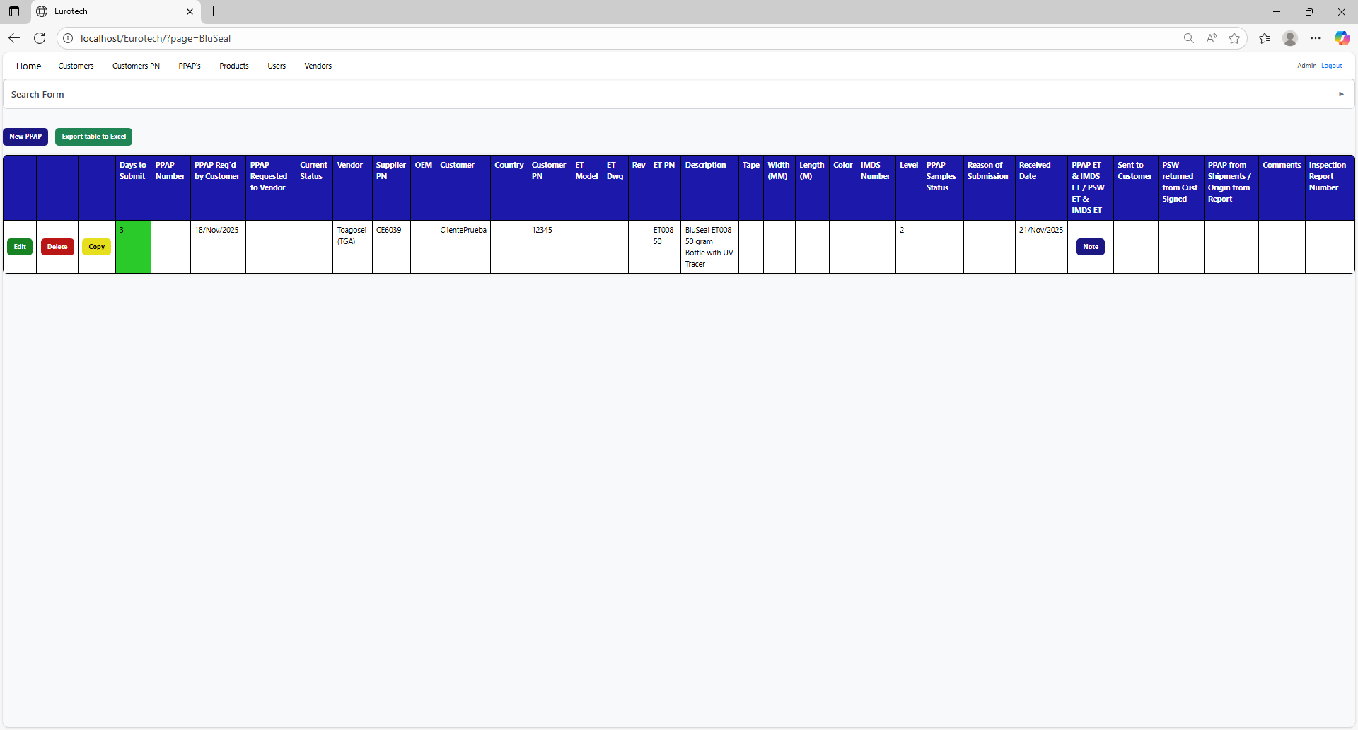

Once you click the “Note” button, it will display a note to check/uncheck the “PPAP ET” and “IMDS ET”.

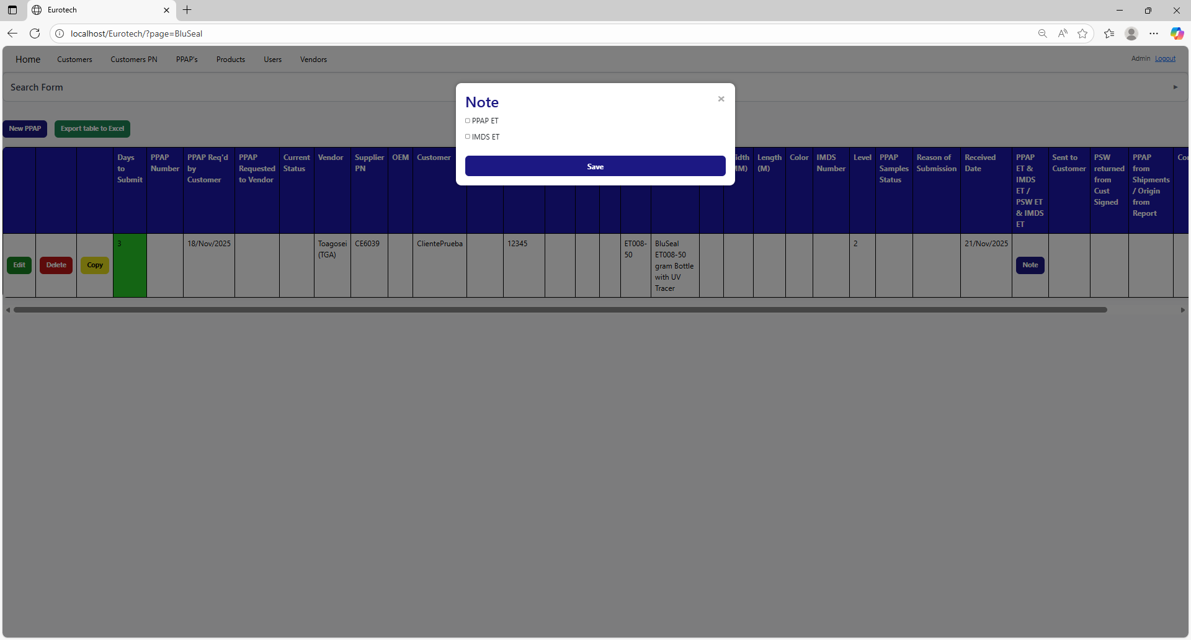

Once you finish to check the fields you need, you must click the “Save” button to save the changes.

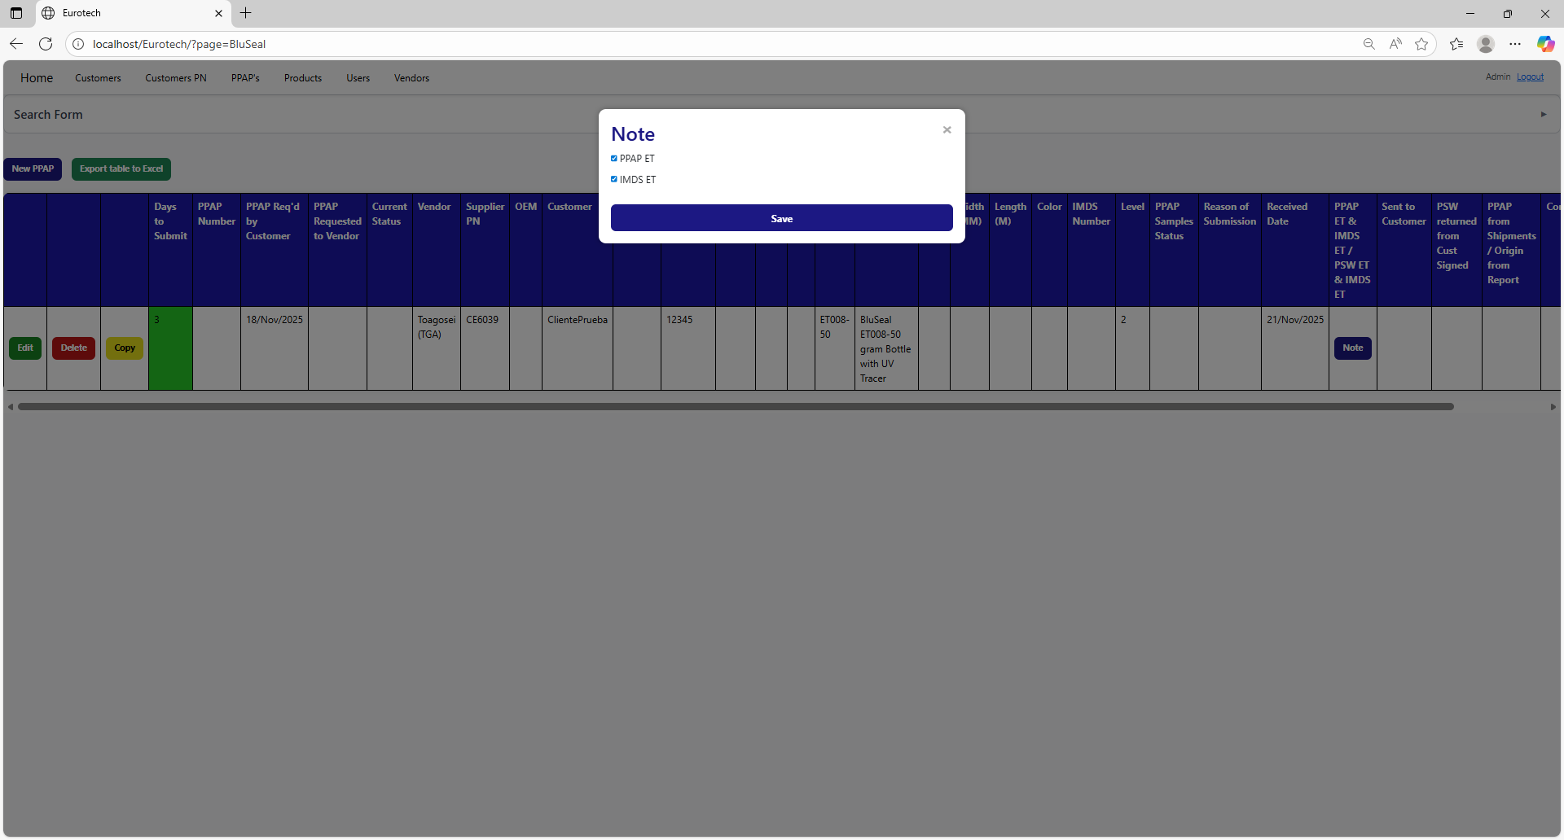

### *3.3.11 How to Check the “PSW ET” & “IMDS ET” of a Cable PPAP.*

To check the “PSW ET” and “IMDS ET” of a Cable PPAP, you must click the “Note” button that is in the “PPAP ET & IMDS ET / PSW ET & IMDS ET” field (the button only appears on registers that have a date in the “Received Date” field).

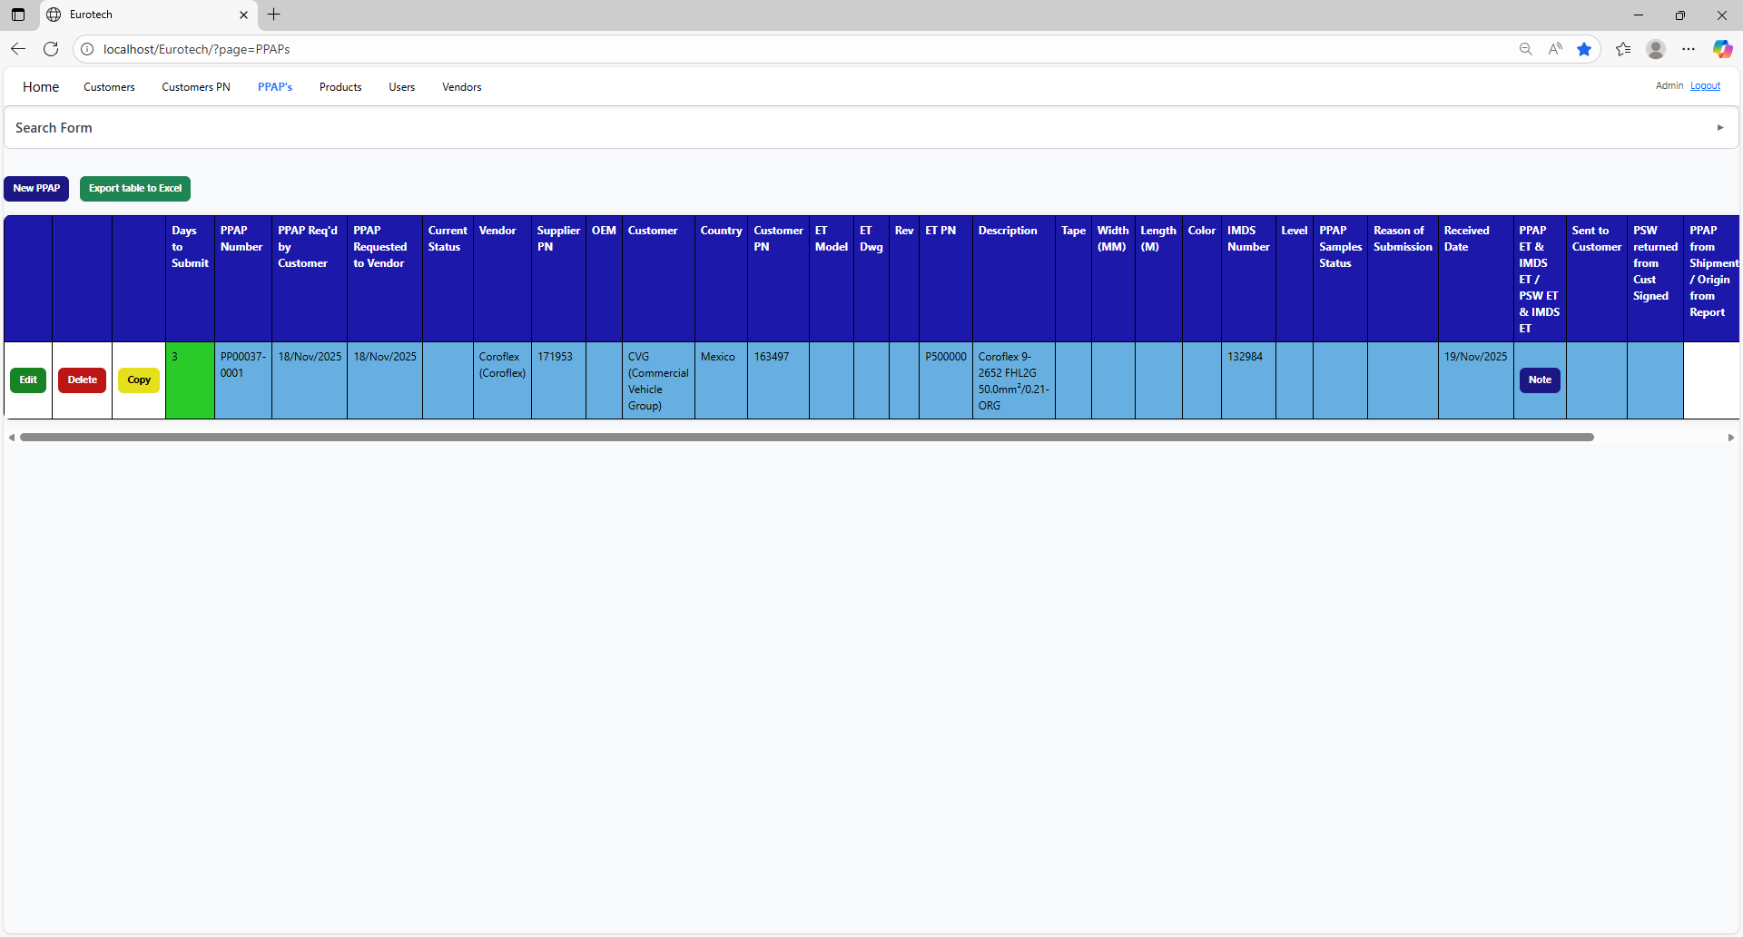

Once you click the “Note” button, it will display a note to check/uncheck the “PSW ET” and “IMDS ET”.

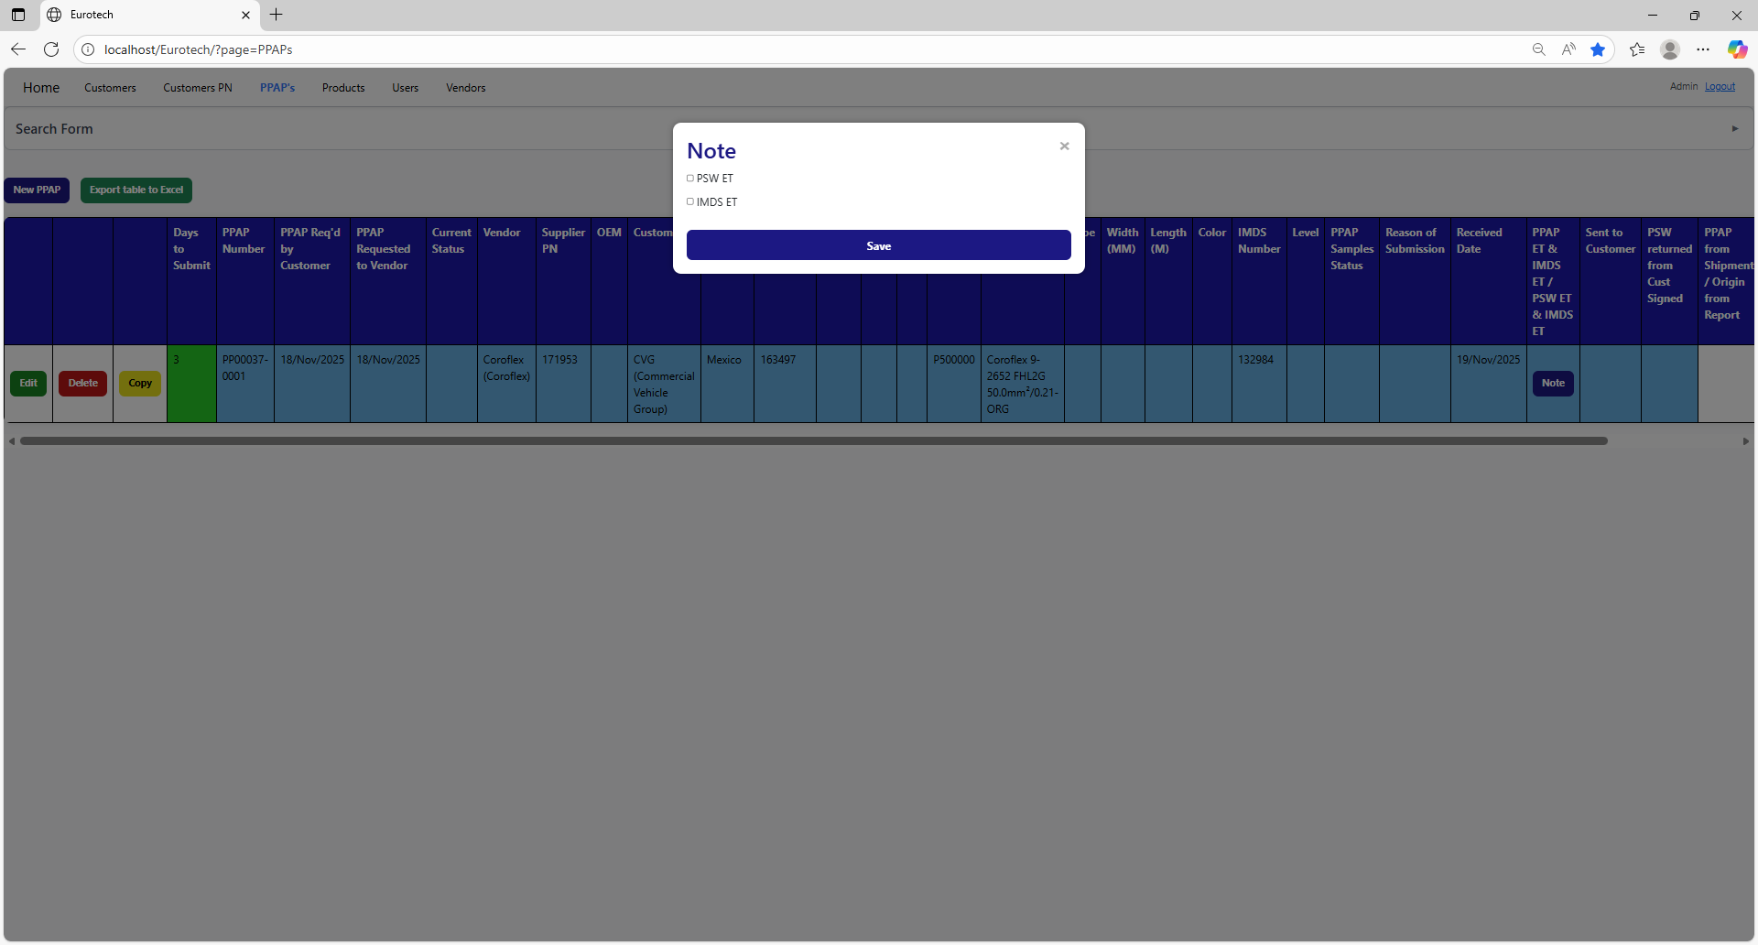

Once you finish to check the fields you need, you must click the “Save” button to save the changes.

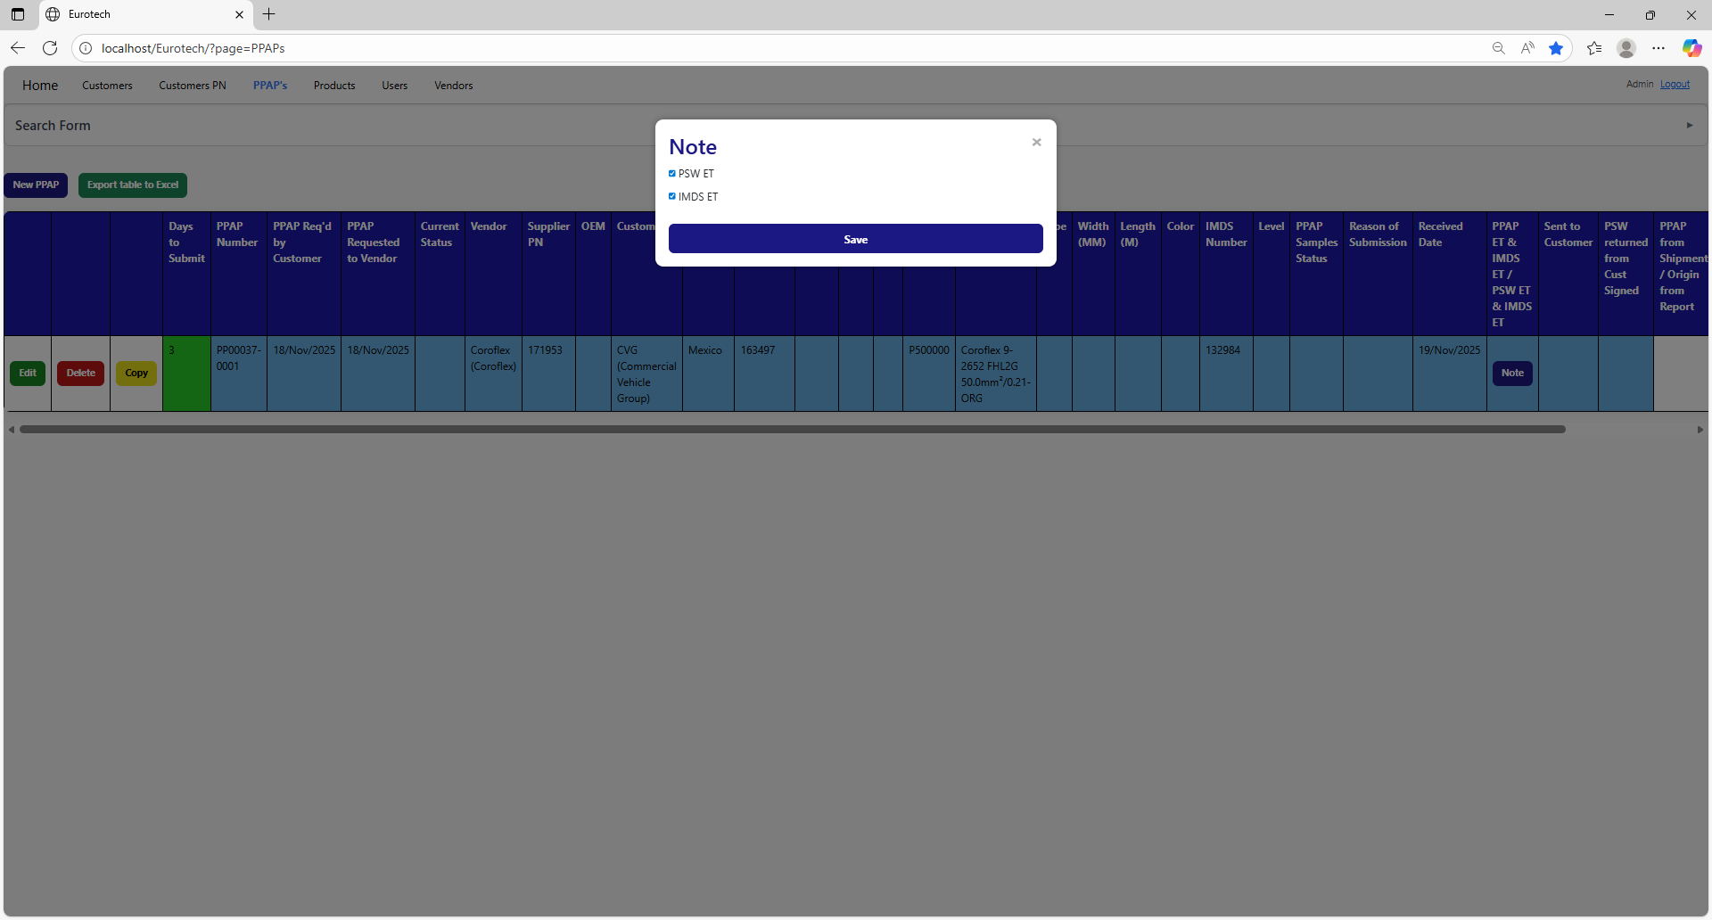

### *3.3.12 How to Export the Information of the Table to an Excel Document.*

To export the table to an Excel document, you must click the “Export table to Excel” button.

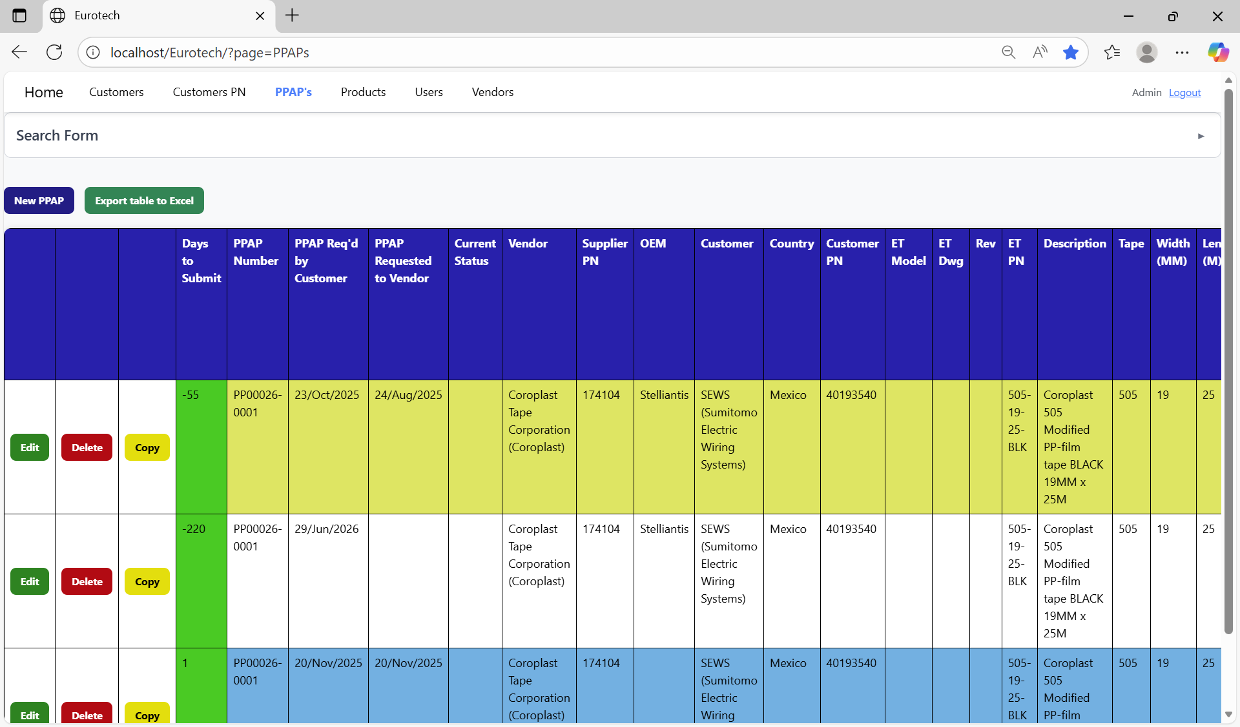

Once you click the “Export table to Excel” button, it will start to download the Excel document with the name “PPAPs_Report.xls”.

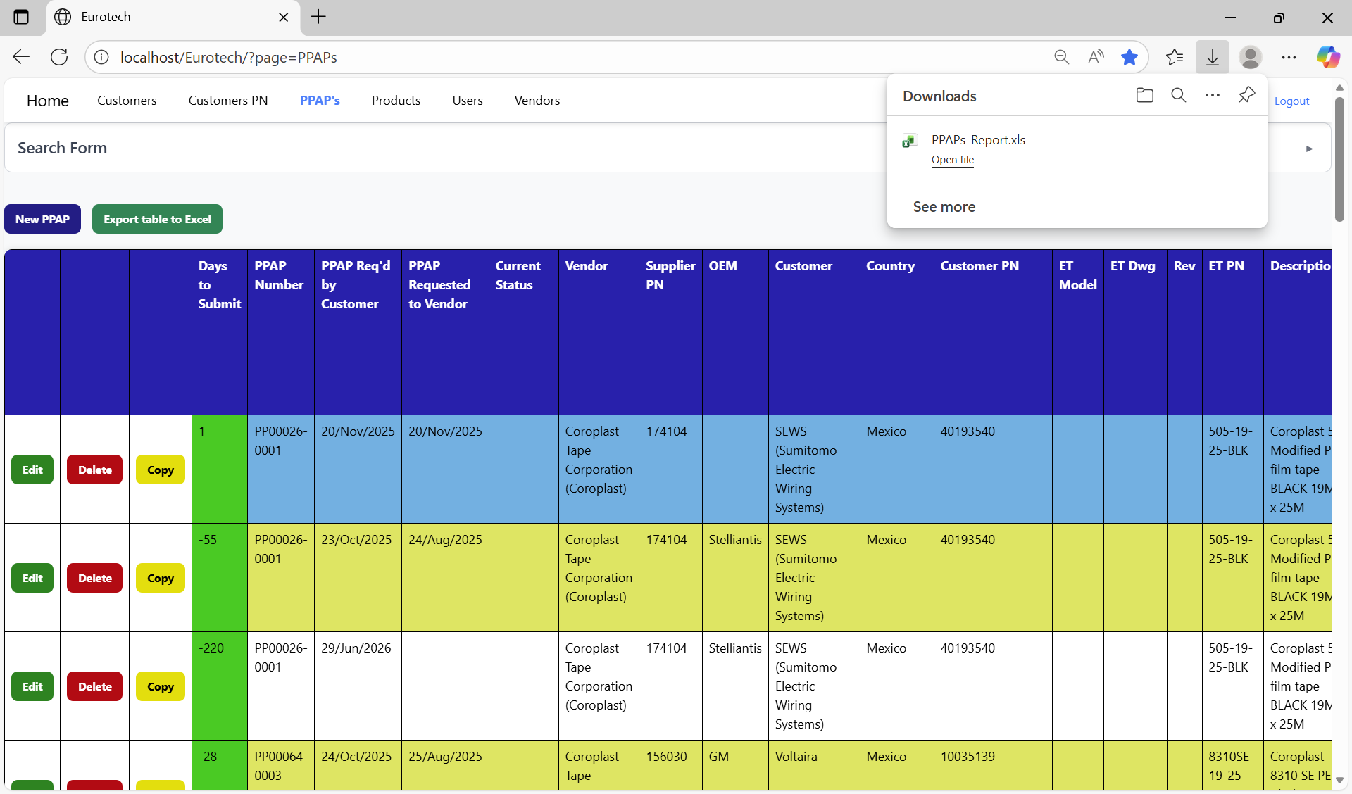

Once the download is finished, you can go to the folder it was downloaded and open the Excel document.

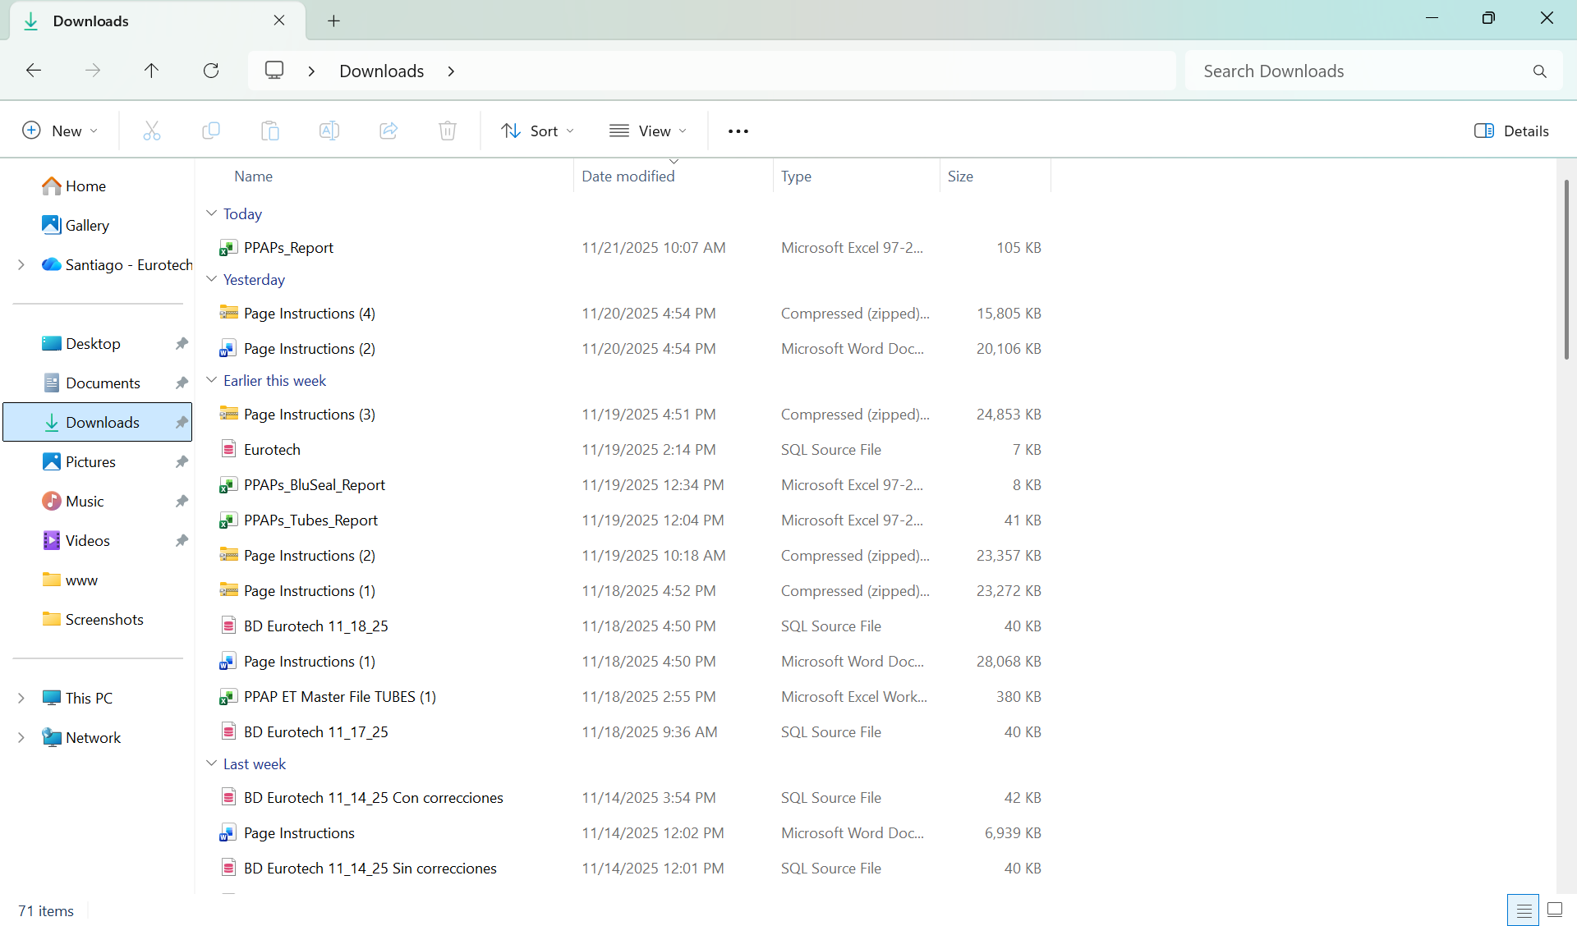

This is an example of how the document would look like:

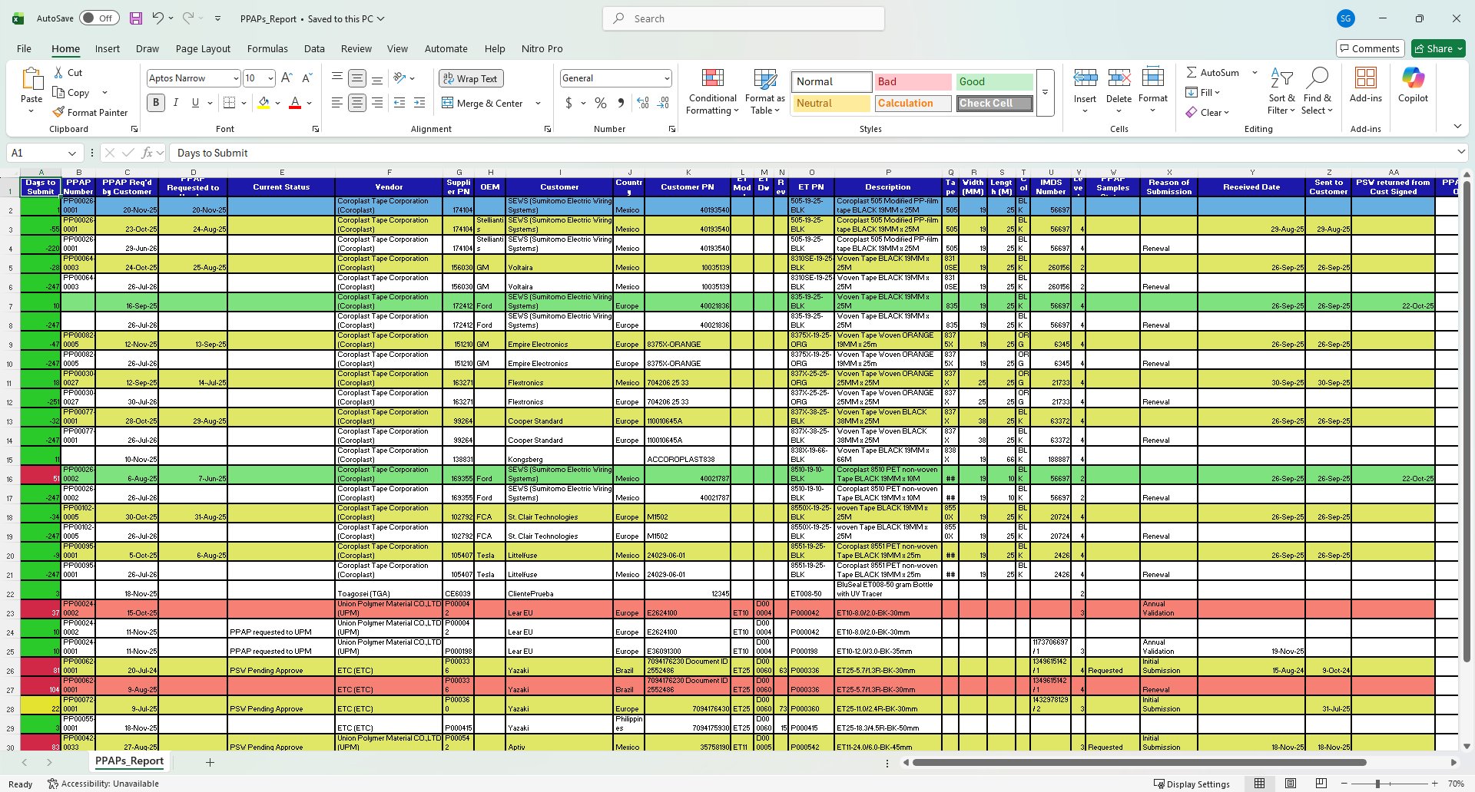

## ***3.4 BluSeal Page.***

### *3.4.1 How to Navigate to “BluSeal” Page.*

On the navigation bar, you can navigate to the “BluSeal” page.

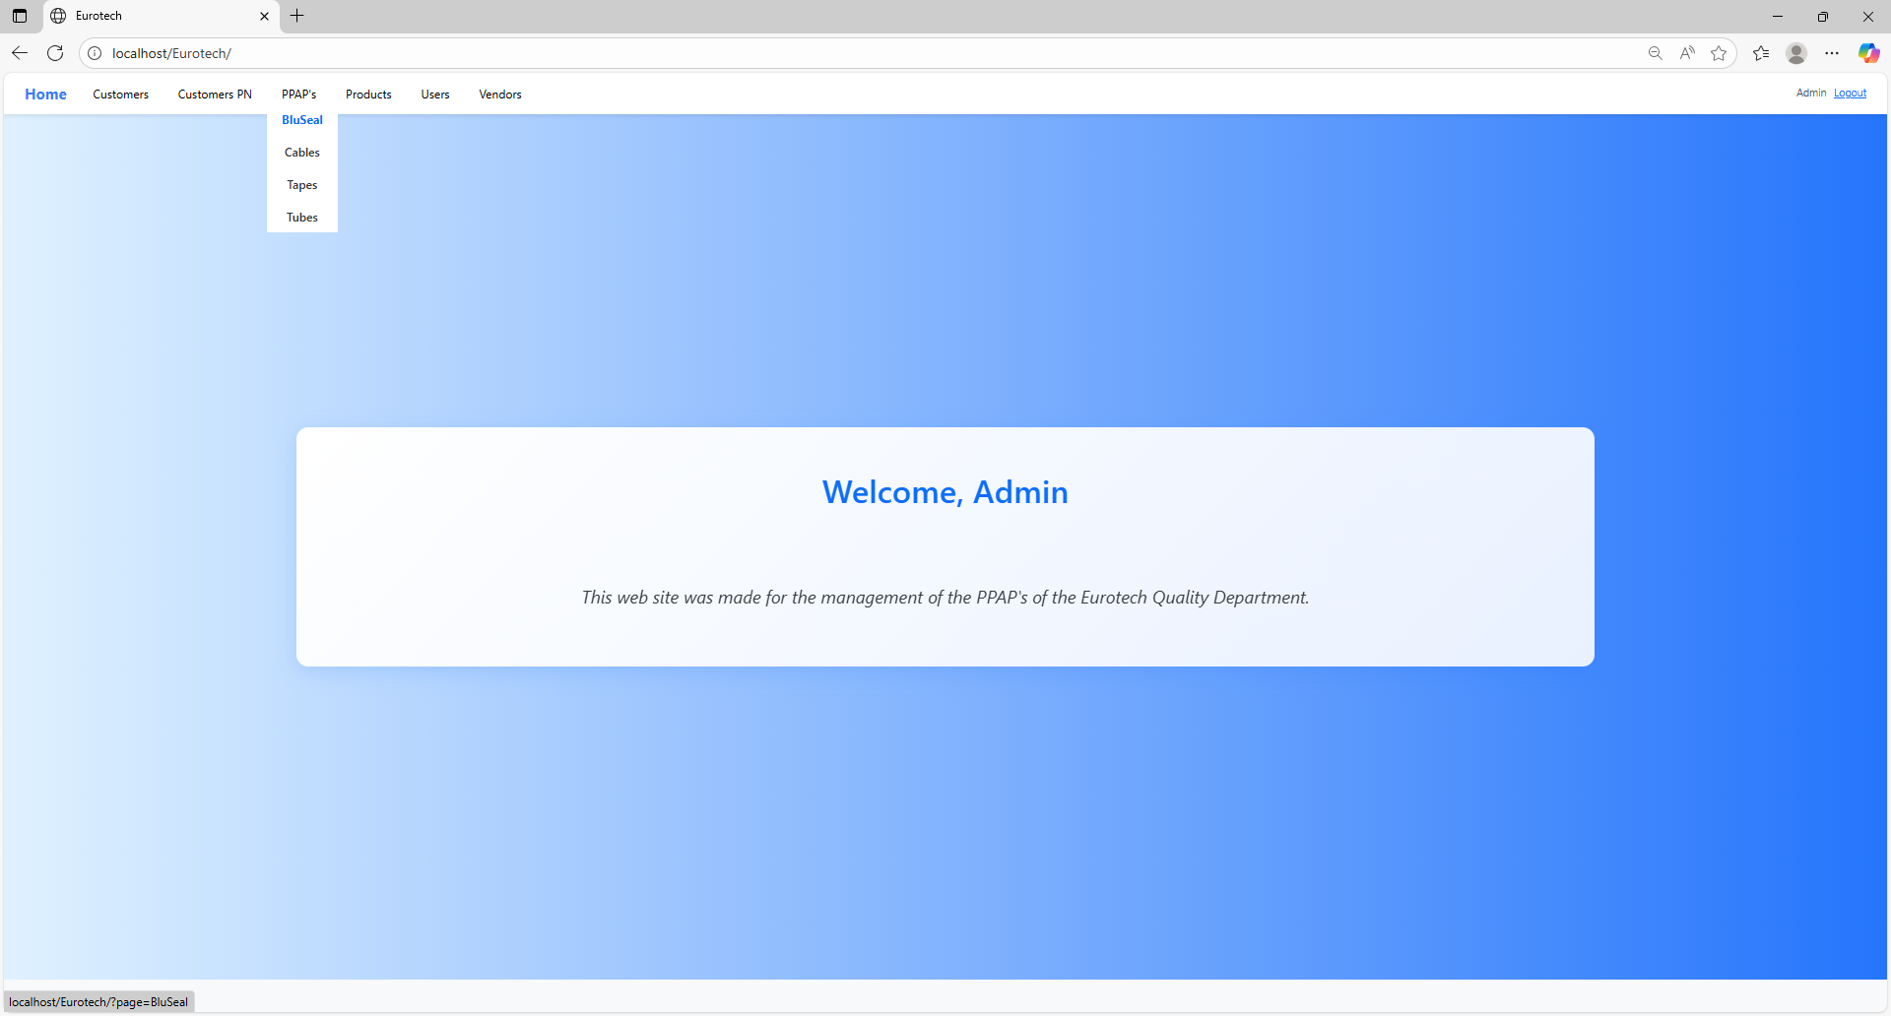

In this page you can manage the registers of all the PPAPs of BluSeal.

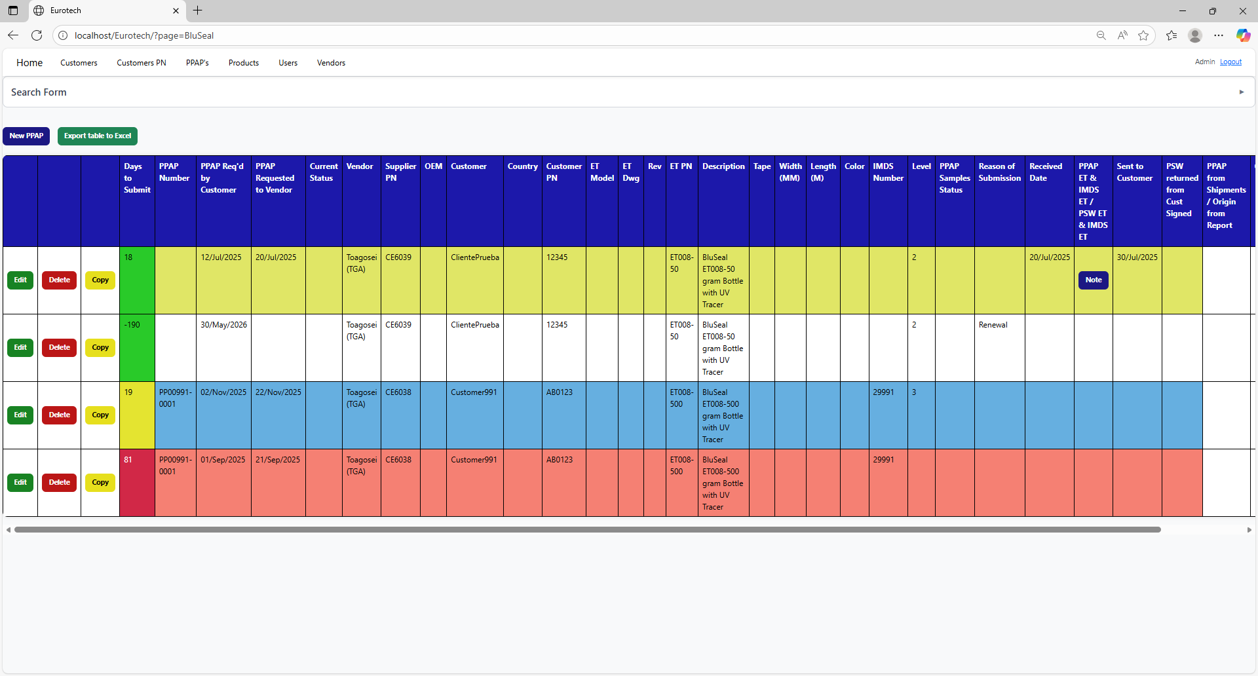

### *3.4.2 How to Search a PPAP.*

At the top of the page, it will be a dropdown “Search Form” that has all the fields of the table for querying registers.

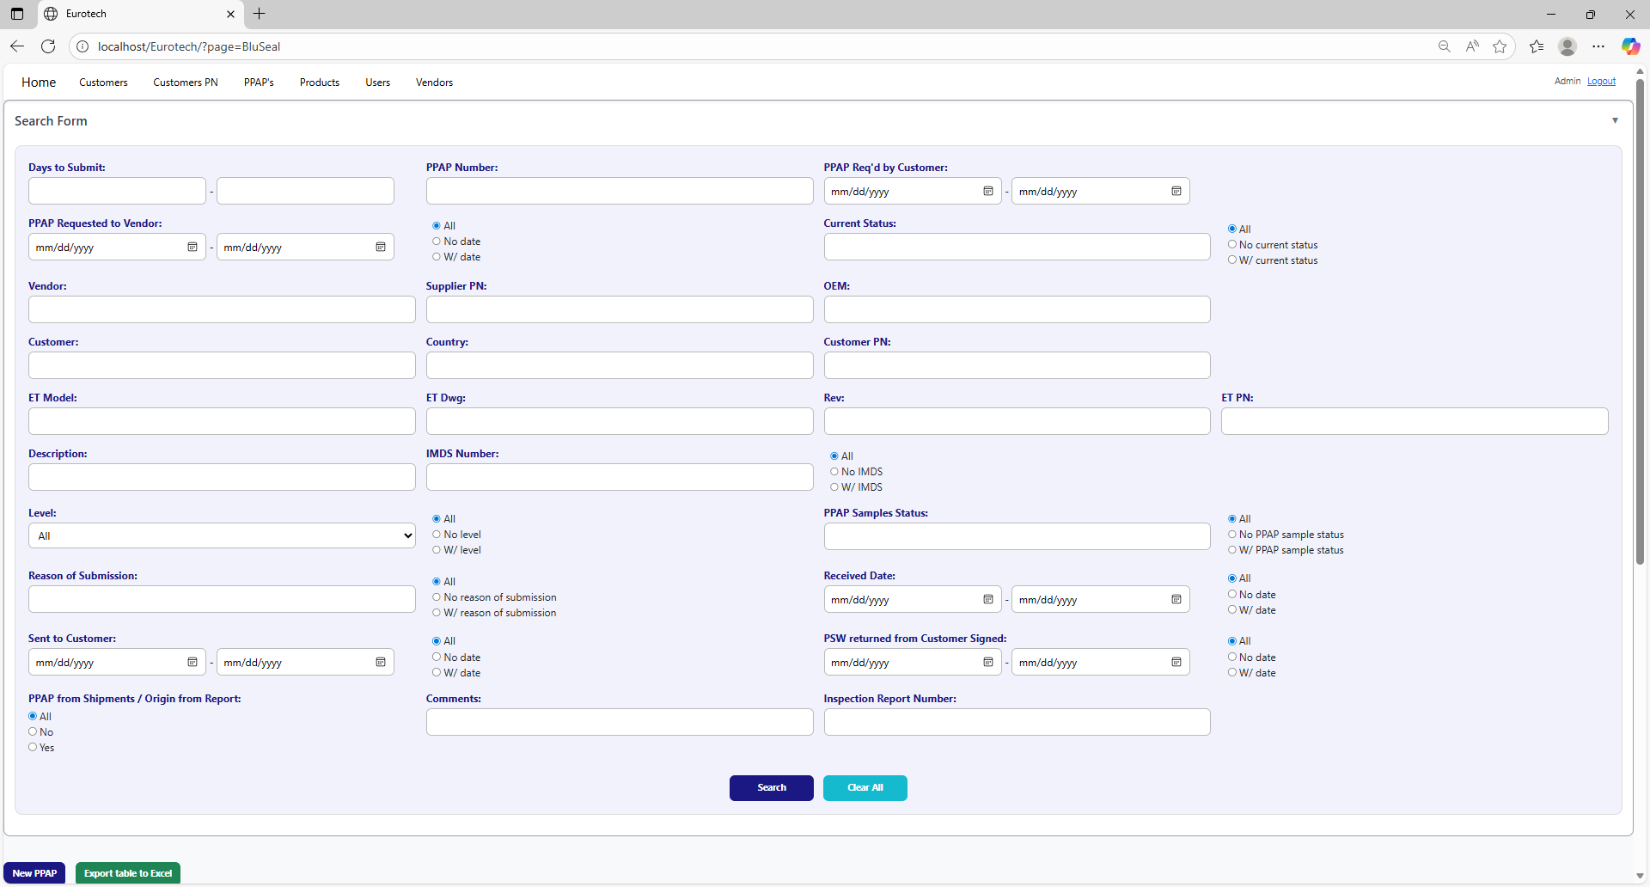

The search form allows you to perform searches by:

* Level
* PPAP Samples Status
* Reason of Submission
* Received Date
* Sent to Customer
* PSW returned from Customer Signed
* PPAP from Shipments / Origin from Report
* Comments
* Inspection Report Number
* Days to Submit
* PPAP Number
* PPAP Req’d by Customer
* PPAP Requested to Vendor
* Current Status
* Vendor
* Supplier PN
* OEM
* Customer
* Country
* Customer PN
* ET Model
* ET Dwg
* Rev
* Eurotech PN
* Description
* IMDS Number

You can search by “Days to Submit”, writing the range of days.

You can search by “PPAP Number”.

You can search by “PPAP Req’d by Customer”, writing the range of dates.



You can search registers that either have or don’t have the “Current Status” field filled in, or all the registers.

You can search by “Current Status”.

You can search registers that either have or don’t have a date on “PPAP Requested to Vendor”, or all the registers.

You can search by “PPAP Requested to Vendor”, writing the range of dates.

You can search by “OEM”.

You can search by “Vendor”.

You can search by “Supplier PN”.



You can search by “Customer PN”.

You can search by “Customer”.

You can search by “Country”.

You can search by “ET PN”.

You can search by “Rev”.

You can search by “ET Dwg”.

You can search by “ET Model”.



You can search registers that either have or don’t have the “IMDS Number” field filled in, or all the registers.

You can search by “IMDS Number”.

You can search by “Description”.

You can search by “PPAP Samples Status”.

You can search by “Level”.

You can search registers that either have or don’t have the “PPAP Samples Status” field filled in, or all the registers.

You can search registers that either have or don’t have the “Level” field filled in, or all the registers.



You can search registers that either have or don’t have a date on “Received Date”, or all the registers.

You can search by “Received Date”, writing the range of dates.

You can search registers that either have or don’t have the “Reason of Submission” field filled in, or all the registers.

You can search by “Reason of Submission”.

You can search registers that either have or don’t have a date on “PSW returned from Customer Signed”, or all the registers.

You can search registers that either have or don’t have a date on “Sent to Customer”, or all the registers.

You can search by “PSW returned from Customer Signed”, writing the range of dates.

You can search by “Sent to Customer”, writing the range of dates.



You can search by “Inspection Report Number”.

You can search by “Comments”.

You can search by “PPAP from Shipments / Origin from Report”.

You must click the “Search” button after you fill any of the fields of the “Search Form” to make the search.



This is an example of how the table would look like after a search (the meaning of the colors of the registers will be explained later).



And with the “Clear All” button, you can clean the querying and see all the registers of the PPAPs.



Once you click the “Clear All” button, the fields of the “Search Form” will be empty, and in the table will be shown all the PPAPs.





### *3.4.3 Meaning of the Colors of the Registers.*

1.- In the “Days to Submit” column there will be:

* Registers with green field indicate that the difference between the “PPAP Req’d by Customer” date and the “Sent to Customer” date is less than 19 days (if there is no “Sent to Customer” date yet, it is compared with the current date).



* Registers with yellow field indicate that the difference between the “PPAP Req’d by Customer” date and the “Sent to Customer” date is between 19 and 29 days (if there is no “Sent to Customer” date yet, it is compared with the current date).

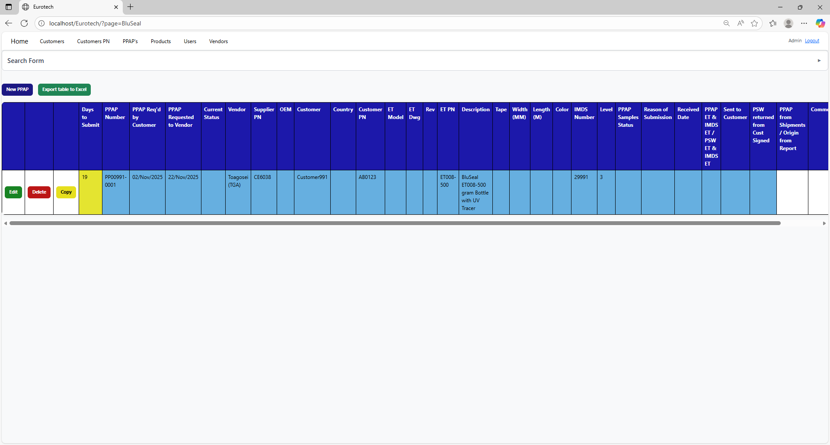

* Registers with red field indicate that the difference between the “PPAP Req’d by Customer” date and the “Sent to Customer” date is greater than 29 days (if there is no “Sent to Customer” date yet, it is compared with the current date).

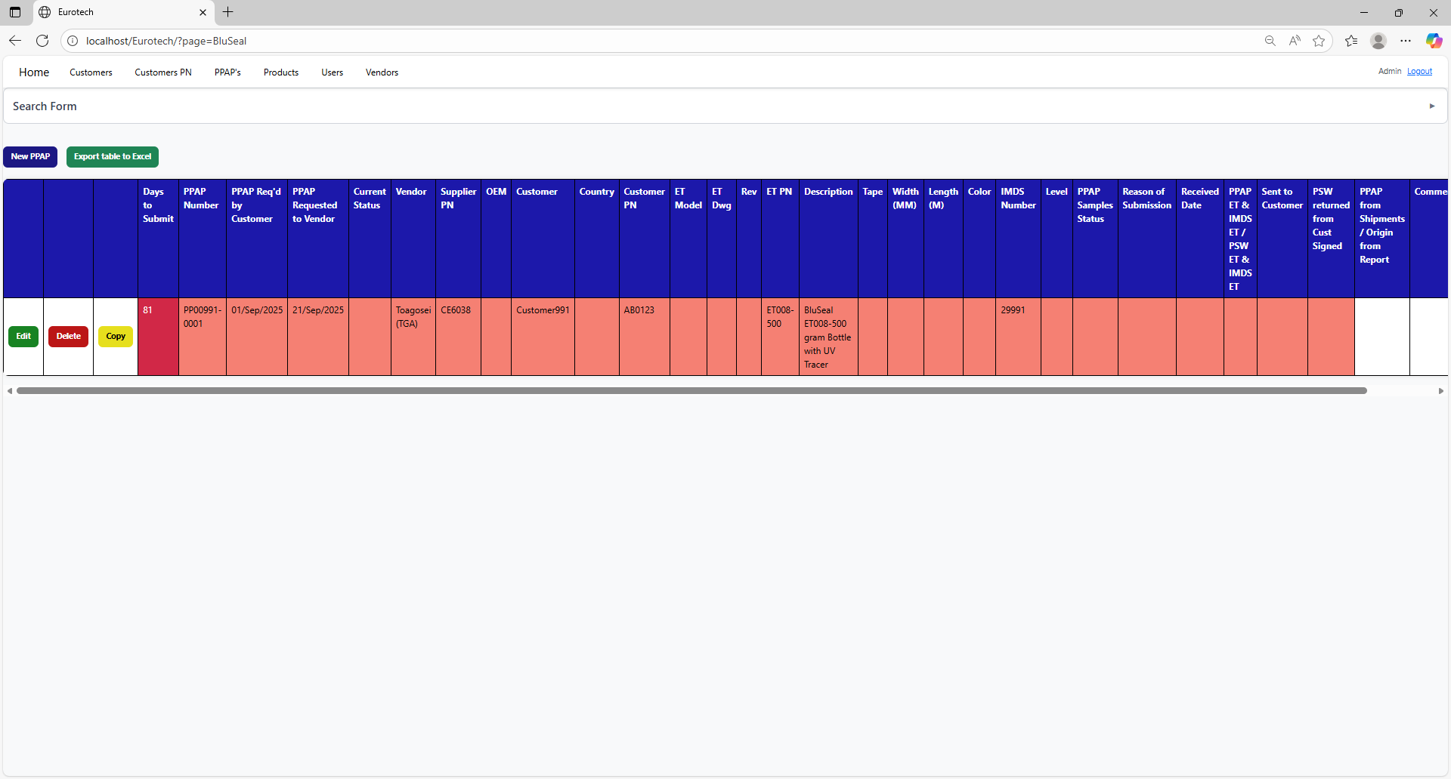

2.- In the rest of the columns of the registers will be:

* Registers with white background indicate that the PPAP has been requested by the customer, the request has not been sent to the vendor, and 30 days have not passed without the documentation being sent to the customer.

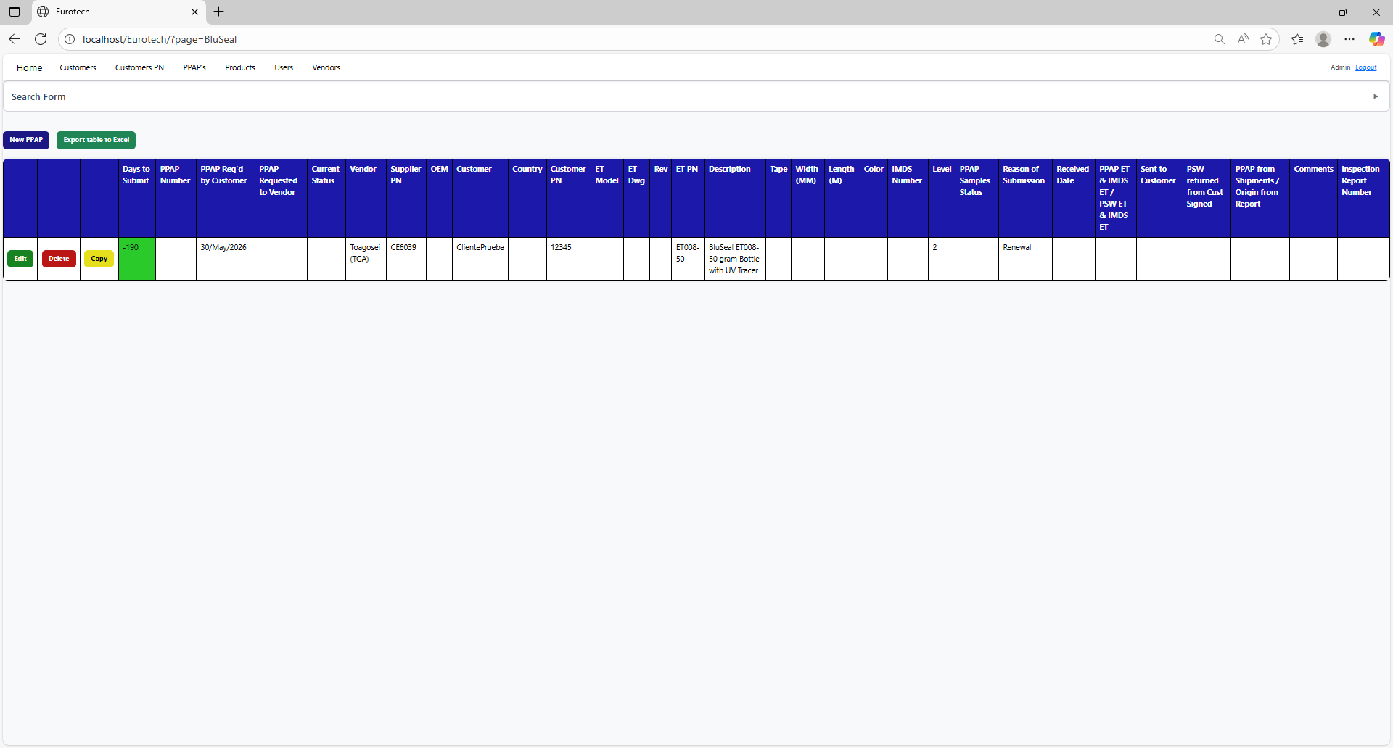

* Registers with blue background indicate that the PPAP has been requested by the customer, the request has been sent to the vendor, and 30 days have not passed without the documentation being sent to the customer.

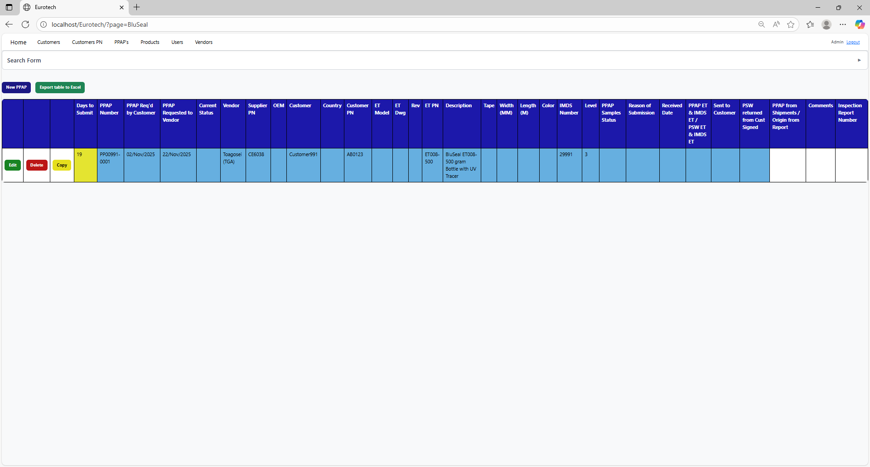

* Registers with red background indicate that the PPAP has been requested by the customer, and the 30-day limit has passed without the documentation being sent to the customer.

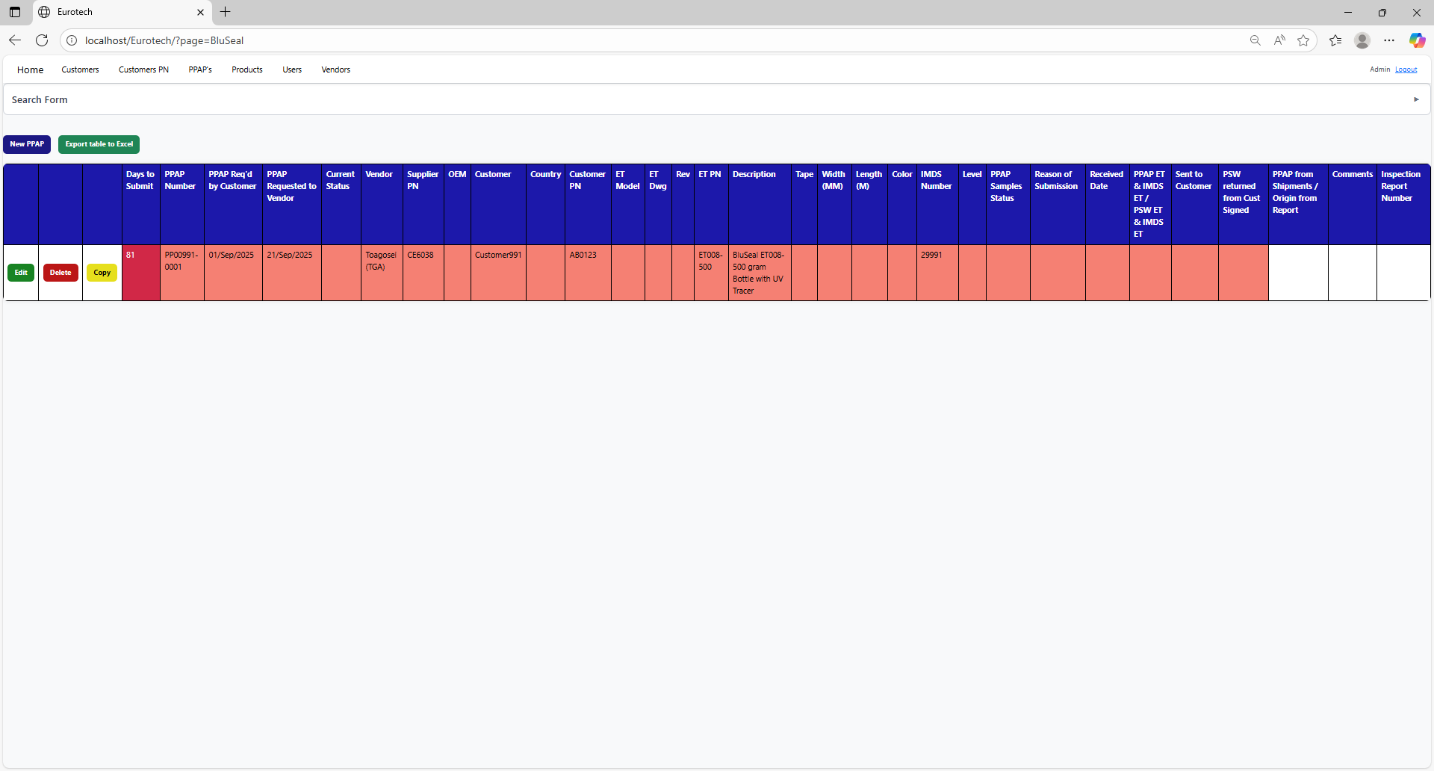

* Registers with yellow background indicate that the PPAP has been sent to the customer, and the PSW has not been returned signed by the customer.



* Registers with green background indicate that the PSW has been returned signed by the customer.

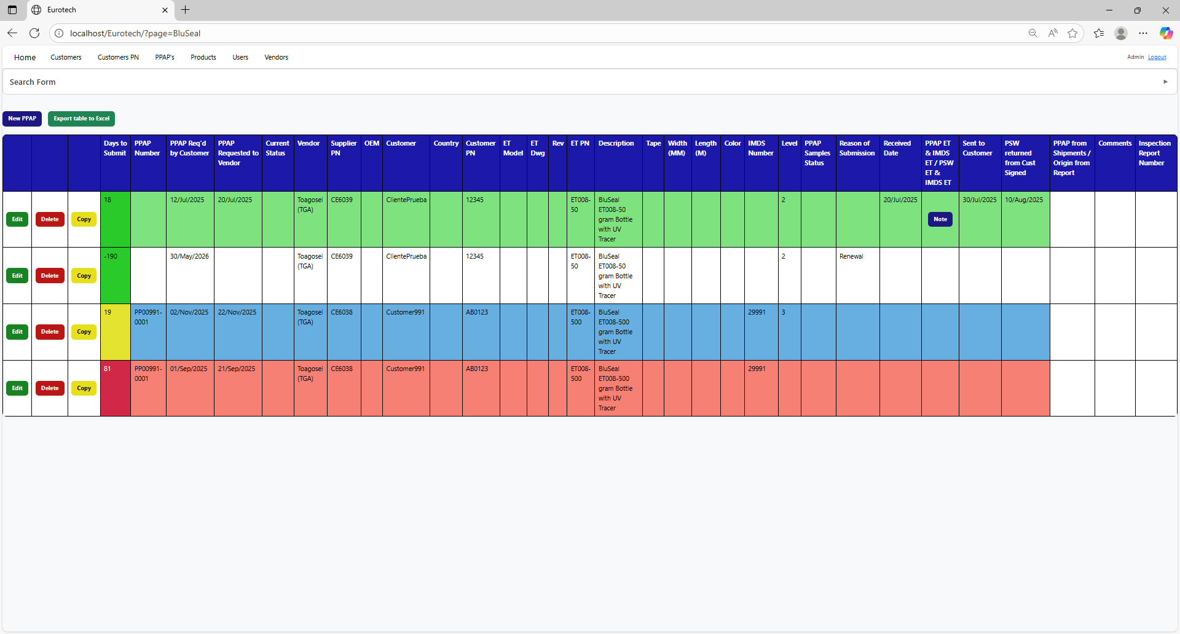

### *3.4.4 How to Add a New PPAP.*

If you want to add a new PPAP, you must click the “New PPAP” button that is below the “Search Form”.

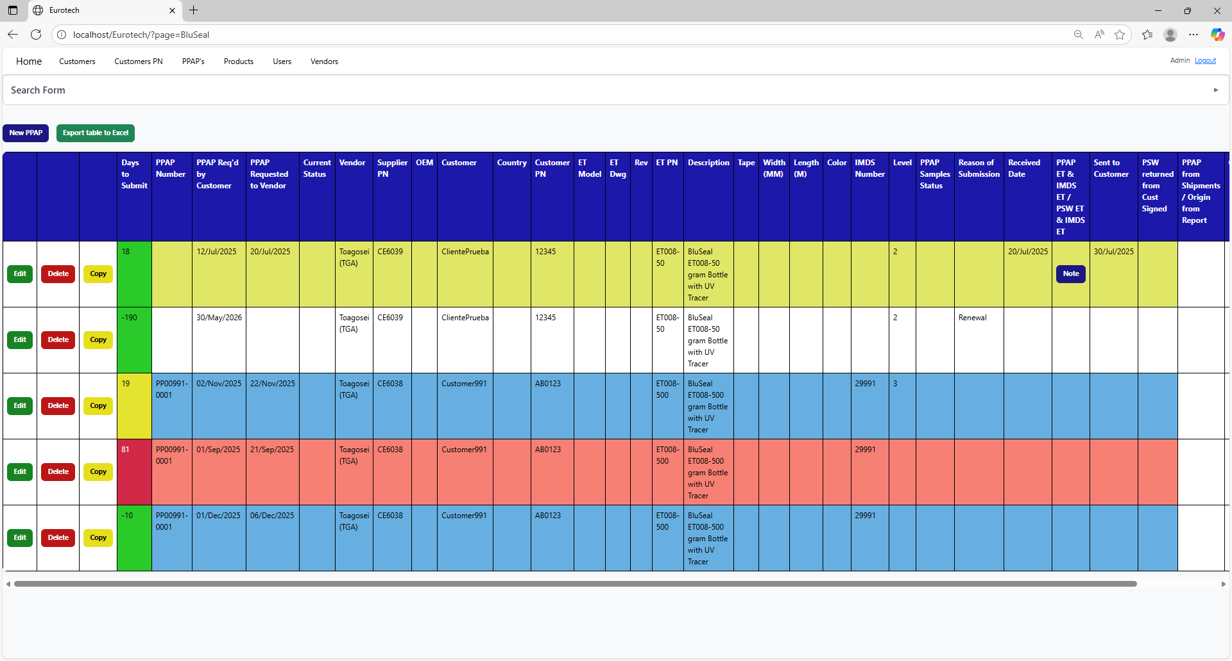

Once you click the “New PPAP” button, it will display a register form to create a new PPAP.



Non-mandatory field

Mandatory fields



Non-mandatory field

If you want to save the register of a new PPAP, you must click the “Save” button.

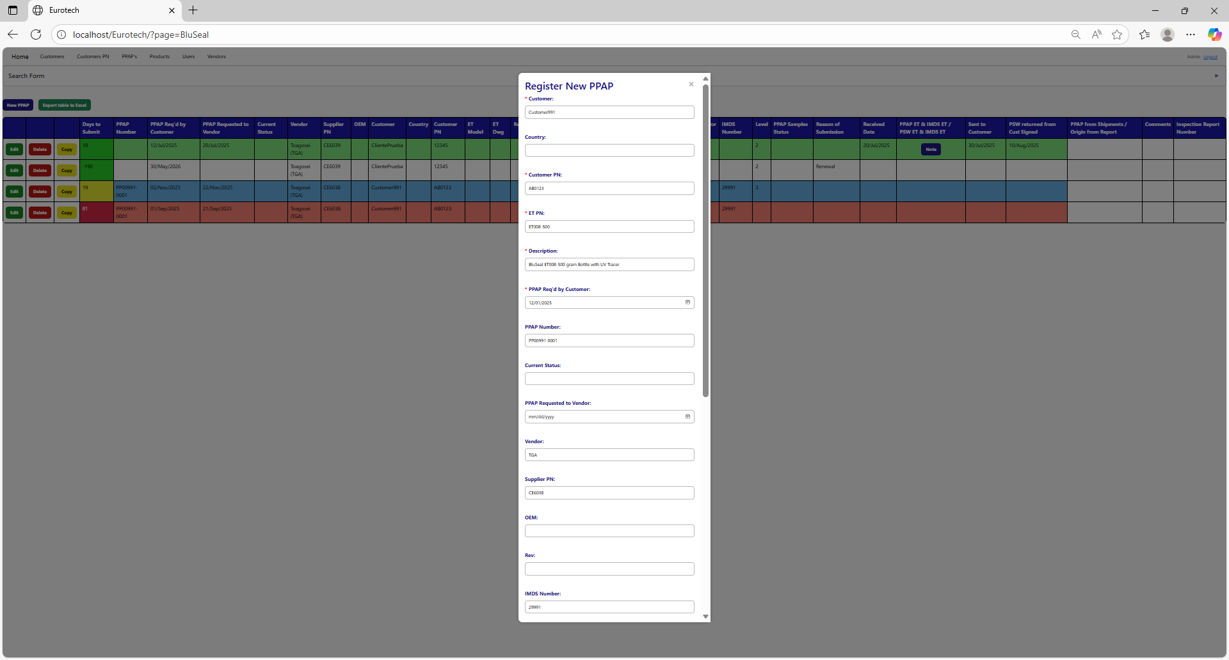



If no errors are found, the register will be added successfully.

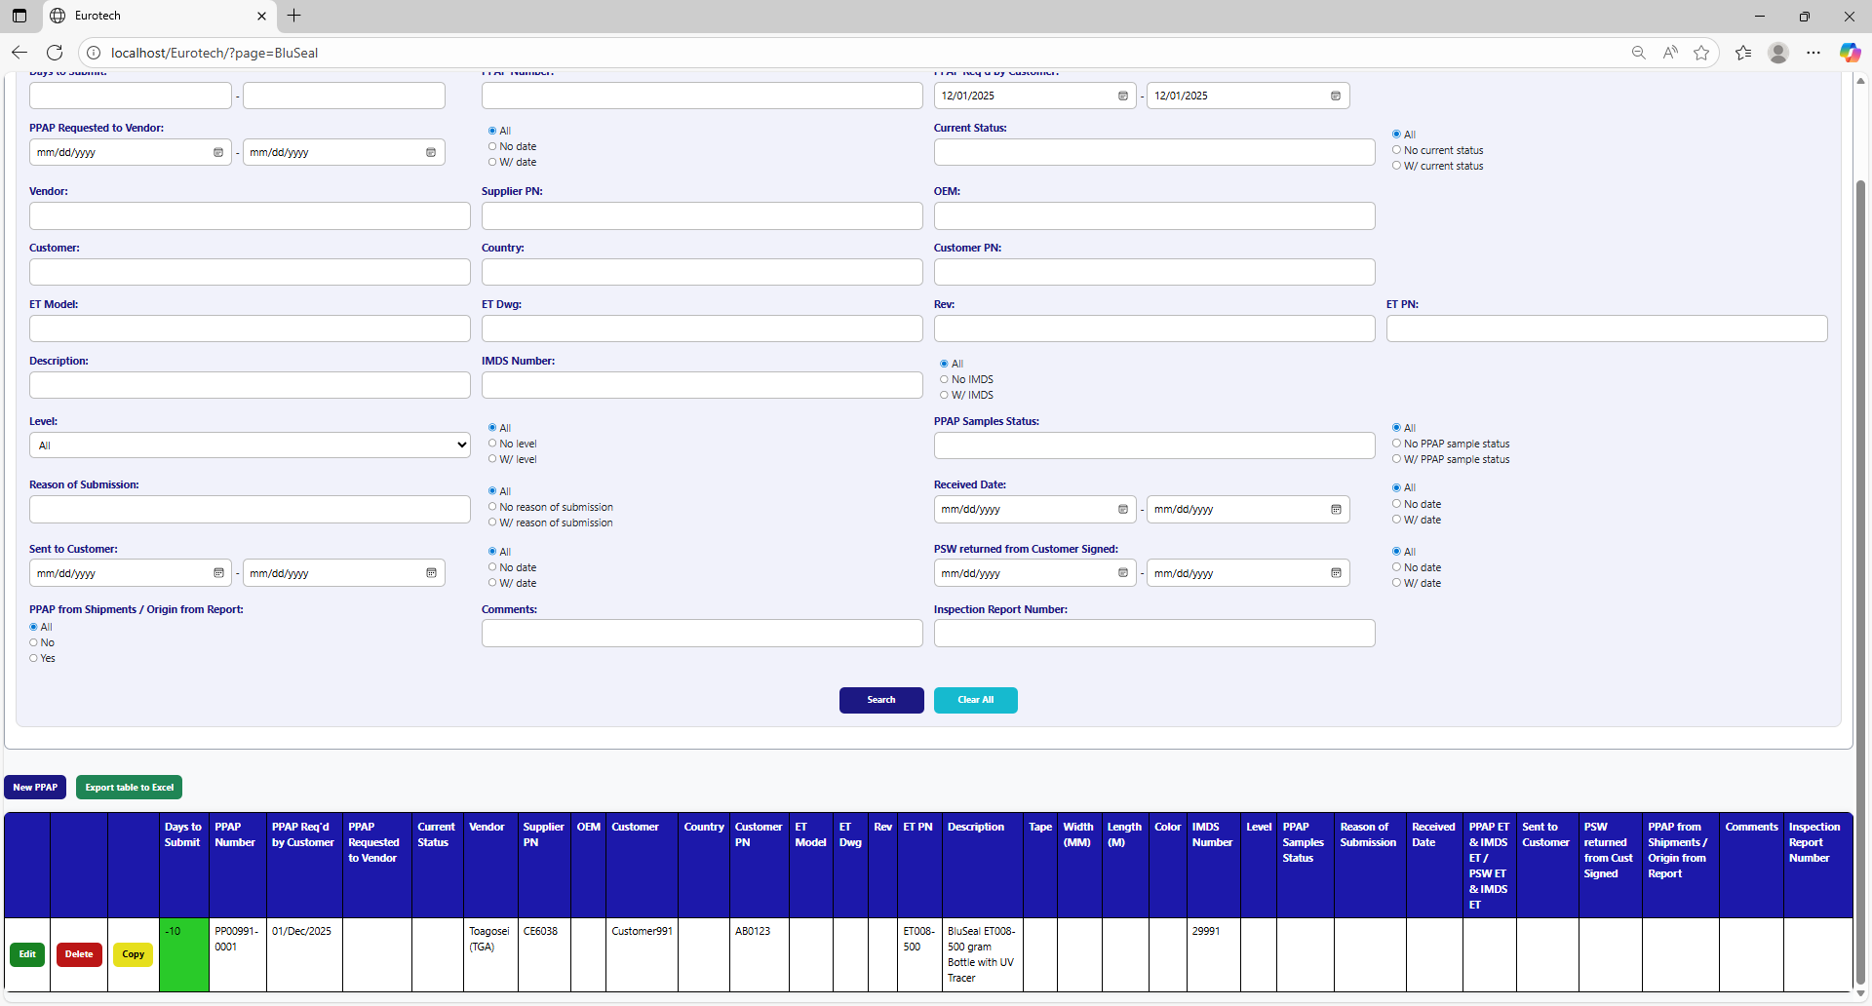

If an error is found, you can check in the Index the instruction *3.11.3.1 Register Form Errors.*

### *3.4.5 How to Edit Information of a PPAP.*

In each register from the table, it will be an “Edit” button. If this button is clicked, it will display an update form to edit the information of the selected PPAP.



Once you click the “Edit” button, it will display an update form to edit the information of the selected PPAP.

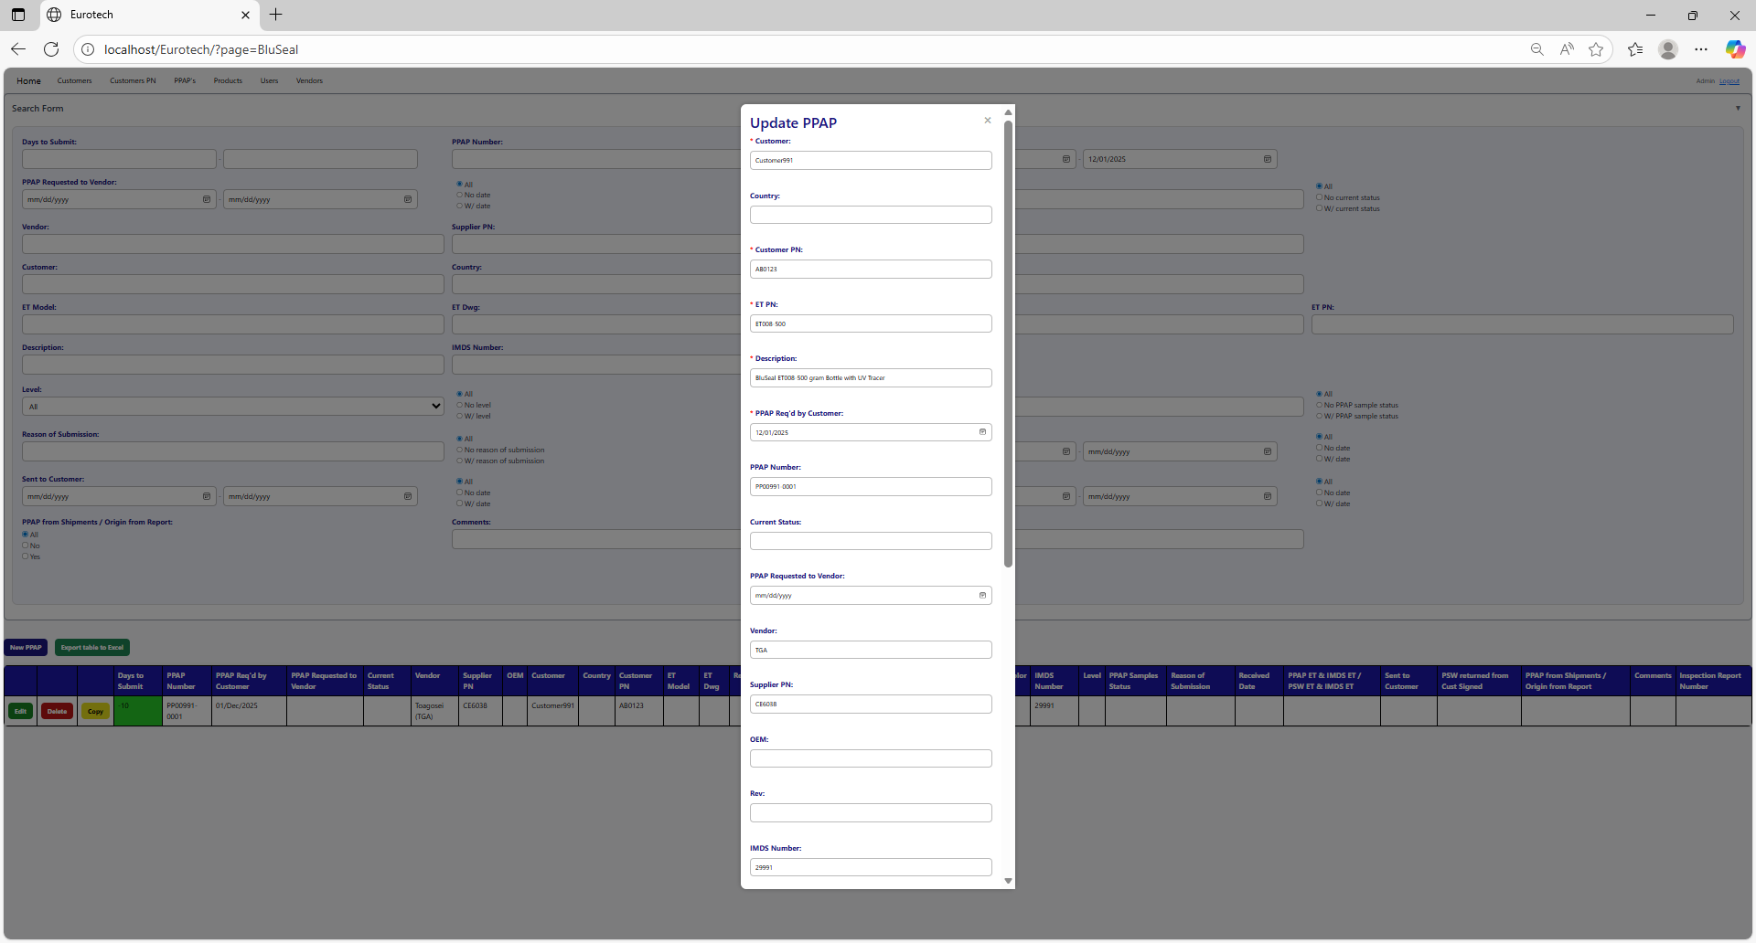



Example of a modification:

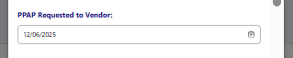

To save the changes, you must click the “Save” button.



If no errors are found, the register will be updated successfully.

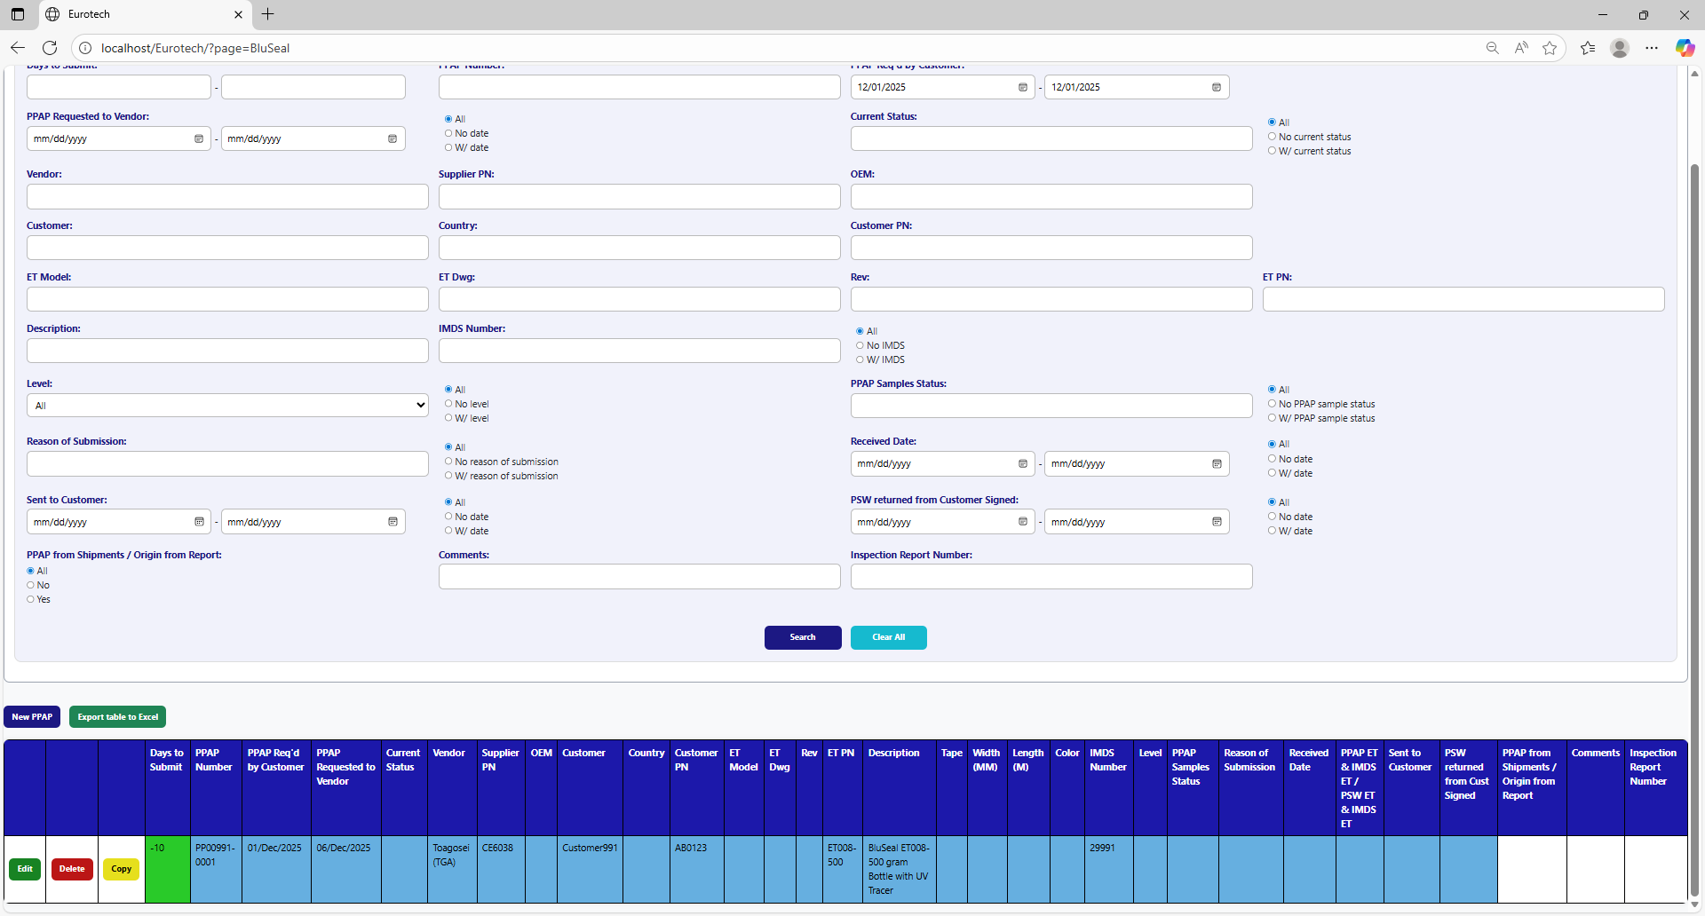

If an error is found, you can check in the Index the instruction *3.11.3.2 Edit Form Errors.*

### *3.4.6 How to Copy the Information of a PPAP.*

In each register from the table, it will be a “Copy” button. You must click the “Copy” button of the register you want to copy its information.



Once you click the “Copy” button, it will display the register form, but with the information of the PPAP selected.

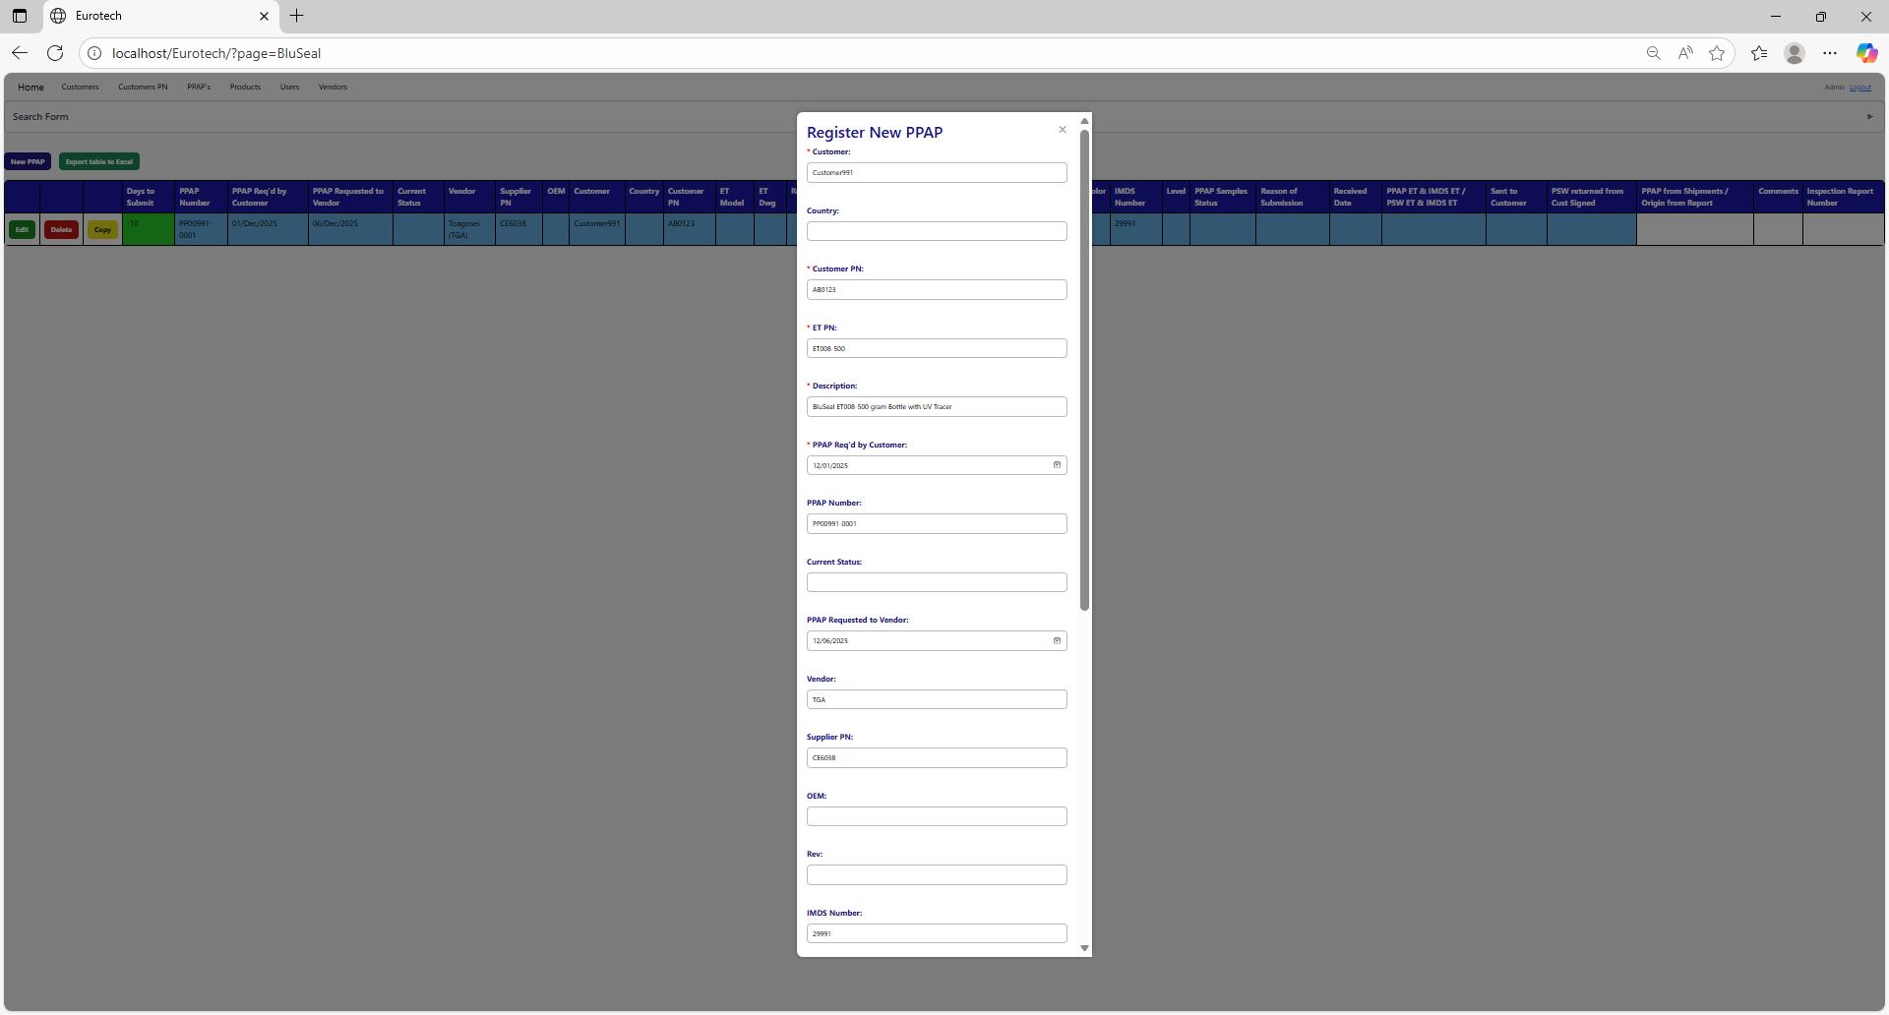

You can do the modifications you need to the information and use the “Save” button to save the new register.



### *3.4.7 How to Delete a PPAP.*

In each register from the table, it will be a “Delete” button. You must click the “Delete” button of the register you want to delete.



Once you click the “Delete” button, it will display the information of the selected PPAP with a message to confirm the delete action. To confirm the delete of the PPAP, you must click the “Confirm” button.

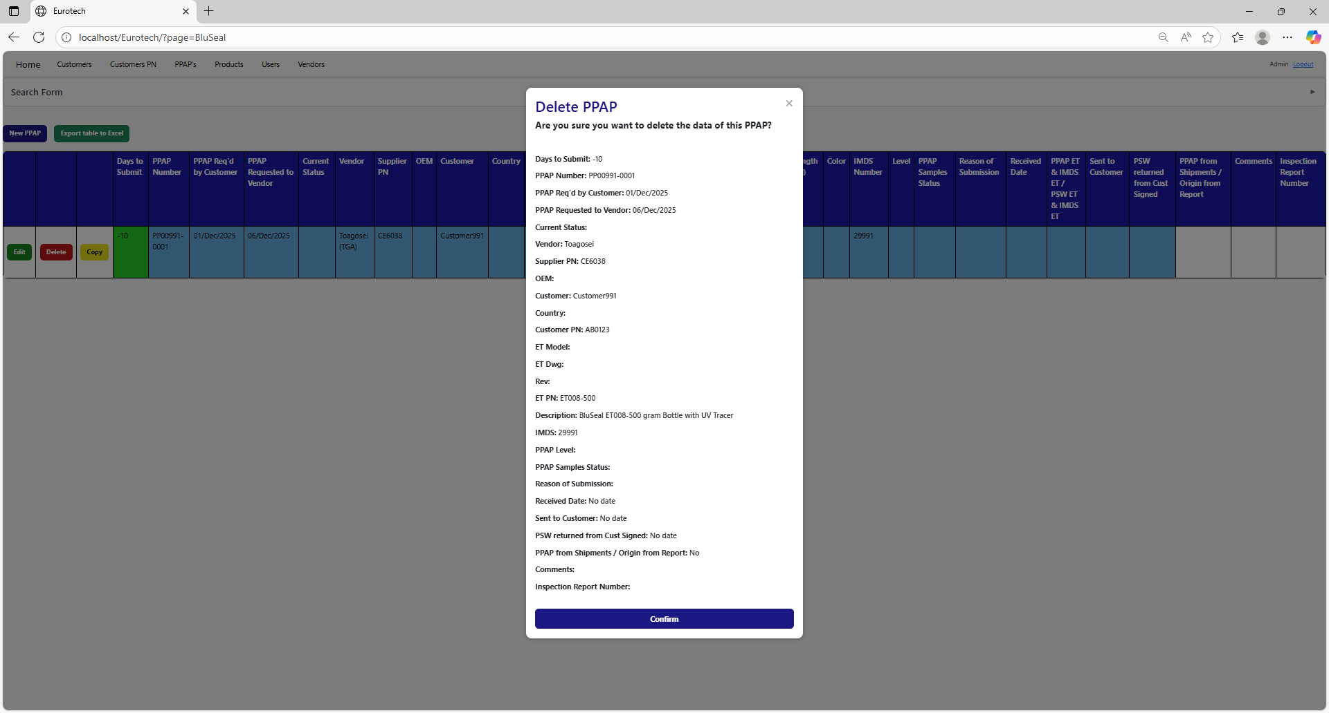

### *3.4.8 How to Automatically Create a Renewal for a PPAP.*

When a PPAP is registered or updated, and the "Sent to Customer" field is filled in, it also creates the register for the following year's renewal, putting the date of "Sent to Customer" in the "PPAP Req'd by Customer" field, adding 10 more months.

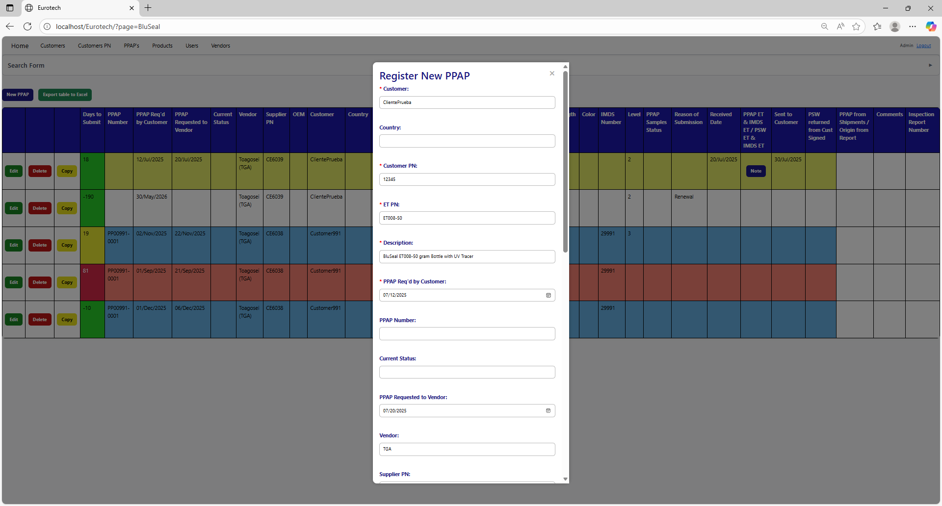

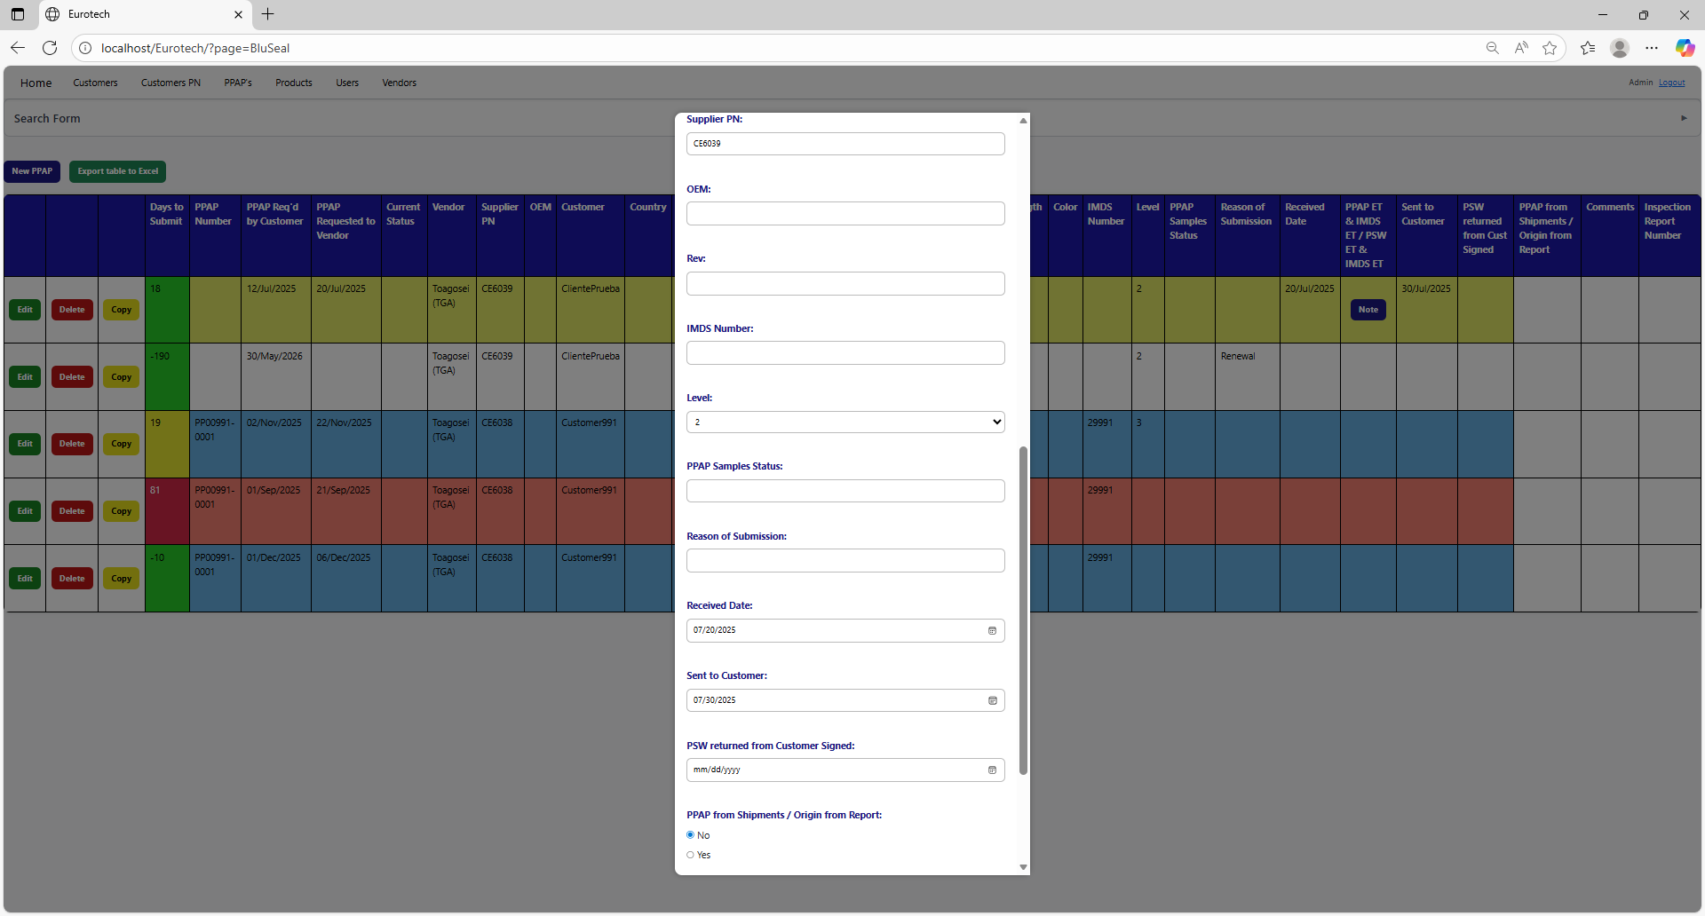



Once you click the “Save” button, the register for the following year's renewal will be created.

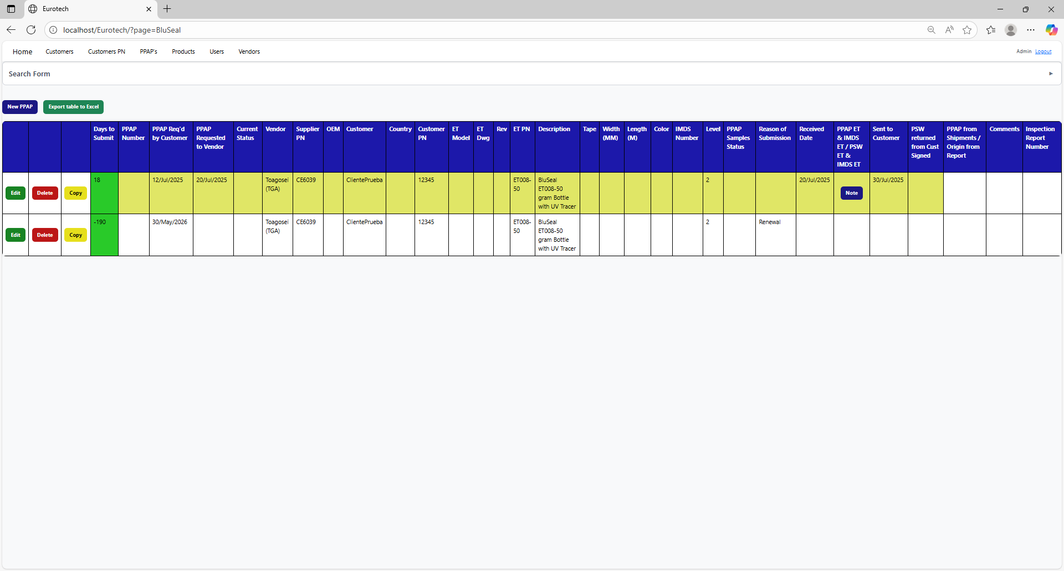

### *3.4.9 Duplicating Register Alert.*

If you were trying to register a new PPAP and it shows you a message with the title “Duplicating Register”, is not an error. The page is trying to prevent duplicate registers by verifying if there is another register in which the fields “Customer”, “Country”, “Customer PN” and “ET PN” match with the data of the new PPAP and its dates are between 10 months before the “PPAP Req'd by Customer” date of the new PPAP and that same date, or if there is a future renewal register that already exists, it will show its renewal date, and it will ask you if you are sure to register the PPAP.

This is an example of the “Duplicating Register” alert:

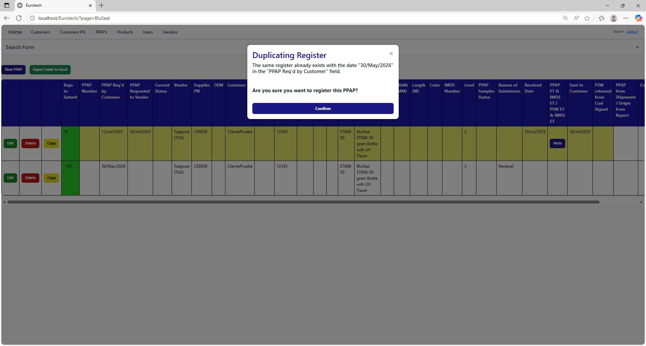

Once you are sure to register the PPAP, you must click the “Confirm” button.



### *3.4.10 How to Check the “PPAP ET” & “IMDS ET” of a PPAP.*

To check the “PPAP ET” and “IMDS ET” of a PPAP, you must click the “Note” button that is in the “PPAP ET & IMDS ET / PSW ET & IMDS ET” field (the button only appears on registers that have a date in the “Received Date” field).

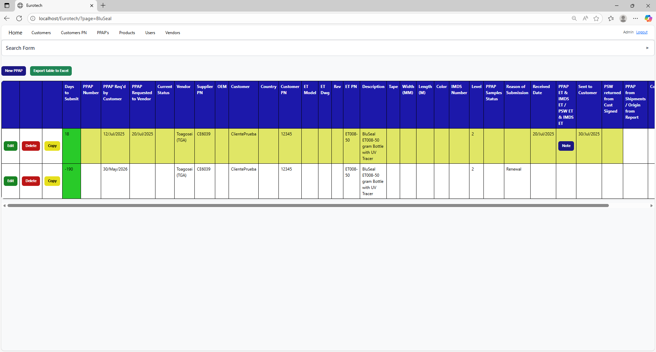

Once you click the “Note” button, it will display a note to check/uncheck the “PPAP ET” and “IMDS ET”.

**

Once you finish to check the fields you need, you must click the “Save” button to save the changes.

**

### *3.4.11 How to Export the Information of the Table to an Excel Document.*

To export the table to an Excel document, you must click the “Export table to Excel” button.

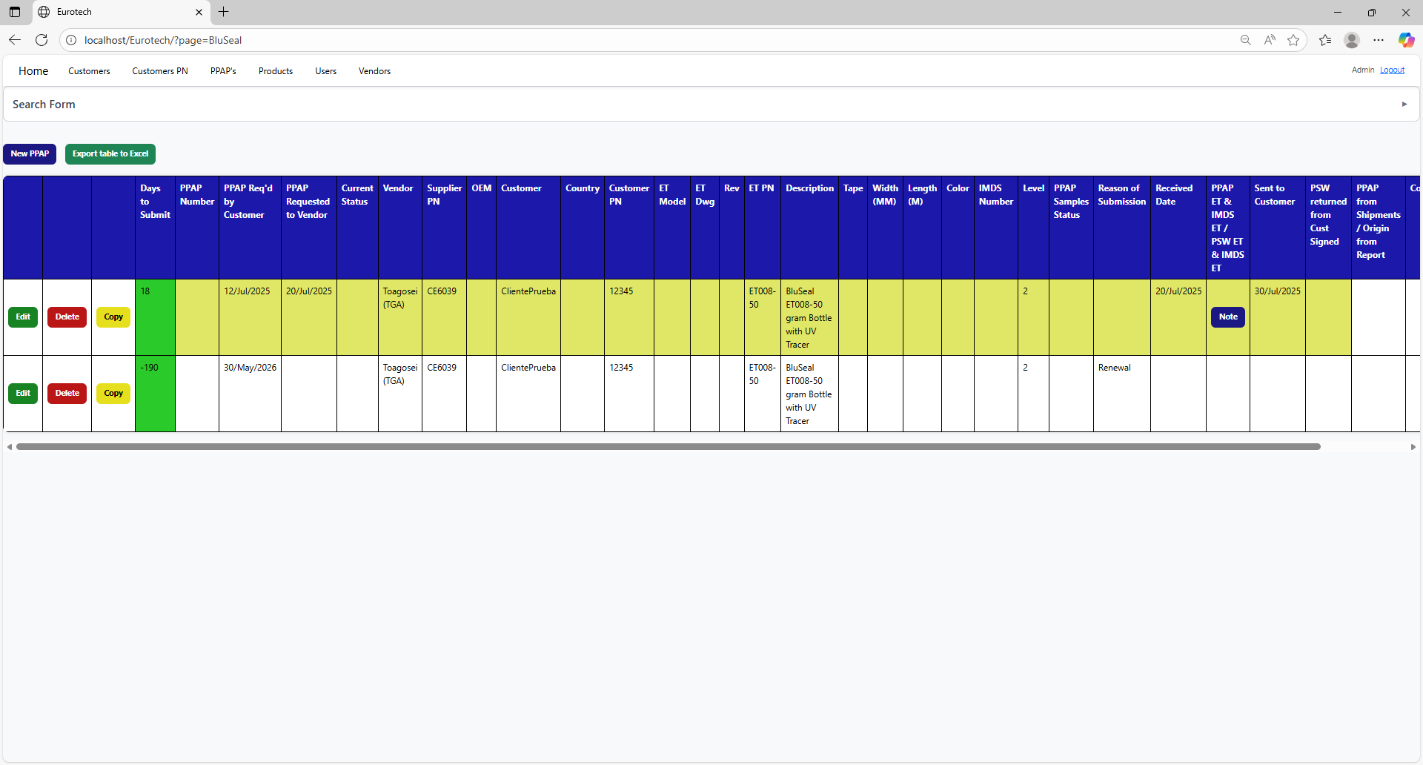

Once you click the “Export table to Excel” button, it will start to download the Excel document with the name “PPAPs_BluSeal_Report.xls”.

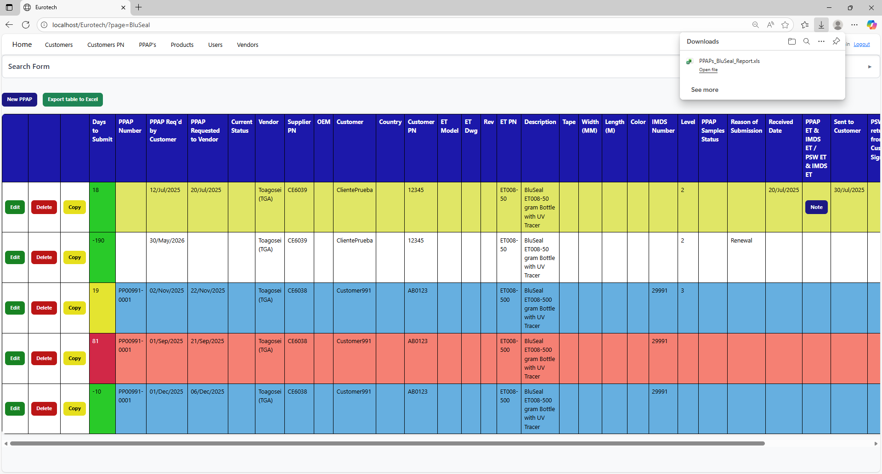

Once the download is finished, you can go to the folder it was downloaded and open the Excel document.

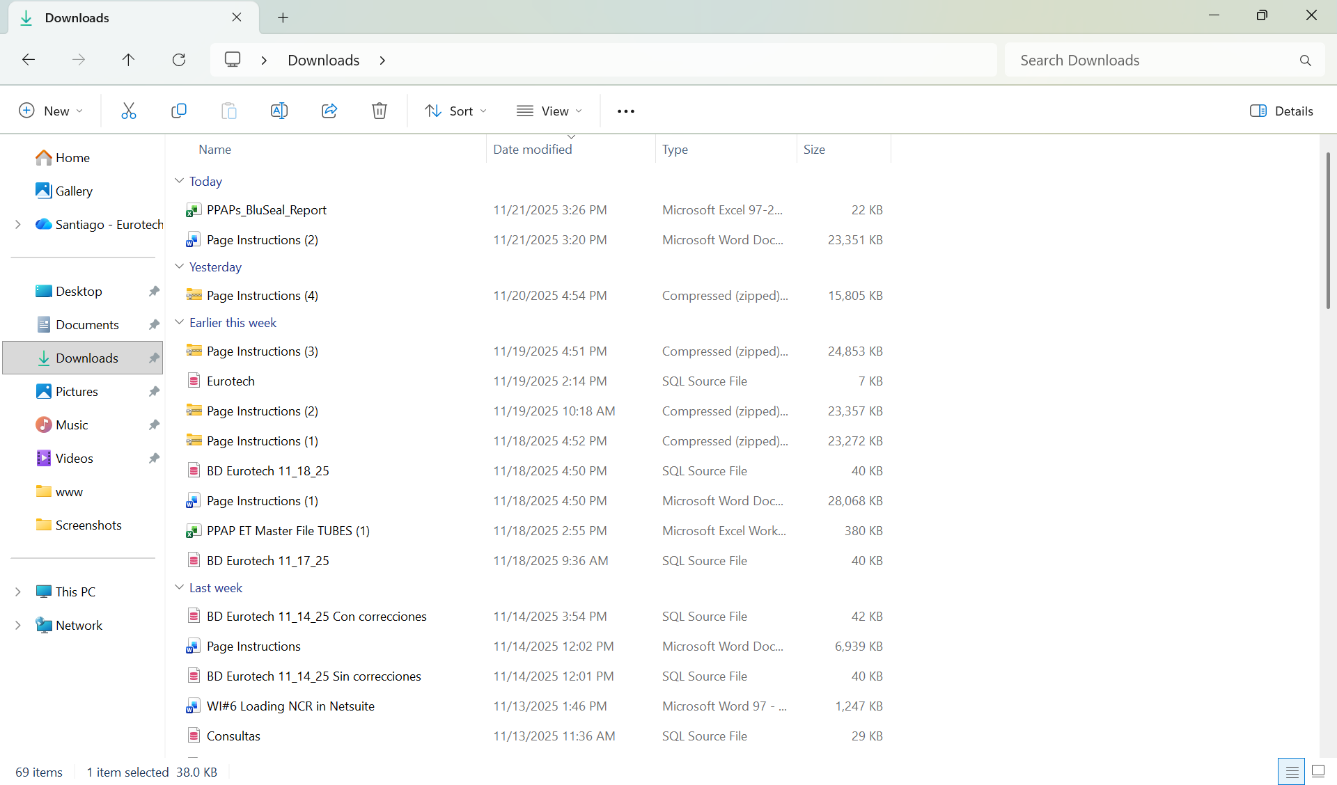

This is an example of how the document would look like:

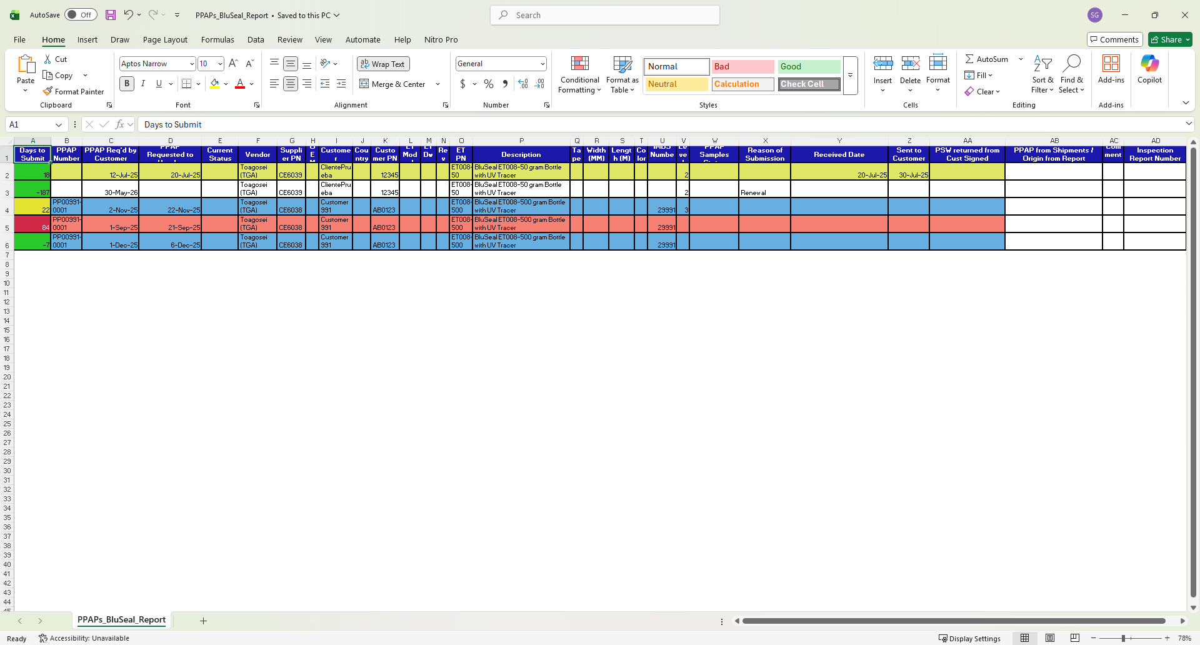

## ***3.5 Cables Page.***

### *3.5.1 How to Navigate to “Cables” Page.*

On the navigation bar, you can navigate to the “Cables” page.

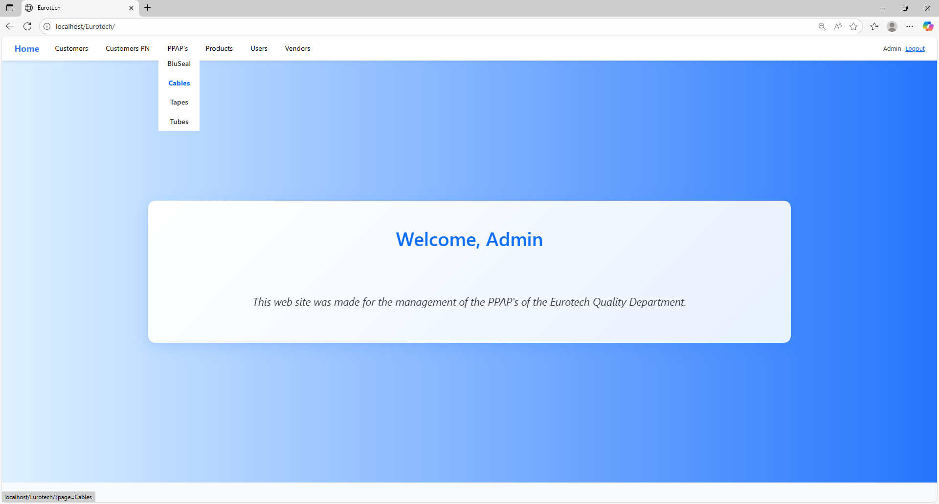

In this page you can manage the registers of all the PPAPs of Cables.

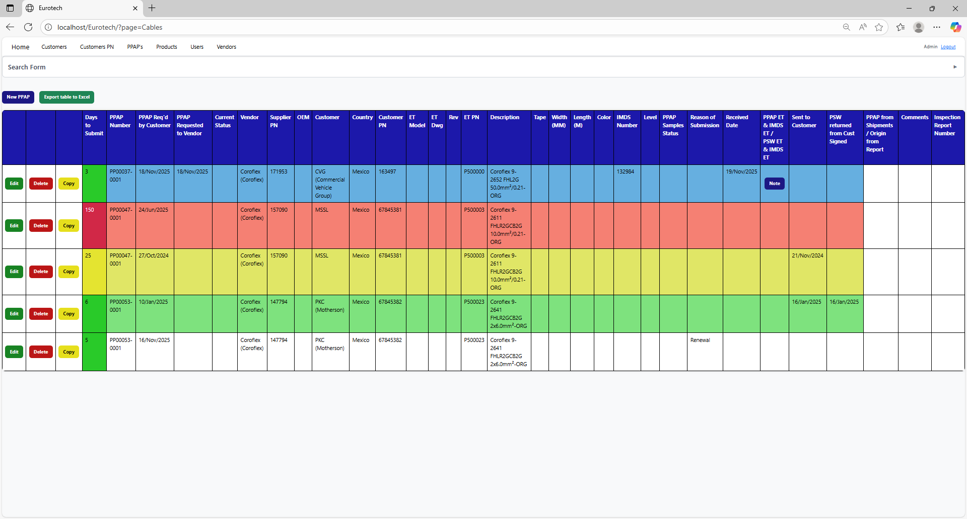

### *3.5.2 How to Search a PPAP.*

At the top of the page, it will be a dropdown “Search Form” that has all the fields of the table for querying registers.

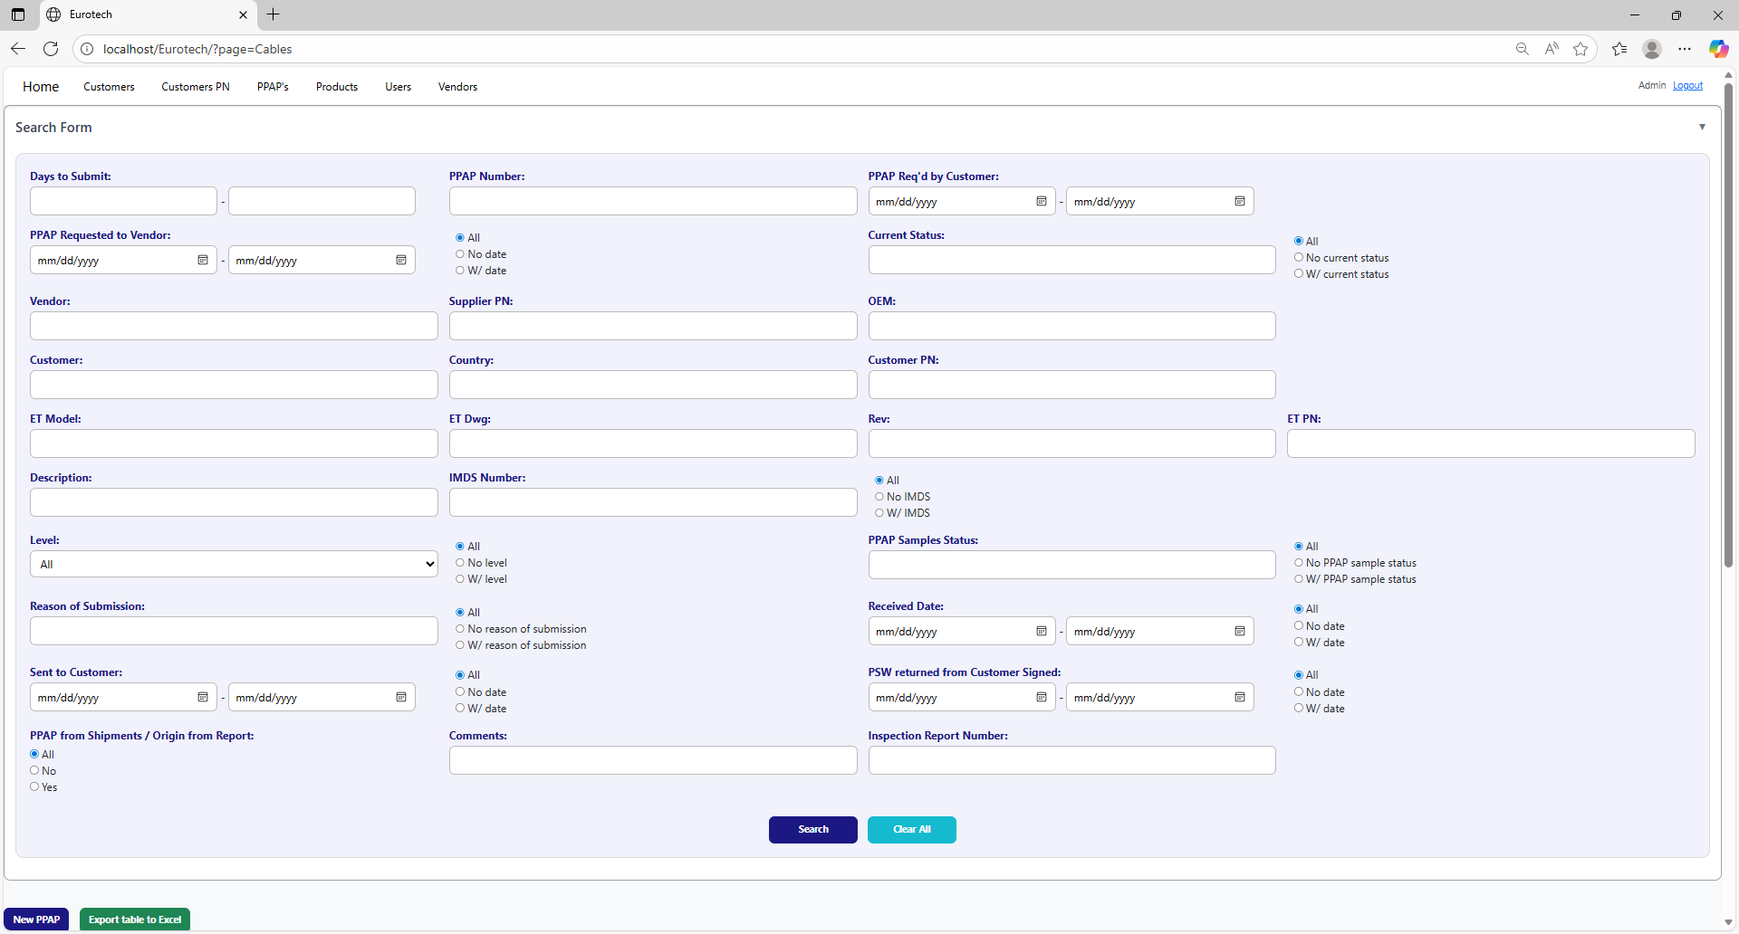

The search form allows you to perform searches by:

* Level
* PPAP Samples Status
* Reason of Submission
* Received Date
* Sent to Customer
* PSW returned from Customer Signed
* PPAP from Shipments / Origin from Report
* Comments
* Inspection Report Number
* Days to Submit
* PPAP Number
* PPAP Req’d by Customer
* PPAP Requested to Vendor
* Current Status
* Vendor
* Supplier PN
* OEM
* Customer
* Country
* Customer PN
* ET Model
* ET Dwg
* Rev
* Eurotech PN
* Description
* IMDS Number

You can search by “Days to Submit”, writing the range of days.

You can search by “PPAP Number”.

You can search by “PPAP Req’d by Customer”, writing the range of dates.



You can search registers that either have or don’t have the “Current Status” field filled in, or all the registers.

You can search by “Current Status”.

You can search registers that either have or don’t have a date on “PPAP Requested to Vendor”, or all the registers.

You can search by “PPAP Requested to Vendor”, writing the range of dates.

You can search by “OEM”.

You can search by “Vendor”.

You can search by “Supplier PN”.



You can search by “Customer PN”.

You can search by “Customer”.

You can search by “Country”.

You can search by “ET PN”.

You can search by “Rev”.

You can search by “ET Dwg”.

You can search by “ET Model”.



You can search registers that either have or don’t have the “IMDS Number” field filled in, or all the registers.

You can search by “IMDS Number”.

You can search by “Description”.

You can search by “PPAP Samples Status”.

You can search by “Level”.

You can search registers that either have or don’t have the “PPAP Samples Status” field filled in, or all the registers.

You can search registers that either have or don’t have the “Level” field filled in, or all the registers.



You can search registers that either have or don’t have a date on “Received Date”, or all the registers.

You can search by “Received Date”, writing the range of dates.

You can search registers that either have or don’t have the “Reason of Submission” field filled in, or all the registers.

You can search by “Reason of Submission”.

You can search registers that either have or don’t have a date on “PSW returned from Customer Signed”, or all the registers.

You can search registers that either have or don’t have a date on “Sent to Customer”, or all the registers.

You can search by “PSW returned from Customer Signed”, writing the range of dates.

You can search by “Sent to Customer”, writing the range of dates.



You can search by “Inspection Report Number”.

You can search by “Comments”.

You can search by “PPAP from Shipments / Origin from Report”.

You must click the “Search” button after you fill any of the fields of the “Search Form” to make the search.



This is an example of how the table would look like after a search (the meaning of the colors of the registers will be explained later).



And with the “Clear All” button, you can clean the querying and see all the registers of the PPAPs.



Once you click the “Clear All” button, the fields of the “Search Form” will be empty, and in the table will be shown all the PPAPs.





### *3.5.3 Meaning of the Colors of the Registers.*

1.- In the “Days to Submit” column there will be:

* Registers with green field indicate that the difference between the “PPAP Req’d by Customer” date and the “Sent to Customer” date is less than 19 days (if there is no “Sent to Customer” date yet, it is compared with the current date).

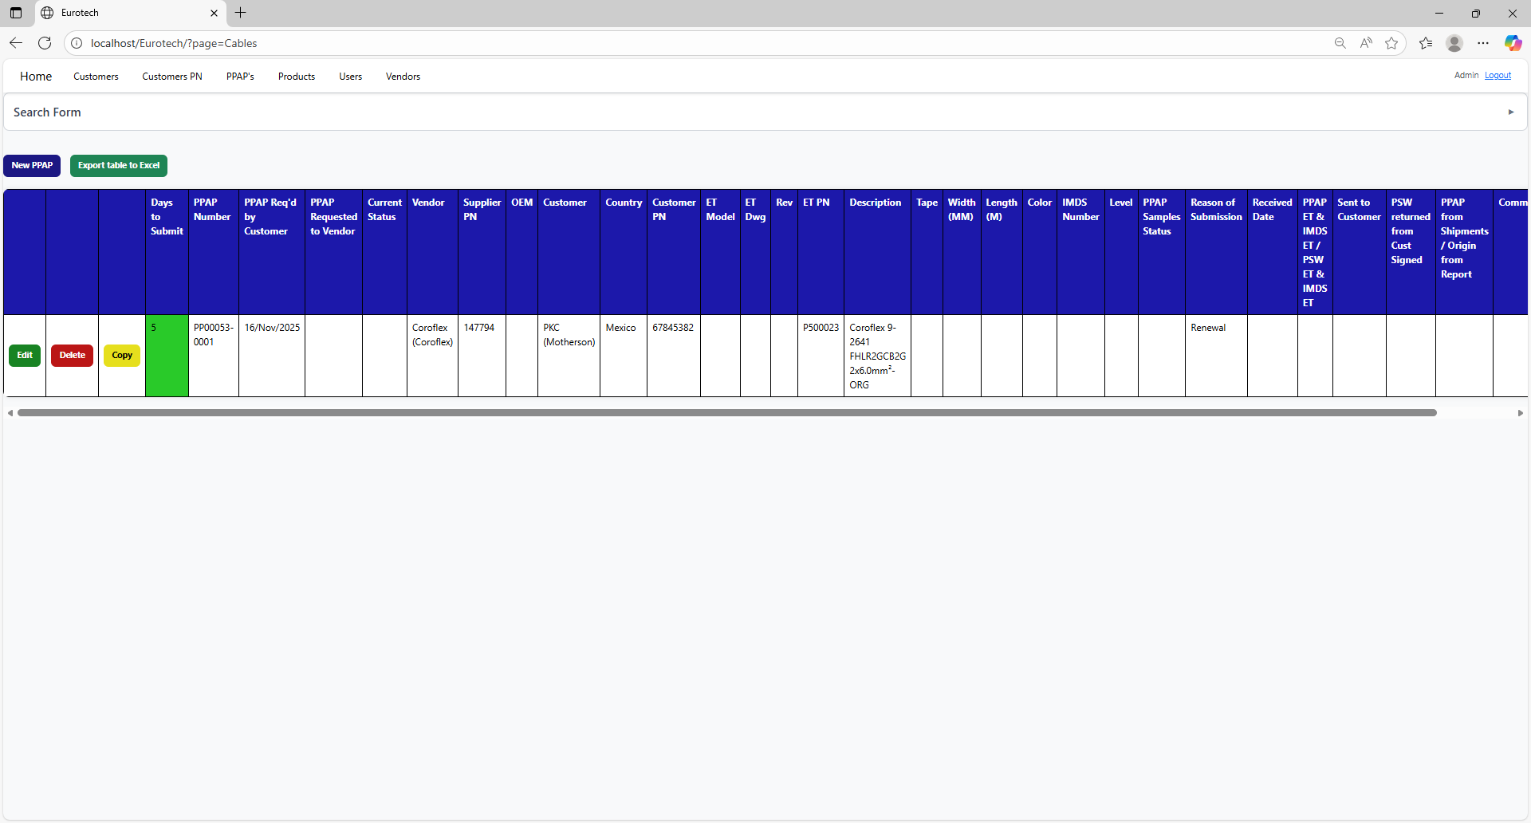

* Registers with yellow field indicate that the difference between the “PPAP Req’d by Customer” date and the “Sent to Customer” date is between 19 and 29 days (if there is no “Sent to Customer” date yet, it is compared with the current date).

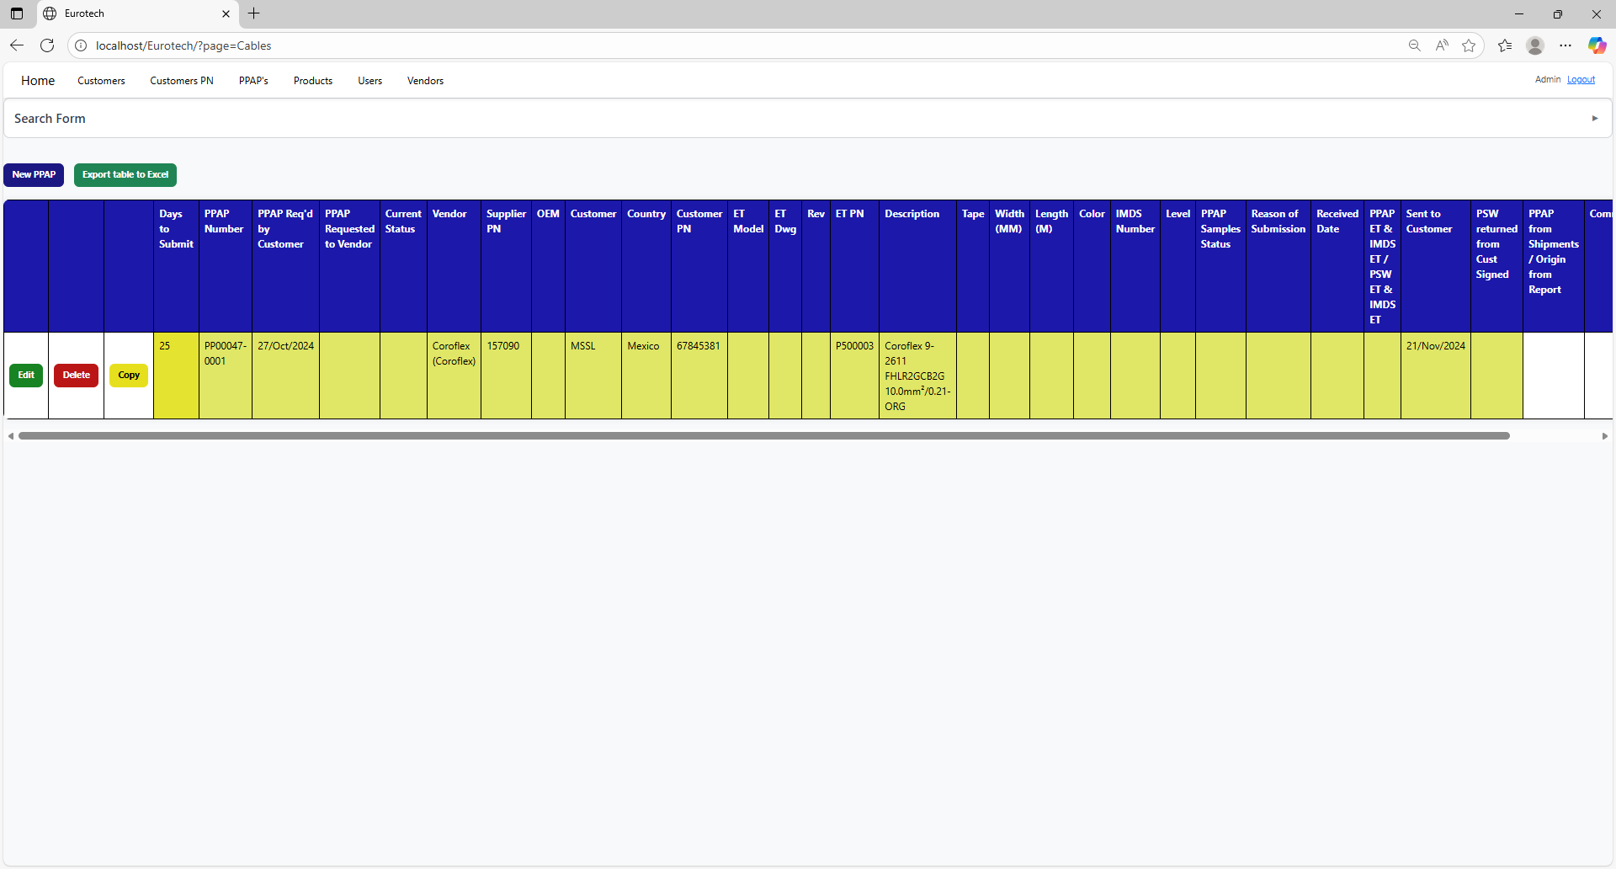

* Registers with red field indicate that the difference between the “PPAP Req’d by Customer” date and the “Sent to Customer” date is greater than 29 days (if there is no “Sent to Customer” date yet, it is compared with the current date).

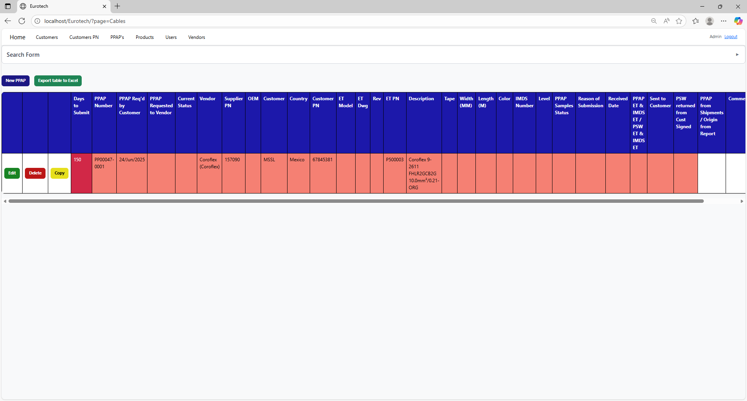

2.- In the rest of the columns of the registers will be:

* Registers with white background indicate that the PPAP has been requested by the customer, the request has not been sent to the vendor, and 30 days have not passed without the documentation being sent to the customer.



* Registers with blue background indicate that the PPAP has been requested by the customer, the request has been sent to the vendor, and 30 days have not passed without the documentation being sent to the customer.

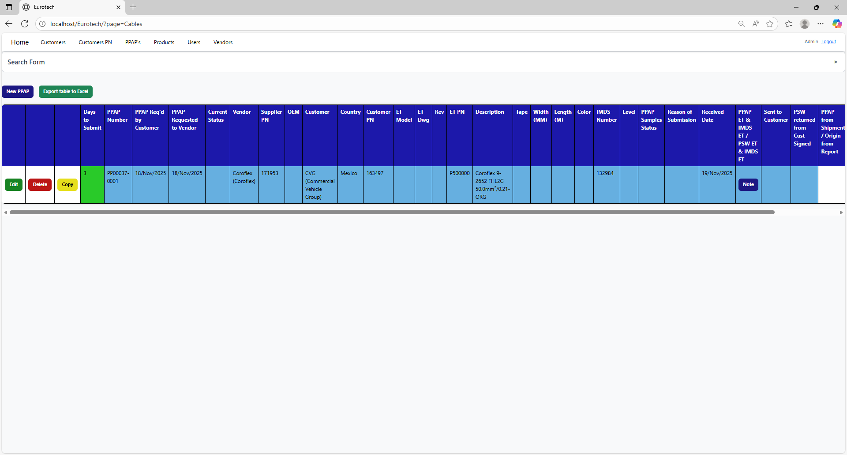

* Registers with red background indicate that the PPAP has been requested by the customer, and the 30-day limit has passed without the documentation being sent to the customer.



* Registers with yellow background indicate that the PPAP has been sent to the customer, and the PSW has not been returned signed by the customer.



* Registers with green background indicate that the PSW has been returned signed by the customer.

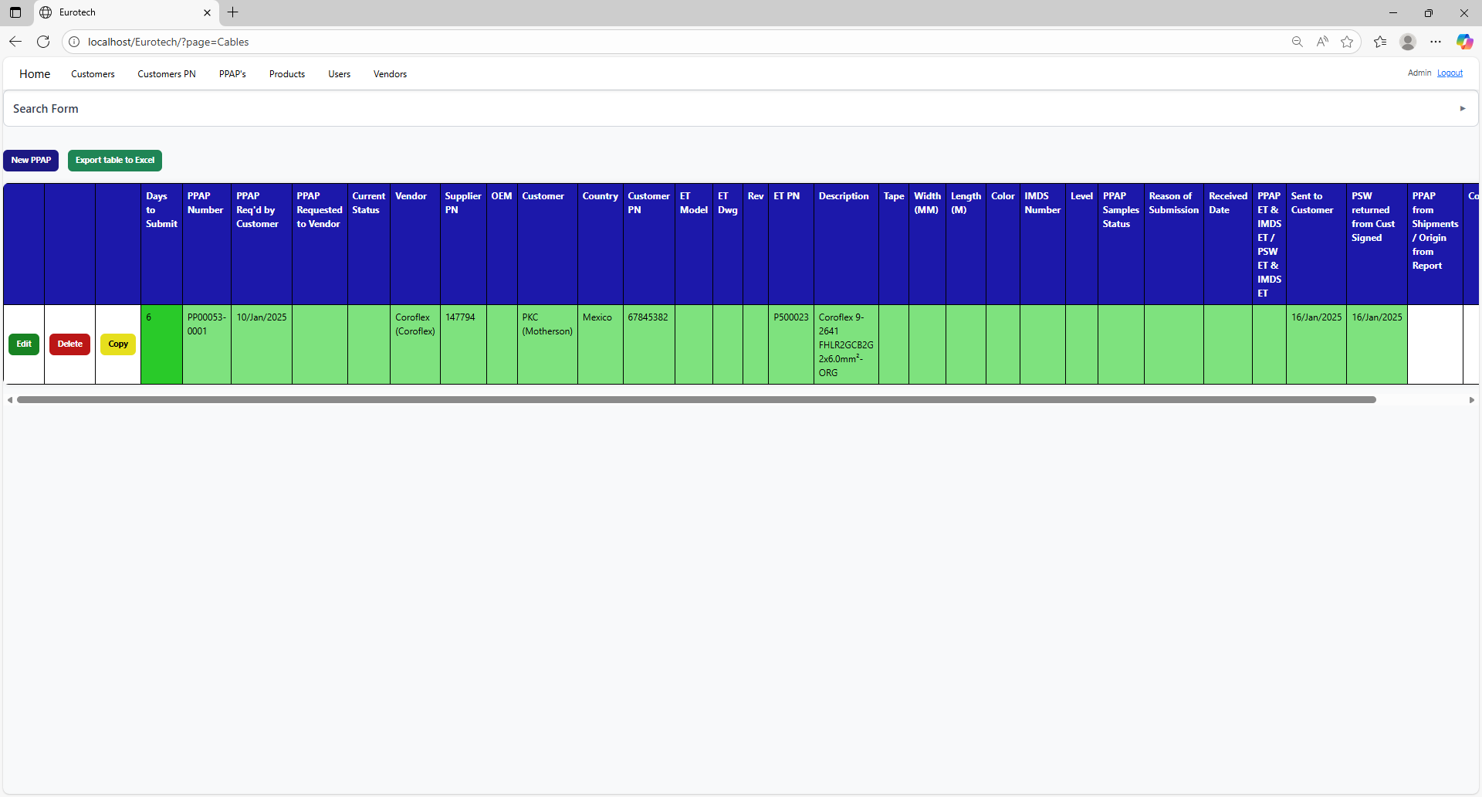

### *3.5.4 How to Add a New PPAP.*

If you want to add a new PPAP, you must click the “New PPAP” button that is below the “Search Form”.



Once you click the “New PPAP” button, it will display a register form to create a new PPAP.



Non-mandatory field

Mandatory fields



Non-mandatory field

If you want to save the register of a new PPAP, you must click the “Save” button.

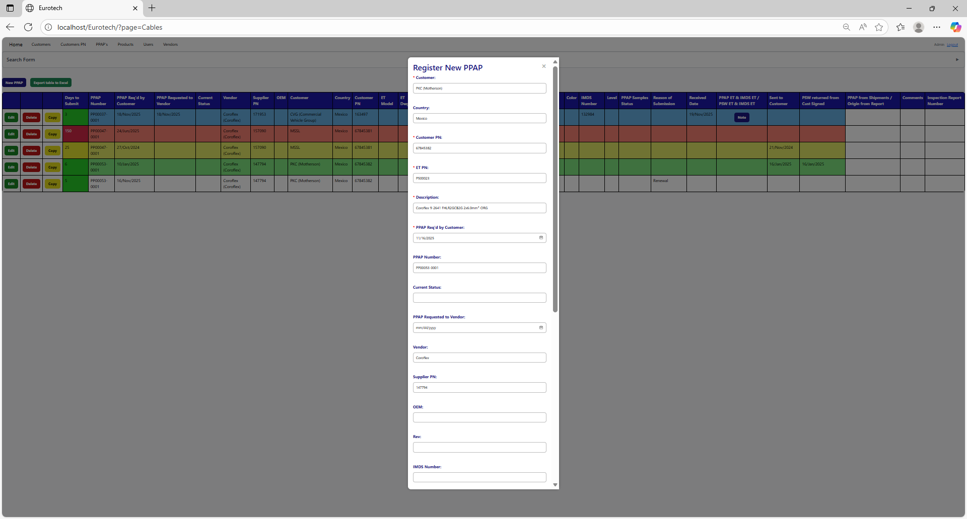



If no errors are found, the register will be added successfully.

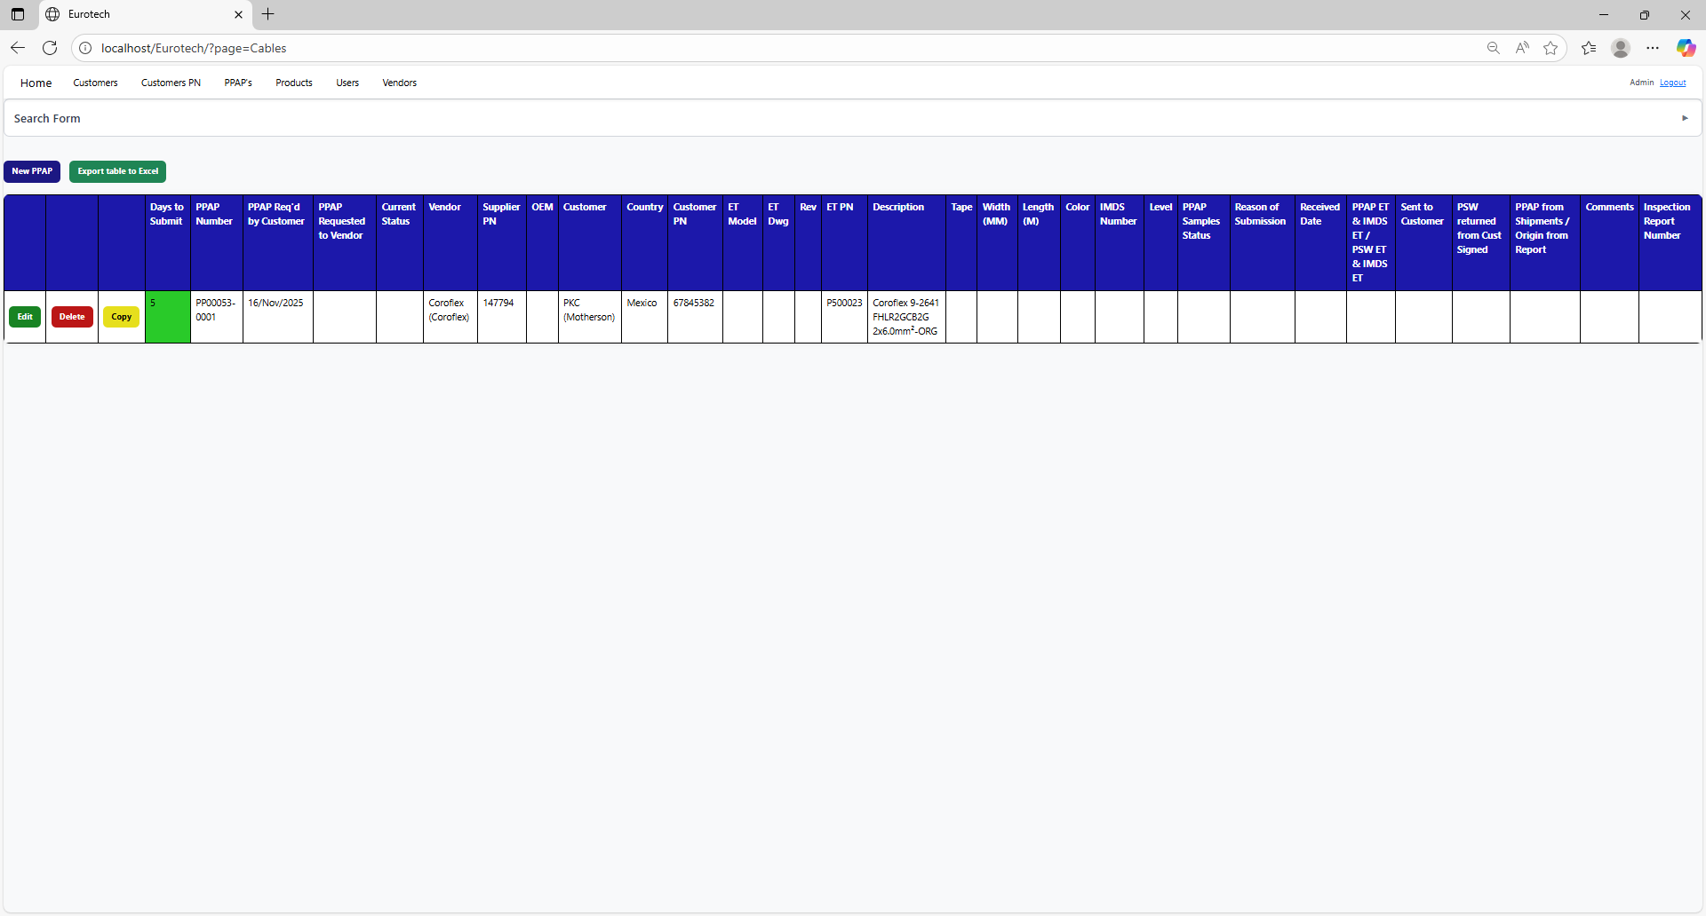

If an error is found, you can check in the Index the instruction *3.11.3.1 Register Form Errors.*

### *3.5.5 How to Edit Information of a PPAP.*

In each register from the table, it will be an “Edit” button. If this button is clicked, it will display an update form to edit the information of the selected PPAP.



Once you click the “Edit” button, it will display an update form to edit the information of the selected PPAP.

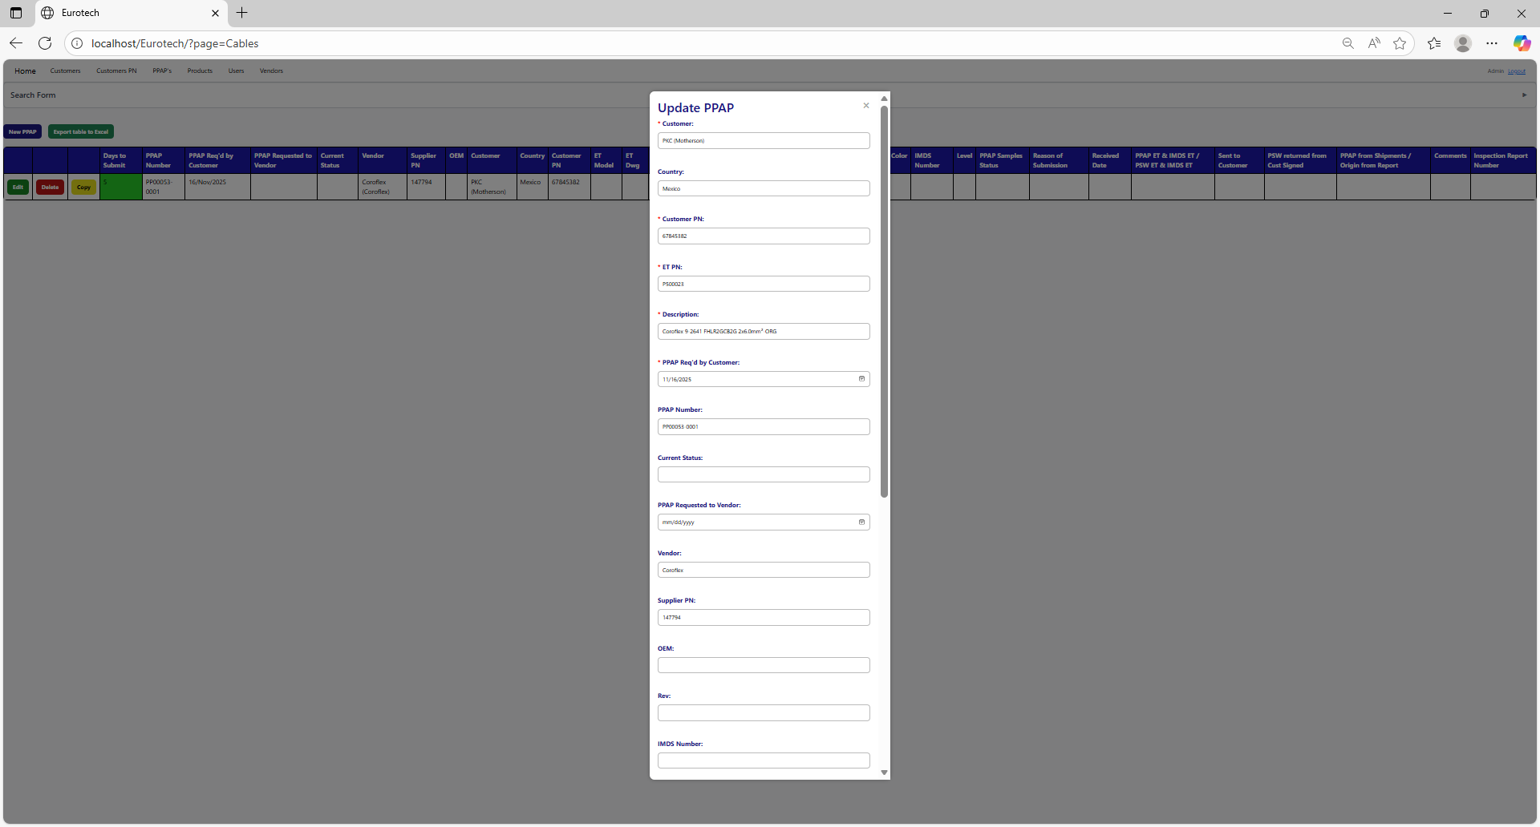



Example of a modification:

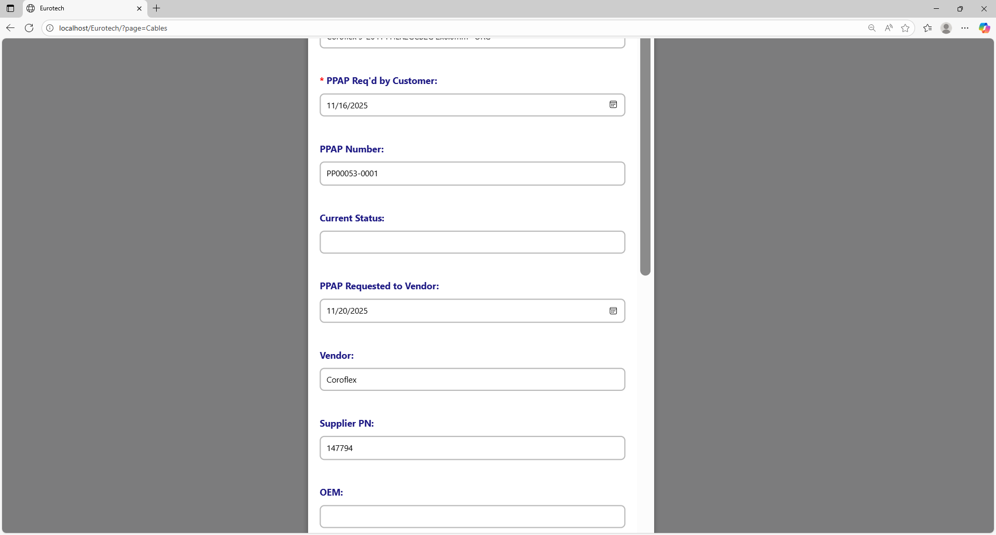

To save the changes, you must click the “Save” button.



If no errors are found, the register will be updated successfully.

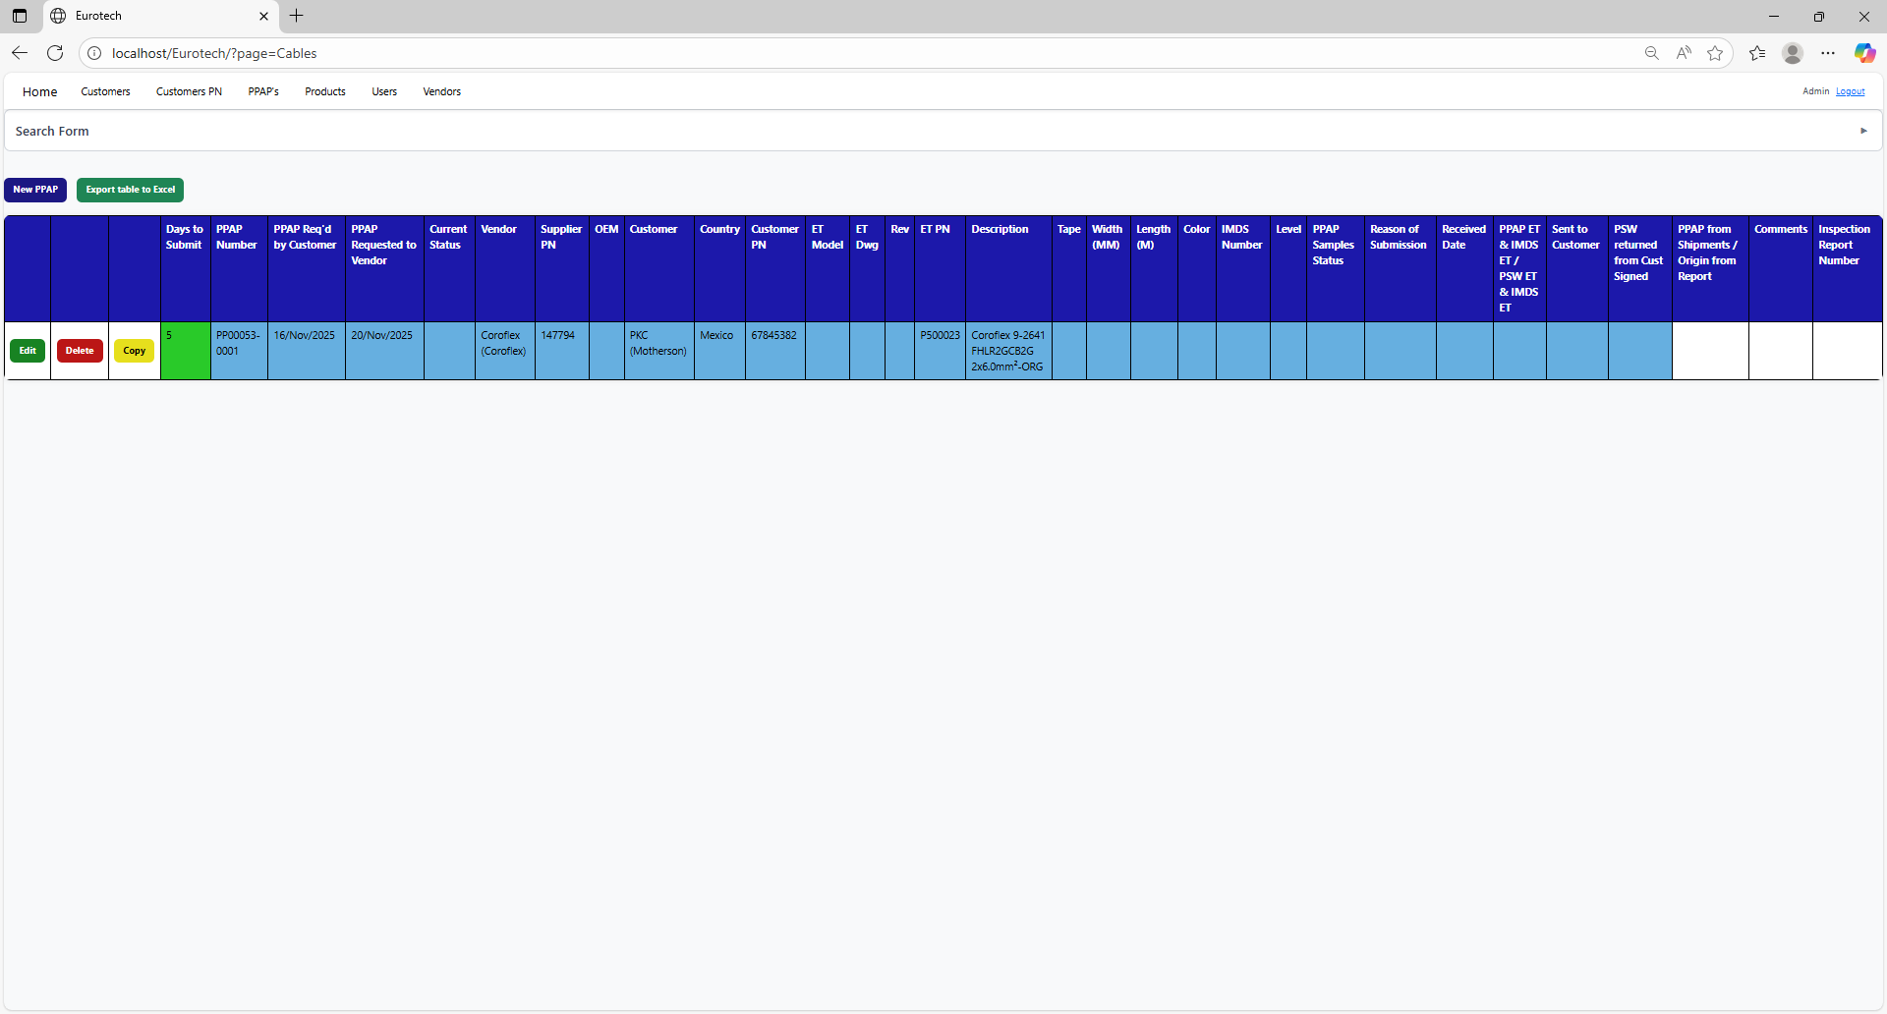

If an error is found, you can check in the Index the instruction *3.11.3.2 Edit Form Errors.*

### *3.5.6 How to Copy the Information of a PPAP.*

In each register from the table, it will be a “Copy” button. You must click the “Copy” button of the register you want to copy its information.



Once you click the “Copy” button, it will display the register form, but with the information of the PPAP selected.

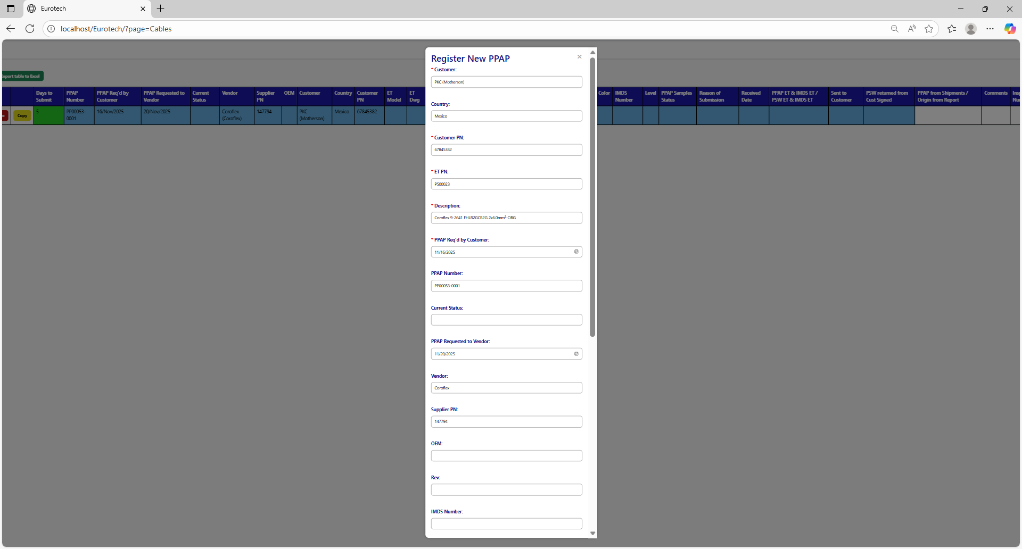

You can do the modifications you need to the information and use the “Save” button to save the new register.



### *3.5.7 How to Delete a PPAP.*

In each register from the table, it will be a “Delete” button. You must click the “Delete” button of the register you want to delete.



Once you click the “Delete” button, it will display the information of the selected PPAP with a message to confirm the delete action. To confirm the delete of the PPAP, you must click the “Confirm” button.

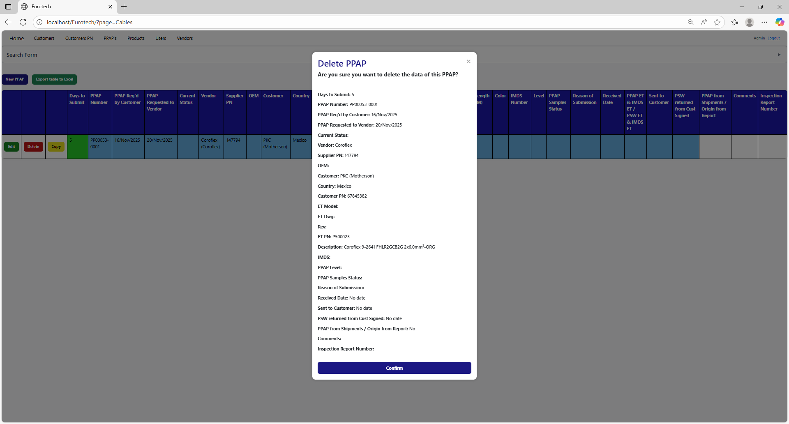

### *3.5.8 How to Automatically Create a Renewal for a PPAP.*

When a PPAP is registered or updated, and the "Sent to Customer" field is filled in, it also creates the register for the following year's renewal, putting the date of "Sent to Customer" in the "PPAP Req'd by Customer" field, adding 10 more months.

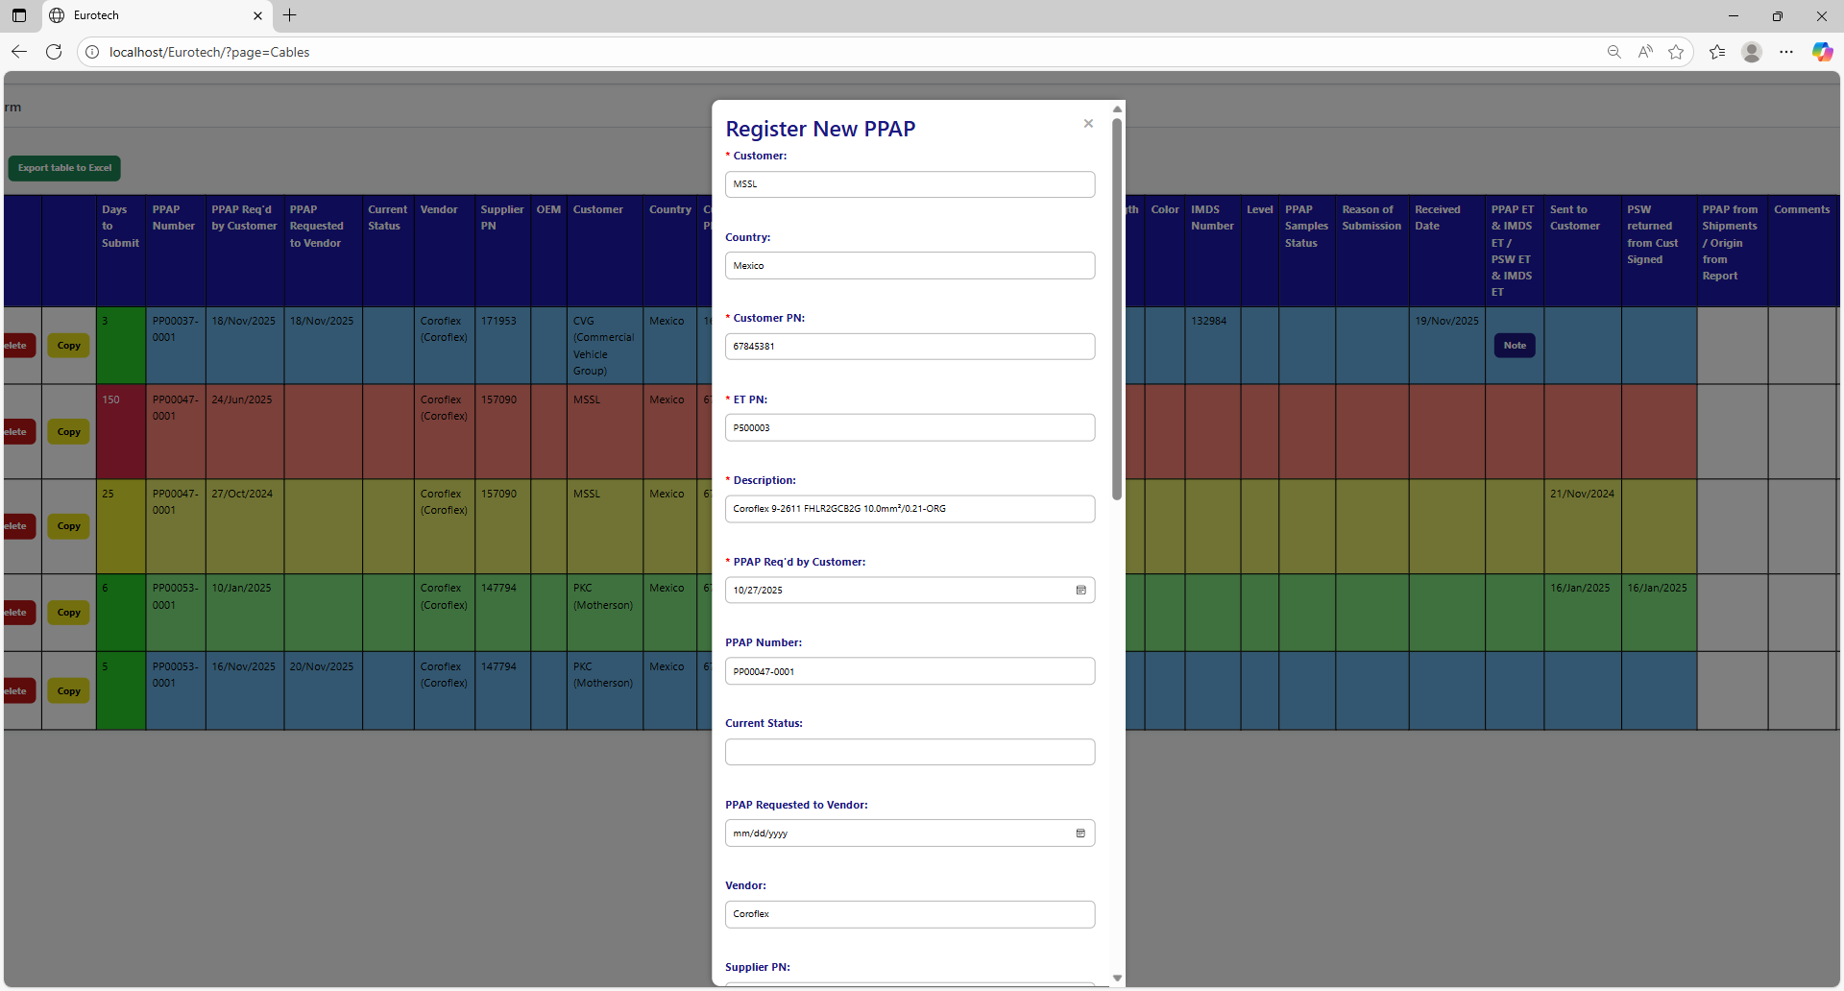

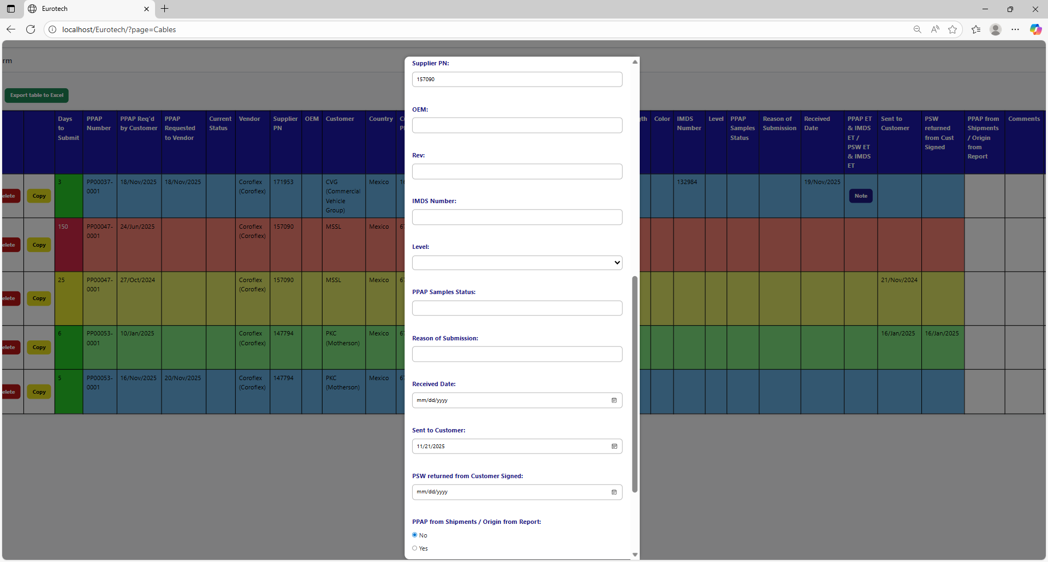



Once you click the “Save” button, the register for the following year's renewal will be created.

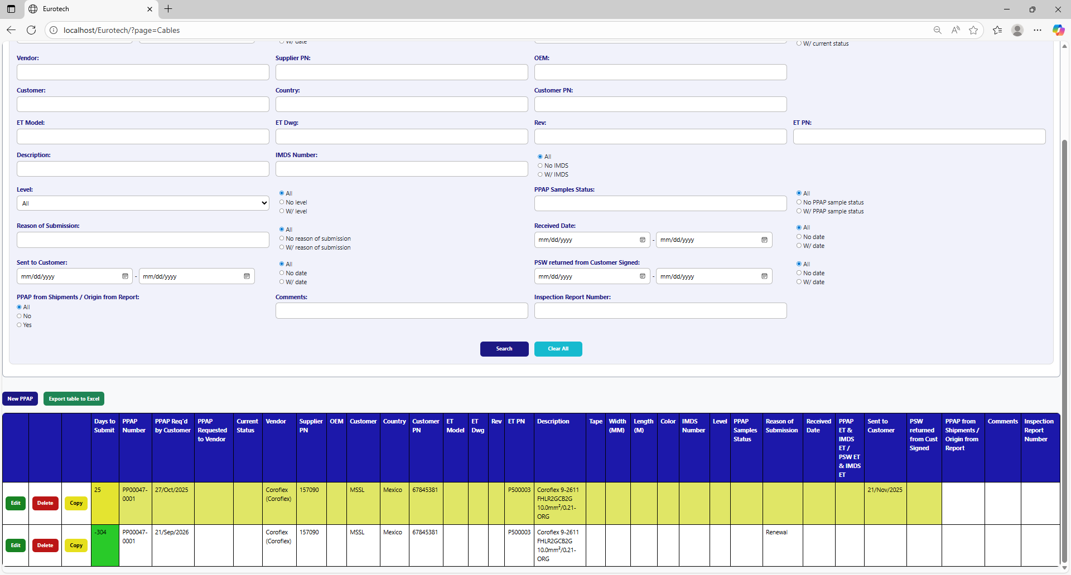

### *3.5.9 Duplicating Register Alert.*

If you were trying to register a new PPAP and it shows you a message with the title “Duplicating Register”, is not an error. The page is trying to prevent duplicate registers by verifying if there is another register in which the fields “Customer”, “Country”, “Customer PN” and “ET PN” match with the data of the new PPAP and its dates are between 10 months before the “PPAP Req'd by Customer” date of the new PPAP and that same date, or if there is a future renewal register that already exists, it will show its renewal date, and it will ask you if you are sure to register the PPAP.

This is an example of the “Duplicating Register” alert:

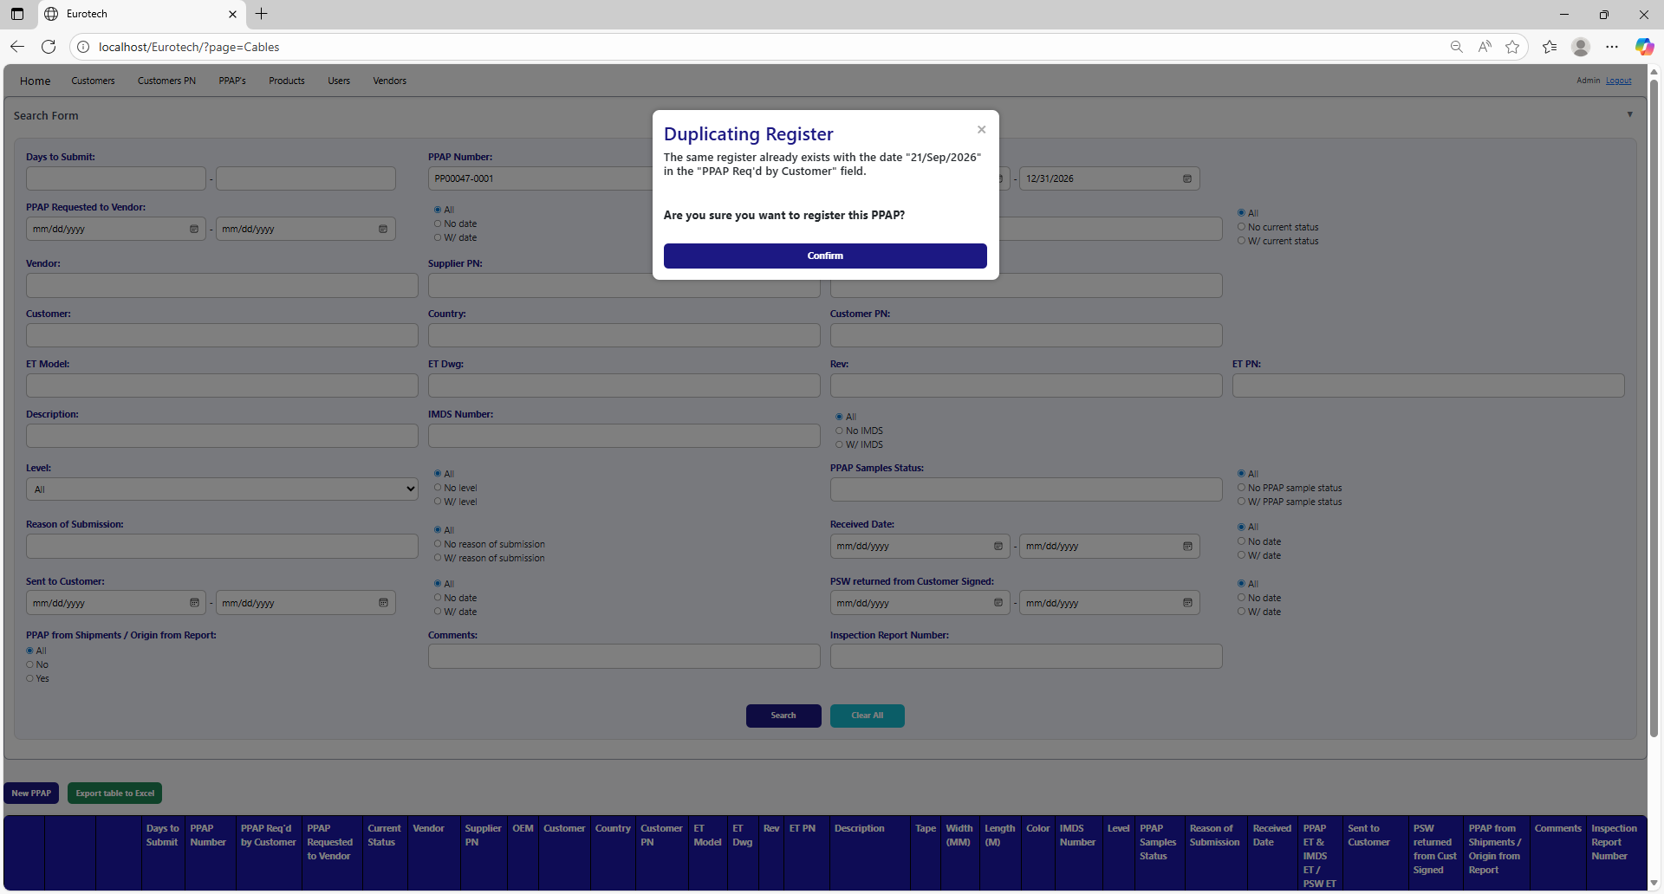

Once you are sure to register the PPAP, you must click the “Confirm” button.



### *3.5.10 How to Check the “PSW ET” & “IMDS ET” of a PPAP.*

To check the “PSW ET” and “IMDS ET” of a PPAP, you must click the “Note” button that is in the “PPAP ET & IMDS ET / PSW ET & IMDS ET” field (the button only appears on registers that have a date in the “Received Date” field).



Once you click the “Note” button, it will display a note to check/uncheck the “PSW ET” and “IMDS ET”.

**

Once you finish to check the fields you need, you must click the “Save” button to save the changes.

**

### *3.5.11 How to Export the Information of the Table to an Excel Document.*

To export the table to an Excel document, you must click the “Export table to Excel” button.



Once you click the “Export table to Excel” button, it will start to download the Excel document with the name “PPAPs_Cables_Report.xls”.

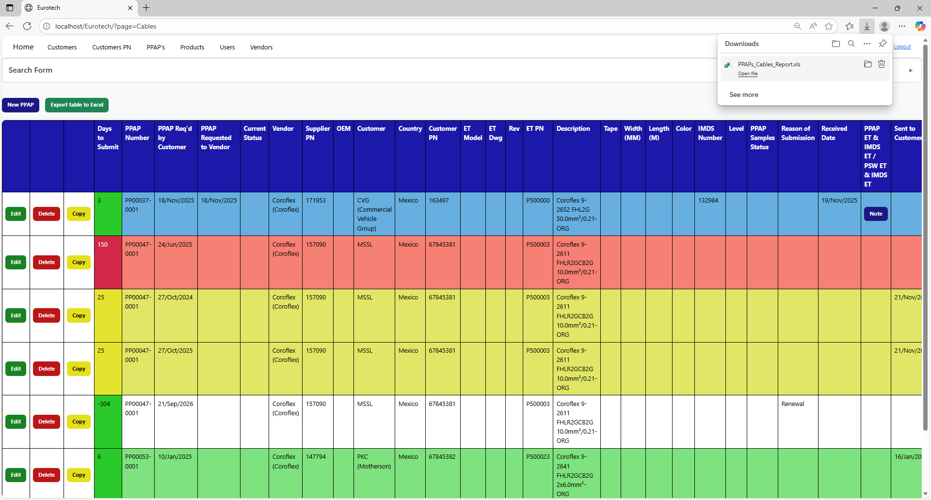

Once the download is finished, you can go to the folder it was downloaded and open the Excel document.

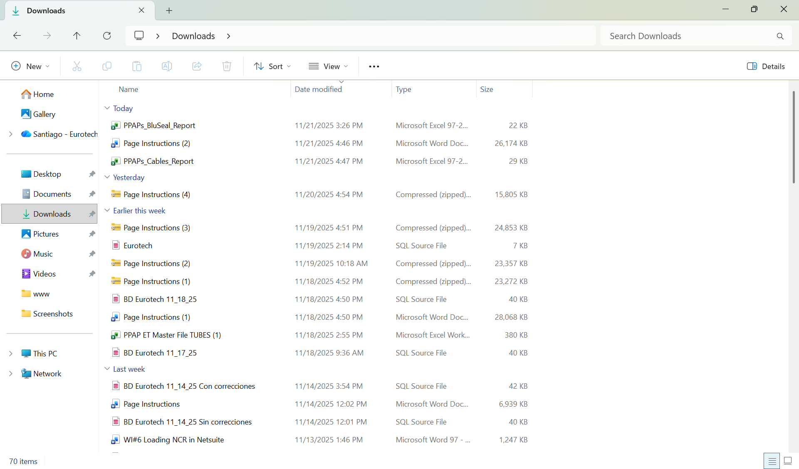

This is an example of how the document would look like:

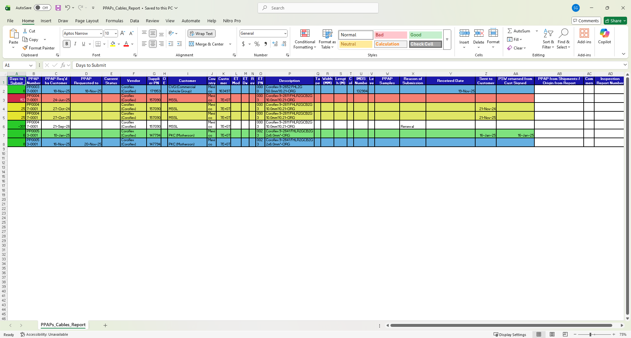

## ***3.6 Tapes Page.***

### *3.6.1 How to Navigate to “Tapes” Page.*

On the navigation bar, you can navigate to the “Tapes” page.

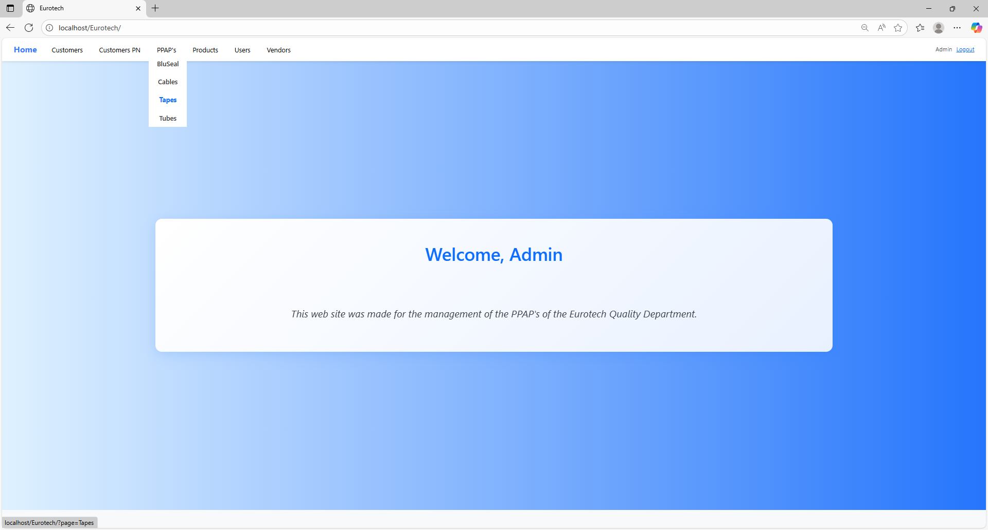

In this page you can manage the registers of all the PPAPs of Tapes.

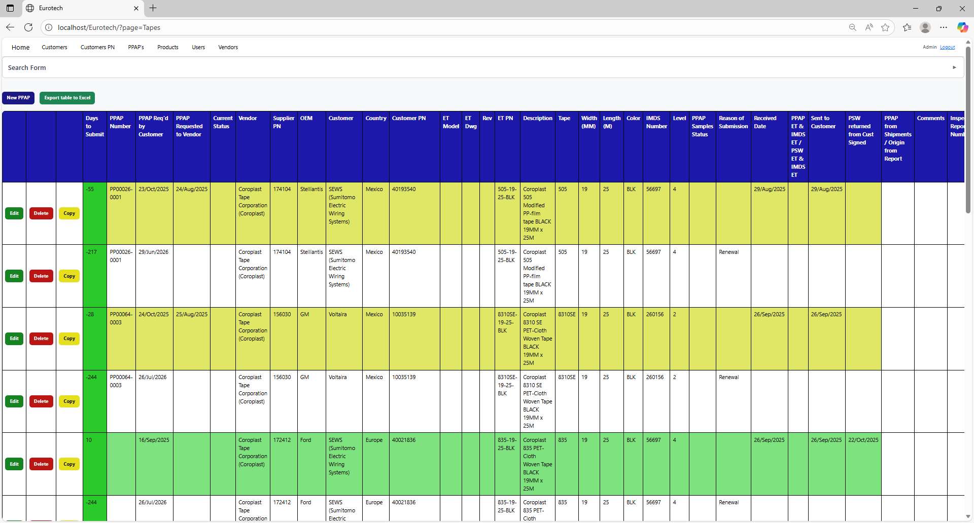

### *3.6.2 How to Search a PPAP.*

At the top of the page, it will be a dropdown “Search Form” that has all the fields of the table for querying registers.

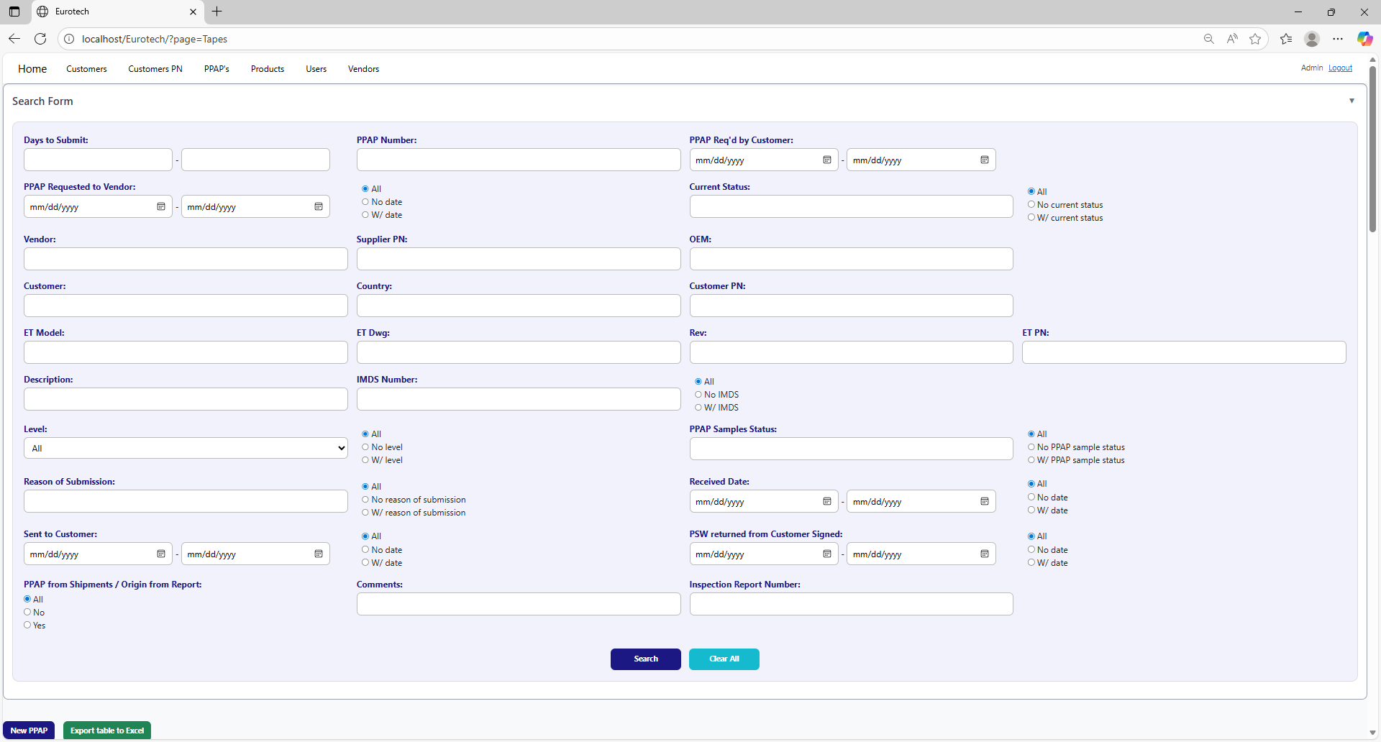

The search form allows you to perform searches by:

* Level
* PPAP Samples Status
* Reason of Submission
* Received Date
* Sent to Customer
* PSW returned from Customer Signed
* PPAP from Shipments / Origin from Report
* Comments
* Inspection Report Number
* Days to Submit
* PPAP Number
* PPAP Req’d by Customer
* PPAP Requested to Vendor
* Current Status
* Vendor
* Supplier PN
* OEM
* Customer
* Country
* Customer PN
* ET Model
* ET Dwg
* Rev
* Eurotech PN
* Description
* IMDS Number

You can search by “Days to Submit”, writing the range of days.

You can search by “PPAP Number”.

You can search by “PPAP Req’d by Customer”, writing the range of dates.



You can search registers that either have or don’t have the “Current Status” field filled in, or all the registers.

You can search by “Current Status”.

You can search registers that either have or don’t have a date on “PPAP Requested to Vendor”, or all the registers.

You can search by “PPAP Requested to Vendor”, writing the range of dates.

You can search by “OEM”.

You can search by “Vendor”.

You can search by “Supplier PN”.



You can search by “Customer PN”.

You can search by “Customer”.

You can search by “Country”.

You can search by “ET PN”.

You can search by “Rev”.

You can search by “ET Dwg”.

You can search by “ET Model”.



You can search registers that either have or don’t have the “IMDS Number” field filled in, or all the registers.

You can search by “IMDS Number”.

You can search by “Description”.

You can search by “PPAP Samples Status”.

You can search by “Level”.

You can search registers that either have or don’t have the “PPAP Samples Status” field filled in, or all the registers.

You can search registers that either have or don’t have the “Level” field filled in, or all the registers.



You can search registers that either have or don’t have a date on “Received Date”, or all the registers.

You can search by “Received Date”, writing the range of dates.

You can search registers that either have or don’t have the “Reason of Submission” field filled in, or all the registers.

You can search by “Reason of Submission”.

You can search registers that either have or don’t have a date on “PSW returned from Customer Signed”, or all the registers.

You can search registers that either have or don’t have a date on “Sent to Customer”, or all the registers.

You can search by “PSW returned from Customer Signed”, writing the range of dates.

You can search by “Sent to Customer”, writing the range of dates.



You can search by “Inspection Report Number”.

You can search by “Comments”.

You can search by “PPAP from Shipments / Origin from Report”.

You must click the “Search” button after you fill any of the fields of the “Search Form” to make the search.



This is an example of how the table would look like after a search (the meaning of the colors of the registers will be explained later).

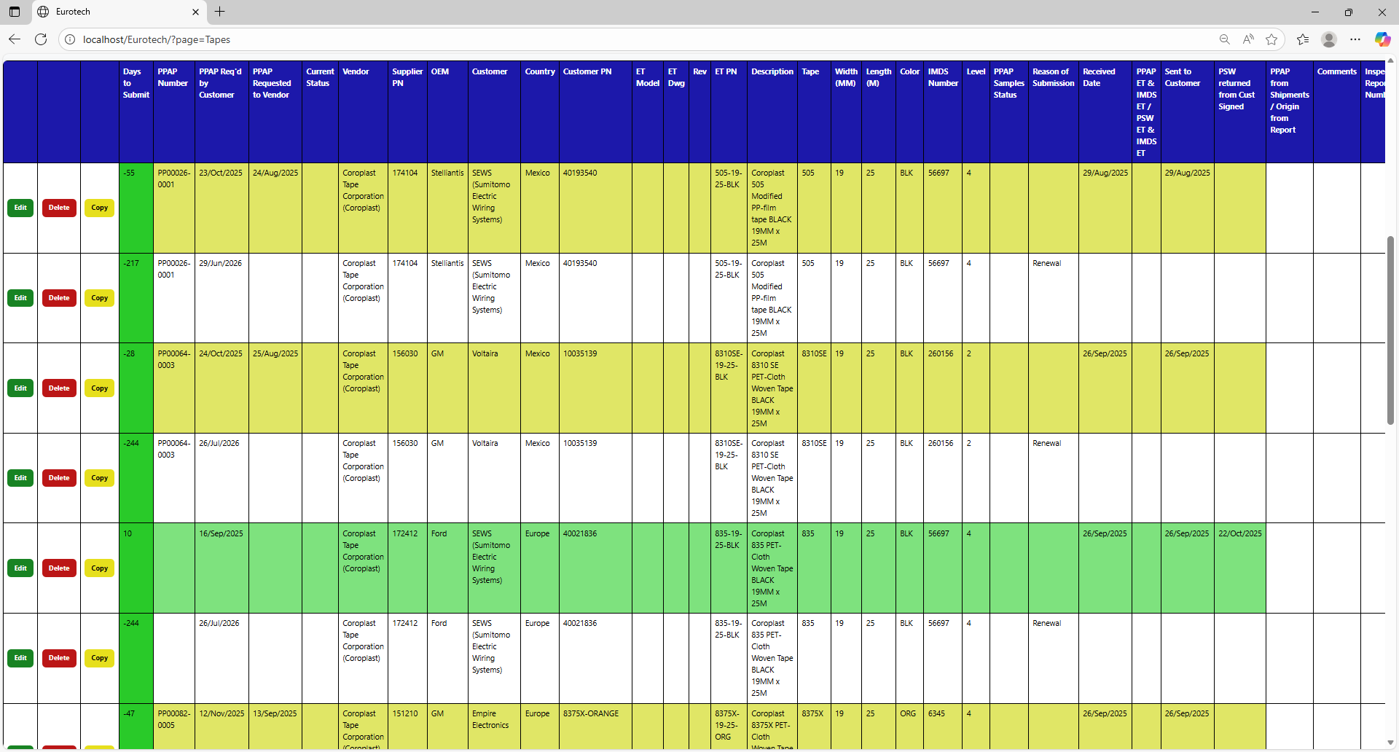

And with the “Clear All” button, you can clean the querying and see all the registers of the PPAPs.



Once you click the “Clear All” button, the fields of the “Search Form” will be empty, and in the table will be shown all the PPAPs.



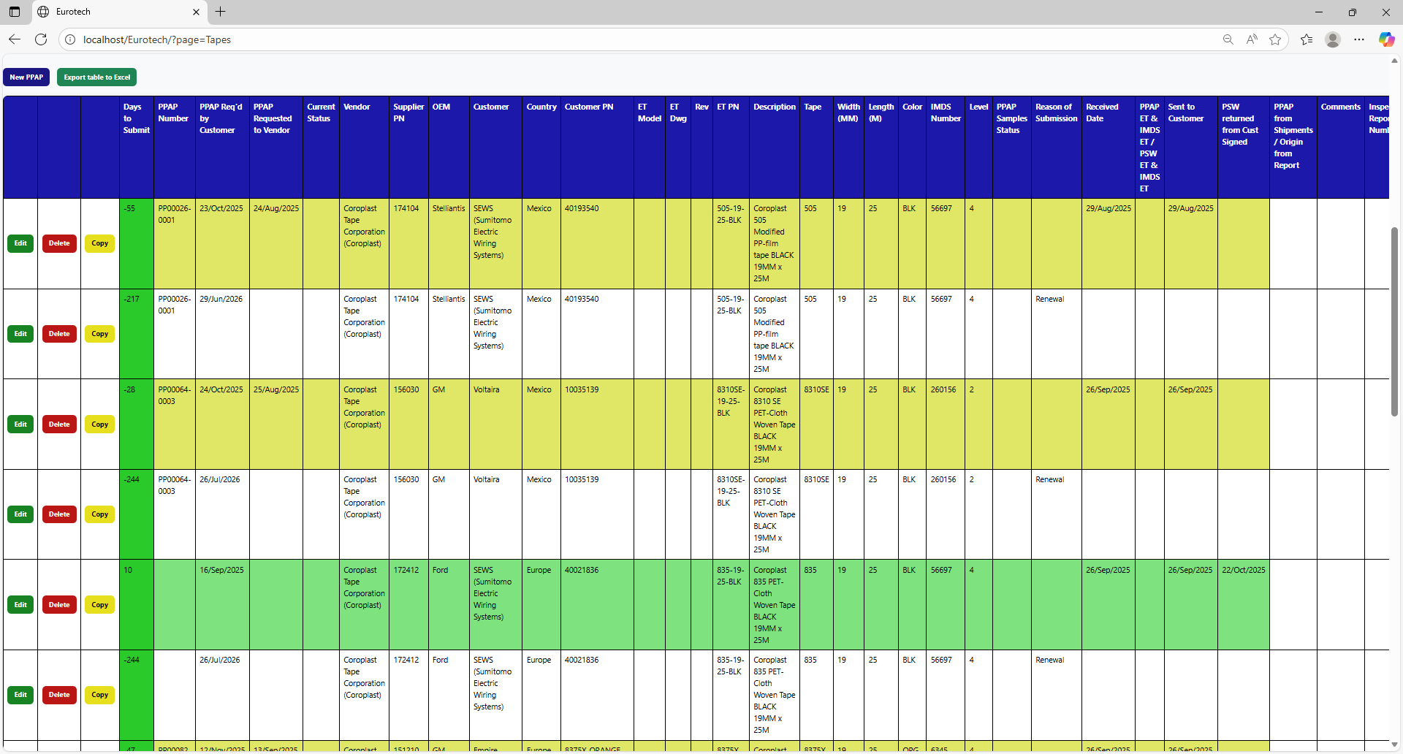

### *3.6.3 Meaning of the Colors of the Registers.*

1.- In the “Days to Submit” column there will be:

* Registers with green field indicate that the difference between the “PPAP Req’d by Customer” date and the “Sent to Customer” date is less than 19 days (if there is no “Sent to Customer” date yet, it is compared with the current date).

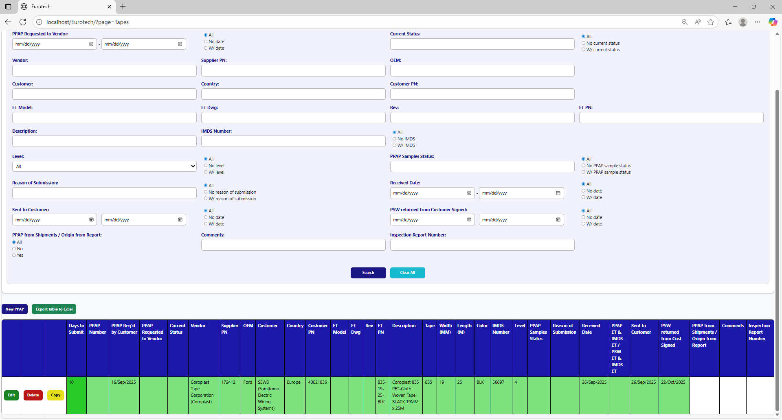

* Registers with yellow field indicate that the difference between the “PPAP Req’d by Customer” date and the “Sent to Customer” date is between 19 and 29 days (if there is no “Sent to Customer” date yet, it is compared with the current date).

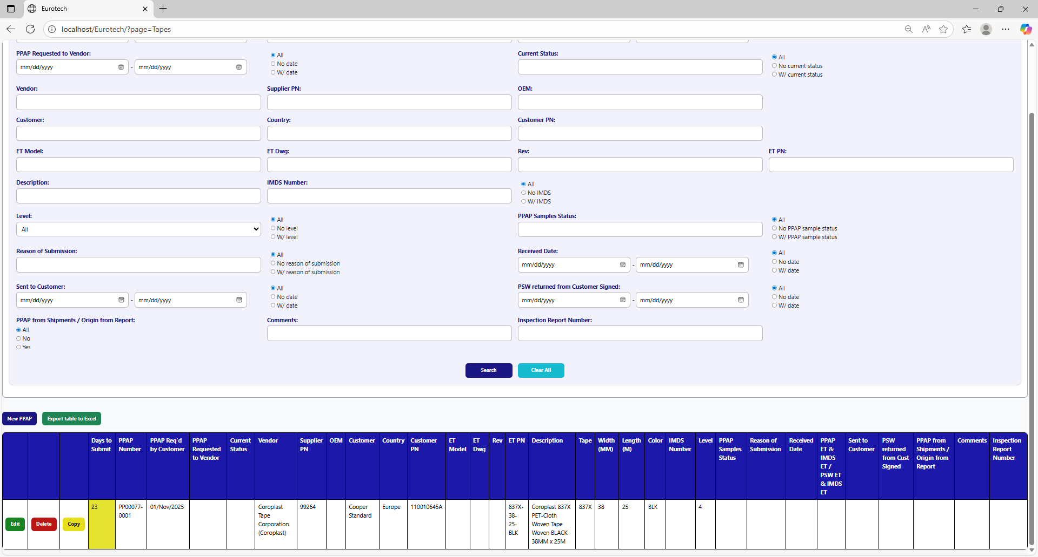

* Registers with red field indicate that the difference between the “PPAP Req’d by Customer” date and the “Sent to Customer” date is greater than 29 days (if there is no “Sent to Customer” date yet, it is compared with the current date).

